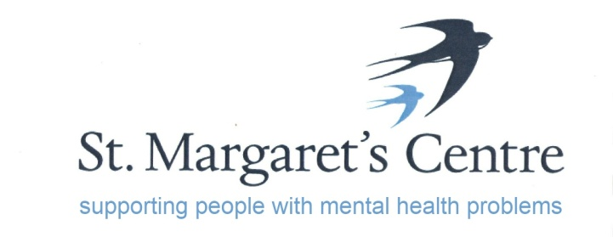

“The Old School”, Priory Orchard, Margery Lane, Durham, DH1 4QJ. Tel: (0191)3848100/3848462
e-mail: enquiries@stmargaretscentre.co.uk
www.stmargaretscentre.co.uk
Registered Charity No. 1160900

St Margaret’s Centre (SMC) works in the field of mental health and learning disabilities, providing opportunities to improve the quality of our service users’ lives and to help them achieve their potential.
It provides daily care for up to 30 people, with the majority being referred to the centre by secondary mental health teams.
The main aim is to provide a range of therapeutic activities to stimulate and aid recovery by increasing confidence and self-esteem, allowing individuals to better enjoy their lives.
Activities are extensive and varied, including cooking, woodwork and joinery, upholstery, horticultural therapy, arts and crafts, music, computer/IT studies, and bespoke courses at the request of service users.
St Margaret’s Centre takes an active working approach to Early Intervention, Prevention, Self Help and Recovery programmes, and promotes Understanding Mental Health through the delivery of courses.
As part of the final phase of refurbishment to St Margarets Centre we are developing a café, the main purpose of the venture is to provide a safe and supported environment to service users wishing to explore employment opportunities in hospitality.
The plans also include opening to the general public thus helping to reduce the stigma associated around mental health.
Any interested applicants should request an application form by emailing enquiries@stmargaretscentre.co.uk
Closing date for applications is 15/06/2018 with interviews arranged for 5th and 6th July for shortlisted applicants.

Rob Chatwin
Centre Manager

