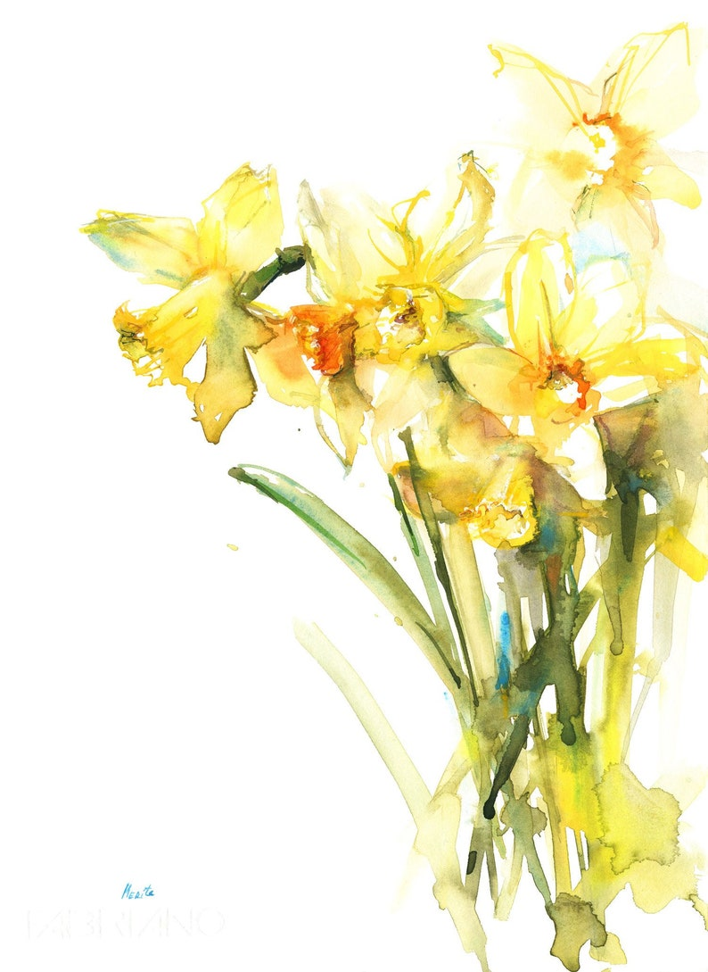
To Book Classes Call: 0191 384 8100
MONDAY 7TH MARCH
Morning -
Drawing Angels – 9.30am – 12pm – Olwyn (Craft Room)
- Shading with pencils
Afternoon –
Script Writing & Mental Health Awareness – 1pm – 3pm - Michelle - (Continued) Watercolour Cards – 1.30pm – 4pm – Olwyn (Craft Room)
TUESDAY 8TH MARCH
Morning –
Pencil Shaving Cards – 9.30am – 12pm – Olwyn (Craft room)
- Creating imagery/characters using pencil shavings with a little bit of fun doodling
Afternoon –
One Stroke Painting – 1.30pm – 4pm – Olwyn (Craft room)

WEDNESDAY 9TH MARCH
All day –
Social Day – 9am – 4pm – (Both Rooms)
(Come and go as you please, 50p tea and coffee charge)
THURSDAY 10TH MARCH
All Day –
Social Day – 9am – 4pm – (Both Rooms)
(Come and go as you please, 50p tea and coffee charge)

FRIDAY 11TH MARCH

Morning –
Foam Board Fish Paperweight – 9.30am – 12pm – Olwyn (Craft room)
- Created with a natural pebble and wire
Afternoon –
Textiles – 1.30pm – 3.30pm – Isabelle (Craft Room)
Meditation & Level 1 Stress Awareness Course – 2pm – 4pm – Margaret (Continued)

MONDAY 14TH MARCH – CENTRE CLOSED UNTIL MONDAY 28TH MARCH
MONDAY 28TH MARCH
Morning –
Emotional Resilience – 9.30am – 12pm – Andrea (Room 2)
Afternoon –
Script Writing & Mental Health Awareness – 1pm – 3pm – Michelle (Continued)
Paint and decorate your own Bird Box – 1.30am – 3.30pm – Nicola (Craft Room)
- Paint and decorate a premade full sized bird box to take home with you (£5.00)
TUESDAY 29TH MARCH
Morning –
Watercolour Daffodils – 9.30am – 12pm – Nicola (Craft Room)
Afternoon –
Gentle Chair Exercise Class & Eating Well – 1.30pm – 3.30pm – Nicola (Room 2)
WEDNESDAY 30TH MARCH
All day -
Social Day – 9am – 4pm – (Both Rooms)
(Come and go as you please, 50p tea and coffee charge)
THURSDAY 31ST MARCH
All day –
Social Day – 9am – 4pm – (Both Rooms)
(Come and go as you please, 50p tea and coffee charge)

FRIDAY 1st APRIL
Morning -
Easter Bunny Cards – 9.30am – 12pm – Nicola (Craft Room)
Afternoon –
Textiles – 1.30pm – 3.30pm – Isabelle (Craft Room)
Walking Group – 1.30pm – 3.30pm – Nicola (Meet in room 3)
Meditation & Level 1 Stress Awareness Course – 2pm – 4pm – Margaret (Continued)

