To Book Classes Call: 0191 384 8100
(There is an attendance fee of 50p per day, this is to help with cost of materials and hot beverages)
MONDAY 5TH SEPTEMBER
Morning –
Gardening – 11am – 1pm – Sandra (Shed Area)
- Learn the basics of weeding, potting, planting bulbs, herbs, and flowers with basic upkeep of flowerbeds and greenhouse/shed. A lovely way to unwind and re-energize.
Afternoon -
Expressive Finger Painting - 1.15pm – 3.30pm – Nicola (Craft Room)
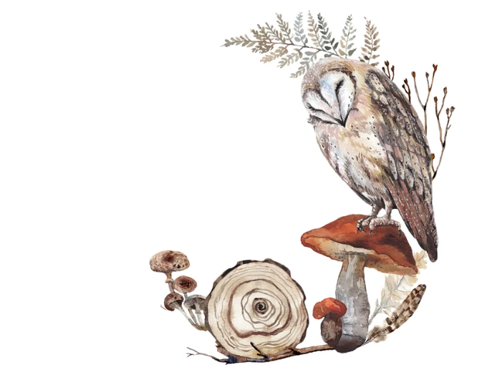
- This class is a way of exploring and expressing your emotions onto paper using acrylics, thinking about patterns, flow, colours and using only your hands to apply the paint. This can be fun, uplifting or simply a way to release any negative energy you may have built up. (A little messy, but fun)

TUESDAY 6TH SEPTEMBER
All day -
Social day – 9.30am – 4pm – Nicola (Craft Room & Room 3)
- Come and go as you please. A gentle introduction into
social interaction and a safe place to get on with any
hobbies you may have e.g., Painting, drawing, writing, jigsaws,
crosswords, knitting. Or just enjoy a nice little chin wag with a
cuppa. You must book your slot on any social day you wish to
attend to secure a seat.
Afternoon –
Communicating With Makaton Course – 1pm – 3pm – Maria – (Week 6)

WEDNESDAY 7TH SEPTEMBER
Morning –
Mountainscape Fridge Magnet – 10am – 12pm – Nicola (Craft Room)
- You will create a unique Mountainscape Fridge magnet by layering up multiple different coloured cut out pieces of card.
Horticulture – 10am – 12pm – Joy (Allotments)
- Potter about in our Allotments, planting bulbs, caring for and maintaining our vegetable, fruits, and herb patch. Learn to use correct gardening tools and simply unwind out in the fresh air. A great way to feel re-energised and soak in that all important vitamin D.

Afternoon –
DIY Landscape Bookmarks – 1.15pm – 3.30pm – Nicola (Craft Room)
- You will create a complimentary set of bookmarks using Card, simple lines, and watercolours to create different landscapes and finish with metallic details.

THURSDAY 8TH SEPTEMBER
All day –
Social day – 9.30am – 4pm – Nicola (Craft Room & Room 3)
- Come and go as you please. A gentle introduction into social interaction and a safe place to get on with any hobbies you may have e.g., Painting, drawing, writing, jigsaws, crosswords, knitting. Or just enjoy a nice little chin wag with a cuppa. You must book a slot on any social day you wish to attend to secure a seat.
Joinery Work Skills Course – Small hinged Table (5 weeks) – 9am – 4pm – Tony (Workshop)
- In this course you will practice scale drawing, marking out and how to cut different joints. You will also learn how to select and dress timber, how to fit hinges and how to apply finishes to timber. (If you book onto this course, please remember to pop the following 4 weeks in your diary)
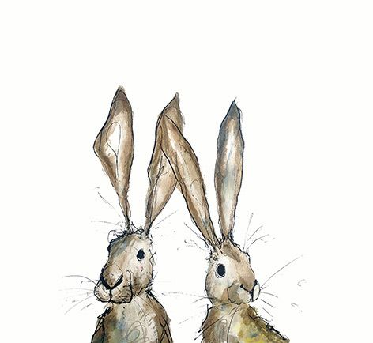

FRIDAY 9TH SEPTEMBER
Morning –
Paint Splatter Clay Wall Hanger Course (2 Weeks) - 10am – 12pm – Nicola (Craft Room)
- Using air dry clay, you will make small discs which you can imprint using stamps. Once dried you will then decorate with a colourful paint splatter effect. Your clay discs will then be attached together on a hanging wire which can be decorated with beading.
Afternoon –
Walking Group - 1.15pm – 3.30pm – Nicola (Meet in Room 2)
- A good walk can do wonders for your mental wellbeing. It improves self- perception and self-esteem, mood, and sleep quality, and it reduces stress, anxiety, and fatigue. This walk is an easy paced, relaxing, short adventure within our local City.

Textiles – 1.30pm – 3.30pm – Isabelle (Craft Room)
- Learn the basics of Sewing, knitting, and quilting in this friendly, upbeat, and social class. Learn how to use sewing machines and the correct tools and techniques to create wonderful textile pieces whilst expanding your social skills.

MONDAY 12TH SEPTEMBER
Morning –
Gardening – 11am – 1pm – Sandra – (Shed Area)
Afternoon –
Dry Brush Painting – 1.15pm – 3.30pm – Olwyn (Craft Room)
- Acrylic painting technique using only a dry brush to paint on to black card. Amazing results can be achieved by applying multiple colours without washing the brush in between.
Colour Fade Mosaic Plaque Course (2 weeks) – 1.15pm – 3.30pm – Nicola (Room 3)
- Using small irregular shaped colourful tiles, you will cover an MDF plaque with a colour fade mosaic pattern and create a decorative hanger

TUESDAY 13TH SEPTEMBER
All day –
Social day – 9.30am – 4pm – Nicola (Craft Room & Room 3)
Afternoon -
Communicating With Makaton Course – 1pm – 3pm – Maria – (Continued - Week 7)
WEDNESDAY 14TH SEPTEMBER
Morning –
Paper Collage Designs – 10am – 12pm – Olwyn (Craft Room)
- Create a repeated bird collage design using pear shaped cut outs of decorated papers and finish off with fineliner details

Beginners Phone Photography & Simple Editing - 10am – 12pm – Nicola (Room 3)
- Learn useful and creative ways you can use your phone camera to create interesting and professional looking photographs. Then learn how to utilise your built-in editing tools to tweak and creatively finish off your images.
Horticulture – 10am – 12pm – Joy (Allotments)
Afternoon –
Time to Sparkle – 1.15pm – 3.30pm – Olwyn (Craft Room)
- Delicately personalise a lovely illustrated, pre-printed card with gorgeous sparkling gems
Mountainscape Fridge Magnet - 1.15pm – 3.30pm – Nicola (Room 3)

THURSDAY 15TH SEPTEMBER
All day –
Social day – 9.30am – 4pm – Olwyn (Craft Room & Room 3)

Joinery Work Skills Course – Small hinged Table – 9am – 4pm (Continued – Week 2)
- In this course you will practice scale drawing, marking out and how to cut different joints. You will also learn how to select and dress timber, how to fit hinges and how to apply finishes to timber.
Afternoon -

Gentle Chair Exercise & Eating Well – 1.30pm – 3.30pm – Nicola (Room 2)

FRIDAY 16TH SEPTEMBER
Morning –
Back to Black - 10am – 12pm – Olwyn (Room 3)
- Create Striking patterns using bright Posca paint pens on black Card

Paint Splatter Clay Wall Hanger Course – 10am – 12pm – Nicola (Continued – Final class)
Afternoon –
Desert Island Discs – 1.15pm – 3.30pm – Olwyn (Room 3)
- Choose 3 songs which have a positive impact on you. We will play each song and you can share a little story on what they mean to you. This is a good team bonding session and allows you to discover more about one another.
Walking Group – 1.15pm – 3.30pm - Nicola (Meet in Room 2)

Textiles – 1.30pm – 3.30pm – Isabelle (Craft Room)
- Learn the basics of Sewing, knitting, and quilting in this friendly, upbeat, and social class. Learn how to use sewing machines and the correct tools and techniques to create wonderful textile pieces whilst expanding your social skills.

MONDAY 19TH SEPTEMBER
Morning –
Gardening – 11am – 1pm – Sandra – (Greenhouse/Gardens)
Afternoon –
Pebble Painting – 1.15pm – 3.30pm – Olwyn (Craft Room)
- Create a bright and playful, decorative pebble using Posca pens in this fun and therapeutic class

Colour Fade Mosaic Plaque Course – 1.15pm – 3.30pm – Nicola (Continued - Final Class)

TUESDAY 20TH SEPTEMBER
All day –
Social day – 9.30am – 4pm – Nicola (Craft Room & Room 3)
Afternoon –
Communicating With Makaton Course – 1pm – 3pm – Maria – (Continued - Week 8)
WEDNESDAY 21ST SEPTEMBER
Morning –
Dry Brush Painting – 10am – 12pm – Olwyn (Craft Room)
DIY Landscape bookmarks – 10am – 12pm – Nicola (Room 3)
Horticulture – 10 am – 12pm – Joy (Allotments)
Afternoon –
Mountainscape Fridge Magnet – 1.15pm – 3.30pm – Nicola (Room 3)
Paper Collage Designs – 1.15pm – 3.30pm – Olwyn (Craft Room)

THURSDAY 22ND SEPTEMBER
All day –
Social day – 9.30am – 4pm – Olwyn (Craft Room & Room 3)
Joinery Work Skills Course – Small hinged Table – 9am – 4pm (Continued – Week 3)
- In this course you will practice scale drawing, marking out and how to cut different joints. You will also learn how to select and dress timber, how to fit hinges and how to apply finishes to timber.
Afternoon –
Gentle Chair Exercise Class & Healthy Eating – 1.30pm – 3.30pm (Room 2)

FRIDAY 23RD SEPTEMBER
Morning –
Time to Sparkle – 10am – 12pm – Olwyn – (Craft Room)
Expressive Finger Painting - 10am – 12pm – Nicola (Room 3)
Afternoon –
Back to Black - 1.15pm – 3.30pm – Olwyn (Room 3)

Walking Group – 1.15pm – 3.30pm – Nicola (Meet in Room 2)
Textiles – 1.30pm – 3.30 pm – Isabelle (Craft Room)

MONDAY 26TH SEPTEMBER
Morning –
Gardening – 11am – 1pm – Sandra – (Shed Area)
Afternoon –
Watercolour Cards – 1.15pm – 3.30pm – Olwyn (Craft Room)
TUESDAY 27TH SEPTEMBER
All day –
Social day – 9.30am – 4pm – Andrea (Craft Room & Room 3)
Afternoon –
Communicating With Makaton Course – 1pm – 3pm – Maria – (Continued – Week 9)
WEDNESDAY 28TH SEPTEMBER
Morning –
Dry Brush Painting – 10am – 12pm – Olwyn (Craft Room)
Horticulture – 10 am – 12pm – Joy (Allotments)
Afternoon –
Paper Collage Designs – 1.15pm – 3.30pm – Olwyn (Craft Room)

THURSDAY 29TH SEPTEMBER
All day –
Social day – 9.30am – 4pm – Olwyn (Craft Room & Room 3)
Joinery Work Skills Course – Small hinged Table – 9am – 4pm (Continued – Week 4)
- In this course you will practice scale drawing, marking out and how to cut different joints. You will also learn how to select and dress timber, how to fit hinges and how to apply finishes to timber.
FRIDAY 30TH SEPTEMBER
Morning -
Pebble Painting – 10am – 12pm – Olwyn (Craft Room)
Afternoon –
Desert Island Discs - 1.15pm – 3.30pm – Olwyn (Room 3)
Textiles – 1.30pm – 3.30pm – Isabelle (Craft Room)

