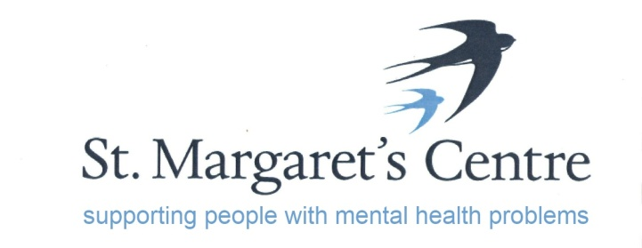

“The Old School”, Priory Orchard, Margery Lane, Durham, DH1 4QJ. Tel: (0191)3848100
e-mail: enquiries@stmargaretscentre.co.uk
www.stmargaretscentre.co.uk
Registered Charity No. 1160900

Looking for a new and exciting challenge? Want to make a real difference?
We are looking for an enthusiastic, highly motivated and suitably qualified person to help us take our Charity forward.

VACANCY: Volunteer Coordinator

£22,369 pro rata

30 hours, Monday to Friday

St Margaret’s Centre supports adults recovering from a wide range of mental health problems. The centre aims to improve the health and wellbeing of the community of County Durham through a delivery of recovery activities, programmes and courses.

This is a new position and an exciting opportunity to make a real difference within an established local Mental Health charity.

We have a fantastic new opportunity for a Volunteer Coordinator who has experience in managing, supporting and retaining volunteers with excellent organisational and time management skills.

The Volunteer Coordinator will play a significant part in contributing to the success of the team to deliver key parts of the “volunteering journey” by supporting the induction and retention of volunteers.

This role is key to producing positive volunteer engagement and raising the profile of volunteering both internally and externally.

There will be a 6 month trial period and an enhanced Disclosure and Barring Service (DBS) check will be required if appointment takes place.

For more information or an application form and job description, please visit our website: www.stmargaretscentre.co.uk/vacancy-volunteer-coordinator

Alternatively, you can contact Rob or Lisa at St Margaret’s Centre on 0191 384 8100 or stmargarets91@hotmail.com

A CV will not be accepted as a form of application

Closing date for applications is Friday 10th February.
Shortlisted applicants will be notified by 14th February.

All shortlisted applicants will have an opportunity to visit the centre prior to their interview.
Interviews will take place on the 1st – 2nd March

