**To Book Classes Call: 0191 384 8100 or Email: enquiries@stmargaretscentre.co.uk**

**(**There is an **attendance fee of** **50p per day**, this is to

help with cost of materials and hot beverages**)**

**MONDAY** **6TH FEBRUARY**

*Afternoon –*

**One Stroke Petal Art -****1.15pm - 3.30pm - Olwyn (Craft Room)**

* One stroke painting meets dry brush painting. We will take a large soft brush and create petal shapes on black paper. As we dip the brush in to new colours, different colour combinations will emerge.

**NEW! Llama Plushie Garland Course (6 weeks) - 1.15pm – 3.30pm – Nicola (Room 3)**

* This course will teach you the basics of hand stitching and soft toy making. You will create Lama and Cactus plushies out of felt, stuffed with toy filling. You will also create individual vibrant, patterned saddles to brighten up each Llama. Finally, these will all be connected onto a long piece of yarn, creating a playful garland to hang up as quirky home décor or give as a gift. **(If you book this course, please remember to pop the following 5 classes in your diaries)**

**TUESDAY 7TH FEBRUARY**

*All day -*

**Social day – 9.30am – 4pm – Nicola (All Rooms)**

* Come and go as you please. A gentle introduction into social interaction and a safe place to get on with any hobbies you may have e.g., Painting, drawing, writing, jigsaws, crosswords, knitting or just enjoy a nice little chin wag with a cuppa. **You must book your slot on any social day you wish to attend to secure a seat.**

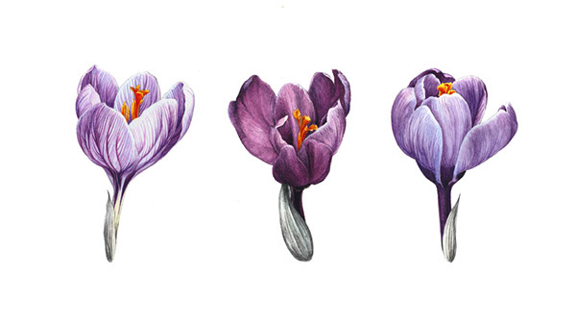



**WEDNESDAY 8TH FEBRUARY**

*Morning –*

**Copperplate Calligraphy - 10am - 12pm – Olwyn (Craft Room)**

* Learn the basics of how to write in beautifully elegant copperplate style, with a pointed nib calligraphy pen.

**Watercolour Mosaic Tiles - 10am - 12pm – Nicola (Room 3)**

* Using simple wet on wet watercolour application techniques, on white card, you will create lots of individual colourful, abstract rectangle and square tiles. These will then be cut out and placed onto A3 black card to create striking mosaic style wall art.

*Afternoon –*

**NEW! Recorder Group - 1.15pm – 3.30pm – Olwyn (Room 2)**

* Learn the basics in this fun beginners Group and make music together. You will learn how to read basic music notation, with potential to progress if you attend regularly.

**Felt Rosette Brooch and Earrings Set - 1.15pm – 3.30pm – Nicola (Craft Room)**

* This is a very basic jewellery making class for beginners. You will create three felt roses with a pearl centre. Two small roses will create the design for a set of stud earrings and one slightly larger rose to form a brooch.

**THURSDAY 9TH FEBRUARY**

*All day -*

**Social day – 9.30am – 4pm – Olwyn (Craft Room & Room 3)**

* Come and go as you please. A gentle introduction into social interaction and a safe place to get on with any hobbies you may have e.g., Painting, drawing, writing, jigsaws, crosswords, knitting. Or just enjoy a nice little chin wag with a cuppa. **You must book a slot on any social day you wish to attend to secure a seat.**

**NEW! Joinery Course – (4 Weeks) – 10am – 3.30pm – Tony (Workshop)**

* **Repurposed Grandmother Clock** - Learn to plan and draw, wood cutting and assembling. You will also learn about joints and how to finish with paint and varnish. **(If you book this course, please remember to pop the following 3 classes in your diaries)**

*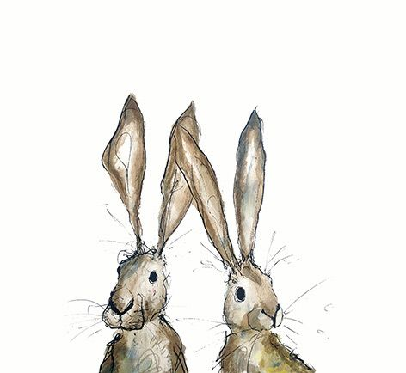***FRIDAY 10TH FEBRUARY**

*Morning –*

**Gatefold Card Tutorial – 10am – 12pm - Olwyn (Room 3)**

* A lovely card with a unique way of opening, which can be adapted to suit any occasion.

**Project Linus - 10am – 12pm – Isabelle & Debbie (Room 2)**

* Project Linus is a volunteer organisation. We aim to provide a sense of security and comfort to sick and traumatised babies, children, and teenagers through the provision of new home-made patchwork quilts and knitted blankets. No sewing skills or experience is required, you will learn new skills as you go.

*Afternoon –*

**Folding Wooden Photo Cubes - 1.15pm - 3.30pm - Olwyn (Room 3)**

* We will take 8 small wooden blocks and tape them together in a way that allows them to work like a Rubix Cube. Then we will attach positive images or words to the sides of the blocks to create an interchanging image display.

**Maintaining Emotional Resilience – 1.15pm – 3.30pm – Andrea (Room 2)**

* In this session we will talk about what emotional resilience and wellbeing means to each of us. We will discuss a variety of coping techniques, learn how to build our social support network, and put it all together in a personal wellbeing plan.

**Textiles (Unfinished projects/Repairs) – 1.30pm – 3.30pm – Isabelle (Craft Room)**

* Learn the basics of Sewing, knitting, and quilting in this friendly, upbeat, and social class. Learn how to use sewing machines and the correct tools and techniques to create wonderful textile pieces whilst expanding your social skills. Every first Friday on the timetable, the textiles class will be dedicated to completing any unfinished projects or repairing clothing and textile items.

**MONDAY 13TH FEBRUARY**

*Afternoon –*

**Pictionary – 1.15pm – 3.30pm – Olwyn (Craft Room)**

* Fun and interactive game where participants rely on teamwork and communication to draw their way to the winning post!

**Llama Plushie Garland Course - 1.15pm – 3.30pm – Nicola (Continued – Week 2)**

**TUESDAY 14TH FEBRUARY**

*All day –*

**Social day – 9.30am – 4pm – Nicola (All Rooms)**

**WEDNESDAY 15TH FEBRUARY**

*Morning –*

**Leather Turtle Coasters – 10am – 12pm – Olwyn (Craft Room)**

* These cute little coasters are fun to make, using hardwearing scrap leather. They make great gifts as they come in their own genuine packaging.

*Afternoon –*

**Recorder Group - 1.15pm – 3.30pm – Olwyn** **(Room 2)**

**THURSDAY 16TH FEBRUARY**

*All day –*

**Social Day – 9.30am – 4pm – Olwyn (Craft Room & Room 3)**

**Joinery Course – 10am – 3.30pm – Tony (Continued – Week 2)**

**FRIDAY 17TH FEBRUARY**

*Morning –*

**One Stroke Petal Art – 10am – 12pm – Olwyn (Craft Room)**

**NEW! Mini Scrapbook Course (6 Weeks) - 10am – 12pm – Nicola (Room 3)**

* In this diverse course you will get to explore with all kinds of mediums and materials. Creating many unique personalised collage style pages in a style that suits you. These pages will then be bound together to create your own unique, small, and chunky scrapbook to take away and cherish. **(If you book onto this course, please pop the following 5 classes in your diaries)**

**Linus Project - 10am – 12pm – Isabelle & Debbie (Room 2)**

*Afternoon –*

**Copperplate Calligraphy -****1.15pm - 3.30pm - Olwyn (Room 2)**

**Watercolour Mosaic Tiles – 1.15pm – 3.30pm – Nicola (Room 3)**

**Textiles (Applique Cushion Project) – 1.30pm – 3.30pm – Isabelle (Craft Room)**

* Design and create your own cushion, with an added personalised applique on the front. You will learn basic sewing skills as you go. This will be an ongoing project throughout February, but you may join onto any textile class throughout the month.

**MONDAY 20TH FEBRUARY**

*Afternoon –*

**Gatefold Card Tutorial – 1.15pm – 3.30pm – Olwyn (Craft Room)**

**Llama Plushie Garland Course – 1.15pm – 3.30pm – Nicola (Continued – Week 3)**

**Maintaining Emotional Resilience – 1.15pm – 3.30pm – Andrea (Room 2)**

* In this session we will talk about what emotional resilience and wellbeing means to each of us. We will discuss a variety of coping techniques, learn how to build our social support network, and put it all together in a personal wellbeing plan.

**TUESDAY 21ST FEBRUARY**

*All day –*

**Social day – 9.30am – 4pm – Nicola (All Rooms)**

**WEDNESDAY 22ND FEBRUARY**

*Morning –*

**Folding Wooden Photo Cube – 10am – 12pm – Olwyn (Craft Room)**

*Afternoon –*

**Recorder Group - 1.15pm – 3.30pm – Olwyn (Room 2)**

**THURSDAY 23RD FEBRUARY**

*All day –*

**Social day – 9.30am – 4pm – Olwyn (Craft Room & Room 3)**

**Joinery Course – 10am – 3.30pm – Tony (Continued – Week 3)**

**FRIDAY 24TH FEBRUARY**

*Morning –*

**Pictionary - 10am – 12pm – Olwyn (Craft Room)**

**Mini Scrapbook Course – 10am – 12pm – Nicola (Continued – Week 2)**

**Linus Project - 10am – 12pm – Isabelle & Debbie (Room 2)**

*Afternoon –*

**Leather Turtle Coasters -****1.15pm - 3.30pm - Olwyn (Room 2)**

**Watercolour Mosaic Tiles - 1.15pm - 3.30pm - Nicola - (Room 3)**

**Textiles (Applique Cushion Project) - 1.30pm - 3.30pm - Isabelle (Craft Room)**

**MONDAY 27TH FEBRUARY**

*Afternoon –*

**Recorder Group – 1.15pm – 3.30pm – Olwyn (Craft Room)**

**Llama Plushie Garland Course – 1.15pm – 3.30pm – Nicola (Continued – Week 4)**

**TUESDAY 28TH FEBRUARY**

*All day –*

**Social day – 9.30am – 4pm – Nicola (All Rooms)**

**WEDNESDAY 1ST MARCH**

*Morning –*

**Felt Rosette Brooch and Earring Set – 10am – 12pm – Nicola (Craft Room)**

*Afternoon –*

**One Stroke Petal Art - 1.15pm – 3.30pm – Olwyn (Craft Room)**

**THURSDAY 2ND MARCH**

*All day –*

**Social day (Minimum spaces available) – 9.30am – 4pm – Olwyn (Craft Room Only)**

* Due to only one room being available, this social day will be on a first come first serve basis, even if you have been designated this day in the past, you must book this day to get a seat other wise you may be turned away due to lack of seating space.

**Joinery Course – 10am – 3.30pm – Tony (Continued – Week 4)**

**FRIDAY 3RD MARCH**

*Morning –*

**Gatefold Card Tutorial – 10am – 12pm – Olwyn (Craft Room)**

**Mini Scrapbook Course - 10am – 12pm – Nicola (Continued - Week 3)**

**Linus Project - 10am – 12pm – Isabelle & Debbie (Room 2)**

*Afternoon –*

**Pictionary – 1.15pm – 3.30pm – Olwyn (Room 2)**

**Watercolour Mosaic Tiles – 1.15pm – 3.30pm – Nicola (Room 3)**

**Textiles (Applique Cushion Project) – 1.30pm – 3.30pm – Isabelle (Craft Room)**