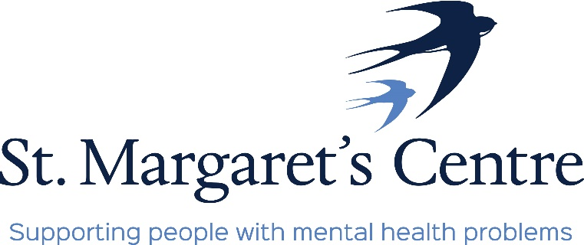
The Old School, Priory Orchard, Margery Lane, Durham, DH1 4QJ. Tel: 0191 384 8100
e-mail: enquiries@stmargaretscentre.co.uk
www.stmargaretscentre.co.uk
Registered Charity No. 1160900

Job Description
Job Title: Volunteer Coordinator
Pay Scale: £22,369 pro-rata (Starting salary, NJC Scale 4)
Hours: 30 hours – Monday to Friday 9am – 3pm
Responsible to: Management
Accountable to: Board of Trustees
General Information
St Margaret’s Centre (SMC) www.stmargaretscentre.co.uk is a registered charity operating as an activity and training hub for adults in County Durham who need support with their mental wellbeing. The main aim of the Centre is to improve the health and wellbeing of the community of County Durham by providing a safe, therapeutic environment for people to regain their confidence, motivation and self-esteem while learning new skills and meeting new friends.
The Centre has been operating since 1991 and currently supports 160 people. We have 6 members of staff and are overseen by a board of 9 trustees. Much of our funding comes from a contract with Durham County Council through the Durham Mental Wellbeing Alliance https://www.durhammentalwellbeingalliance.org, which we supplement through income-generating ventures such as our community café, workshop and craft shop, as well as fundraising, grant applications, and donations.
Role Summary
The Volunteer Coordinator will be responsible for developing volunteering schemes within the centre that support the day-to-day operations, including the community café, craft shop, gardening group, joinery workshop, Health and Wellbeing activities and any other identified areas of need. The role includes liaison with external groups in the community. The role will involve managing volunteers recruited from the community and attendees wishing to volunteer, including recruitment, training, placement, motivation, and ongoing supervision. The Volunteer Coordinator will manage volunteers and their relationships with those they encounter, including staff and attendees, and to monitor, evaluate, and recognise their achievements and contribution.

Responsibilities to include:
- Developing Volunteering schemes within the Centre, working alongside the Support Worker to help attendees with completing ongoing training and work experience
- Working with SMC staff to identify where and what volunteers are required by the charity, generating appropriate role descriptions, and matching opportunities with potential volunteers
- Organising the recruitment, screening, training/induction, and ongoing development of volunteers from the wider community to support the centre’s day to day operation, including the community café and shop - this will include conducting Disclosure and Barring Service (DBS) checks where necessary, and organising rotas and training plans
- Dealing promptly and professionally with all enquiries relating to volunteering to ensure positive outcomes for the volunteers and SMC, communicating face-to-face, by phone, and by email
- Ensuring that all required Environmental Health standards are adhered to within the community café.
- Working alongside the Activity Coordinator to develop a timetable of activities/groups within the Café, facilitated by volunteers and external providers
- Researching and writing volunteer policies and procedures to establish best practice, with the aim of attaining the County Durham Volunteers Kite Mark https://www.countydurhamvolunteering.org.uk/kite-mark
- Establishing a good working relationship with external groups, including our partner organisations within the Durham Mental Wellbeing Alliance, to promote volunteering and training opportunities within SMC
- Monitoring and supporting volunteers to create a sense of teamwork and belonging, collecting regular feedback, providing training, supervisions, and celebrating their achievements
- Attending committees and meetings where required, and drafting reports about volunteering for the centre’s Board of Trustees
- Keeping up to date with legislation and policy related to volunteering, Environmental Health and making necessary modifications to reflect changes
- Undertaking administrative duties related to volunteering
- Liaising with Management to recommend changes and improvements to the structure and operation of volunteers, ensure all tasks required are efficiently carried out, and report any concerns
- Undertaking any other relevant duties as directed by Management
Essential Requirements
- Knowledge and understanding of mental health and wellbeing, learning disabilities and physical disabilities – ideally experience of working in this sector
- Patience for individuals with a range of support needs, and a friendly, non-judgemental, supportive, and motivating attitude
- Ability to handle sensitively, and with compassion, the needs of volunteers and attendees
- Strong problem-solving skills, with a flexible and pragmatic approach to reaching appropriate solutions
- Experience of managing/supervising people
- Able to demonstrate an organised, calm, and compassionate approach to individuals in distress
- Excellent oral and written communication and listening skills
- Flexibility and a willingness to adapt to changing needs and environments
- A proactive approach, including an ability to work on own initiative as well as part of a team
- Working knowledge of MS Office and basic IT

Desirable Requirements
- Experience of working with individuals with support needs around their mental health, as well as learning and physical disabilities
- Experience of working in a hospitality/catering environment
- Food Hygiene training and knowledge of Environmental Health reporting requirements
- Mental Health Awareness / Mental Health First Aid training
- Experience of managing rotas
Support and training will be provided, and we welcome applications from individuals from all backgrounds.
A Disclosure and Barring Service (DBS) check will be required for this role. Please contact us to discuss any concerns you may have regarding this.
To discuss this role further, please contact stmargarets91@hotmail.com

