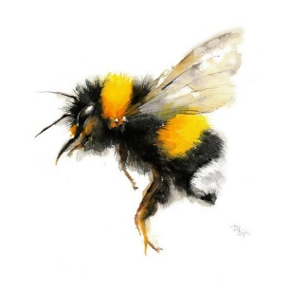
To Book Classes Call: 0191 384 8100 or Email: enquiries@stmargaretscentre.co.uk
(There is an attendance fee of £1 per day, this is to
help with cost of materials and hot beverages)
MONDAY 1ST MAY
CENTRE CLOSED – May Bank Holiday
TUESDAY 2ND MAY
Morning –
Gardening – 10am – 12pm – Sandra (Greenhouse/Flowerbeds/Lawns – Max. 6ppl)
- You will help out with a little weeding, potting plants andbulbs, watering flowers and assisting with the upkeep of our lawns and hedges. You will also help with the maintainence of our beautiful flower patches at the front of our Centre, so that it is always looking fresh and vibrant. Outdoor activities are proven to help with wellbeing and mental health, so come and potter about, breath in the fresh air and absorb some of that all important Vitamin D.
All day –
Social day – 9.30am – 4pm – Andrea (All Rooms)
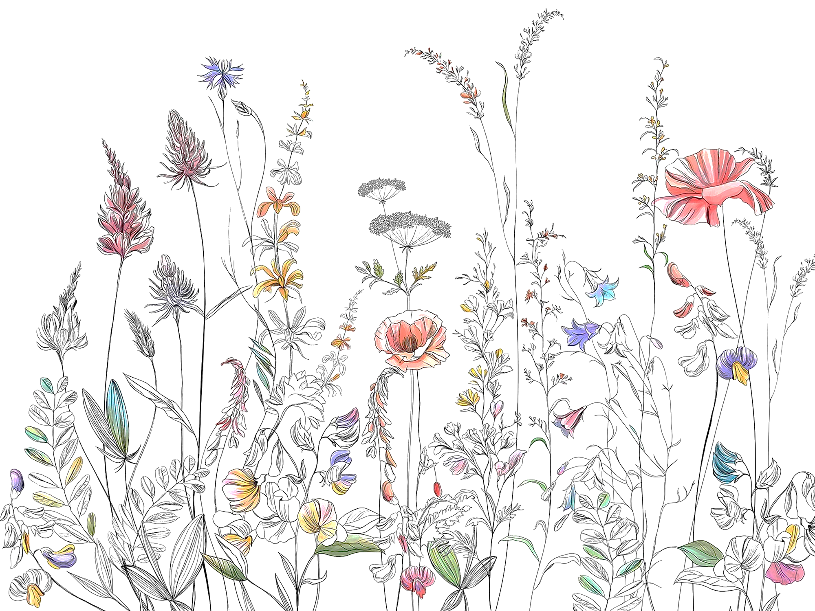
- Come and go as you please. A gentle introduction into social interaction and a safe place to get on with any hobbies you may have e.g., Painting, drawing, writing, jigsaws, crosswords, knitting or just enjoy a nice little chin wag with a cuppa. This can be a little busy but tends to be the quieter of the two social days. You must book your slot on any social day you wish to attend to secure a seat.

WEDNESDAY 3RD MAY
Morning –
Dinner Spinner Challenge (2 Weeks) - 10am - 12pm – Olwyn (Room 2 – Max. 8ppl)
- Spin the wheel of healthy ingredients to create a balanced meal recipe. Your challenge is to create a meal at home and bring a photograph to your next session. In session 2 we spin the wheel again to create our desserts.
Advance With Dance – 11am – 12.30pm – Sandra (Continued – Week 3)
Afternoon –
Recorder Group Course - 1.15pm – 3.30pm – Olwyn (Continued Course)
- This course is for our existing players only whilst they build their music reading skills and confidence to perform their very own Christmas Carol by Christmas time. If you are interested in this course, you will have the opportunity to join next year’s recorder group.
Managing Low Mood & Anxiety (5 Weeks) - 1.15am - 3.30pm - Andrea (Room 2 - Max.8ppl)
- Over the course of 5 weeks, you will learn how to identify the symptoms of stress and anxiety and how to deal with them. The course aims to give you self-help strategies to help you manage your anxiety or low mood yourself, building up your confidence and self-esteem and giving you the tools to manage your life in a more positive way.
THURSDAY 4TH MAY
(Busy day)
All day -
Social day – 9.30am – 4pm – Olwyn (Craft Room & Room 3)
- Come and go as you please. A gentle introduction into social interaction and a safe place to get on with any hobbies you may have e.g., Painting, drawing, writing, jigsaws, crosswords, knitting. Or just enjoy a nice little chin wag with a cuppa. This can be a very busy and quite noisy day. You must book a slot on any social day you wish to attend to secure a seat.
NEW! Joinery Course (5 Weeks) – 10am – 3.30pm – Tony (Workshop – Max 5ppl)
- You will learn the basic technical skills to plan, draw, cut wood, and assemble your project, and learn the correct use of tools. (If you book onto this course, please pop the following 4 classes in your diaries)

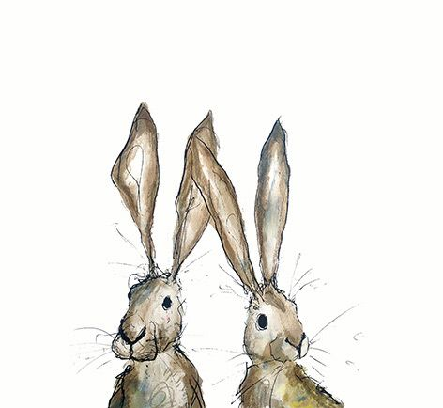
FRIDAY 5TH MAY
(Very busy day)
Morning –
“It’s Okay” - 10am – 12pm – Olwyn (Room 2 – Max 8ppl)
- In this class we will create a positivity card which is all about putting yourself first. Using Fineliners and a few embellishments we will create a card which shows you care.
Linus Project - 10am – 12pm – Isabelle & Debbie (Craft Room – Max 10ppl)
Afternoon –
Vintage Cocktail Poster - 1.15pm - 3.30pm - Olwyn (Room 2 – Max 8ppl)
- You will choose 6 cocktails and create brightly coloured collages of each one to place on an A3 background. This can be framed at home to create a lovely piece of artwork. (This class involves scissors and cutting small fiddly pieces of paper)
Textiles – Continued Projects - 1.30pm - 3.30pm - Isabelle (Craft Room – Max 12ppl)
- This session is for completion of any unfinished projects that you may have started in previous textile classes. You may also bring in items for alterations or for mending, which you can try and do yourself with some support from the tutors.

MONDAY 8TH MAY
CENTRE CLOSED – Bank Holiday for The Kings Coronation

TUESDAY 9TH MAY
Morning –
Gardening – 10am – 12pm – Sandra (Greenhouse/Flowerbeds/Lawns – Max. 6ppl)
All day –
Social day – 9.30am – 4pm – Nicola (All Rooms)
WEDNESDAY 10TH MAY
Morning –
Dinner Spinner Challenge – 10am – 12pm – Olwyn (Continued - Final Class)
Watercolours “Less is More” – 10am – 12pm - Nicola (Room 3 – Max. 7ppl)
- You will paint a majestic looking Siamese Fighting Fish Illustration using a wet-on-wet watercolour technique. You will apply a fair bit of water creating a slight puddle on your paper. You then gently touch these puddles with a just dab of colour, allowing the colour to bleed, blend, and free flow with the water to give off lovely wispy movement to your illustration.
Advance With Dance – 11am – 12.30pm – Sandra (Continued – Week 4)
Afternoon –
Recorder Group Course – 1.15pm – 3.30pm – Olwyn (Continued Course)
DIY Beads & Jewellery Course (3 Weeks) - 1.15pm - 3.30pm - Nicola (Craft Room – Max 12ppl)
- In this course we will begin by creating our own beautiful, handcrafted beads using patterned craft papers or torn magazine pages. Your beads will then be brushed in PVA which will be left to dry and set to allow your paper beads to firm up. Your beads will then be strung onto jewellery wire, along with glass beads to create a stunning necklace and bracelet set.
Managing Low Mood and Anxiety – 1.15am – 3.30pm – Andrea (Continued – Week 2)
THURSDAY 11TH MAY
(Busy day)
All day –
Social Day – 9.30am – 4pm – Olwyn (Craft Room & Room 3)

Joinery Course – 10am – 3.30pm – Tony (Continued – Week 2)
FRIDAY 12TH MAY
(Very busy day)
Morning –
Springtime Watercolour Cards – 10am – 12pm – Olwyn (Room 2 – Max. 8ppl)
- This is a lovely class for beginners, you will be given a simple spring themed illustration which you will add delicate watercolour detailing to bring your illustrations to life.
Decorate A Bird Box (£5.00 Fee) - 10am – 12pm – Nicola (Room 3 – Max. 5ppl)
- In this session you will have a choice of beautifully illustrated wallpapers. You will cut your paper to size and paste onto your very own premade MDF Bird Box which you will get to take home and place in your yard/garden or gift to someone special.
Linus Project - 10am – 12pm – Isabelle & Debbie (Craft Room – Max. 10ppl)
Afternoon –
“It’s Okay” - 1.15pm - 3.30pm - Olwyn (Room 2 – Max. 8ppl)
Walking Group – 1.15pm – 3.30pm – Nicola (Meet in Room 3 – Max. 6ppl)
- We will adventure out into our wonderful City, exploring the ‘nooks & crannies’ of Durham. This is a nice relaxed paced walk, with only slight inclines and as little stairs as possible (but to be expected in “Hilly” Durham) The walks usually take between 90mins to 2hrs depending on the route and individuals’ mobility. The walks are weather permitted, you will be contacted by lunchtime if the walk has been cancelled due to unsettling conditions. Please bring your own water/juice bottle to hydrate, and wear appropriate footwear and clothing. Waterproofs and umbrellas are good to bring along, incase of a downpour whilst out on the walk.
Textiles (Darning/Boro Stitching) – 1.30pm – 3.30pm – Isabelle (Craft Room – Max. 10ppl)
- Darning is a sewing technique for repairing holes or worn areas in fabric or knitting using needle and thread alone. Boro refers to the practice of reworking and repairing textiles (often clothes or bedding) through piecing, patching, and stitching, to extend their use. Derived from the Japanese boroboro, meaning something tattered or repaired.

MONDAY 15TH MAY
Afternoon –
Watercolours “Less is More” – 1.15pm – 3.30pm – Nicola (Craft Room – Max. 10ppl)

TUESDAY 16TH MAY
Morning –
Gardening – 10am – 12pm – Sandra (Greenhouse/Flowerbeds/Lawns – Max. 6ppl)
All day –
Social day – 9.30am – 4pm – Nicola (Craft Room & Room 3)

WEDNESDAY 17TH MAY
Morning –
Decorate a Bird Box (£5.00 Fee) – 10am – 12pm – Nicola (Room 2 – Max. 5ppl)
Advance With Dance – 11am – 12.30pm – Sandra (Continued – Week 5)
Afternoon –
DIY Beads & Jewellery Course – 1.15pm – 3.30pm – Nicola (Continued – Week 2)
Managing Low Mood and Anxiety – 1.15am – 3.30pm – Andrea (Continued – Week 3)

THURSDAY 18TH MAY
(Busy day)
All day –
Social day – 9.30am – 4pm – Nicola (Craft Room & Room 3)
Joinery Course – 10am – 3.30pm – Tony (Continued – Week 3)

FRIDAY 19TH MAY
(Very busy day)
Morning –
Acrylic Abstract Workshop – 10am – 12pm – Nicola (Room 2 – Max. 8ppl)
- In this session you will experiment and play around with paint application techniques. This is a fun a creative way of expressing yourself, no painting experience needed.

Linus Project - 10am – 12pm – Isabelle & Debbie (Craft Room – Max. 10ppl)
Afternoon –
Walking Group - 1.15pm – 3.30pm - Nicola - (Meet in Room 3 – Max. 6ppl)
Textiles (Darning/Boro Stitching) – 1.30pm – 3.30pm – Isabelle (Craft Room – Max. 10ppl)

MONDAY 22ND MAY
Afternoon –
Vintage Cocktail Posters – 1.15pm – 3.30pm – Olwyn (Craft Room – Max. 10ppl)
Watercolours “Less is More” – 1.15pm – 3.30pm – Nicola (Room 3 – Max. 7ppl)

TUESDAY 23RD MAY
Morning –
Gardening – 10am – 12pm – Sandra (Greenhouse/Flowerbeds/Lawns – Max. 6ppl)
All day –
Social day – 9.30am – 4pm – Nicola (All Rooms)

WEDNESDAY 24TH MAY
Morning –
“It’s Okay” – 10am – 12pm – Olwyn (Room 2 – Max. 8ppl)
Acrylic Abstract Workshop – 10am – 12pm – Nicola (Room 3 – Max. 7ppl)
Advance With Dance – 11am – 12.30pm – Sandra (Continued – Week 6)
Afternoon –
Recorder Group - 1.15pm – 3.30pm – Olwyn – (Room 3) - (Continued)
DIY Beads & Jewellery Course – 1.15pm – 3.30pm – Nicola (Continued – Final Class)
Managing Low Mood and Anxiety – 1.15am – 3.30pm – Andrea (Continued – Week 4)

THURSDAY 25TH MAY
(Busy day)
All day –
Social day – 9.30am – 4pm – Olwyn (Craft Room & Room 3)

Joinery Course – 10am – 3.30pm – Tony (Final Session)

FRIDAY 26TH MAY
(Very busy day)
Morning –
Dinner Spinner Challenge (2 Weeks) - 10am - 12pm – Olwyn (Room 2 – Max. 8ppl)
- Spin the wheel of healthy ingredients to create a balanced meal recipe. Your challenge is to create a meal at home and bring a photograph to your next session. In session 2 we spin the wheel again to create our desserts.
Linus Project - 10am – 12pm – Isabelle & Debbie (Craft Room – Max. 10ppl)
Afternoon –
Springtime Watercolour Cards – 1.15pm – 3.30pm – Olwyn (Room 2 – Max. 8ppl)
Textiles (Darning/Boro Stitching) – 1.30pm – 3.30pm – Isabelle (Craft Room – Max 10ppl)

MONDAY 29TH MAY
CENTRE CLOSED – Spring Bank Holiday
TUESDAY 30TH MAY
Morning –
Gardening – 10am – 12pm – Sandra (Greenhouse/Flowerbeds/Lawns – Max. 6ppl)
All day –
Social day – 9.30am – 4pm – Nicola (All Rooms)
WEDNESDAY 31ST MAY
Morning –
Dinner Spinner Challenge – 10am – 12pm – Olwyn (Continued – Final Class)
Acrylic Abstract Workshop – 10am – 12pm – Nicola (Room 3 – Max. 7ppl)
Advance With Dance – 11am – 12.30pm – Sandra (Continued – Week 7)
Afternoon –
Recorder Group - 1.15pm – 3.30pm – Olwyn – (Room 3) - (Continued)
Springtime Phone Photography – 1.15pm – 3.30pm – Nicola (Craft Room – Max. 6ppl)
- In this beginner’s class, you will begin by understanding the very basics of photography techniques, such as composition and vantage point. We will then pop outside and go around the centre grounds and allotments to take photographs using our mobile phone cameras. We will then head back into the centre to learn basic editing techniques using your mobiles built in editing settings. No experience needed.
Managing Low Mood and Anxiety - 1.15am - 3.30pm - Andrea (Continued – Week 4)

THURSDAY 1ST JUNE
(Busy day)
All day –
Social day – 9.30am – 4pm – Olwyn (Craft Room & Room 3)

Joinery Course – 10am – 3.30pm – Tony (Final Session)

FRIDAY 2ND JUNE
(Very busy day)
Morning –
Dinner Spinner Challenge – 10am – 12pm – Olwyn (Continued – Final Class)
Watercolours “Less is more”- 10am – 12pm – Nicola (Room 3 – Max. 7ppl)

Linus Project - 10am – 12pm – Isabelle & Debbie (Craft Room – Max. 10ppl)
Afternoon –
“It’s Okay” – 1.15pm – 3.30pm – Olwyn (Room 2 – Max. 8ppl)
Walking Group – 1.15pm – 3.30pm – Nicola (Meet in Room 3 – Max 6ppl)
Textiles (Cross Stitch Bookmark) – 1.30pm – 3.30pm – Isabelle (Craft Room – Max. 10ppl)

Classes with this symbol - are dedicated, quieter sessions. Anybody can join them, but they are designed to be inclusive of neurodivergent individuals who may struggle to access our standard sessions.

