To Book Classes Call: 0191 384 8100 or Email: enquiries@stmargaretscentre.co.uk
(There is an attendance fee of £1 per day, this is to
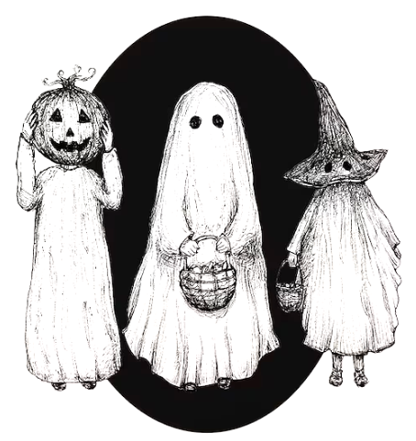
help with cost of materials and hot beverages)

MONDAY 2ND OCTOBER
Morning –
Cutting-Edge Product Design – 9.30am – 12pm - Volunteers & Nicola
- This is for our product design volunteers only. If you are interested in volunteering with us, please speak to Nicola our Volunteer Coordinator.

NEW! Chatty Café Drop in - 10am – 11am – Volunteer/Lisa – Café
- This drop in has been created for those who don’t quite feel ready to dedicate themselves to our Classes/Courses/Dedicated social days. If you feel the need to just get out of the house and unwind in a welcoming environment, then Chatty Café may be for you. There will be one of our lovely Volunteers to sit and chat with or you can just come and purchase a cuppa and a slice of cake and enjoy a board game.
Sugar Craft Course – 10am – 12pm – Jaynie – WEA – Craft Room (Week 4)
Afternoon –
Halloween Watercolour Cards – 1.15pm – 3.30pm – Olwyn (Craft Room – Max. 12ppl)
- In this class you will use basic watercolour techniques to bring a pre printed illustrated halloween card to life!
TUESDAY 3RD OCTOBER
Morning –
Gardening – 10am – 12pm – Sandra (Volunteer) - (Meet in Craft Room)
- You will help out with a little weeding, potting plants and bulbs, watering flowers and assisting with the maintainence and upkeep of our flower beds, lawns and hedges. Outdoor activities are proven to help with wellbeing and mental health, so come and potter about, breath in the fresh air and absorb some of that all important Vitamin D.
All day –
Social day – 9.30am – 4pm – (Craft Room & Room 2)
- Come and go as you please. A gentle introduction into social interaction and a safe place to get on with any hobbies you may have e.g., Painting, drawing, writing, jigsaws, crosswords, knitting or just enjoy a nice little chin wag with a cuppa. This can be a little busy but tends to be the quieter of the two social days. You must book your slot on any social day you wish to attend to secure a seat.
Family History Course – 1.15pm – 3.15pm – Room 2 (Continued – Week 4)

WEDNESDAY 4TH OCTOBER
Morning –
Illuminated Letters -10am – 12pm – Olwyn – Craft Room (12.ppl Craft Room)
- Decorate your initial with Fineliners and embellish with gold.
Afternoon –
Bookbinding & Journalling Course - 1.15pm - 3.30pm – Cloe (Continued – Week 5)
Optical Illusions - 1.15pm – 3.30pm – Olwyn – Craft Room (12.ppl Craft Room)
- A boy and a girl sit at a table……but with a spooky twist.

THURSDAY 5th OCTOBER
(Busy day)
Morning –
Intermediate Joinery Course (5 weeks) – 10am – 3.30pm – Tony (Workshop – Max.5ppl)
- In this course you will learn technical drawing and how to properly plan out a woodwork project. You will then follow your drawn-out plan and use it to craft and assemble your MDF/Hardwood project. (This is for those who have completed our beginner’s joinery course, or those with some experience in woodwork and joinery)
All day –
Social day – 9.30am – 4pm – Olwyn (Craft Room & Room 2)
- Come and go as you please. A day for social interaction and a safe place to get on with any hobbies you may have e.g., Painting, drawing, writing, jigsaws, crosswords, knitting. Or just enjoy a nice little chin wag with a cuppa. We encourage you to bring your own projects to get on with if you would like to keep yourself busy. This can be a very busy and quite noisy day. You must still book a slot on any social day you wish to attend to secure a seat.
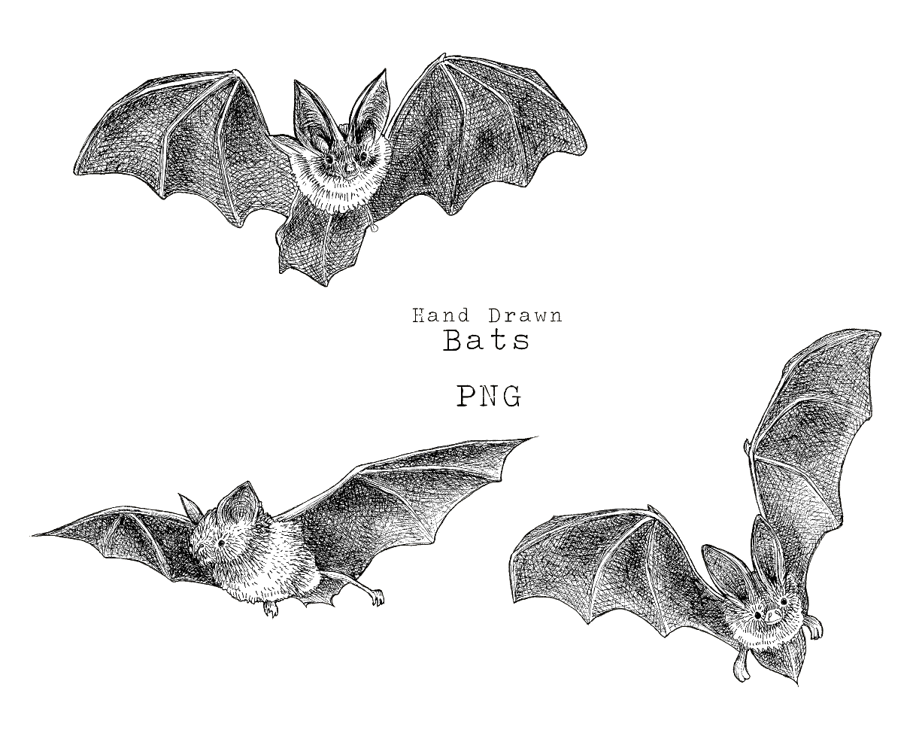

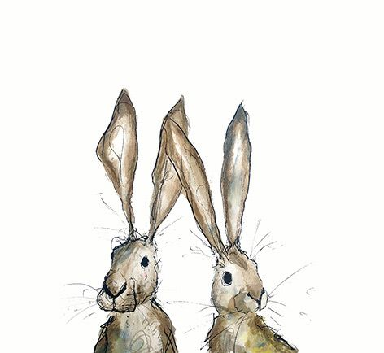
FRIDAY 6TH OCTOBER
(Very busy day)
Morning –
Dry Brush Painting - 10am - 12pm – Olwyn (Room 2 - Max. 8ppl)
- An effective technique using acrylic paint on black paper to achieve stunning and unexpected results.
Textiles For Charities - 10am - 12pm – Isabelle, Meg & Debbie (Craft Room - Max 10ppl)
- In this group you will create textile-based items for multiple different charities across the northeast. The charities you will create for will change month to month. You may end up making home-made patchwork quilts or knitted blankets, shopping bags or sensory toys. No sewing skills or experience is required, you will learn new skills as you go, and our wonderful voluntary instructors will support and guide you throughout.
Afternoon –
3D Nightmare before Christmas Card - 1.15pm - 3.30pm – Olwyn (Room 2 – Max. 8ppl)
- This great card could double up as a Halloween or Christmas card. Based on the much-loved Tim Burton Film, Nightmare Before Christmas

Walking Group - 1.15pm - 3pm - Nicola (Meet in Craft Room – Max. 6ppl)
- We will adventure out into our wonderful City, exploring the ‘nooks & crannies’ of Durham. This is a nice relaxed paced walk, with only slight inclines and as few stairs as possible (but to be expected in “Hilly” Durham) The walks usually take between 90mins to 2hrs depending on the route and individuals’ mobility. The walks are weather permitted, you will be contacted by lunchtime if the walk has been cancelled due to adverse conditions. Please bring your own water/juice bottle to hydrate, and wear appropriate footwear and clothing. Waterproofs and umbrellas are good to bring along, incase of a downpour whilst out on the walk.
Textiles – Unfinished Projects - 1.30pm - 3.30pm – Isabelle, Meg & Alison (Volunteers) - (Craft Room – Max 12ppl)
- This session is for completion of any unfinished projects that you may have started in previous textile classes. You may also bring in items for alterations or for mending, which you will be encouraged to do yourself with the support of the tutors.

MONDAY 9TH OCTOBER
Morning –
Cutting-Edge Product Design – 9.30am – 12pm - Volunteers (Room 2– Max. 8ppl)
- This is for our product design volunteers only, if you are interested in volunteering with us, please speak to Nicola our Volunteer Coordinator.
Chatty Café Drop In - 10am – 11am – Volunteers/Lisa – (Café)
Sugar Craft Course - 10am - 12pm - Jaynie - WEA (Continued – Week 5)
Afternoon –
Botanical Drawing Course (4 weeks) – 1.15pm – 3.30pm – Olwyn (Craft Room- Max. 12ppl)
- This is a 4 week course exploring flowers and foliage. You will use a different medium every week, fineliners, watercolours, acrylic paint and coloured pencils.
(If you book onto this course, pop the following 3 classes in your Diaries)

TUESDAY 10TH OCTOBER
Morning –
Gardening – 10am – 12pm – Sandra (Volunteer) - (Meet in Craft Room – Max. 6ppl)
Social day – 9.30am – 4pm – (Craft Room & Room 2)
Afternoon –
Family History - 1.15pm - 3.15pm - Sharon – WEA - (Continued - Week 5)

WEDNESDAY 11TH OCTOBER
Morning –
3D Nightmare Before Christmas Card – 10am – 12pm – Olwyn (Craft Room – Max 12ppl)
Afternoon –
Dry Brush Painting – 1.15pm – 3.30pm– Olwyn (Craft Room – Max. 12ppl)

Bookbinding Course – 1.15pm – 3.30pm – Cloe (Continued – Week 6)

THURSDAY 12TH OCTOBER
(Busy day)
All day –
Social Day – 9.30am – 4pm – Olwyn (Craft Room & Room 2)

Intermediate Joinery Course – 10am – 3.30pm – Tony – (Continued - Week 2)

FRIDAY 13TH OCTOBER
(Very busy day)
Morning –
Optical Illusions – 10am – 12pm – Olwyn (Room 2 – Max. 8ppl)

Textiles For Charities - 10am – 12pm – Isabelle,Meg & Debbie (Craft Room – Max. 10ppl)
Afternoon –
Illuminated Letters - 1.15pm - 3.30pm - Olwyn (Room 2 – Max. 8ppl)

Walking Group – 1.15pm – 3pm – Nicola (Meet in Craft Room – Max. 6ppl)
Textiles – “Spooky Season” – 1.30pm – 3.30pm – Isabelle, Meg, Alison (Volunteers) – (Craft Room- Max.12)
- This month’s Textile group will be inspired by all things Halloween. You will create spooky textile items suggested by our volunteers. You don’t need any experience in textiles, our lovely volunteers will support and guide you with sewing skills, sewing machines and all thing textile based.

MONDAY 16TH OCTOBER
Morning –
Cutting-Edge Product Design – 9.30am – 12pm - Volunteers (Craft Room – Max. 12ppl)
- This is for our product design volunteers only, if you are interested in volunteering with us, please speak to Nicola our Volunteer Coordinator.
Chatty Café Drop In - 10am – 11am – Volunteers/Lisa – (Café)

Sugar Craft Course - 10am - 12pm - Jayne - WEA (Continued - Week 6)
Afternoon –
Botanical Drawing Course – 1.15pm – 3.30pm – Olwyn (Continued – Week 2)

TUESDAY 17TH OCTOBER
Morning –
Gardening – 10am – 12pm – Sandra (Volunteer) - (Meet in Craft Room – Max. 6ppl)
All day –
Social day – 9.30am – 4pm – (Craft Room & Room 2)
Family History - 1.15pm - 3.15pm - Sharon - (Continued - Week 6)

WEDNESDAY 18TH OCTOBER
Morning –
Watercolour Halloween Cards – 10am – 12pm – Olwyn (Craft Room – Max. 12ppl)
Afternoon –
3D Nightmare Before Christmas Cards - 1.15pm – 3.30pm - Olwyn (Craft Room Max. 12ppl)
Walking Group – 1.15pm – 3pm – Nicola (Meet in Craft Room)
Bookbinding Course – 1.15pm – 3.30pm – Cloe (Continued – Week 7)

THURSDAY 19TH OCTOBER
Morning –
Intermediate Joinery Course – 10am – 3.30pm – Tony (Continued – Week 3)
Afternoon –
Macrame Feather Wall hanging Course (3 Weeks) – 1.15pm – 3.30pm – Rachel B (Room 2)
- Macrame is a creative knotting technique, usually created with wool. This technique can be used to make a variety of items, including jewellery and other decorative items. In this course you will create a variety of feather shapes to create a beautiful boho wall hanging for your home. (If you book onto this course, please pop the following two classes in your diaries)
All day –
Social Day – 9.30am – 4pm – Olwyn (Craft Room & Room 3)

FRIDAY 20TH OCTOBER
(Very busy day)
Morning –
Watercolour Halloween Cards – 10am – 12pm – Olwyn (Room 2 – Max. 8 ppl)
Textiles For Charities - 10am – 12pm – Isabelle, Meg & Debbie (Craft Room – Max. 10ppl)
Afternoon –
Songs For The Soul – 1.15pm – 3.30pm – Olwyn (Room 2 – Max. 8ppl)
- In this interactive singalong session, you will be singing in a group to help promote the feeling of wellbeing. There will be songs that you are familiar with, and they will all be positively uplifting! (Lyric sheets will be provided)
Walking Group – 1.15pm – 3pm (Meet in Craft Room)
Textiles “Spooky Season” – 1.30pm – 3.30pm – Isabelle, Meg, Alison (Volunteers) – (Craft Room. 12ppl)

MONDAY 23RD OCTOBER
Mornings –
Cutting - Edge Product Design – 9.30am – 12pm - Volunteers (Craft Room – Max. 12ppl)
Chatty Café Drop In – 10am – 11am – Volunteer/Lisa (Café)
Afternoon –
Botanical Drawing Course – 1.15pm – 3.30pm – Olwyn (Continued – Week 3)

TUESDAY 24TH OCTOBER
Morning –
Gardening – 10am – 12pm – Sandra (Volunteer) - (Meet in Craft Room – Max. 6ppl)
All day –
Social day – 9.30am – 4pm – (Craft Room & Room 2)
WEDNESDAY 25TH OCTOBER
Morning –
Optical Illusions – 10am – 12pm – Olwyn (Craft Room – Max. 12ppl)
Afternoon –
Songs For The Soul - 1.15pm – 3.30pm – Olwyn – (Craft Room – Max.12ppl)

THURSDAY 26TH OCTOBER
(Busy day)
Morning –
Intermediate Joinery Course – 10am – 3.30pm – Tony (Continued – Week 4)
Afternoon –
Macrame Feather Wall hanging – 1.15pm – 3.30pm – Rachel B (Continued – week 2)
All day –
Social day – 9.30am – 4pm – Olwyn (Craft Room & Room 3)

FRIDAY 27TH OCTOBER
(Very busy day)
Morning –
Glass Bead Gift Tags – 10am – 12pm – Olwyn (Room 2 – Max. 8ppl)
- Using glass pebbles and tiny Christmas motifs, on brown card, we will create stunning gift tags.
Textiles For Charities - 10am – 12pm – Isabelle, Meg & Debbie (Craft Room – Max. 10ppl)
Afternoon –
Autumn Acorn Garland – 1.15pm – 3.30pm – Olwyn (Room 2 – Max. 8ppl)
- Using patterned paper in autumnal colours, we will create a garland of acorns to hang in your home.
Walking Group – 1.15pm – 3.30pm – Nicola (Meet in Craft Room)
Textiles “Spooky Season” - 1.30pm - 3.30pm - Isabelle, Meg & Alison (Craft Room Max 10ppl)

MONDAY 30TH OCTOBER
Morning –
Cutting-Edge Product Design – 9.30am – 12pm - Volunteers & Nicola (Room 2)

Chatty Café Drop In – 10am – 11am – Volunteer/Lisa - (Café)

Sugar Craft Course – 10am – 12pm – Jaynie – WEA – Craft Room (Continued – Week 7)
Afternoon –
Botanical Drawing Course - 1.15pm - 3.30pm - Olwyn (Continued – Final Class)

Pumpkin Carving/Painting (£2.00 fee) – 1.15pm – 3.30pm – Nicola (Room 2 – Max 8ppl)
- In this Halloween inspired activity you will carve or paint your pumpkin with a design of your choice. A sheet of insperational spooky images and tools will be provided.

TUESDAY 31ST OCTOBER
Morning –
Gardening – 10am – 12pm – Sandra (Volunteer) - (Meet in Craft Room)
- You will help out with a little weeding, potting plants and bulbs, watering flowers and assisting with the maintenance and upkeep of our flower beds, lawns and hedges. Outdoor activities are proven to help with wellbeing and mental health, so come and potter about, breath in the fresh air and absorb some of that all important Vitamin D.
All day –
Social day – 9.30am – 4pm – (Craft Room & Room 2)
- Come and go as you please. A gentle introduction into social interaction and a safe place to get on with any hobbies you may have e.g., Painting, drawing, writing, jigsaws, crosswords, knitting or just enjoy a nice little chin wag with a cuppa. This can be a little busy but tends to be the quieter of the two social days. You must book your slot on any social day you wish to attend to secure a seat.
Family History Course – 1.15pm – 3.15pm – Room 2 (Continued – Week 7)

WEDNESDAY 1ST NOVEMBER
Morning –
Autumn Acorn Garland -10am – 12pm – Olwyn – Craft Room (12.ppl Craft Room)
Afternoon –
Bookbinding & Journalling Course - 1.15pm - 3.30pm – Cloe (Continued – Final Class)
Glass bead Gift Tags 1.15pm – 3.30pm – Olwyn – Craft Room (12.ppl Craft Room)
THURSDAY 2ND NOVEMBER
(Busy day)
Morning –
Intermediate Joinery Course – 10am – 3.30pm – Tony (Continued – Week 4)
Afternoon –
Macrame Feather Wall Hanging – 1.15pm – 3.30pm – Rachel B (Continued – Final class)
All day –
Social day – 9.30am – 4pm – Olwyn (Craft Room & Room 3)

FRIDAY 3RD NOVEMBER
(Very busy day)
Morning –
Dry Brush Painting - 10am - 12pm – Olwyn (Room 2 - Max. 8ppl)
Textiles For Charities - 10am - 12pm – Isabelle, Meg & Debbie (Craft Room - Max 10ppl)
Afternoon –
Songs for the Soul - 1.15pm - 3.30pm – Olwyn (Room 2 – Max. 8ppl)

Walking Group - 1.15pm - 3pm - Nicola (Meet in Craft Room – Max. 6ppl)
Textiles “Spooky Season” - 1.30pm - 3.30pm – Isabelle, Meg & Alison (Volunteers) - (Craft Room – Max 12ppl)

Classes with this symbol - are dedicated, quieter sessions. Anybody can join them, but they are designed to be inclusive of neurodivergent individuals who may struggle to access our standard sessions.

