**To Book Classes Call: 0191 384 8100 or Email: enquiries@stmargaretscentre.co.uk**

**(**There is an **attendance fee of** **£1 per day**, this is to

help with cost of materials and hot beverages**)**

**MONDAY** **6TH NOVEMBER**

*Morning –*

**Cutting-Edge Product Design – 9.30am – 12pm – Volunteer Led**

* Prep, paint and decorate our Cutting-Edge products, ready to be sold in our own Gift shop. This is for our product design volunteers only. If you are interested in volunteering with us, please speak to Nicola our Volunteer Coordinator.

**NEW! Chatty Café Drop in - 10am – 11am – Liz (Volunteer) – Café**

* This drop in has been created for those who don’t quite feel ready to dedicate themselves to our Classes/Courses/Dedicated social days. If you feel the need to just get out of the house and unwind in a welcoming environment, then Chatty Café may be for you. There will be one of our lovely Volunteers to sit with and have a general chit chat, or you can just come and purchase a cuppa and a slice of cake and enjoy a board game.

**Sugar Craft Course – 10am – 12pm – Jaynie – WEA – Craft Room (Continued - Week 8)**

**Awareness to Pride: The Evolution of Autism Symbols from 1963 to Today***Afternoon –*

**Stacked up Cats Doodles – 1.15pm – 3.30pm – Olwyn - (Craft Room - Max. 12ppl)**

* Fun Fineliner Feline doodles which you will hand draw, one behind the other, and finish with a splash of watercolour. This is a simple and very do-able fun activity.

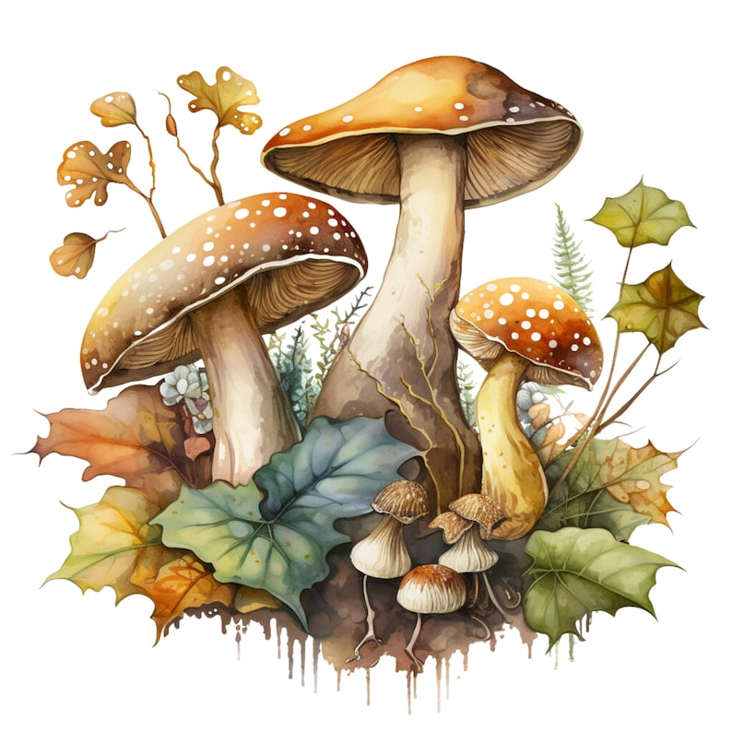

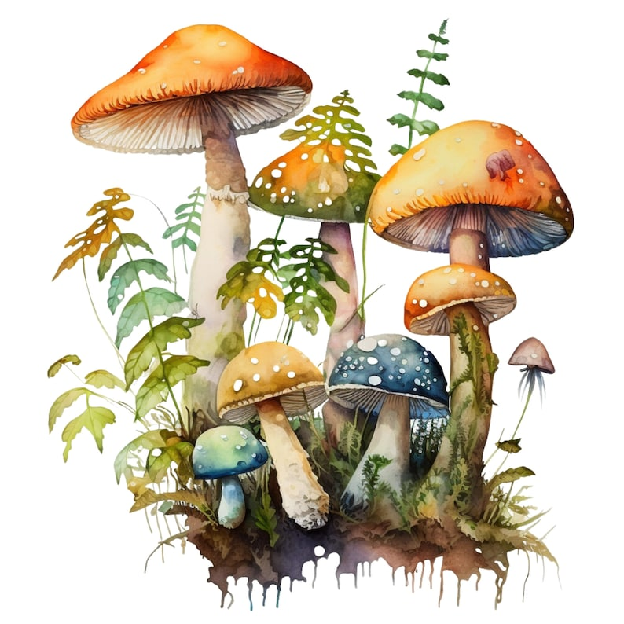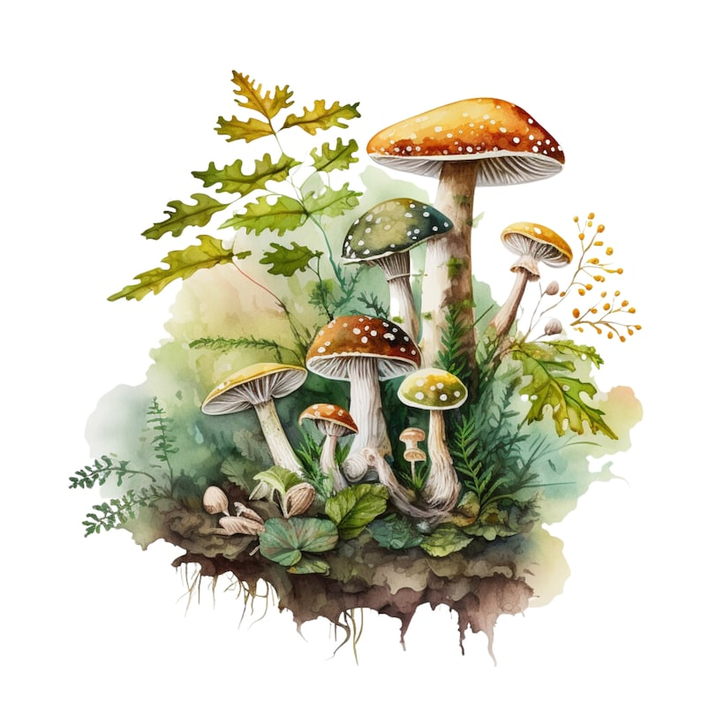

**TUESDAY 7TH NOVEMBER**

*Morning –*

**Social day – 9.30am – 4pm – (Craft Room & Room 2)**

* Come and go as you please. A gentle introduction into social interaction and a safe place to get on with any hobbies you may have e.g., Painting, drawing, writing, jigsaws, crosswords, knitting or just enjoy a nice little chin wag with a cuppa. This can be a little busy but tends to be the quieter of the two social days. **You must book your slot on any social day you wish to attend to secure a seat.**

**Gardening – 10am – 12pm – Sandra (Volunteer) - (Meet in Craft Room)**

* You will help out with a little weeding, potting plants and bulbs, watering flowers and assisting with the maintainence and upkeep of our flower beds, lawns and hedges. Outdoor activities are proven to help with wellbeing and mental health, so come and potter about, breath in the fresh air and absorb some of that all important Vitamin D.

*Afternoon -*

**Family History Course – 1.15pm – 3.15pm – Room 2 (Continued – Week 8)**

**WEDNESDAY 8TH NOVEMBER**

*Morning –*

**Crosswords and Cuppas - 10am – 12pm – Group Acitvity – (Craft Room - Max. 12ppl)**

*Afternoon –*

**DIY Antique Map – 1.15pm – 3.30pm – Kirsty (Volunteer) - (Room 2 - Max. 8ppl)**

* In this nostalgic class you will use some classic techniques such as coffee & tea staining on A3 paper to create your own unique, antique style map.

**THURSDAY 9th NOVEMBER**

**(Busy day)**

*All day –*

**NEW! Beginners Woodwork Course (4 weeks) 10am - 3.30pm - Tony (Workshop Max.5ppl)**

* In this course you will be shown the correct use of tools and learn the basic technical skills to plan, cut, and assemble an MDF project. (If you book onto this course, please pop the following 3 weeks in your diary)

**Social day – 9.30am – 4pm – Olwyn (Craft Room & Room 2)**

* Come and go as you please. A day for social interaction and a safe place to get on with any hobbies you may have e.g., Painting, drawing, writing, jigsaws, crosswords, knitting. Or just enjoy a nice little chin wag with a cuppa. We encourage you to bring your own projects to get on with if you would like to keep yourself busy. This can be a very busy and quite noisy day. **You must still book a slot on any social day you wish to attend to secure a seat.**

*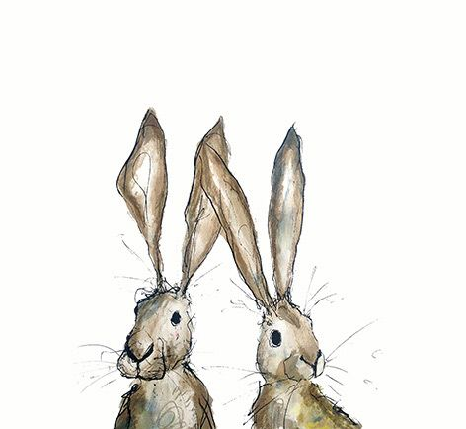***FRIDAY 10TH NOVEMBER**

**(Very busy day)**

*Morning –*

**Embellished Sparkle Cards - 10am - 12pm – Olwyn (Room 2 - Max. 8ppl)**

* Turn an ordinary illustrated card into a glistening work of art with the addition of gemstone embellishments.

**Textiles For Charities - 10am - 12pm – Isabelle, Meg & Debbie (Craft Room - Max 7ppl)**

* In this group you will create textile-based items for multiple different charities across the northeast. The charities you will create for will change month to month. You may end up making home-made patchwork quilts or knitted blankets, shopping bags or sensory toys. No sewing skills or experience is required, you will learn new skills as you go, and our wonderful voluntary instructors will support and guide you throughout.

*Afternoon –*

**Calligraphy Christmas Tree – 1.15pm – 3.30pm – Olwyn (Room 2 – Max. 8ppl)**

* Using gold ink, we will use dip pens to create a stunning ornate Christmas tree on black card.

**Walking Group - 1.15pm - 3pm - Nicola (Meet in Craft Room) – (Final walk of the year)**

* We will adventure out into our wonderful City, exploring the ‘nooks & crannies’ of Durham. This is a nice slow paced walk, with only slight inclines and as few stairs as possible (but to be expected in “Hilly” Durham) The walks usually take between 90mins to 2hrs depending on the route and individuals’ mobility. The walks are weather permitted, you will be contacted by lunchtime if the walk has been cancelled due to adverse conditions. Please bring your own water/juice bottle to hydrate, and wear appropriate footwear and clothing. Waterproofs and umbrellas are good to bring along, incase of a downpour whilst out on the walk.

**Poppies For Remembrance- 1.30pm - 3.30pm – Isabelle, Meg & Alison (Volunteers) - (Craft Room – Max. 7ppl)**

* In this one-off session you will create a fabric poppy broach using felt. You or someone you know can wear the poppy as a show of support for the service and sacrifice of our armed forces, veterans, and their families. You will be guided and supported by three of our wonderful Volunteer Instructors.

**MONDAY 13TH NOVEMBER**

*Morning –*

**Cutting-Edge Product Design – 9.30am – 12pm - Volunteers (Room 2 - Max. 8ppl)**

* This is for our product design volunteers only, if you are interested in volunteering with us, please speak to Nicola our Volunteer Coordinator.

**Chatty Café Drop In - 10am – 11am – Liz (Volunteer) – (Café)**

**Sugar Craft Course - 10am - 12pm - Jaynie - WEA (Continued – Week 9)**

**Awareness to Pride: The Evolution of Autism Symbols from 1963 to Today***Afternoon –*

**Embellished Sparkle Cards – 1.15pm – 3.30pm – Olwyn (Craft Room - Max. 12ppl)**

**TUESDAY 14TH NOVEMBER**

*Morning –*

**Social day – 9.30am – 4pm – (Craft Room & Room 2)**

**Gardening – 10am – 12pm – Sandra (Volunteer) - (Meet in Craft Room - Max. 6ppl)**

*Afternoon –*

**Family History - 1.15pm - 3.15pm - Sharon – WEA - (Continued - Week 9)**

**WEDNESDAY 15TH NOVEMBER**

*Morning –*

**NEW! Paper Quilling (4 Weeks) 10am - 12.30pm - Rachael - (Craft Room- Max. 12ppl)**

* This is a course delivered by Bishop College. Quilling is an art form that involves the use of strips of paper that are rolled, shaped, and glued together to create decorative designs. You can create art that could be framed as well as create cards using chosen quilling designs. You will also learn how colours and patterns can work together. (This course is **free** to those on **means tested benefits only**. Please have your national insurance number on 1st day. If you book up to this course, please pop the following **3** **weeks** in your diary)

**Awareness to Pride: The Evolution of Autism Symbols from 1963 to Today***Afternoon –*

**Calligraphy Christmas Tree – 1.15pm – 3.30pm –Olwyn - (Craft Room - Max. 12ppl)**

**Crosswords & Cuppas – 1.15pm – 3.30pm – Group Activity – (Room 2 - Max. 8ppl)**

**THURSDAY 16TH NOVEMBER**

**(Busy day)**

*Morning –*

**NEW! Self-Care Salon “HAIR”- 10am -12pm - Angela (Volunteer)-(Room 2 Max.4ppl)**

* We have the pleasure of introducing you to one of our wonderfully talented volunteers Angela, who will be running a couple of Self-care sessions each month. This month she will be Trimming/cutting/shearing to give you that fresh feeling. Self-care is essential to one’s mental health, it can boost your mood, reduce stress and anxiety, and boost your confidence and self-esteem.

*All day –*

**Beginners Woodwork Course - 10am - 3.30pm - Tony (Continued – Week 2)**

**Social Day – 9.30am – 4pm – (Craft Room & Room 2)**

**FRIDAY 17TH NOVEMBER**

**(Very busy day)**

*Morning –*

**Walnut Mice Tree Décor – 10am – 12pm – Olwyn (Room 2 - Max. 8ppl)**

* You will create cute mice using hazelnuts. These mice will then be nestled into a walnut shell. These make lovely hanging tree or table centre decorations (Quite fiddly to craft)

**Textiles For Charities - 10am – 12pm – Isabelle, Meg & Debbie (Craft Room - Max. 7ppl)**

*Afternoon –*

**Watercolour Christmas Cards -****1.15pm - 3.30pm - Olwyn (Room 2 - Max. 8ppl)**

* This popular and therapeutic class is going festive! Learn simple watercolour techniques to add a splash of colour and bring to life a lovely Christmas illustration. This will become your own bespoke Christmas card.

**Textile Xmas Gift Décor (5 Week Course) - 1.30pm - 3.30pm – Isabelle, Meg & Alison (Volunteers) - (Craft Room – Max. 7ppl)**

* In this course you will learn basic hand sewn and sewing machine skills. You will create festive, textile-based Xmas decorations or small gifts. You will be guided and supported by three of our wonderful Volunteer Instructors. If you book onto this course, please pop the **following** **4 weeks** in your diary.

**MONDAY 20TH NOVEMBER**

*Morning –*

**Cutting-Edge Product Design – 9.30am – 12pm - Volunteers (Room 2 - Max. 8ppl)**

* This is for our product design volunteers only, if you are interested in volunteering with us, please speak to Nicola our Volunteer Coordinator.

**Chatty Café Drop In - 10am – 11am –Liz– (Café)**

**Sugar Craft Course - 10am - 12pm - Jaynie - WEA (Continued - Week 10)**

*Afternoon –*

**DIY Antique Map - 1.15pm – 3.30pm – Kirsty (Volunteer) - (Craft Room - Max. 8ppl)**

**TUESDAY 21ST NOVEMBER**

*All day –*

**Social day – 9.30am – 4pm – (Craft Room & Room 2)**

*Afternoon -*

**Family History - 1.15pm - 3.15pm - Sharon - (Continued - Week 10)**

**WEDNESDAY 22ND NOVEMBER**

*Morning –*

**Paper Quilling – 10am – 12.30pm – Rachael – Bishop College - (Continued – Week 2)**

*Afternoon –*

**Decorated Self Soothe Box – 1.15pm – 3.30pm – Olwyn - (Craft Room - Max. 12ppl)**

* When you are struggling or feel distressed it can be hard to think clearly about what coping strategies can help you through it. In this class we will be decorating a shoe box which you can take home and fill with lovely things to use as a healthy distraction.(Please bring your own shoe box, or any similar sized box)

**THURSDAY 23RD NOVEMBER**

*All day –*

**Beginners Woodwork Course - 10am - 3.30pm - Tony (Continued – Week 3)**

**Social Day – 9.30am – 4pm – Olwyn (Craft Room & Room 3)**

**FRIDAY 24TH NOVEMBER**

**(Very busy day)**

*Morning –*

**Calligraphy Christmas Tree – 10am – 12pm – Olwyn (Room 2 – Max. 8ppl)**

* Using gold ink, we will use dip pens to create a stunning ornate Christmas tree on black card.

**Textiles For Charities - 10am – 12pm – Isabelle, Meg & Debbie (Craft Room – Max. 7ppl)**

*Afternoon –*

**Desert Island Discs “Christmas Special” – 1.15pm – 3.30pm – Olwyn (Room 2 – Max. 8ppl)**

* Let’s ramp up the nostalgia of days gone by with Christmas songs and personal anecdotes.

**Textile Xmas Gift Décor – 1.30pm – 3.30pm – Isabelle, Meg, Alison (Continued – Week 2)**

**MONDAY 27TH NOVEMBER**

*Mornings –*

**Cutting - Edge Product Design – 9.30am – 12pm - Volunteers (Room 2 – Max. 8ppl)**

**Chatty Café Drop In – 10am – 11am – Liz (Café)**

**Sugar Craft Course – 10am – 12pm – Jaynie – WEA – Craft Room (Final Session)**

**Awareness to Pride: The Evolution of Autism Symbols from 1963 to Today***Afternoon –*

**Walnut Mice Tree Décor – 1.15pm – 3.30pm – Olwyn (Craft Room - Max. 12ppl)**

**TUESDAY 28TH NOVEMBER**

*All day –*

**Social day – 9.30am – 4pm – (Craft Room & Room 2)**

**Family History – 1.15pm – 3.30pm – Sharon – WEA (Final Session)**

**WEDNESDAY 29TH NOVEMBER**

*Morning –*

**Awareness to Pride: The Evolution of Autism Symbols from 1963 to TodayPaper Quilling – 10am – 12.30pm – Rachael – Bishop College - (Continued - Week 3)**

**Calligraphy Christmas Tree – 10am – 12pm – Olwyn (Room 2 - Max. 8ppl)**

*Afternoon –*

**DIY Antique Map – 1.15pm – 3.30pm – Kirsty – (Craft Room – Max. 8ppl)**

**Desert Island Discs “ Christmas Special” 1.15pm – 3.30pm – Olwyn – (Room 2 - Max.8ppl)**

**THURSDAY 30TH NOVEMBER**

**(Busy day)**

*Morning –*

**NEW! Self-Care Salon “HAIR”- 10am -12pm - Angela (Volunteer)-(Room 2 Max.4ppl)**

*All day –*

**Beginners Woodwork Course - 10am - 3.30pm - Tony (Final Session)**

**Social day – 9.30am – 4pm – Olwyn (Craft Room & Room 2)**

**FRIDAY 1ST DECEMBER**

**(Very busy day)**

*Morning –*

**Stacked Up Cats Doodles – 10am – 12pm – Olwyn (Room 2 – Max. 8ppl)**

**Textiles For Charities - 10am – 12pm – Isabelle, Meg & Debbie (Craft Room – Max. 7ppl)**

*Afternoon –*

**Embellished Sparkle Cards – 1.15pm – 3.30pm – Olwyn (Room 2 – Max. 8ppl)**

**Textile Xmas Gift Décor - 1.30pm - 3.30pm - Isabelle, Meg & Alison (Continued – Week 3)**

**Awareness to Pride: The Evolution of Autism Symbols from 1963 to Today**

**Classes with this symbol - are dedicated, quieter sessions. Anybody can join them, but they are designed to be inclusive of neurodivergent individuals who may struggle to access our standard sessions.**