Please read carefully.
Hello,
We hope this letter finds you well.
Enclosed you will find the latest timetable of activities for February 2024. We will be taking bookings for these activities via phone call or email from 9:30am on Monday 29th January. Please do not phone us to try booking before this date and time. You will find our contact number and email address on the front page of your timetable.
We would like to reiterate some of our rules with regards to classes. Please turn up to your class on time especially if you are already on the premises, unless you have called to say you are running late. Do not eat food or leave to go for a cigarette during classes, this can be very disruptive for other attendees and the instructor. You are all given a 15-minute break halfway through your classes to eat, make a beverage and smoke.
Our attendance fee is £1 per day. Your attendance fee charge goes back to the Centre and helps towards cost of materials and use of tea and coffee facilities in our craft room, throughout the day, your contribution is much appreciated.
If you are booked onto any class and cannot make it for whatever reason you must call the centre to inform us of this as early as possible, so that we can offer the space to somebody else. We also ask that you attend classes on time, if you know you are going to be late, please contact us and let us know, if able to do so.
Remember, you need to book to attend Social Days and Textile groups as well as regular craft classes, to guarantee you have a seat.
We look forward to seeing you.
Warmest wishes from all the staff at St. Margarets Centre.

To Book Classes Call: 0191 384 8100 or Email: enquiries@stmargaretscentre.co.uk
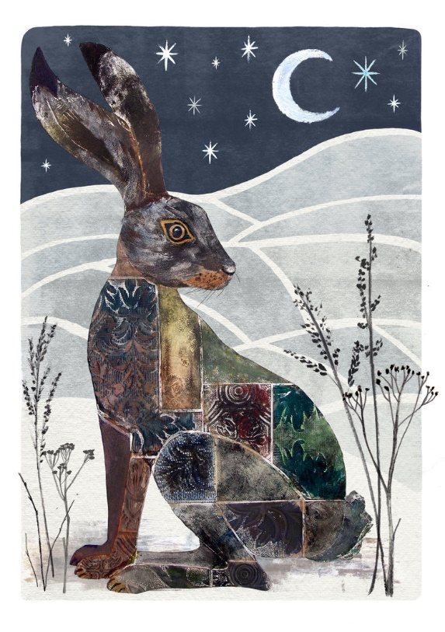
(There is an attendance fee of £1 per day)

MONDAY 5TH FEBRUARY
Morning –
Makaton Course – 10am – 12pm – Maria – WEA - (Continued - Week 4)

Chatty Café Drop In - 10am – 11am – Liz - Volunteer – (The Old School Café)
- Are you feeling isolated and in need of a little chat and some friendly company? Then we welcome you to pop into The Old School Café, where one of our lovely volunteers will be there waiting. You can have a lovely chit chat or maybe play some board games. Hopefully this little drop in will leave you feeling a little brighter.
Afternoon -
Chatty Café Drop In - 1pm – 2pm – John - Volunteer – (The Old School Café)
Drawing with Pastels - 1.15pm – 3.30pm – Olwyn - (Craft Room – Max. 12ppl)
- Dramatic results can be achieved by blending pastel chalks on paper, observing light and dark to add stunning effects whilst enjoying the sensory nature of this medium. No drawing experience is needed – just come along and immerse yourself in the process.

TUESDAY 6TH FEBRUARY
All day –
Social Day – 9.30am – 4pm – (Craft Room)
- Come and go as you please. A day for social interaction and a safe place to get on with any hobbies you may have e.g., Painting, drawing, writing, jigsaws, crosswords, knitting. Or just enjoy a nice little chin wag with a cuppa. We encourage you to bring your own projects to get on with if you would like to keep yourself busy.
You must still book a slot on any social day you wish to attend to secure a seat.
Afternoon -
Meditation & Mindfulness – 1.15pm – 3.30pm – Margaret – WEA - (Continued – Week 4)
NEW! “Knit Happens”- 1.15pm - 3.30pm - Gail & Michelle (The Old School Café - Max 8ppl)
- Our “Knit Happens” sessions are for new and experienced knitters alike. Feel free to bring your own knitting projects or simply turn up without so much as a knitting needle where we'll help you to begin knitting squares to make into a blanket. No experience is required to join, and equally, accomplished Knitters are welcome too. These sessions will be held every week in our Café situated on the ground floor of our Centre. You will still need to book onto these sessions as there is limited space.
WEDNESDAY 7TH FEBRUARY
All Day -
Social Day – 9.30am – 4pm – (Craft Room & Room 2)
THURSDAY 8TH FEBRUARY
(Busy Day)
All day –
Social Day – 9.30am – 4pm – (Craft Room)
Afternoon -
NEW! Create a Mandala Print (4 weeks) 1.15pm – 3.30pm – Janet – Volunteer - (Room 2)
- The mandala is a decorative circular pattern representing spiritualism. This 4-week course will introduce you to simple print making techniques using ink pads and stamps. These will be used to help you design and create your own Mandala suitable for hanging. If you book onto this course, please pop the following 3 weeks in your diary.

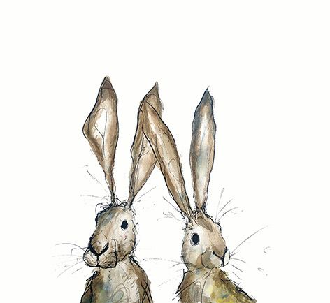
FRIDAY 9TH FEBRUARY
(Very busy day)
Morning –
Printed Brown Wrapping Paper – 10am – 12pm – Olwyn – (Room 2 - Max.8ppl)
- Using wooden block stamps and ink we will create repeat patterns on our paper and embellish with gold, to give a classy and ornate finish.

Textiles For Charities “Dress A Girl Around the World” (4 Week Project) - 10am – 12pm – Isabelle, Meg & Debbie – Volunteers - (Craft Room - Max. 10ppl)
- Dress a Girl Around the World - UK, aims to provide the very best new dresses made especially by you for children living in poverty around the world. The aim of Dress a Girl Around the World is to ensure that every girl has at least one new dress to wear. Our lovely volunteers will show you the skills to create simple dress patterns and guide you through sewing and finishing a lovely new dress. No skills necessary to join these sessions, but a little sewing experience would be beneficial. If you book onto this project, please pop the following 3 Fridays in your diary.
Afternoon –
Pictionary - 1.15pm - 3.30pm - Olwyn - (Room 2 - Max. 8ppl)
- The hilarious interactive drawing game that encourages team building and social skills. No drawing skills needed!

Textiles Group “Craft Storage Roll up’s” (4 Week Course) - 1.30pm - 3.30pm -
With Izzy, Meg & Alison - Volunteers - (Craft Room – Max.10ppl)
- In this course you will be making a sturdy fabric storage case, that you can personalise and conveniently roll up. Some basic hand sewing skills will be required, but no experience is needed as you will be guided by our wonderful and experienced volunteers along the way. If you book onto this course please pop the following 3 Fridays in your diary.

MONDAY 12TH FEBRUARY
Morning –
Product Design Workshop – 9.30am – 12pm – Erica – (Craft Room – Max. 12ppl)
- This is for our product Design Volunteers only and will be led by our Craft Volunteer, Erica. If you are interested in volunteering with us, please speak to Nicola.
--No Makaton Today--
Afternoon –
Chatty Café Drop In – 1pm – 2pm – John - Volunteer – ( The Old School Café)
“Cute” Illustrations – 1.15pm – 3.30pm – Olwyn - (Craft Room - Max. 12)
- Learn how to illustrate simple cute characters from scratch using simple tips and tricks.
TUESDAY 13TH FEBRUARY
All Day –
Social Day – 9.30am – 4pm – (Craft Room & Room 2)
Afternoon –
--No Meditation Today--
“Knit Happens” – 1.15pm – 3.30pm – Gail & Michelle - Volunteers – (The Old School Café)
WEDNESDAY 14TH FEBRUARY
Morning –
Sound & Vision – 10am – 12pm – Olwyn – (Craft Room - Max.12ppl)
- We will be exploring instrumental music as inspiration for pieces of art. Art is not always about being “precise”, “in proportion” or “realistic”. In this class we will immerse ourselves in gorgeous music, and paint whatever comes into our heads. This can be a mindful, relaxing, and diversional process. Lots of happy accidents to be made!
Afternoon –
Misty Forest Watercolour Landscape -1.15pm - 3.30pm - Olwyn - (Craft Room-Max. 12ppl)
- Using watercolour on wet paper we will create simple misty forest scenes with a Pine tree silhouette landscape.

THURSDAY 15TH FEBRUARY
(Busy day)
All day –
Social Day – 9.30am – 4pm – (Craft Room & Room 2)
Afternoon -
Create a Mandala Print - 1.15pm – 3.30pm – Janet – Volunteer (Continued – Week 2)
FRIDAY 16TH FEBRUARY
(Very busy day)
Morning –
Drawing with Pastels – 10am – 12pm – Olwyn – (Room 2 - Max.8ppl)

Textiles For Charities “Dress A Girl Around the World” - 10am – 12pm – Izzy, Meg & Debbie – Volunteers - (Continued – Week 2)
Afternoon –
Embossed Wallpaper Wildlife - 1.15pm - 3.30pm - Olwyn (Room 2 - Max. 8ppl)
- We will create animal silhouettes from embossed wallpaper which will be brushed with metallic paint. These will be mounted on black card, and you will create a background using a dry brush technique.

Textiles Group “Craft Storage Roll up’s” - 1.30pm - 3.30pm - With Izzy, Meg & Alison -Volunteers - (Continued - Week 2)

MONDAY 19TH FEBRUARY
Morning –
Makaton Course – 10am – 12pm – Maria – WEA (Week 5)
Chatty Café Drop In - 10am – 11am – Liz – Volunteer – (The Old School Café)
Afternoon –
Chatty Café Drop In – 1pm – 2pm – John – Volunteer – (The Old School Café)
TUESDAY 20TH FEBRUARY
All day-
Social Day – 9.30am – 4pm – (Craft Room)
Afternoon –
Meditation & Mindfulness - 1.15pm - 3.30pm – Margaret - WEA (Continued – Week 5)
“Knit Happens” – 1.15pm – 3.30pm – Gail & Michelle – Volunteers - (The Old School Café)

WEDNESDAY 21ST FEBRUARY
Morning –
“Cute” Illustrations – 10am – 12pm – Olwyn – (Craft Room - Max.12ppl)
Afternoon –
Drawing With Pastels – 1.15pm – 3.30pm – Olwyn - (Craft Room - Max. 12ppl)

THURSDAY 22ND FEBRUARY
(Busy day)
All day –
Social day – 9.30am – 4pm – Olwyn (Craft Room & Room 2)
Afternoon –

Create a Mandala Print – 1.15pm – 3.30pm – Janet – Volunteer – (Continued – Week 3)

FRIDAY 23RD FEBRUARY
(Very busy day)
Morning –
Misty Forest Watercolour Landscape – 10am – 12pm – Olwyn (Room 2 - Max. 8ppl)

Textiles For Charities “Dress A Girl Around the World” - 10am - 12pm - Isabelle, Meg & Debbie (Continued – Week 3)
Afternoon –
Sound & Vision - 1.15pm - 3.30pm - Olwyn (Room 2 - Max. 8ppl)

Textiles Group “Craft Storage Roll Up’s” - 1.30pm - 3.30pm – Izzy, Meg & Alison - Volunteers – (Continued – Week 3)

MONDAY 26TH FEBRUARY
Morning –
Makaton Course – 10am – 12pm – Maria - (Continued – Week 6)

Chatty Café Drop In - 10am – 11am – Liz – Volunteer – (The Old School Café)
Afternoon –
Chatty Café Drop In – 1pm – 2pm – John – Volunteer – (The Old School Café)
Printed Brown Wrapping Paper – 1.15pm – 3.30pm – Olwyn – (Craft Room – Max.12ppl)

TUESDAY 27TH FEBRUARY
All day-
Social Day – 9.30am – 4pm – (Craft Room)
Afternoon –
Meditation & Mindfulness Course - 1.15pm - 3.30pm – Margaret - (Continued – Week 6)

“Knit Happens” – 1.15pm – 3.30pm – Gail & Michelle – Volunteers - (The Old School Café)

WEDNESDAY 28TH FEBRUARY
Morning –
Embossed Wallpaper Wildlife – 10am – 12pm – Olwyn – (Craft Room - Max.12ppl)
Afternoon –
“Cute” Illustrations – 1.15pm – 3.30pm – Olwyn - (Craft Room - Max. 12ppl)

THURSDAY 29TH FEBRUARY
(Busy day)
All day –
Social day – 9.30am – 4pm – Olwyn - (Craft Room & Room 2)

Afternoon-
Create a Mandala Print – 1.15pm – 3.30pm – Janet – Volunteer – (Final Session)

FRIDAY 1ST MARCH
(Very busy day)
Morning –
Pictionary – 10am – 12pm – Olwyn (Room 2 - Max. 8ppl)
Textiles For Charities “Dress A Girl Around the World” - 10am - 12pm - Isabelle, Meg & Debbie – Volunteers - (Final Session)
Afternoon –
Printed Brown Wrapping Paper - 1.15pm - 3.30pm - Olwyn (Room 2 - Max. 8ppl)

Textiles Group “Craft Storage Roll Up’s” - 1.30pm - 3.30pm – Izzy, Meg & Alison - Volunteers – (Final Session)

Classes with this symbol - are dedicated, quieter sessions. Anybody can join them, but they are designed to be inclusive of neurodivergent individuals who may struggle to access our standard sessions.
(Up to a Maximum of 12ppl in a room)

