**Please read carefully.**

Hello,

We hope this letter finds you well.

Enclosed you will find the latest timetable of activities for December 2024. We will be taking bookings for these activities via phone call or email from **10am** on **Monday 25th November**. Please do not phone us to try booking before this date and time. You will find our contact number and email address on the front page of your timetable.

**We will be taking bookings for our Christmas parties**, as of Monday 25th November. Please use the booking sheet in the craft room or book on the phone whilst booking your classes. Party days will be spread over 3 days, **17th**, **18th** **&** **19th** **December** **from 10am - 2pm**. you can attend **one party** only**.** Please put your name down for your **1st** **and** **2nd** **choice,** on the day you wish to attend, if we cannot fit you in for your 1st choice, you will be put in on the day of your 2nd choice. We will be serving a Christmas lunch with drinks and there will be a raffle with prizes to be won. There is a **£4.50 charge** **per person**, which covers the cost of food & drinks throughout the day.

Due to the volume of new referrals coming through. You will now only be able to book onto **one social day** (Tuesday **or** Thursday) and **two classes** per week (Not including WEA, Bishop college, Walking groups or external tutors). This is so we can give new attendees a fair chance of booking onto sessions.

**We please ask that you pay a £1 attendance fee per session,** your attendance fee goes back into the Centre and helps towards cost of materials and use of our tea and coffee facilities situated in our craft room. Your contribution is much appreciated.

Please turn up to your class **on time** especially if you are already on the premises, unless you have called to say you are running late. **Do not eat food or leave to go for a cigarette during classes**, this can be very disruptive for other attendees and the instructor. You are all given a **15-minute break halfway through your classes** to eat, make a beverage and smoke.

If you are booked onto any class and cannot make it for whatever reason you must call the centre to inform us of this as early as possible, so that we can offer the space to somebody else. **You still need to book to attend Social Days** as well as regular craft classes, to guarantee you have a seat.

We look forward to seeing you.

A very Merry Christmas and a Happy New Year! From all at St. Margaret’s Centre

**To Book Classes Call: 0191 384 8100 or Email: enquiries@stmargaretscentre.co.uk**

**(**There is an **attendance fee of** **£1 per session)**

**MONDAY 2ND DECEMBER**

*Afternoon -*

**Chatty Café Drop In – 1pm – 2pm – John (Volunteer) – (The Old School Café)**

* Are you feeling isolated and in need of a little chat and some friendly company? Then we welcome you to pop into The Old School Café, where one of our lovely volunteers will be there waiting. This is not counselling session, but a safe space where you can have a lovely chit chat or play some board games. Hopefully, this little drop in will leave you feeling a little brighter.



**Bokeh Berries – 1.15pm – 3.30pm – Olwyn – (Craft Room – Max. 14ppl)**

* Bokeh is a technique often used in photography which blurs out spots of light in the background so that they resemble hazy orbs. This can be simulated using watercolour paints and the results are beautiful. In this class we will create a Bokeh background with a foreground of red berries on branches and a flutter of snow – the magic will happen before your eyes.

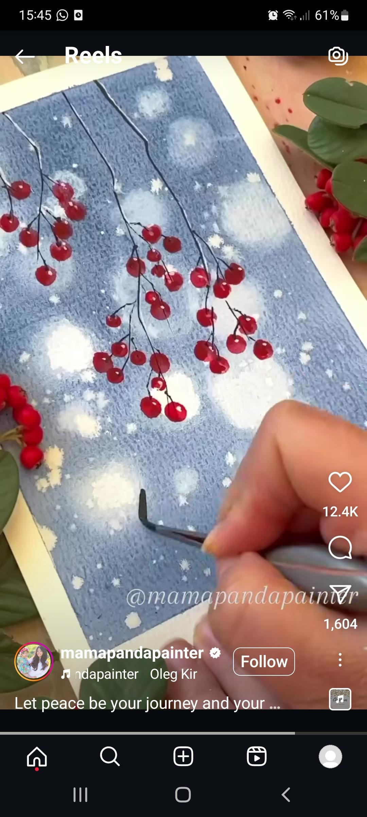

“Bokeh Berries” Example

**TUESDAY 3RD DECEMBER**

*Morning –*

**Social Day – 9.30am – 4pm – (Craft Room. Max. 20ppl)**

* A day for social interaction and a safe place to get on with any hobbies you may have e.g., Painting, drawing, writing, jigsaws, crosswords, knitting. Or just enjoy a nice little chin wag with a cuppa. We encourage you to bring your own projects to get on with if you would like to keep yourself busy, but we have an array of arts and crafts materials to get you inspired. You must still book a slot on any social day you wish to attend, to secure a seat.

**“Knit Happens” Introductory - 1.30pm - 3.30pm - Gail - (Volunteer) - (The Old School Café)**

* This simple knitting session is ideal for those who have minimal to no experience in knitting. Our lovely volunteer will gently guide you, showing you the very basics of techniques. From here, if you feel confident enough, you can then join onto our following sessions each week to gain more knowledge and knitting skills as you go. Or you may want to continue doing our monthly Introductory sessions, until you feel ready to progress.

**WEDNESDAY 4TH DECEMBER**

**Awareness to Pride: The Evolution of Autism Symbols from 1963 to Today***Morning –*

**Gemstone Christmas Tree (2 weeks) - 10am - 12pm - Olwyn - (Craft Room - Max. 14ppl)**

* In this class we will use fineliners to draw a triangular tree and divide it up into sections. Each of the sections will be turned into gemstones by shading in an effective way with your coloured pencils. Designed to focus the mind, but leaving plenty of time for some lovely chit chat amongst yourselves. If you book onto this course, please pop the following week in your diary.

*Afternoon -*

**Candy Cane Elves - 1.15pm - 3.30pm - Olwyn - (Craft Room - Max. 14ppl)**

* This is a simple but fun class where you will create decorative Christmas elves using a combination of paper templates which you will colour with Posca Paint pens. You will then add candy canes as limbs to create your little elf characters.

**Christmas Wreath (2 weeks) - 1.15pm - 3.30pm - Marie (Volunteer) - (Room 2 - Max.7ppl)**

* In this class you'll craft a simple but effective wreath made entirely out of toilet roll tubes, which you'll paint and decorate as you wish. This will be a lovely addition to any home this festive season. If you book onto this course, pop the following week in your diary.

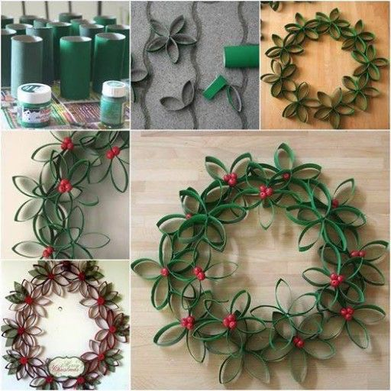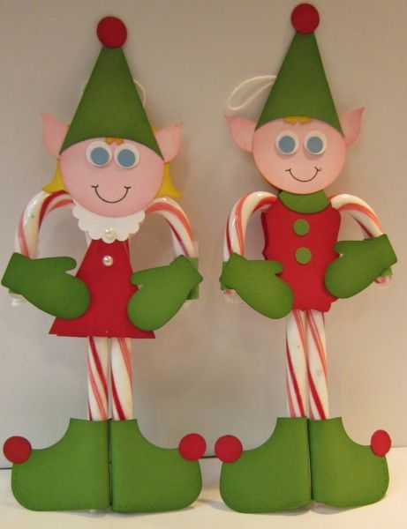

**“Gemstone Tree” “Candy Cane Elves” “Christmas Wreath”**

**THURSDAY 5TH DECEMBER**

**(Busy Day)**

*Morning –*

**Social Day – 9.30am – 4pm – (Craft Room – Max. 20ppl)**

* A day for social interaction and a safe place to get on with any hobbies you may have e.g., Painting, drawing, writing, jigsaws, crosswords, knitting. Or just enjoy a nice little chin wag with a cuppa. We encourage you to bring your own projects to get on with if you would like to keep yourself busy, but we have an array of arts and crafts materials to get you inspired. You must still book a slot on any social day you wish to attend, to secure a seat.

*Afternoon –*

**Makaton Course - 1.15pm - 3.15pm - Maria - WEA - (Continued - Week 9)**

*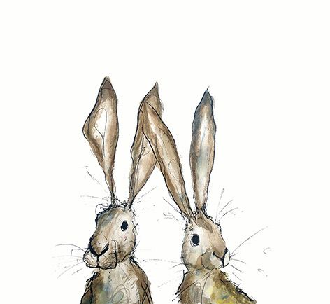***FRIDAY 6TH DECEMBER**

**(Very busy day)**

*Morning –*

**Watercolour Penguins - 10am - 12pm – Olwyn - (Craft Room - Max. 14ppl)**

* Back with an old favourite! These little characters take a bit of practice to create, but once you pick up this simple watercolour technique, they look incredibly effective. These little illustrations are perfect for adorning your personalised Christmas cards.

**Textiles “Felt & Fabric Xmas Decorations” (2 weeks) - 10am - 12pm - Meg, Alison & Gail (Volunteers)**

* In this simple, short beginner’s course, you will create Christmas decorations, such as Candle Mats and tree décor. If you book this course, please pop the following week in your diary.

*Afternoon –*

**Optical Illusions -****1.15pm - 3.30pm - Olwyn - (Room 2 - Max. 8ppl)**

* This is a great optical illusion which is simple and fun to create. We will draw a spiral on an A3 sheet of card, and then add the most simplistic silhouettes of individuals standing around the spiral and then add their shadows to complete the illusion.

**Textiles “Santa Hats & Mini Stockings” (2 Weeks) - 1.15pm - 3.30pm - Meg, Alison & Gail (Volunteers) - (Craft Room - Max.10ppl)**

* In this course you will be making your very own Santa hats and Xmas stockings using a combination of colourful fabrics. If you book onto this course, please pop the following week in your diary.

*Fridays Class Examples*

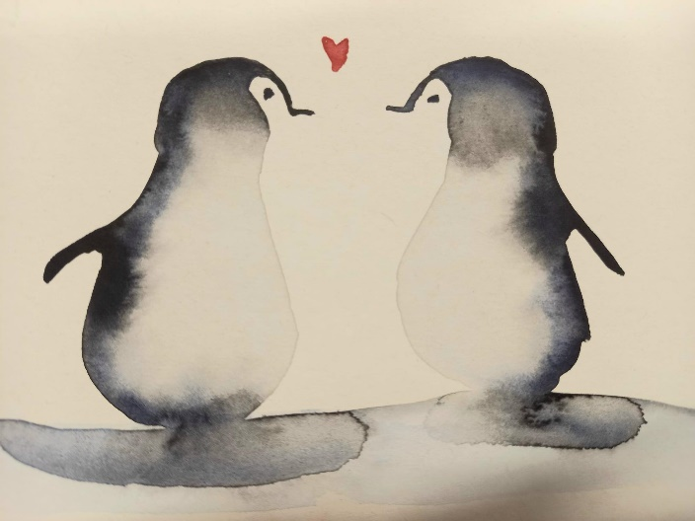*Morning -*

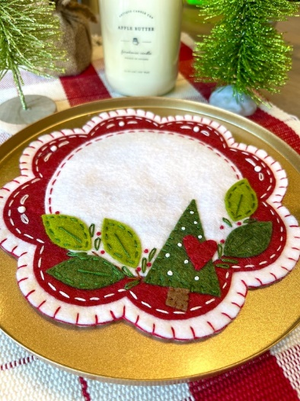

*Watercolour Penguins “Example” “Felt & Fabric Xmas Decorations” Example*

*Afternoon –*

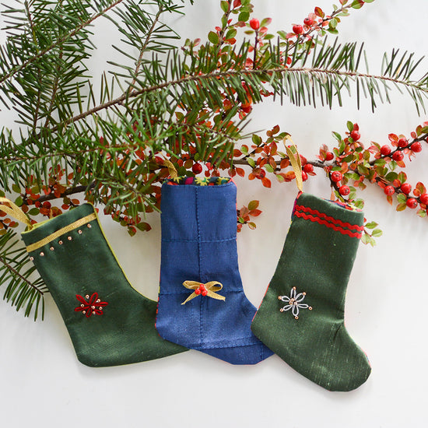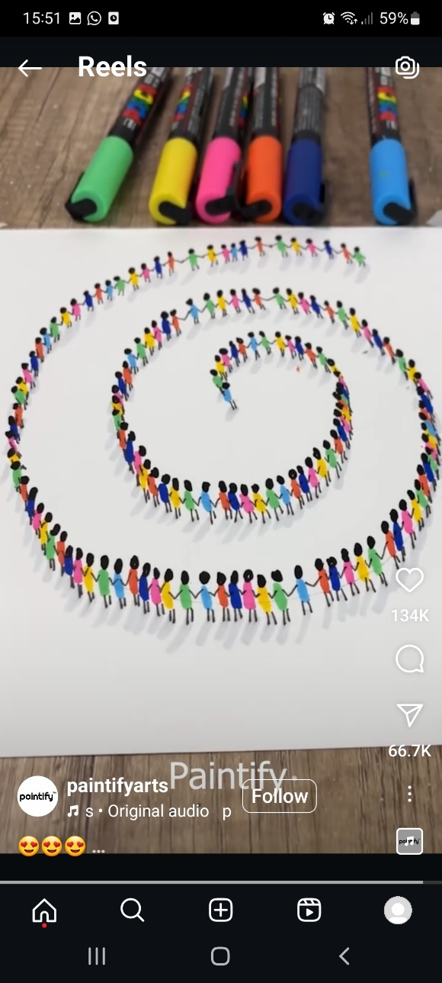



*“ Optical Illusions Example” “Santa Hats & Mini Stockings” Examples*

**MONDAY 9TH DECEMBER**

*Afternoon -*

**Chatty Café Drop In – 1pm – 2pm – John (Volunteer) – (The Old School Café)**

**Watercolour Penguins – 1.15pm – 3.30pm - (Craft Room - Max. 14ppl)**

**TUESDAY 10TH DECEMBER**

*Morning –*

**Social Day – 9.30am – 4pm – (Craft Room – Max. 20ppl)**

*Afternoon –*

**“Knit Happens” Intermediate - 1.30pm - 3.30pm - Gail (Volunteer) - (The Old School Café)**

* Our Intermediate sessions are for experienced knitters or anyone that has completed one or more of our beginners’ sessions. Feel free to bring your own knitting projects or simply turn up without so much as a knitting needle, and our lovely volunteer will get you set away on a project. These sessions will be held every week in our Café situated on the ground floor of our Centre. You will still need to book onto these sessions as there is limited space.

**WEDNESDAY** **11TH DECEMBER**

*Morning –*

**Gemstone Christmas Tree - 10am - 12pm - Olwyn - (Continued – Final Class)**

**Awareness to Pride: The Evolution of Autism Symbols from 1963 to Today***Afternoon –*

**Desert Island Discs “Xmas Special” - 1.15pm - 3.30pm - Olwyn - (Craft Room - Max. 14ppl)**

* In this fun and sociable activity, you will all take turns in choosing Christmas songs, these could mean something to you, or it may just be your favourite Xmas tune. Your songs will then be played out to the group, whilst you do a bit of therapeutic colouring in alongside the music. You are all free to tell a little story, if you have any good memories attached to your chosen songs.

**Christmas Wreath - 1.15pm - 3.30pm - Marie (Volunteer) - (Continued – Final Class)**

**THURSDAY 12TH DECEMBER**

**(Busy day)**

*Morning –*

**Social Day - 9.30am - 4pm - (Craft Room - Max. 20ppl)**

*Afternoon –*

**Makaton Course 1.15pm - 3.15pm - Maria - WEA - (Continued – Final Class)**

**FRIDAY** **13TH DECEMBER**

**(Very busy day)**

*Morning –*

**Acrylic Painting “Lily Pads” - 10am - 12pm - Olwyn - (Craft Room - Max. 14ppl)**

* A painting of leaves floating on water

  Description automatically generatedUsing acrylics as our medium, on black card we will paint Lilly pads floating on water. We will use simple techniques to create the appearance of ripples on the surface from gentle falling raindrops.

**Felt & Fabric Decorations - 10am - 12pm - Meg, Alison & Gail - (Continued - Final Class)**

*Afternoon –*

**Bokeh Berries - 1.15pm - 3.30pm - Olwyn - (Room 2 - Max. 8ppl)**

**Santa Hats & Mini Stockings- 1.15pm - 3.30pm - Meg, Alison, Gail - (Continued- Final Class)**

**MONDAY 16TH DECEMBER**

*Afternoon –*

**Awareness to Pride: The Evolution of Autism Symbols from 1963 to TodayAwareness to Pride: The Evolution of Autism Symbols from 1963 to TodayChatty Café Drop In – 1pm – 2pm – John (Volunteer) – (The Old School Café)**

**Acrylic Painting “Lily Pads” - 1.15pm - 3.30pm - Olwyn – (Craft Room – Max. 14ppl)**

Please remember to book your 1ST & 2nd choice, to attend a Christmas party from the days below. You can only attend one party day. There will be a **£4.50** charge for Food and Drinks.

**TUESDAY 17TH DECEMBER**

**Christmas Party Day – 10am – 2pm – (Craft Room)**

**WEDNESDAY 18TH DECEMBER**

**Christmas Party Day – 10am – 2pm – (Craft Room)**

**THURSDAY 19TH DECEMBER**

**Christmas Party Day – 10am – 2pm – (Craft Room)**

**FRIDAY 20TH DECEMBER**

**CENTRE CLOSED**

**We will reopen on THURSDAY 2ND JANUARY**

**THURSDAY 2ND JANUARY**

**Social Day – 9.30am – 4pm – (Craft Room – Max. 20ppl)**

**FRIDAY 3RD JANUARY**

**Social Day – 9.30am – 4pm – (Craft Room – Max. 20ppl)**

Awareness to Pride: The Evolution of Autism Symbols from 1963 to Today

Classes with this symbol - are dedicated, quieter sessions. Anybody can join them, but they are designed to be inclusive of neurodivergent individuals who may struggle to access our standard sessions.

(Up to a Maximum of 20ppl in our Craft Room and 8ppl in Room 2)