
Please read carefully.
Hello,
We hope this letter finds you well.
Enclosed you will find the latest timetable of activities for July 2025. We will be taking bookings for these activities via phone call or email from 10am on Monday 23rd June. Please do not phone us to try booking before this date and time. You will find our contact number and email address on the front page of your timetable.
WEA Courses are free to all our attendees. You must enrol onto these courses as they are run by an external organisation. Upon booking, we will request a national insurance number, and you must bring in a form of ID such as Drivers Licence, Passport or Bus Pass before the course start date.
Can we please remind everyone that if you are feeling unwell, DO NOT attend the Centre. Even if you feel just a little unwell, if you pass that on to someone else more vulnerable, it may impact them far worse. We also have limited staff who all play important roles, and if one of them get sick, it can have a significant impact on the rest of the Centre. Please be mindful and look out for each other and staff. Thank you.
Due to the volume of new referrals coming through. You will only be able to book onto one Social Day (Tuesday or Thursday) and two of Olwyn’s classes per week. This is so we can give new attendees a fair chance of booking onto sessions. (Not including WEA, Bishop college or volunteer led classes).
We please ask that you pay a £1 attendance fee per session. Your attendance fee goes back into the Centre and helps towards cost of materials and use of our tea and coffee facilities situated in our craft room. Your contribution is much appreciated.
Please turn up to your class on time especially if you are already on the premises, unless you have called to say you are running late. Do not eat food or leave to go for a cigarette during classes, this can be very disruptive for other attendees and the instructor. You are all given a 15-minute break halfway through your classes to eat, make a beverage and smoke.
If you are booked onto any class and cannot make it for whatever reason you must call the centre to inform us of this as early as possible, so that we can offer the space to somebody else. You still need to book to attend Social Days as well as regular classes, to guarantee you have a seat.
We look forward to seeing you.

To Book Classes Call: 0191 384 8100 or Email: enquiries@stmargaretscentre.co.uk
(There is an attendance fee of £1 per session)


MONDAY 30TH JUNE
Afternoon –
Chatty Café Drop In - 1pm - 2pm - John (Volunteer) - (The Old School Café)
- Are you feeling isolated and in need of a little chat and some friendly company? Then we welcome you to pop into The Old School Café, where one of our lovely volunteers will be there waiting. This is not a counselling session, but a safe space where you can have a lovely chat or play some board games. Hopefully you will leave feeling a little brighter.
Watercolour Botanicals - 1.15pm - 3.30pm - NO TUTOR - (Craft Room - Max. 14ppl)
- In this laid-back session, you will be offered a selection of preprinted botanical illustrations, which you will bring to life with a pop of colour using watercolours. There is no tutor instructing this session, so some experience with watercolours would be beneficial.


TUESDAY 1ST JULY
Morning –
(Busy Morning)
Social Day - 9.30am - 4pm - (Craft Room - Max. 20ppl)
- A day for social interaction and a safe place to get on with any hobbies you may have e.g., Painting, drawing, writing, jigsaws, crosswords, knitting. Or just enjoy a nice little chin wag with a cuppa. You must still book a slot on any social day you wish to attend, to secure a seat.
Needle Felting Course - 10am - 12pm - Karen - WEA - (Continued - Week 9)
Gardening - 10.30am - 12.30pm - Sandra (Volunteer) - (Meet in Craft Room)
- You will help with a little weeding, potting plants, and bulbs, watering flowers and assisting with the maintenance of our flower beds, lawns, and hedges. Outdoor activities are proven to help with wellbeing and mental health, so come and potter about, breathe in the fresh air and absorb some of that all-important Vitamin D.
Afternoon –
Positive Pathways to Mental Health - 1.15pm - 3.15pm - Margaret - (Continued - Week 8)
“Knit Happens” Introductory - 1.30pm - 3.30pm - Gail - (Volunteer) - (The Old School Café)
- This simple knitting session is ideal for those who have minimal to no experience in knitting. Our lovely volunteer will gently guide you, showing you the basic of techniques. From here, if you feel confident enough, you can then join onto our following sessions each week to gain more knowledge and knitting skills as you go.


WEDNESDAY 2ND JULY

Morning –
“One Scoop or Two?” - 10am - 12pm - Olwyn - (Craft Room - Max.14ppl)
- In this session you will learn how to layer up watercolours to create fun and colourful illustrations of ice cream cones. Some faint outline imagery will be provided to which you can enjoy applying the paint, layer by layer until we get just the right level of light and shadows on our cones. They will look good enough to eat!


Horticulture - 10am - 12pm - Joy (Volunteer) - (Meet in Craft Room)
- You will assist in the general upkeep of our allotment, helping with digging, planting
fresh bulbs, weeding, and maintaining the grounds. You will help grow fresh produce
such as fruit, vegetables, and herbs as well as growing flowers, whilst learning new
skills as you go. Outdoor activities are proven to help with wellbeing and mental
health, so come and potter about, breath in the fresh air and absorb some of that all-important Vitamin D
Afternoon -
Desert Island Discs - 1.15pm – 3.30pm - Olwyn - (Craft Room - Max.14ppl)
- “Memorable T.V Themes” - In this very popular and uplifting group session, you will have the opportunity to request and listen to songs from classic TV shows. So, get ready to step back in time and feel all nostalgic. Clients may share stories or briefly discuss why they have chosen a specific song, but you are more than welcome to just play a song and listen without sharing anything particular with the group.
THURSDAY 3RD JULY
(Busy Day)
Morning -
Social Day - 9.30am - 4pm - (Craft Room - Max. 20ppl)
“Harmonise Your Mind” - 10.30am - 11.30am - Linda (Volunteer) - (Room 2 - Max.9ppl)
- Looking for a fun and uplifting way to brighten your week? Join our Harmonise Your Mind group, where voices come together to create harmony and joy! - For more info, please see the sheet attached to the back of this timetable.

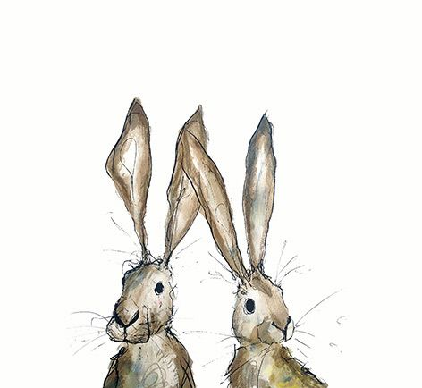
FRIDAY 4TH JULY
(Very busy day)
Morning -
Embellished Cards - 10am - 12pm - Olwyn - (Craft Room - Max. 14ppl)
- Everyone loves a sparkle here at the centre, so in this class we will embellish beautifully illustrated cards using glistening gems. May be a little fiddly for some but can be a very relaxing class.
Embroidery Skills (5 Weeks) - 10am - 12pm - Meg, Alison & Gail - (Room 2 - Max.7ppl)
- This basic embroidery course teaches students how to hand stitch and embroider using a needle and thread. Sessions may include instruction on how to prepare fabric, transfer designs, practice different stitch patterns and use a hoop. This course is designed for all skill levels. If you book onto this course, please pop the following 4 weeks in your diary.
Afternoon -
Dot Mandala (2 Weeks) - 1.15pm - 3.30pm - Olwyn - (Room 2 - Max.8ppl)
- A new technique where we apply dots in varying sizes to a grid on black card. As we start in the centre and work outwards, our design will begin to grow, just like our confidence! It’s amazing what you can create with just a few basic tools.

Textiles Group ‘Doorstop’ (5 weeks) - 1.15pm - 3.30pm - Meg, Alison & Gail (Volunteers) - (Craft Room - Max.10ppl)
- Using a combination of hand sewing and machine sewing techniques you will create a decorative weighted Doorstop. You will have a choice of a duck or an owl. If you book onto this course, please pop the following 4 weeks in your diary.

Fridays Class Examples

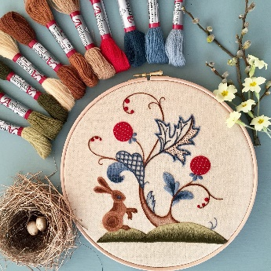
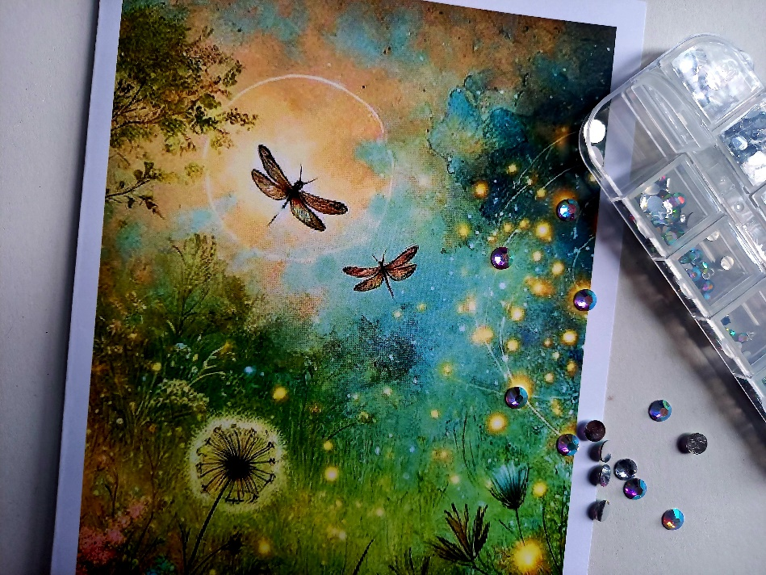
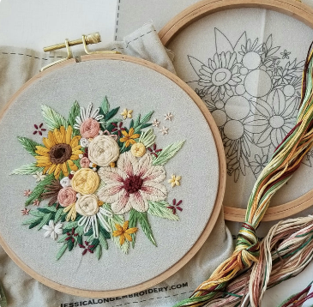
Morning -

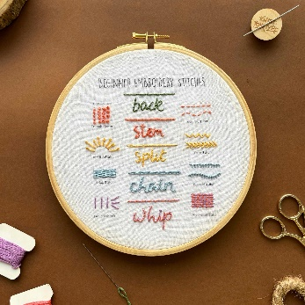
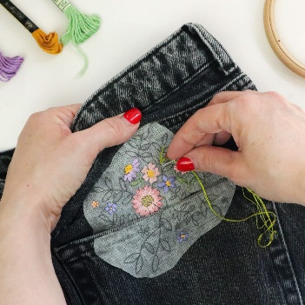

“Embellished Cards” Example “Embroidery Skills” Example

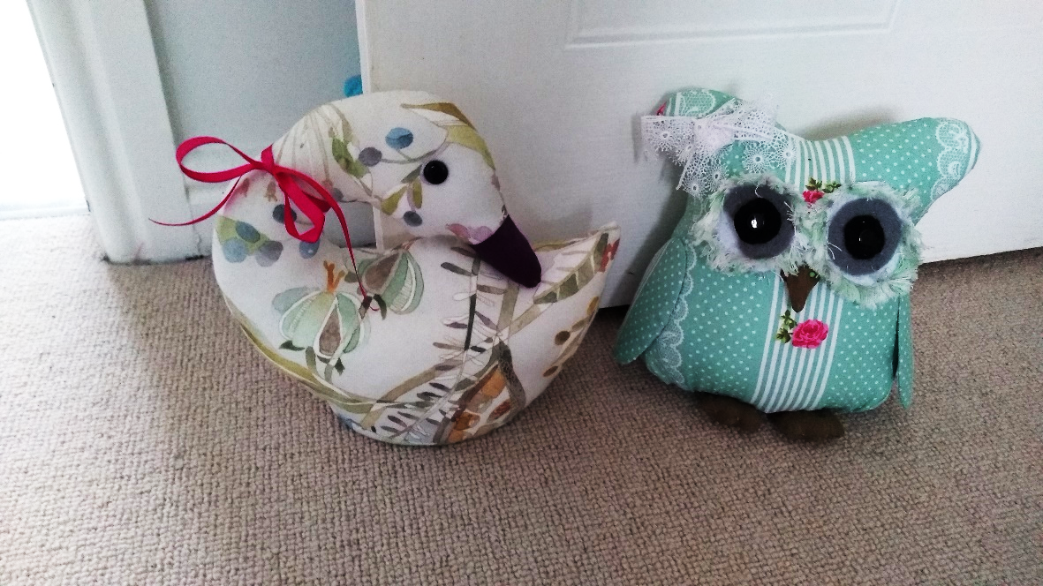
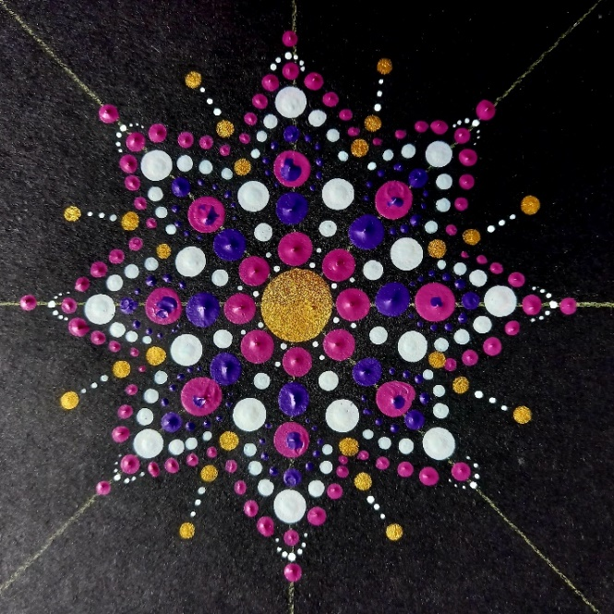
Afternoon -

“Dot Mandala” Example “Decorative Doorstop” Example

MONDAY 7TH JULY

Afternoon -
How to Draw A House - 1.15pm - 3.30pm - Olwyn - (Craft Room - Max.14ppl)
- In this class, we will show you how to draw a house using a 1-point perspective technique, this helps transform 2-dimensional images into realistic 3D images. It’s all about getting your angles right, so you will be taught how to incorporate a ‘vanishing point’. We’ll have you going home feeling like an architect!


TUESDAY 8TH JULY
Morning -
Social Day - 9.30am - 4pm - (Craft Room - Max. 20ppl)
Needle Felting Course - 10am - 12pm - Karen - WEA - (Continued - Week 10)
Gardening - 10.30am - 12.30pm - Sandra (Volunteer) - (Meet in Craft Room)
Afternoon -
Positive Pathways to Mental Wellbeing - 1.15pm - 3.15pm - Margaret - (Continued - Week 9)
“Knit Happens” Intermediate - 1.30pm - 3.30pm - Gail (Volunteer) - (The Old School Café)
- Our Intermediate sessions are for experienced knitters or anyone that has completed one or more of our beginners’ sessions. Feel free to bring your own knitting projects or simply turn up without so much as a knitting needle, and our lovely volunteer will get you set away on a project. These sessions will be held every week in our Café situated on the ground floor of our Centre. You will still need to book onto these sessions as there is limited space.
WEDNESDAY 9TH JULY
Morning -
Pastel Drawing “Panelled Windows” - 10am - 12pm - Olwyn - (Craft Room - Max.14ppl)
- Before we begin our drawing, we will mask off our paper into 4 vertical panels. We will then create 4 different coloured skies in our panels, grading our pastels from dark to light. A forest scene silhouette against our coloured skies will complete the picture and we will then be ready to peel back our masking tape, for the great reveal!


Horticulture Group - 10am - 12pm - Joy (Volunteer) - (Allotments)
- You will assist in the general upkeep of our allotment, helping with digging, planting
fresh bulbs, weeding, and maintaining the grounds. You will help grow fresh produce
such as fruit, vegetables, and herbs as well as growing flowers, whilst learning new
skills as you go. Outdoor activities are proven to help with wellbeing and mental
health, so come and potter about, breath in the fresh air and absorb some of that all-important Vitamin D
Afternoon -
On The Shelf - 1.15pm - 3.30pm - Olwyn - (Craft Room - Max. 14ppl)
- What would you put on your shelf? A nice trailing plant? A cute little vase? A prickly Cactus. A favourite Picture? You will draw and personalise your own display shelf using fineliners and watercolours.
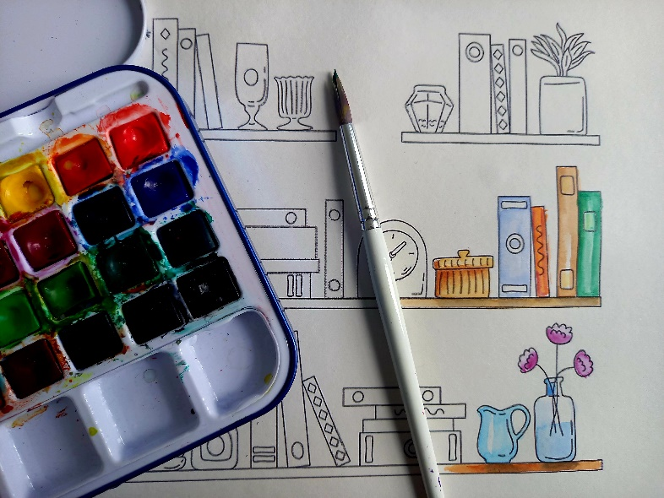

THURSDAY 10TH JULY
(Busy day)
Morning –
Social Day - 9.30am - 4pm - (Craft Room - Max.20ppl)
“Harmonise Your Mind” - 10.30am - 11.30am - Linda (Volunteer) - (Room 2 - Max.9ppl)

FRIDAY 11TH JULY
(Very busy day)
Morning –
“One Scoop or Two?” - 10am - 12pm - Olwyn - (Craft Room - Max. 14ppl)
Embroidery Skills - 10am - 12pm - Meg, Alison & Gail - (Continued - Week 2)
Afternoon –
Dot Mandala - 1.15pm - 3.30pm - Olwyn - (Continued - Final Session)
Textiles ‘Doorstop’ - 1.15pm - 3.30pm - Meg, Alison, Gail - (Continued - Week 2)

MONDAY 14TH JULY
Afternoon –
Chatty Café Drop In - 1pm - 2pm - John (Volunteer) - (The Old School Café)
“One Scoop or Two?” - 1.15pm - 3.30pm - Olwyn - (Craft Room - Max.14ppl)

TUESDAY 15TH JULY
Morning –
Social Day - 9.30am - 4pm - (Craft Room - Max.20ppl)
Needle Felting Course - 10am - 12pm - Karen - WEA - (Continued - Week 11)
Gardening - 10.30am - 12.30pm - Sandra (Volunteer) - (Meet in Craft Room)
Afternoon –
Positive Pathways to Mental Health - 1.15pm - 3.15pm - Margaret - (Continued - Week 10)

“Knit Happens” Intermediate - 1.30pm - 3.30pm - Gail (Volunteer) - (The Old School Cafe)
WEDNESDAY 16TH JULY
Morning –
How To Draw A House - 10am - 12pm - Olwyn - (Craft Room - Max. 14ppl)
Horticulture Group - 10am - 12pm - Joy (Volunteer) - (Meet in Craft Room)
Afternoon –
Embellished Cards - 1.15pm - 3.30pm - Olwyn - (Craft Room - Max.14ppl)

THURSDAY 17TH JULY
(Busy day)
Morning –
Social Day - 9.30am - 4pm - (Craft Room - Max. 20ppl)
“Harmonise Your Mind” - 10.30am - 11.30am - Linda (Volunteer) - (Room 2 - Max.9ppl)
Afternoon -
“Away With The Faeries” (3 weeks) - 1.15pm - 3.30pm - Joanne (Volunteer) - (Room 2)
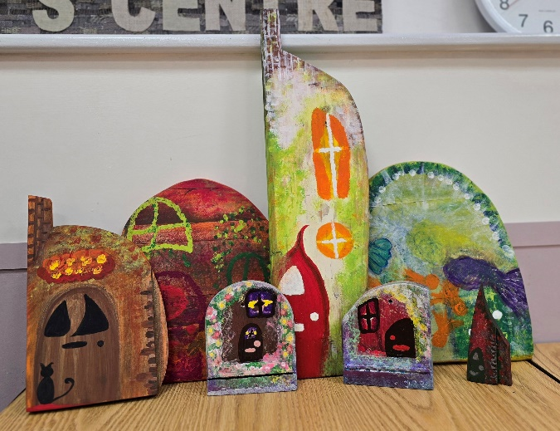
- In this 3-week course you will decorate a
premade wooden faery door. Using
predominantly paints, with a touch
of mixed media. Lose yourself in the
whimsy of a magical faery door.
“Come away, O’ human child! To the
waters and the wild, with faery hand in
hand for the worlds more full of weeping
than you understand”
The stolen Child by
William Butler Yates
FRIDAY 18TH JULY
Morning -
Pastel Drawing “Panelled Windows” - 10am - 12pm - Olwyn - (Craft Room - Max. 14ppl)
Embroidery Skills - 10am - 12pm - Meg, Alison & Gail - (Continued - Week 3)
Afternoon -
On The Shelf - 1.15pm - 3.30pm - Olwyn - (Room 2 - Max. 8ppl)
Textiles ‘Doorstop’ - 1.15pm - 3.30pm - Meg, Alison, Gail - (Continued - week 3)
Walking Group - 1.30pm - 3pm - Nicola - (Meet in The Old School Café)
- We will venture out into our wonderful City, exploring the ‘nooks & crannies’ of Durham. This is a nice relaxed paced walk, with only slight inclines and as few stairs as possible (but to be expected in “Hilly” Durham) The walks usually take around 90mins depending on the route and individuals’ mobility. The walks are weather permitted; you will be contacted by lunchtime if the walk has been cancelled due to adverse conditions. Bring your own water and wear appropriate clothing for the weather.
MONDAY 21ST JULY
Afternoon –
Chatty Café Drop In - 1pm - 2pm - John (Volunteer) - (The Old School Café)
Dot Mandala (2 Weeks) - 1.15pm - 3.30pm - (Craft Room - Max.14ppl)

TUESDAY 22ND JULY
Morning –
Social Day - 9.30am - 4pm - (Craft Room - Max.20ppl)
Needle Felting Course - 10am - 12pm - Karen - WEA - (Continued - Final Session)
Gardening - 10.30am - 12.30pm - Sandra (Volunteer) - (Meet in Craft Room)
Afternoon –
Positive Pathways - 1.15pm - 3.15pm - Margaret - (Continued - Final Session)

“Knit Happens” Intermediate - 1.30pm - 3.30pm - Gail (Volunteer) - (The Old School Cafe)
WEDNESDAY 23RD JULY
Morning –
Flower Posy Cards - 10am - 12pm - (Craft Room - Max. 14ppl)
- Why not send someone a bunch of flowers…in a card. In this class, we will make a pretty posy with paper flowers tied with a string. You can be as creative as you wish with your designs.
Horticulture Group - 10am - 12pm - Joy (Volunteer) - (Meet in Craft Room)
Afternoon –
Clay ‘Cactus in a pot’ (2 Weeks) - 1.15pm - 3.30pm - Olwyn - (Craft Room - Max.14ppl)
- In our first week of this short course, we will create our cactus plants out of clay and leave them to air dry. In week 2 we will paint our cactus plants and decorate the pots as we wish. Tiny paper cactus flowers can be added as a final embellishment.

Wednesday Class Examples


“Flower Posy Cards” Example


“Clay Cactus Pot” Example
THURSDAY 24TH JULY
(Busy day)
Morning –
Social Day - 9.30am - 4pm - (Craft Room - Max. 20ppl)
“Harmonise Your Mind” - 10.30am - 11.30am - Linda (Volunteer) - (Final Session)
Afternoon –
“Away With The Faeries” - 1.15pm - 3.30pm - Joanne (Volunteer) - (Continued - Week 2)

FRIDAY 25TH JULY
Morning –
Desert Island Discs “Memorable TV Themes” - 10am - 12pm - (Craft Room - Max. 14ppl)
Embroidery Skills - 10am - 12pm - Meg, Alison, Gail - (Continued - Week 4)
Afternoon –
How To Draw A House - 1.15pm – 3.30pm - Olwyn - (Room 2 - Max. 8ppl)
Textiles Group - 1.15pm - 3.30pm - Meg, Alison, Gail - (Continued - Week 4)

MONDAY 28TH JULY
Afternoon –
Chatty Café Drop In - 1pm - 2pm - John (Volunteer) - (The Old School Café)
Dot Mandala - 1.15pm - 3.30pm - (Continued - Final Session)

TUESDAY 29TH JULY
Morning –
Social Day - 9.30am - 4pm - (Craft Room - Max.20ppl)
Gardening - 10.30am - 12.30pm - Sandra (Volunteer) - (Meet in Craft Room)
Afternoon –
“Knit Happens” Intermediate - 1.30pm - 3.30pm - Gail (Volunteer) - (The Old School Cafe)
WEDNESDAY 30TH JULY
Morning –
Embellished Cards - 10am - 12pm - Olwyn - (Craft Room - Max. 14ppl)
Horticulture Group - 10am - 12pm - Joy (Volunteer) - (Meet in Craft Room)
Afternoon –
Clay ‘Cactus in a pot’ - 1.15pm - 3.30pm - Olwyn - (Continued - Final Session)

THURSDAY 31ST JULY
(Busy day)
Morning –
Social Day - 9.30am - 4pm - (Craft Room - Max. 20ppl)
Afternoon –
“Away With The Faeries” - 1.15pm - 3.30pm - (Continued - Final session)

FRIDAY 1ST AUGUST
Morning –
Flower Posy Cards - 10am - 12pm - (Craft Room - Max. 14ppl)
Embroidery Skills - 10am - 12pm - Meg, Alison, Gail - (Continued - Final Session)
Afternoon –
Pastel Drawing “Panelled Windows” - 1.15pm - 3.30pm - Olwyn (Room 2 - Max.8ppl)
Textiles Group - 1.15pm - 3.30pm - Meg, Alison, Gail - (Continued - Final Session)
Walking Group - 1.30pm - 3pm - Nicola (Meet in The Old School Café - Max.6ppl)

Classes with this symbol - are dedicated, quieter sessions. Anybody can join them, but they are designed to be inclusive of neurodivergent individuals who may struggle to access our standard sessions.
(Up to a Maximum of 20ppl in our Craft Room and 8ppl in Room 2)



