**Please read carefully.**

Hello,

We hope this letter finds you well.

Enclosed you will find the latest timetable of activities for August 2025. We will be taking bookings for these activities via phone call or email from **10am** on **Monday 28th July**. Please do not phone us to try booking before this date and time. You will find our contact number and email address on the front page of your timetable.

**Our Summer Party will take place on Thursday 28th August 10am - 2pm. Please inform us if you would like to attend.**

**Can we please remind everyone that if you are feeling unwell, DO NOT attend the Centre. Even if you feel just a little unwell, if you pass that on to someone else more vulnerable, it may impact them far worse. We also have limited staff who all play important roles, and if one of them get sick, it can have a significant impact on the rest of the Centre. Please be mindful and look out for each other and staff. Thank you.**

Due to the volume of new referrals coming through. You will only be able to book onto **one Social Day** (Tuesday **or** Thursday) and **two of Olwyn’s classes** per week. This is so we can give new attendees a fair chance of booking onto sessions. (Not including WEA, Bishop college or volunteer led classes).

**We please ask that you pay a £1 attendance fee per session.** Your attendance fee goes back into the Centre and helps towards cost of materials and use of our tea and coffee facilities situated in our craft room. Your contribution is much appreciated.

Please turn up to your class **on time**, unless you have called to say you are running late. **Please do not eat food or leave to go for a cigarette during classes**, this can be very disruptive for other attendees and the instructor. You are all given a **15-minute break halfway through your classes** to eat, make a beverage and smoke.

If you are booked onto any class and cannot make it for whatever reason you must call the centre to inform us of this as early as possible, so that we can offer the space to somebody else. **You still need to book to attend Social Days** as well as regular classes, to guarantee you have a seat.

Classes with this symbol - are dedicated, quieter sessions. Anybody can join them, but they are designed to be inclusive of neurodivergent individuals who may struggle to access our standard sessions. (Up to a Maximum of 20ppl in our Craft Room and 8ppl in Room 2)

We look forward to seeing you.

**To Book Classes Call: 0191 384 8100 or Email: enquiries@stmargaretscentre.co.uk**

**(**There is an **attendance fee of** **£1 per session)**



**MONDAY 4TH AUGUST**

**(Café Closed All This Week)**

*Afternoon -*

**Plastic Bag Printing - 1.15pm - 3.30pm - Olwyn - (Craft Room - Max. 14ppl)**

* For those of you who were not able access our last printing classes, this amazing acrylic painting class is back by popular request. We use an inflated sandwich bag which we dip into multiple colours of paint to create beautiful floral prints on card. A relaxing and enjoyable class with surprisingly effective results.

Mondays Class

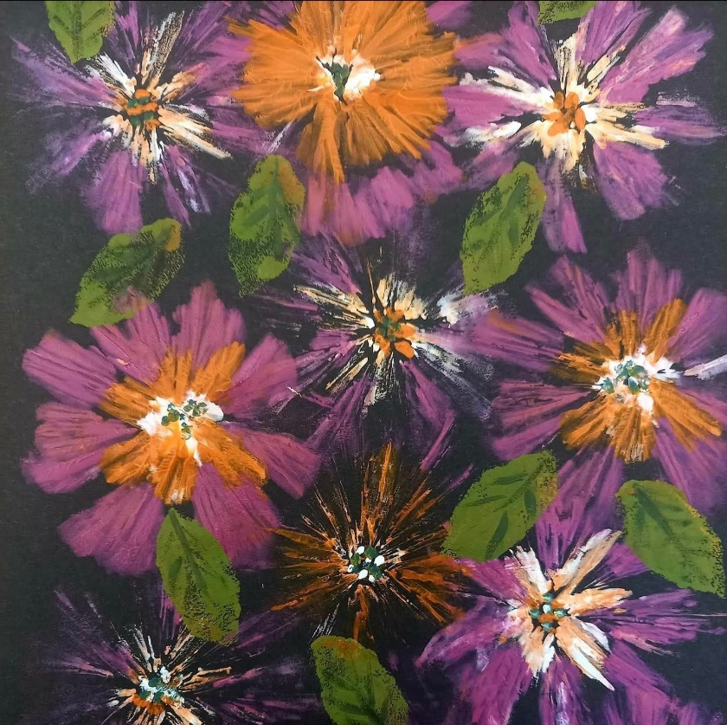

*“Plastic Bag Printing” Example*

**TUESDAY 5TH AUGUST**

*Morning –*

**(Busy Morning)**

**Social Day - 9.30am - 4pm - (Craft Room - Max. 20ppl)**

* A day for social interaction and a safe place to get on with any hobbies you may have e.g., Painting, drawing, writing, jigsaws, crosswords, knitting. Or just enjoy a nice little chin wag with a cuppa. ***You must still book a slot on any social day you wish to attend, to secure a seat.***

**Gardening - 10.30am - 12.30pm - Sandra (Volunteer) - (Meet in Craft Room)**

* You will help with a little weeding, potting plants, and bulbs, watering flowers and assisting with the maintenance of our flower beds, lawns, and hedges. Outdoor activities are proven to help with wellbeing and mental health, so come and potter about, breathe in the fresh air and absorb some of that all-important Vitamin D.

*Afternoon –*

**“Knit Happens” Introductory - 1.30pm - 3.30pm - Gail - (Volunteer) - (The Old School Café)**

* This simple knitting session is ideal for those who have minimal to no experience in knitting. Our lovely volunteer will gently guide you, showing you the basic of techniques. From here, if you feel confident enough, you can then join onto our following sessions each week to gain more knowledge and knitting skills as you go.

**WEDNESDAY 6TH AUGUST**

**Awareness to Pride: The Evolution of Autism Symbols from 1963 to Today***Morning -*

**Watercolour Heart Gift Bags - 10am - 12pm - Olwyn - (Craft Room - Max.14ppl)**

* A white bag with hearts and a label on it

  AI-generated content may be incorrect.A simple watercolour class which involves drawing 3 or more heart shapes with fineliners and painting them using colours that will coordinate with your choice of decorative strips of colour. Other embellishments can be added if you wish.

**Horticulture - 10am - 12pm - Joy (Volunteer) - (Meet in Craft Room)**

* You will assist in the general upkeep of our allotment, helping with digging, planting

fresh bulbs, weeding, and maintaining the grounds. You will help grow fresh produce

such as fruit, vegetables, and herbs as well as growing flowers, whilst learning new

skills as you go. Outdoor activities are proven to help with wellbeing and mental

health, so come and potter about, breath in the fresh air and absorb some of that all-important Vitamin D

*Afternoon -*

**Collage Card - 1.15pm - 3.30pm - Olwyn - (Craft Room - Max.14ppl)**

*-* ***“21 Bun Salute***” A fun card class, where we will cut out simple bunny shapes from patterned paper and draw simple shapes with fineliners. **This class is quite fiddly, so please be aware you will be cutting lots of very small shapes with scissors.**

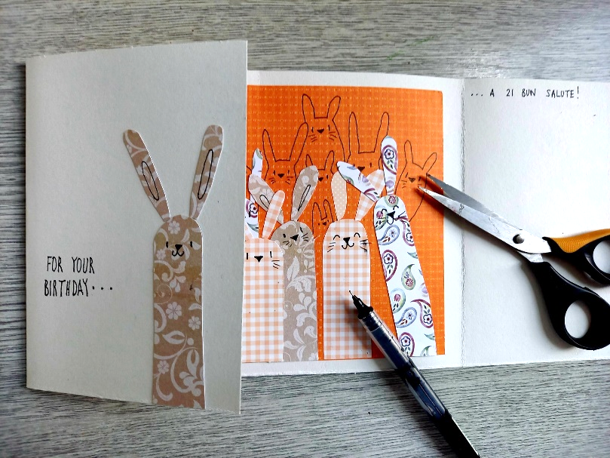

**THURSDAY 7TH AUGUST**

**(Busy Day)**

*Morning -*

**Social Day - 9.30am - 4pm - (Craft Room - Max. 20ppl)**

*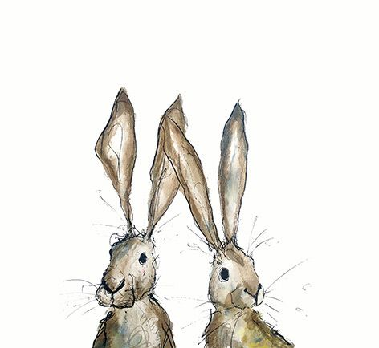***FRIDAY 8TH AUGUST**

**(Very busy day)**

*Morning -*

**Dry Brush Painting - 10am - 12pm - Olwyn - (Craft Room - Max. 14ppl)**

* ***“Dramatic Skies”*** In this class you will learn an effective painting technique where small amounts of paint are applied to a brush and gently brushed back and forth across paper, without applying any water.We will use acrylic paint to paint the landscapes with dramatic sunsets and swooping clouds. The foreground will be simple, allowing us to concentrate on capturing the glorious effect of the setting sun. Images will be provided for inspiration.

**Embroidery Skills (4 Weeks) - 10am - 12pm - Meg, Alison & Gail - (Room 2 - Max.7ppl)**

* This basic embroidery course teaches students how to hand stitch and embroider using a needle and thread. Sessions may include instruction on how to prepare fabric, transfer designs, practice different stitch patterns and use a hoop. This course is designed for all skill levels***. If you book onto this course, please pop the following 3 weeks in your diary.***

*Afternoon -*

**Hand Illustrated Watercolour Cards -****1.15pm - 3.30pm - Olwyn - (Room 2 - Max.8ppl)**

* Back with an old favourite, but this time we will be drawing the lovely illustrations ourselves, using step by step instructions. A touch of Fineliner and a splash of watercolour will then help bring your illustrations to life.

**Textiles (4 Weeks) - 1.15pm - 3.30pm - Meg, Alison & Gail - (Craft Room - Max.10ppl)**

* ***“Boro Cushions”*** Boro stitching is a Japanese mending technique where worn or damaged textiles are repaired by layering and stitching patches of fabric onto the garment or item. In this course you will be using hand stitching and a small amount of machine work to apply boro stitch to a handcrafted cushion.

**Walking Group - 1.30pm - 3pm - Nicola - (Meet in The Old School Café)**

* We will venture out into our wonderful City, exploring the ‘nooks & crannies’ of Durham. This is a nice relaxed paced walk, with only slight inclines and as few stairs as possible (but to be expected in “Hilly” Durham) The walks usually take around 90mins depending on the route and individuals’ mobility. The walks are weather permitted; you will be contacted by lunchtime if the walk has been cancelled due to adverse conditions. Bring water and wear appropriate clothing for the weather.

*Fridays Classes*

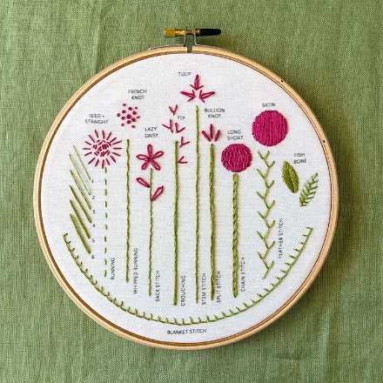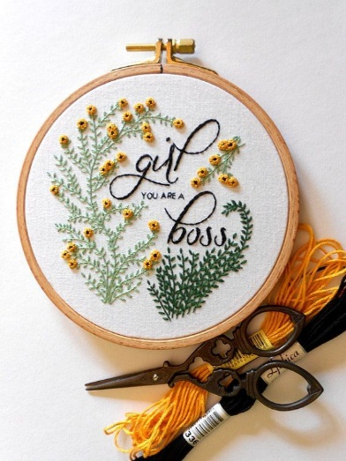*Morning -*

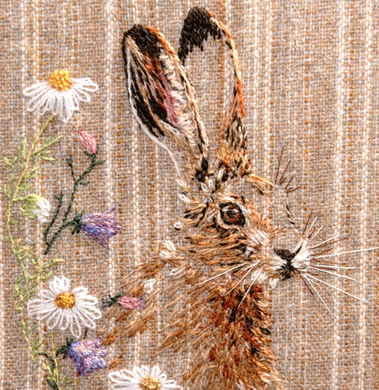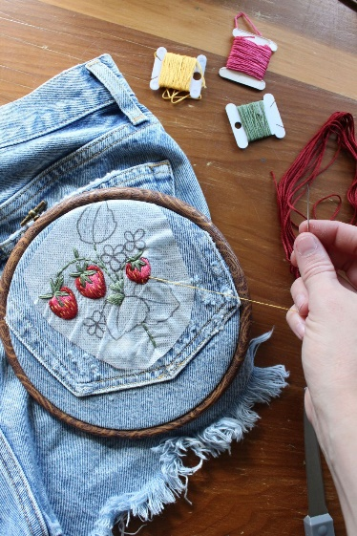

*“Dry Brush Painting” Example “Embroidery Skills” Example*

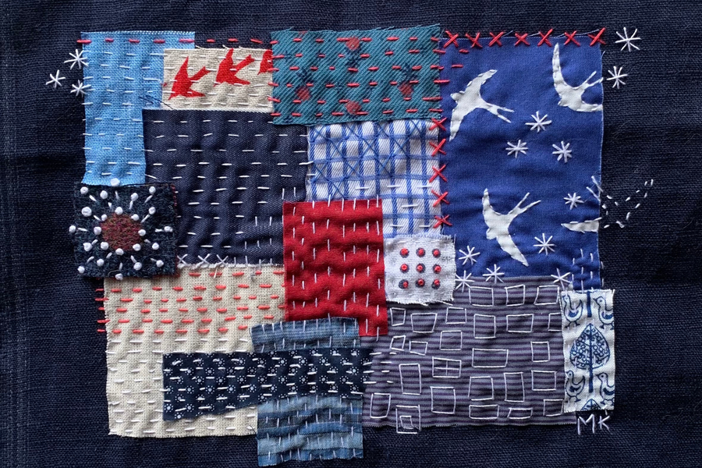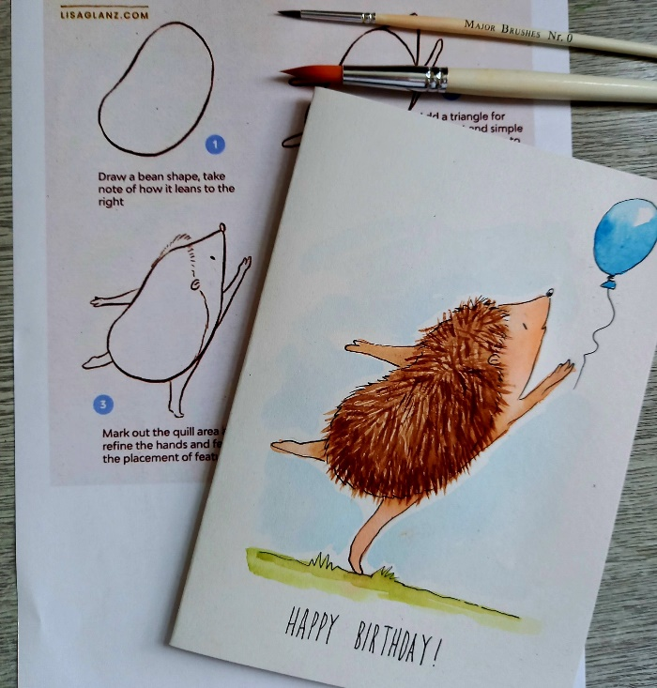Afternoon *-*

*“Watercolour Cards” Example “Boro Cushions ” Example*

**MONDAY 11TH AUGUST**

*****Afternoon -*

**Pastel Drawing - 1.15pm - 3.30pm - Olwyn - (Craft Room - Max.14ppl)**

* ***“Fireworks Over the Bay”*** Pastel drawing is always a popular class, promoting stress relief with its sensory nature and ease of use. In this class, we will combine two different techniques, soft, blended areas with stronger, more vibrant strokes. There will be an extensive collection of images to provide alternative inspiration if preferred.

**TUESDAY 12TH AUGUST**

*Morning -*

**Social Day - 9.30am - 4pm - (Craft Room - Max. 20ppl)**

**Gardening - 10.30am - 12.30pm - Sandra (Volunteer) - (Meet in Craft Room)**

*Afternoon -*

**“Knit Happens” Intermediate - 1.30pm - 3.30pm - Gail (Volunteer) - (The Old School Café)**

* Our Intermediate sessions are for experienced knitters or anyone that has completed one or more of our beginners’ sessions. Feel free to bring your own knitting projects or simply turn up without so much as a knitting needle, and our lovely volunteer will get you set away on a project. These sessions will be held every week in our Café situated on the ground floor of our Centre. ***You will still need to book onto these sessions as there is limited space.***

**WEDNESDAY** **13TH AUGUST**

**Awareness to Pride: The Evolution of Autism Symbols from 1963 to Today***Morning -*

**Plastic Bag Printing - 10am - 12pm - Olwyn - (Craft Room - Max.14ppl)**

**Horticulture Group - 10am - 12pm - Joy (Volunteer) - (Allotments)**

* You will assist in the general upkeep of our allotment, helping with digging, planting

fresh bulbs, weeding, and maintaining the grounds. You will help grow fresh produce

such as fruit, vegetables, and herbs as well as growing flowers, whilst learning new

skills as you go. Outdoor activities are proven to help with wellbeing and mental

health, so come and potter about, breath in the fresh air and absorb some of that all-important Vitamin. D

*Afternoon -*

**Dry Brush Painting “Dramatic Skies” - 1.15pm - 3.30pm - Olwyn - (Craft Room - Max.14ppl)**

**THURSDAY 14TH AUGUST**

**(Busy day)**

*Morning –*

**Social Day - 9.30am - 4pm - (Craft Room - Max.20ppl)**

**FRIDAY** **15TH AUGUST**

**(Very busy day)**

*Morning –*

**Collage Card - 10am - 12pm - Olwyn - (Craft Room - Max.14ppl)**

**Embroidery Skills - 10am - 12pm - Meg, Alison & Gail - (Continued - Week 2)**

*Afternoon –*

**NEW! I’ve Got Rhythm - 1.15pm - 3.30pm - Olwyn - (Room 2 - Max. 8ppl)**

* A brand-new upbeat and fun session where we will work together to create rhythm from household objects! As well as tapping out the rhythms, we will learn how to read rhythm too! We will learn the value of crochets and quavers, and how to apply it to our playing. This is a trial session, if this class goes well, we may start a regular group.

**Textiles “Boro Cushions” - 1.15pm - 3.30pm - Meg, Alison, Gail - (Continued - Week 2)**

**MONDAY 18TH AUGUST**

*Afternoon –*

**“What Does Your Medication Mean To You?” - 1pm - 3pm - Simran (Pharmacist)**

* The aim of this workshop is to build a positive connection between you and your medication and empower you in decision making around your care. This workshop will encourage reflection on experiences with medication and how this can be related to the CHIME model of recovery, Connectedness, Hope, Identity, Meaning and Empowerment, as well as tackling obstacles to taking medication and how to get the most out of consultations with healthcare professionals. **This session is being held at Waddington Street, you can either go straight there, or Andrea our support worker will meet you at our Centre and will go down with you and also sit in on the session.**

******Chatty Café Drop In - 1pm - 2pm - John (Volunteer) - (The Old School Café)**

**Hand Illustrated Watercolour Cards - 1.15pm - 3.30pm -** **Olwyn - (Craft Room - Max.14ppl)**

**TUESDAY 19TH AUGUST**

*Morning –*

**Social Day - 9.30am - 4pm - (Craft Room - Max.20ppl)**

**Gardening - 10.30am - 12.30pm - Sandra (Volunteer) - (Meet in Craft Room)**

*Afternoon –*

**“Knit Happens” Intermediate - 1.30pm - 3.30pm - Gail (Volunteer) - (The Old School Cafe)**

**WEDNESDAY 20TH AUGUST**

**Awareness to Pride: The Evolution of Autism Symbols from 1963 to Today***Morning –*

**Pastel Drawing “Fireworks Over the Bay” - 10am - 12pm - Olwyn - (Craft Room-Max.14ppl)**

**Horticulture Group - 10am - 12pm - Joy (Volunteer) - (Meet in Craft Room)**

*Afternoon –*

**Watercolour Heart Gift Bags - 1.15pm - 3.30pm - Olwyn - (Craft Room - Max. 14ppl)**

**THURSDAY 21ST AUGUST**

**(Busy day)**

*Morning –*

**Social Day - 9.30am - 4pm - (Craft Room - Max. 20ppl)**

**Voices Shared - 11.30am - 12.30pm - Erica (Trustee) - (Room 2 - Max. 8ppl)**

* These sessions have been created to allow attendees voices to be heard. They are in place for you to provide your feedback and any suggestions you may have with regards to the centre. Erica, who is one of the centres trustees, will be available to listen and take note of any ideas that are shared, these are then passed onto Lisa our Centre Manager. ***You must still book these sessions as there is limited capacity.***

**FRIDAY 22ND AUGUST**

*Morning -*

**Plastic Bag Printing - 10am - 12pm - Olwyn - (Craft Room - Max. 14ppl)**

**Embroidery Skills - 10am - 12pm - Meg, Alison & Gail - (Continued - Week 3)**

*Afternoon -*

**Pictionary - 1.15pm - 3.30pm - Olwyn - (Room 2 - Max. 8ppl)**

* Pictionary is a fun game where teams compete to guess words or phrases based on drawings. One player from a team acts as the “artist” drawing clues on paper while their teammates try to guess the word within a time limit. The team that correctly guesses the most words wins.

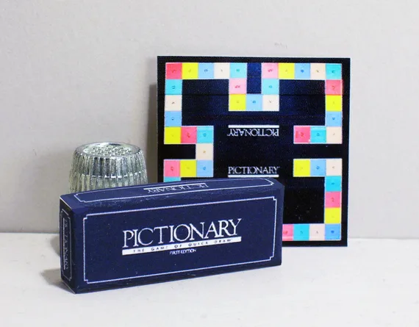

**Textiles “Boro Cushions” - 1.15pm - 3.30pm - Meg, Alison, Gail - (Continued - Week 3)**

**MONDAY 25TH AUGUST**

**CENTRE CLOSED - *SUMMER BANK HOLIDAY***

**TUESDAY 26TH AUGUST**

*Morning –*

**Social Day - 9.30am - 4pm - (Craft Room - Max.20ppl)**

**Gardening - 10.30am - 12.30pm - Sandra (Volunteer) - (Meet in Craft Room)**

*Afternoon –*

**“Knit Happens” Intermediate - 1.30pm - 3.30pm - Gail (Volunteer) - (The Old School Cafe)**

**WEDNESDAY 27TH AUGUST**

*Morning –*

**Dry Brush Painting “Dramatic Skies”- 10am - 12pm - (Craft Room - Max.14ppl)**

**Horticulture Group - 10am - 12pm - Joy (Volunteer) - (Meet in Craft Room)**

*Afternoon –*

**Hand Illustrated Watercolour Cards - 1.15pm - 3.30pm - Olwyn - (Craft Room - Max.14ppl)**

**THURSDAY 28TH AUGUST**

**SUMMER PARTY! - 10am - 2pm - (Outside Area & Craft Room)**

* **Join us for our annual summer party! There will be games, music, food and a Tombola. This is for referred Attendees and Volunteers of St. Margaret’s Centre only. Please inform us when booking, if you would like to attend. If we have wet weather on the day, we will have to cancel outside activities and continue the party indoors.**

**FRIDAY 29TH AUGUST**

*Morning –*

**Collage Card - 10am - 12pm - (Craft Room - Max. 14ppl)**

**Embroidery Skills - 10am - 12pm - Meg, Alison, Gail - (Final Session)**

*Afternoon –*

**Watercolour Heart Gift Bags - 1.15pm - 3.30pm - Olwyn - (Room 2 - Max. 8ppl)**

**Textiles “Boro Cushions” - 1.15pm - 3.30pm - Meg, Alison, Gail - (Final Session)**

**Walking Group - 1.30pm - 3pm - Nicola - (Meet in The Old School Café)**