Please read carefully.
Hello,
We hope this letter finds you well.
Enclosed you will find the latest timetable of activities for September 2025. We will be taking bookings for these activities via phone call or email from 10am on Tuesday 26th August Please do not phone us to try booking before this date and time. You will find our contact number and email address on the front page of your timetable.
After a review to our safety and security measures, we ask that our attendees and volunteers do not enter the building any earlier than 15 minutes before your session starts. All class start and finish times are stated on your timetable. Our Centre door will now be locked until 9.15am. We also ask that if you are not booked onto anything, please do not wander upstairs or into the workshop and disturb staff/classes. You are welcome to come in and purchase food or use a token in our Café. Thank you for your understanding.
Due to the volume of new referrals coming through. You will only be able to book onto one Social Day (Tuesday or Thursday) and two of Olwyn’s classes per week. This is so we can give new attendees a fair chance of booking onto sessions. (Not including volunteer led classes).
We please ask that you pay a £1 attendance fee per session. Your attendance fee goes back into the Centre and helps towards cost of materials and use of our tea and coffee facilities situated in our craft room. Your contribution is much appreciated.
Please turn up to your class on time, unless you have called to say you are running late. Please do not eat food or leave to go for a cigarette during classes, this can be very disruptive for other attendees and the instructor. You are all given a 15-minute break halfway through your classes to eat, make a beverage and smoke.

If you are booked onto any class and cannot make it for whatever reason you must call the centre to inform us of this as early as possible, so that we can offer the space to somebody else. You still need to book to attend Social Days as well as regular classes, to guarantee you have a seat.
Classes with this symbol - are dedicated, quieter sessions. Anybody can join them, but they are designed to be inclusive of neurodivergent individuals who may struggle to access our standard sessions. (Up to a Maximum of 20ppl in our Craft Room and 8ppl in Room 2)
We look forward to seeing you.

To Book Classes Call: 0191 384 8100 or Email: enquiries@stmargaretscentre.co.uk
(There is an attendance fee of £1 per session)
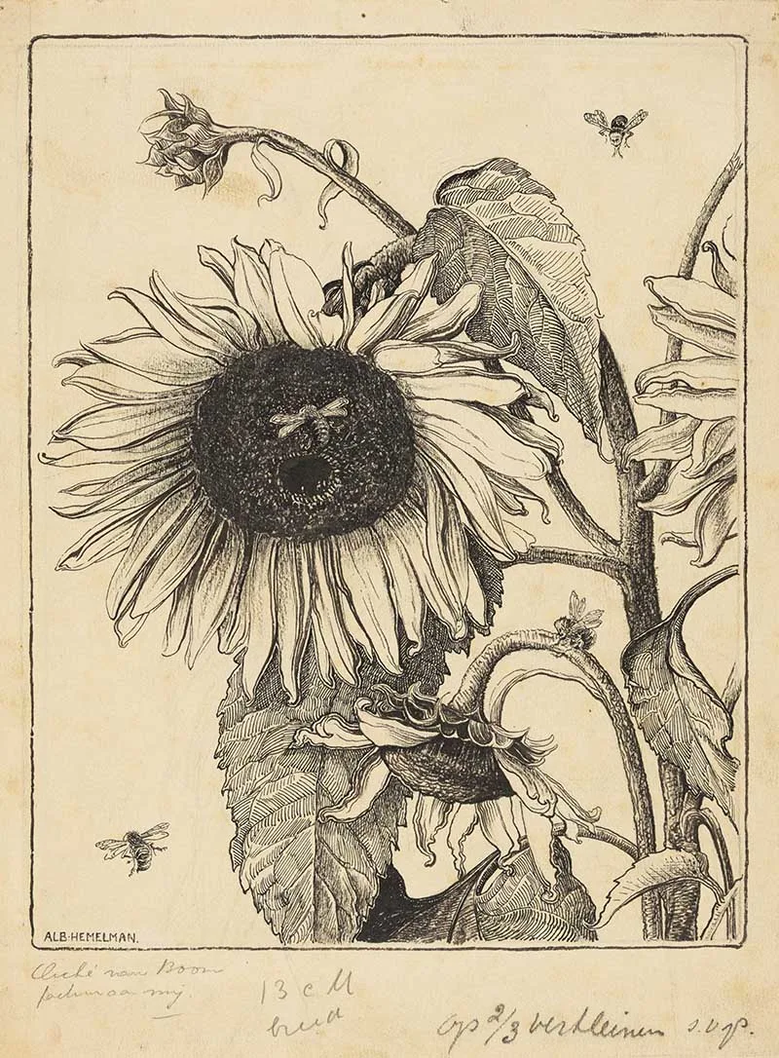

MONDAY 1ST SEPTEMBER
Afternoon –
Chatty Café Drop In - 1pm - 2pm - John (Volunteer) - (The Old School Café)
- Are you feeling isolated and in need of a little chat and some friendly company? Then we welcome you to pop into The Old School Café, where one of our lovely volunteers will be there waiting. This is not a counselling session, but a safe space where you can have a lovely chat or play some board games. Hopefully you will leave feeling a little brighter.
Miniature Positivity Cards - 1.15pm - 3.30pm - Olwyn - (Craft Room - Max. 14ppl)
- There can be something quite satisfying about painting on a small area of card, with a little watercolour, Fineliner and a few meaningful words. These little art cards are lovely to pop in an envelope for someone who needs a bit of positivity, or alternatively, you can challenge yourself to paint one a day and keep them in a special box for yourself.

Mondays Class
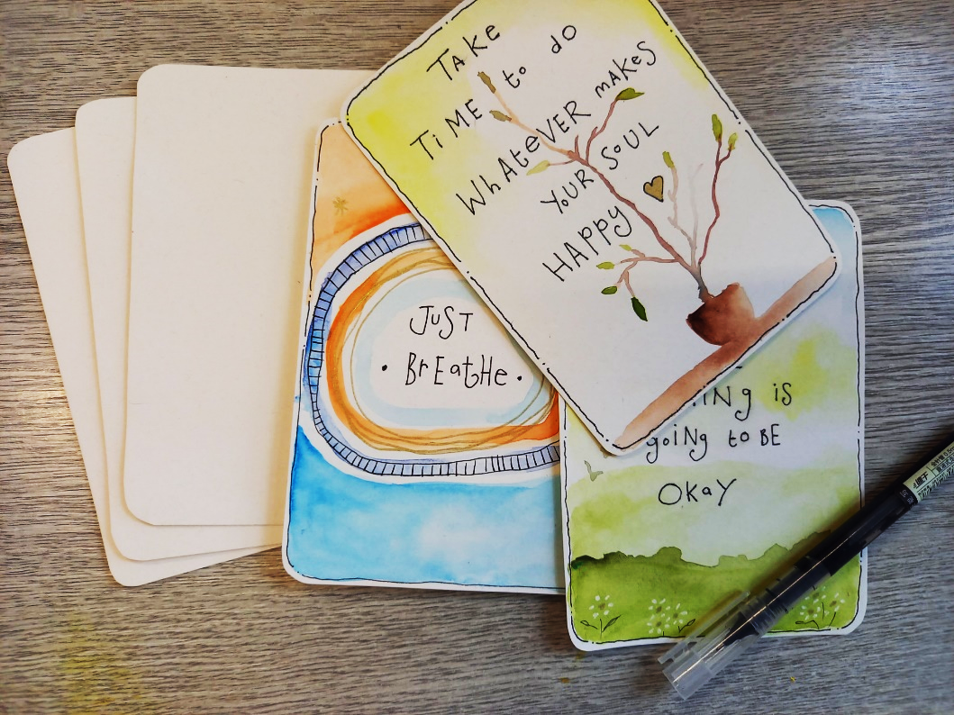

“Miniature Positivity Cards” Example
TUESDAY 2ND SEPTEMBER
Morning -
(Busy Morning)
Social Day - 9.30am - 4pm - (Craft Room - Max. 20ppl)
- A day for social interaction and a safe place to get on with any hobbies you may have e.g., Painting, drawing, writing, jigsaws, crosswords, knitting. Or just enjoy a nice little chin wag with a cuppa. You must still book a slot on any social day you wish to attend, to secure a seat.
Gardening - 10.30am - 12.30pm - Sandra (Volunteer) - (Meet in Craft Room)
- You will help with a little weeding, potting plants, and bulbs, watering flowers and assisting with the maintenance of our flower beds, lawns, and hedges. Outdoor activities are proven to help with wellbeing and mental health, so come and potter about, breathe in the fresh air and absorb some of that all-important Vitamin D.
Afternoon -
“Knit Happens” Introductory - 1.30pm - 3.30pm - Gail - (Volunteer) - (The Old School Café)
- This simple knitting session is ideal for those who have minimal to no experience in knitting. Our lovely volunteer will gently guide you, showing you the basic of techniques. From here, if you feel confident enough, you can then join onto our following sessions each week to gain more knowledge and knitting skills as you go.

WEDNESDAY 3RD SEPTEMBER

Morning -
“Box Clever” Recycled Card Making - 10am - 12pm - Olwyn - (Craft Room - Max.14ppl)
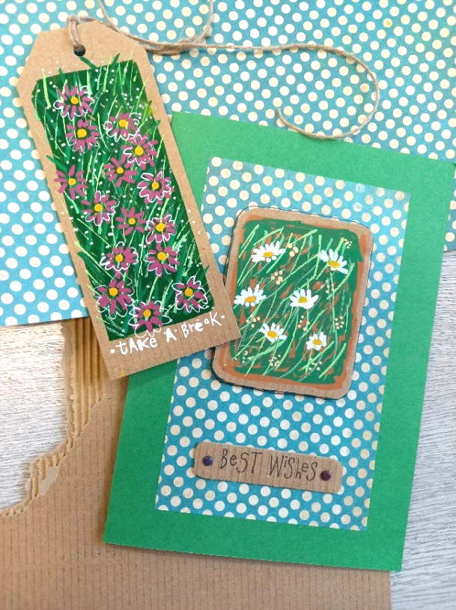
- Make beautiful cards from old cardboard boxes! We will use Posca Paint pens to build up layers of grass and flowers on a small rectangle of brown card. This mini artwork will be the focal point of greetings card. This mini artwork will be the focal point of greetings card or gift tag.

Horticulture - 10am - 12pm - Joy (Volunteer) - (Meet in Craft Room)
- You will assist in the general upkeep of our allotment, helping with digging, planting fresh bulbs, weeding, and maintaining the grounds. You will help grow fresh produce such as fruit, vegetables, and herbs as well as growing flowers, whilst learning new
skills as you go. Outdoor activities are proven to help with wellbeing and mental health, so come and potter about, breath in the fresh air and absorb some of that all-important Vitamin D
Afternoon -
Desert Island Discs - 1.15pm - 3.30pm - Olwyn - (Craft Room - Max. 14ppl)
- “Upbeat & Chill out” In this extremely popular and uplifting group session, you will have the opportunity to request and listen to songs that that you enjoy or may have meaning to you. This session is a class of two halves - The first half will be upbeat sounds with a happy, uplifting vibe. The second half will be more laid-back tunes to help us all wind down and chill out.

THURSDAY 4TH SEPTEMBER
(Busy Day)
Morning -

Social Day - 9.30am - 4pm - (Craft Room - Max. 20ppl)
Introduction To Woodwork (3 Weeks) - 10am - 3pm - Tony (Workshop - Max 5ppl)
- You will learn how to make and assemble a small planter in the shape of a garden bench. You will get the opportunity to personalise this with either your name or a pattern. Most of the materials will be prepared for you, but you will be shown how to finish and assemble. You will be working from a drawing and a set of measurements, don’t worry if you have not worked with measurements for a while, you will be taught this along with the correct use of tools and materials. If you wish to take this home, there will be a £5 charge, or it will be donated to The Old School Woodcrafts. Please check your diaries to make sure you can attend all 3 sessions before booking this course, 3 sessions allow enough time to fully complete your project.
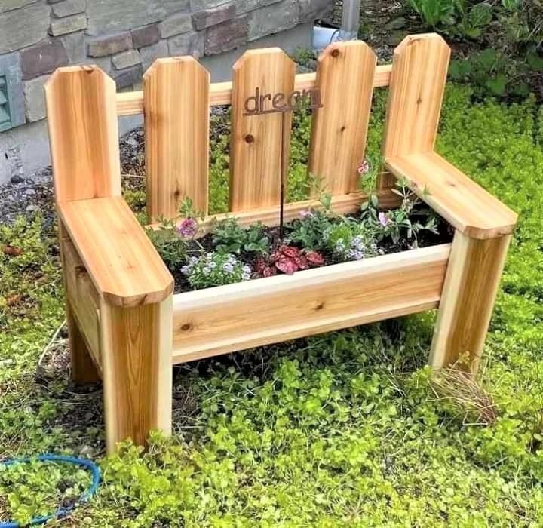

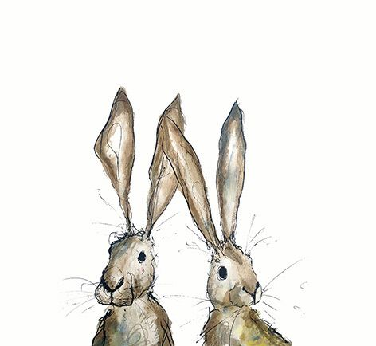
FRIDAY 5TH SEPTEMBER
(Very busy day)
Morning -
Crosswords & Cuppas - 10am - 12pm - Group Led Session - (Craft Room - Max. 14ppl)
- Come and join us for a laid-back social activity and a cuppa, you can either do a crossword as a group exercise or go solo.
Embroidery Skills (5 Weeks) - 10am - 12pm - Meg, Alison & Gail - (Room 2 - Max.7ppl)
- This basic embroidery course teaches students how to hand stitch and embroider using a needle and thread. Sessions may include instruction on how to prepare fabric, transfer designs, practice different stitch patterns and use a hoop. This course is designed for all skill levels. If you book onto this course, please pop the following 4 weeks in your diary.
Afternoon –
Watercolour Illustrations - 1.15pm - 3.30pm - No Tutor - (Room 2 - Max.8ppl)
- In this laid-back session, you will have a selection of pre-printed, simple line illustrations to choose from, which you will bring to life with a pop of watercolour. Note that this is a relaxed and social, self-led session. There will be no tutor delivering the class, so a little watercolour painting experience would be beneficial.
Textiles (5 Weeks) - 1.15pm - 3.30pm - Meg, Alison & Gail - (Craft Room - Max.10ppl)
- “Applique Tote Bags” In this course we will be making applique tote bags. You will use hand stitching and embroidery and will have a variety of applique designs to use from, which you will hand sew into your premade tote bag. If you finish this project in good time, there will be an option to also design a zip pouch. Some hand sewing experience would be beneficial. There will be a £1 charge for the tote bag and a 50p charge for the zip pouch.

Fridays Classes
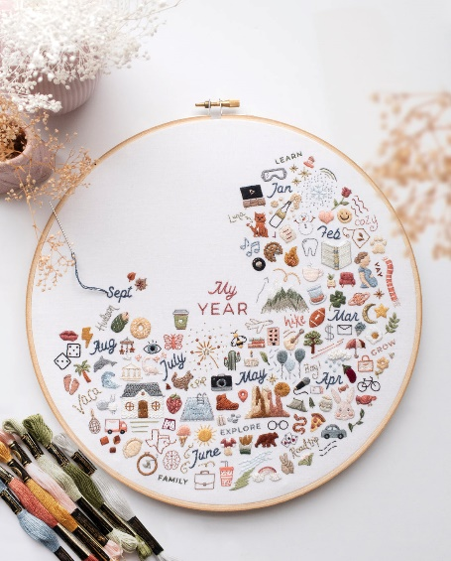
Morning -
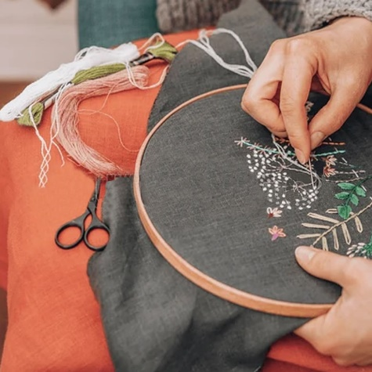
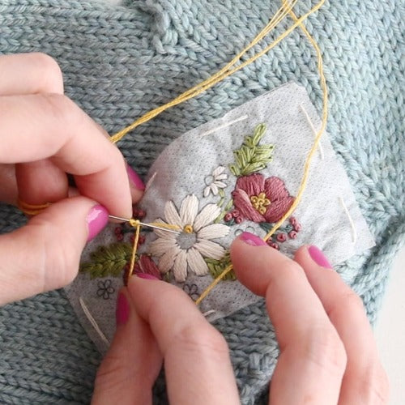

“Embroidery Skills” Example

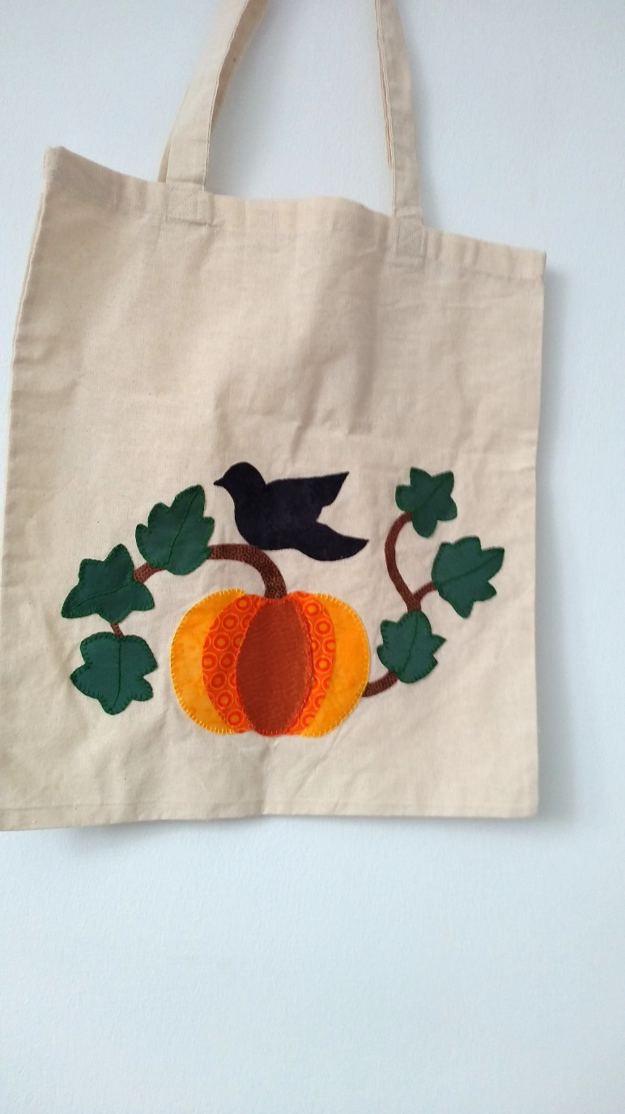
Afternoon -

“Applique Tote Bag ” Example
MONDAY 8TH SEPTEMBER
Afternoon -

Chatty Café Drop In - 1pm - 2pm - John (Volunteer) - (The Old School Café)
Watercolour Illustrations - 1.15pm - 3.30pm – No Tutor - (Craft Room - Max.14ppl)
- In this laid-back session, you will have a selection of pre-printed, simple line illustrations to choose from, which you will bring to life with a pop of watercolour. Note that this is a relaxed and social, self-led session. There will be no tutor delivering the class, so a little watercolour painting experience would be beneficial.
TUESDAY 9TH SEPTEMBER
Morning -
Social Day - 9.30am - 4pm - (Craft Room - Max. 20ppl)
“Let’s Paint” Exploring Acrylics - 10am - 12pm - Sue (Local Artist) - (Room 2 - Max.7ppl)
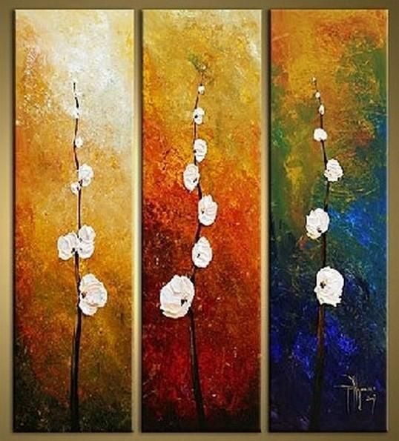
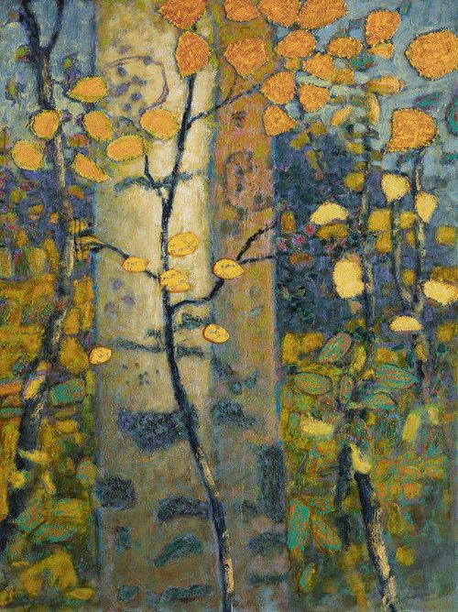
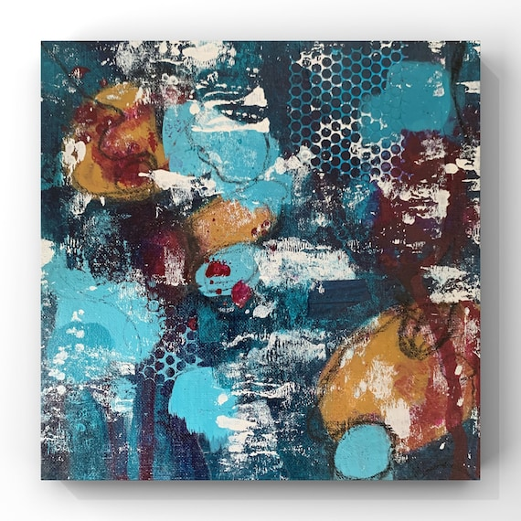
- Unlock your creativity by expressing your own unique voice in acrylic Paint, just because we can! Painting gives us an opportunity for freedom and growth. Give painting a try and see what discoveries of your own you can make on paper or canvas through guided sessions, in a safe, fun creative space with others. In this taster session we will explore colour pairs together using two colours painting a single subject of your choice. There will be objects and pictures to help with your choices .

Abstract examples
Gardening - 10.30am - 12.30pm - Sandra (Volunteer) - (Meet in Craft Room)
Afternoon -
“Knit Happens” Intermediate - 1.30pm - 3.30pm - Gail (Volunteer) - (The Old School Café)
- Our Intermediate sessions are for experienced knitters or anyone that has completed one or more of our beginners’ sessions. Feel free to bring your own knitting projects or simply turn up without so much as a knitting needle, and our lovely volunteer will get you set away on a project. These sessions will be held every week in our Café situated on the ground floor of our Centre. You will still need to book onto these sessions as there is limited space.

WEDNESDAY 10TH SEPTEMBER
Morning –
Social Day - 9.30am - 4pm - (Craft Room - Max.20ppl)
Horticulture Group - 10am - 12pm - Joy (Volunteer) - (Allotments)

THURSDAY 11TH SEPTEMBER
(Busy day)
Morning -
Social Day - 9.30am - 4pm - (Craft Room - Max.20ppl)
Introduction To Woodwork - 10am - 3pm - Tony - (Continued - Week 2)

FRIDAY 12TH SEPTEMBER
(Very busy day)
Morning -
Watercolour Illustrations - 10am - 12pm - No Tutor - (Craft Room - Max.12ppl)
- In this laid-back session, you will have a selection of pre-printed, simple line illustrations to choose from, which you will bring to life with a pop of watercolour. Note that this is a relaxed and social, self-led session. There will be no tutor delivering the class, so a little watercolour painting experience would be beneficial.
Embroidery Skills - 10am - 12pm - Meg, Alison & Gail - (Continued - Week 2)
Afternoon -
Textiles “Applique Tote Bag” - 1.15pm - 3.30pm - Meg, Alison, Gail - (Continued - Week 2)
Crosswords & Cuppas - 1.15pm - 3.30pm - Group Led Session - (Room 2 - Max.8ppl)
Walking Group - 1.30pm - 3pm - Nicola - (Meet in The Old School Café)
- We will venture out into our wonderful City, exploring the ‘nooks & crannies’ of Durham. This is a nice relaxed paced walk, with only slight inclines and as few stairs as possible (but to be expected in “Hilly” Durham) The walks usually take around 90mins depending on the route and individuals’ mobility. The walks are weather permitted; you will be contacted by lunchtime if the walk has been cancelled due to adverse conditions. Bring water and wear appropriate clothing for the weather

MONDAY 15TH SEPTEMBER
Morning -
Introduction To Line Dancing (12 Weeks) - 11am - 12pm - Penny - (Craft Room - Max.8ppl)
- In this energetic and uplifting Dance course, you will learn the basics of Line Dancing. Line Dancing is a form of choreographed dance where individuals dance in one or more lines, performing the same steps simultaneously. It's a social activity, often done to country music, where dancers don't need a partner and can join in easily.
Afternoon -
Chatty Café Drop In - 1pm - 2pm - John (Volunteer) - (The Old School Café)
Fold It, Print It - 1.15pm - 3.30pm - Olwyn - (Craft Room - Max.14ppl)

- If you have ever had trouble painting fine, delicate lines with a paintbrush, in this session you will practice the ideal solution. Folding and dipping the edges of cardboard into paints can give you beautiful fine lines, with an organic effect. In this class, we will be using different lengths of card and acrylic paints to print an image of delicate dandelions.

TUESDAY 16TH SEPTEMBER
Morning -
Social Day - 9.30am - 4pm - (Craft Room - Max.20ppl)
Gardening - 10.30am - 12.30pm - Sandra (Volunteer) - (Meet in Craft Room)
Afternoon -
“Knit Happens” Intermediate - 1.30pm - 3.30pm - Gail (Volunteer) - (The Old School Cafe)
WEDNESDAY 17TH SEPTEMBER
Morning -
Metallic Watercolours “Dragonflies” - 10am - 12pm - Olwyn - (Craft Room - Max.14ppl)
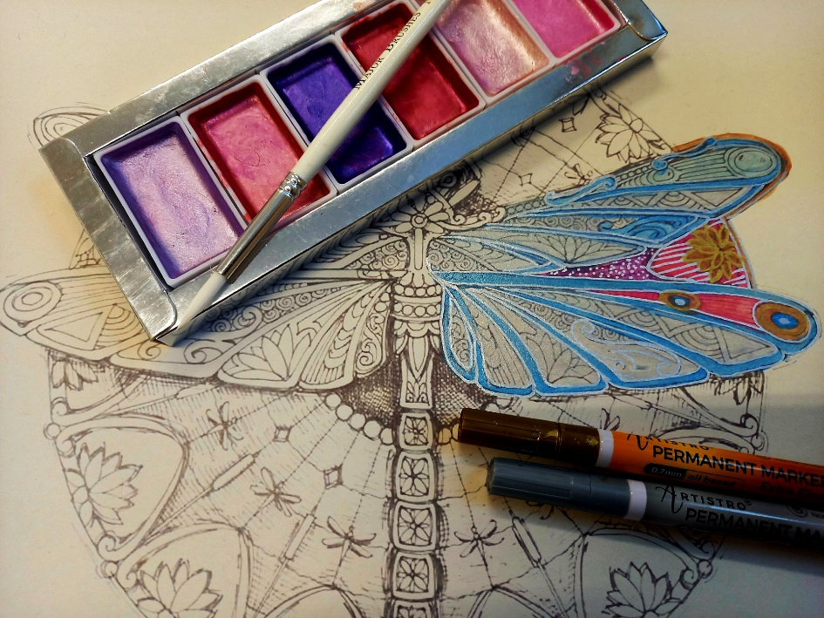
- A relaxing class using pastel-coloured watercolours and metallics to paint an intricate pre-printed image of a dragonfly.

Horticulture Group - 10am - 12pm - Joy (Volunteer) - (Meet in Craft Room)
Afternoon –
Tin of Sardines (3 Weeks) - 1.15pm - 3.30pm - Olwyn - (Craft Room - Max.14ppl)

- In this 3-week course we will create a lovely little decorative sardine tin, made from MDF, card and patterned paper. The card will be rolled back to reveal 3 handmade clay fish, which you will create in week 2. We will also create a small clay trinket dish, decorated with fish. All detailing and decoration will be completed in week 3.

THURSDAY 18TH SEPTEMBER
(Busy day)
Morning -
Social Day - 9.30am - 4pm - (Craft Room - Max. 20ppl)
Introduction To Woodwork - 10am - 3pm - Tony (Continued - Final Session)

FRIDAY 19TH SEPTEMBER
Morning -
Optical Illusions - 10am - 12pm - Olwyn - (Craft Room - Max. 14ppl)
- An interesting illusion which requires some delicate pencil shading to make it work, a bit of cutting out, and a phone camera at the end, to complete the illusion!
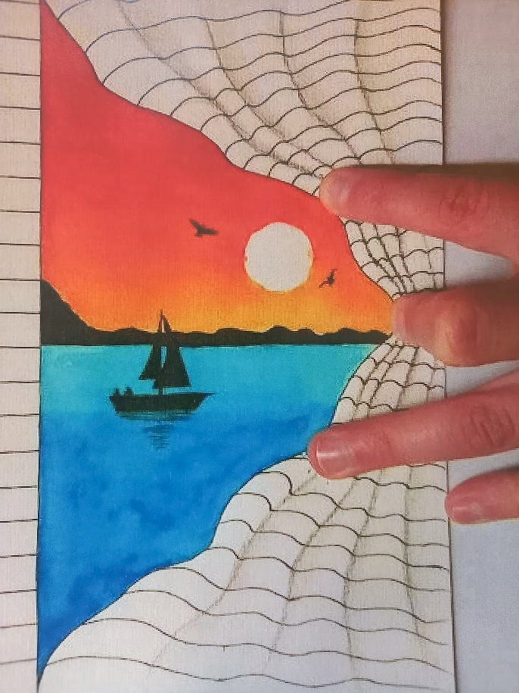

Embroidery Skills - 10am - 12pm - Meg, Alison & Gail - (Continued - Week 3)
Afternoon -
Miniature Positivity Cards - 1.15pm - 3.30pm - Olwyn - (Room 2 - Max. 8ppl)
Textiles “Applique Tote Bag” - 1.15pm - 3.30pm - Meg, Alison, Gail - (Continued - Week 3)

MONDAY 22ND SEPTEMBER
Morning -
Introduction To Line Dancing - 11am - 12pm - Penny - (Continued - Week 2)
Afternoon -
Chatty Café Drop In - 1pm - 2pm - John (Volunteer) - (The Old School Café)
“Box Clever” Recycled Cardmaking - 1.15pm - 3.30pm - Olwyn - (Craft Room - Max.14ppl)

TUESDAY 23RD SEPTEMBER
Morning -
Social Day - 9.30am - 4pm - (Craft Room - Max.20ppl)
Gardening - 10.30am - 12.30pm - Sandra (Volunteer) - (Meet in Craft Room)
Afternoon -
“Knit Happens” Intermediate - 1.30pm - 3.30pm - Gail (Volunteer) - (The Old School Cafe)
WEDNESDAY 24TH SEPTEMBER
Morning -
Optical Illusions - 10am - 12pm - (Craft Room - Max.14ppl)
Horticulture Group - 10am - 12pm - Joy (Volunteer) - (Meet in Craft Room)
Afternoon -
Tin of Sardines - 1.15pm - 3.30pm - Olwyn - (Continued - Week 2)

THURSDAY 25TH SEPTEMBER
(Busy day)
Morning -
Social Day - 9.30am - 4pm - (Craft Room - Max. 20ppl)

FRIDAY 26TH SEPTEMBER
Morning –
“Fold it, Print it” - 10am - 12pm - (Craft Room - Max. 14ppl)
Embroidery Skills - 10am - 12pm - Meg, Alison, Gail - (Continued - Week 4)
Afternoon –
Metallic Watercolours “Dragonflies” - 1.15pm - 3.30pm - Olwyn - (Room 2 - Max. 8ppl)
Textiles “Applique Tote Bag” - 1.15pm - 3.30pm - Meg, Alison, Gail - (Continued - Week 4)

MONDAY 29TH SEPTEMBER
Morning –
Introduction To Line Dancing - 11am - 12pm - Penny - (Continued - Week 3)
Afternoon -
Chatty Café Drop In - 1pm - 2pm - John (Volunteer) - (The Old School Café)
Metallic Watercolours “Dragonflies” - 1.15pm - 3.30pm - Olwyn - (Craft Room - Max.14ppl)

TUESDAY 30TH SEPTEMBER
Morning -
Social Day - 9.30am - 4pm - (Craft Room - Max.20ppl)
Gardening - 10.30am - 12.30pm - Sandra (Volunteer) - (Meet in Craft Room)
Afternoon -
“Knit Happens” Intermediate - 1.30pm - 3.30pm - Gail (Volunteer) - (The Old School Cafe)
WEDNESDAY 1ST OCTOBER
Morning -
“Fold It, Print it” - 10am - 12pm - (Craft Room - Max.14ppl)
Horticulture Group - 10am - 12pm - Joy (Volunteer) - (Meet in Craft Room)
Afternoon -
Tin of Sardines - 1.15pm - 3.30pm - Olwyn - (Continued - Final Session)

THURSDAY 2ND OCTOBER
(Busy day)
Morning -
Social Day - 9.30am - 4pm - (Craft Room - Max. 20ppl)

FRIDAY 3RD OCTOBER
Morning -
Miniature Positivity Cards - 10am - 12pm - (Craft Room - Max. 14ppl)
Embroidery Skills - 10am - 12pm - Meg, Alison, Gail - (Final Session)
Afternoon -
“Box Clever” Recycled Cardboard - 1.15pm - 3.30pm - Olwyn - (Room 2 - Max. 8ppl)
Textiles “Applique Tote Bag” - 1.15pm - 3.30pm - Meg, Alison, Gail - (Final Session)
Walking Group - 1.30pm - 3pm - Nicola - (Meet in The Old School Café)

