Please read carefully.
Hello,
We hope this letter finds you well.
Enclosed you will find the latest timetable of activities for October 2025. We will be taking bookings for these activities via phone call or email from 10am on Monday 29th September Please do not phone us to try booking before this date and time. You will find our contact number and email address on the front page of your timetable.
After a review to our safety and security measures, we ask that our attendees and volunteers do not enter the building any earlier than 15 minutes before your session starts. All class start and finish times are stated on your timetable. Our Centre door will now be locked until 9.15am. We also ask that if you are not booked onto anything, please do not wander upstairs or into the workshop and disturb staff/classes. You are welcome to come in and purchase food or use a token in our Café. Thank you for your understanding.
Due to the volume of new referrals coming through. You will only be able to book onto one Social Day (Tuesday or Thursday) and two of Olwyn’s classes per week. This is so we can give new attendees a fair chance of booking onto sessions. (Not including volunteer led classes).
We please ask that you pay a £1 attendance fee per session. Your attendance fee goes back into the Centre and helps towards cost of materials and use of our tea and coffee facilities situated in our craft room. Your contribution is much appreciated.
Please turn up to your class on time, unless you have called to say you are running late. Please do not eat food or leave to go for a cigarette during classes, this can be very disruptive for other attendees and the instructor. You are all given a 15-minute break halfway through your classes to eat, make a beverage and smoke.
If you are booked onto any class and cannot make it for whatever reason you must call the centre to inform us of this as early as possible, so that we can offer the space to somebody else. You still need to book to attend Social Days as well as regular classes, to guarantee you have a seat.

Classes with this symbol - are dedicated, quieter sessions. Anybody can join them, but they are designed to be inclusive of neurodivergent individuals who may struggle to access our standard sessions. (Up to a Maximum of 20ppl in our Craft Room and 8ppl in Room 2)

We look forward to seeing you.

To Book Classes Call: 0191 384 8100 or Email: enquiries@stmargaretscentre.co.uk
(There is an attendance fee of £1 per session)


MONDAY 6TH OCTOBER
Morning -
Introduction to Line Dancing - 11am - 12pm - Penny - (Continued - Week 4)
Afternoon -
Chatty Café Drop In - 1pm - 2pm - John (Volunteer) - (The Old School Café)
- Are you feeling isolated and in need of a little chat and some friendly company? Then we welcome you to pop into The Old School Café, where one of our lovely volunteers will be there waiting. This is not a counselling session, but a safe space where you can have a lovely chat or play some board games. Hopefully you will leave feeling a little brighter.
“Cute” Toadstool Tutorial - 1.15pm - 3.30pm - Olwyn - (Craft Room - Max. 14ppl)
- Learn how to draw cute toadstools using a step-by-step technique. You'll be amazed at what you can draw when you follow simple instructions! Your cute illustrations can be turned into fun greetings cards if you wish.

Mondays Class

“Cute - Toadstool Tutorial ” Example
TUESDAY 7TH OCTOBER
Morning -
(Busy Morning)
Social Day - 9.30am - 4pm - (Craft Room - Max. 20ppl)
- A day for social interaction and a safe place to get on with any hobbies you may have e.g., Painting, drawing, writing, jigsaws, crosswords, knitting. Or just enjoy a nice little chin wag with a cuppa. You must still book a slot on any social day you wish to attend, to secure a seat.

Exploring Acrylics (4 Weeks) - 10am - 12pm - Sue (Local Artist) - (Room 2 - Max.7ppl)
- This is a follow-on course from September’s taster session, however if there are any spaces available, you may still have a chance to book onto this course. We will look in more detail at basic techniques, tools and keep exploring together with an acrylic
project for each week, on canvas board or paper.
Gardening - 10.30am - 12.30pm - Sandra (Volunteer) - (Meet in Craft Room)
- You will help with a little weeding, potting plants, and bulbs, watering flowers and assisting with the maintenance of our flower beds, lawns, and hedges. Outdoor activities are proven to help with wellbeing and mental health, so come and potter about, breathe in the fresh air and absorb some of that all-important Vitamin D.
Afternoon -
“Knit Happens” Introductory - 1.30pm - 3.30pm - Gail - (Volunteer) - (The Old School Café)
- This simple knitting session is ideal for those who have minimal to no experience in knitting. Our lovely volunteer will gently guide you, showing you the basic of techniques. From here, if you feel confident enough, you can then join onto our following sessions each week to gain more knowledge and knitting skills as you go.

WEDNESDAY 8TH OCTOBER
Morning -

Social Day - 9.30am - 4pm - (Craft Room - Max.20ppl)

Horticulture - 10am - 12pm - Joy (Volunteer) - (Meet in Craft Room)
- You will assist in the general upkeep of our allotment, helping with digging, planting fresh bulbs, weeding, and maintaining the grounds. You will help grow fresh produce such as fruit, vegetables, and herbs as well as growing flowers, whilst learning new
skills as you go. Outdoor activities are proven to help with wellbeing and mental health, so come and potter about, breath in the fresh air and absorb some of that all-important Vitamin D.

THURSDAY 9TH OCTOBER
(Busy Day)
Morning -
Social Day - 9.30am - 4pm - (Craft Room - Max. 20ppl)
Introduction To Woodwork (3 Weeks) - 10am - 3pm - Tony (Workshop - Max 5ppl)
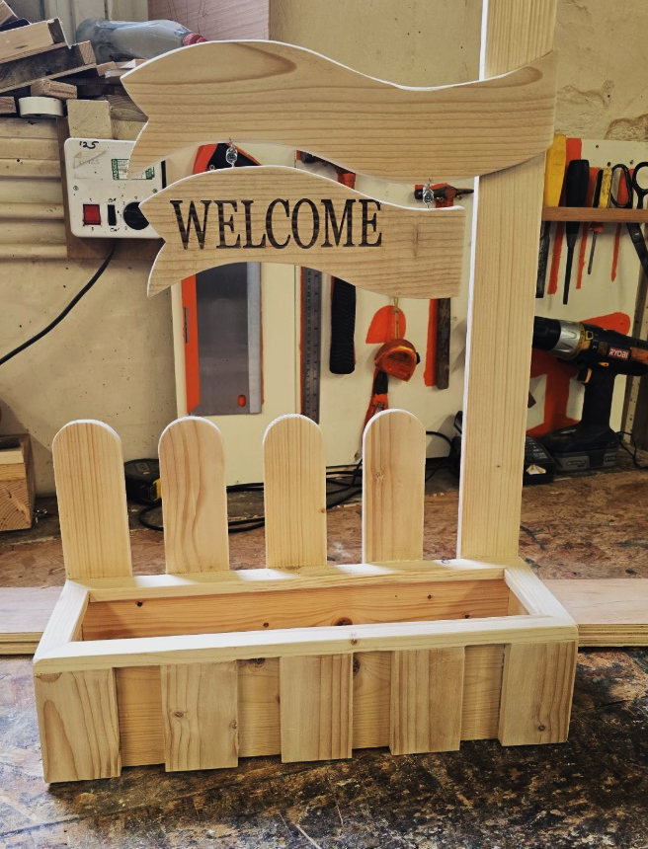
- You will learn how to make and assemble a small planter with welcome sign. Some of the materials will be prepared for you, but you will be shown how to finish and assemble. You will be working from a drawing and a set of measurements, don’t worry if you have not worked with measurements, you will be taught this along with the correct use of tools and materials. If you wish to take this home, there will be a £5 charge, or it will be donated to The Old School Woodcrafts. Please check your diaries to make sure you can attend all 3 sessions before booking this course, 3 sessions allow enough time to fully complete your project.

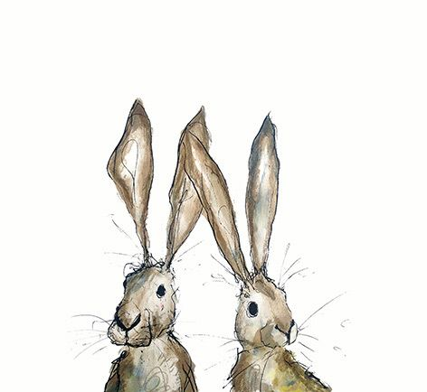
FRIDAY 10TH OCTOBER
(Very busy day)
Morning -
“Creepers Peepers” - 10am - 12pm - (Craft Room - Max. 14ppl)
- Create this optical illusion using marker pens and coloured pencils. We will show you to shade with your pencils to create shadows in the grooves and how to add highlights to make these creepy little creatures pop from your page!

Embroidery Skills (4 Weeks) - 10am - 12pm - Meg, Alison & Gail - (Room 2 - Max.7ppl)
- This basic embroidery course teaches students how to hand stitch and embroider using a needle and thread. Sessions may include instruction on how to prepare fabric, transfer designs, practice different stitch patterns and use a hoop. This course is designed for all skill levels. If you book onto this course, please pop the following 4 weeks in your diary.

Afternoon -
Autumn Pastel Drawing - 1.15pm - 3.30pm - Olwyn - (Room 2 - Max.8ppl)
- In this class we will use our chalk pastels to create lovely autumnal images with earthy browns and golds and lose ourselves in this relaxing and sensory process. A selection of inspiring images will be available to get you started.

Textiles (4 Weeks) - 1.15pm - 3.30pm - Meg, Alison & Gail - (Craft Room - Max.10ppl)
- Advent Calendar Wall Hanging - In this course you will be creating your very own reusable, fabric advent calendar wall hanging, ready to be used over the Christmas period. This course will involve a combination of hand stitch and machine sewing. If you book onto this course, please pop the following 4 weeks in your diary.

Fridays Classes
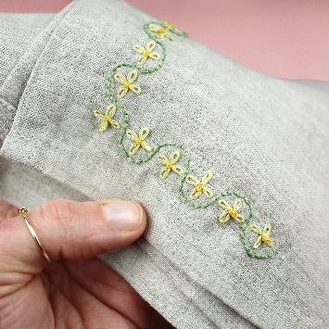
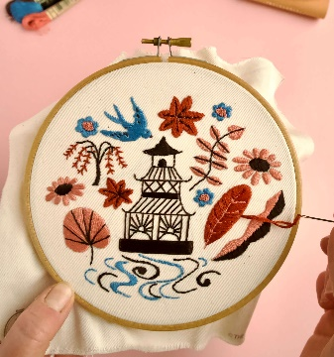

Morning -

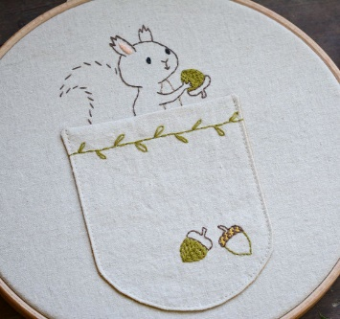
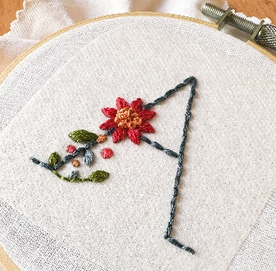

“Creepers Peepers” Example “Embroidery Skills” Examples

Afternoon -

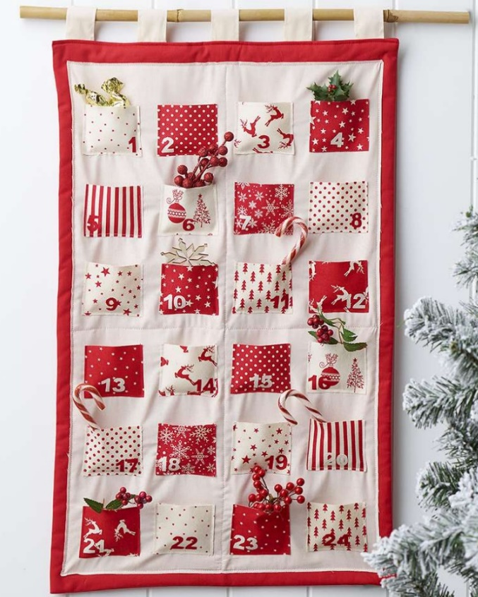

“Autumn Pastel Drawing” “Advent Calendar Wall Hanging” Example
This is a general example, you will be given
different materials, colours and patterns

MONDAY 13TH OCTOBER
Morning –
Introduction To Line Dancing - 11am - 12pm - Penny - (Continued - Week 5)
Afternoon -

Chatty Café Drop In - 1pm - 2pm - John (Volunteer) - (The Old School Café)
Autumnal Watercolours - 1.15pm - 3.30pm - Olwyn - (Craft Room - Max.14ppl)
- In this relaxing session you will be using a combination of watercolour paints and Fineliners to create a beautiful, autumnal, repeat pattern. You have the opportunity to be as creative as you like, forming your own unique patterns to decorate your autumn leaves how you wish.

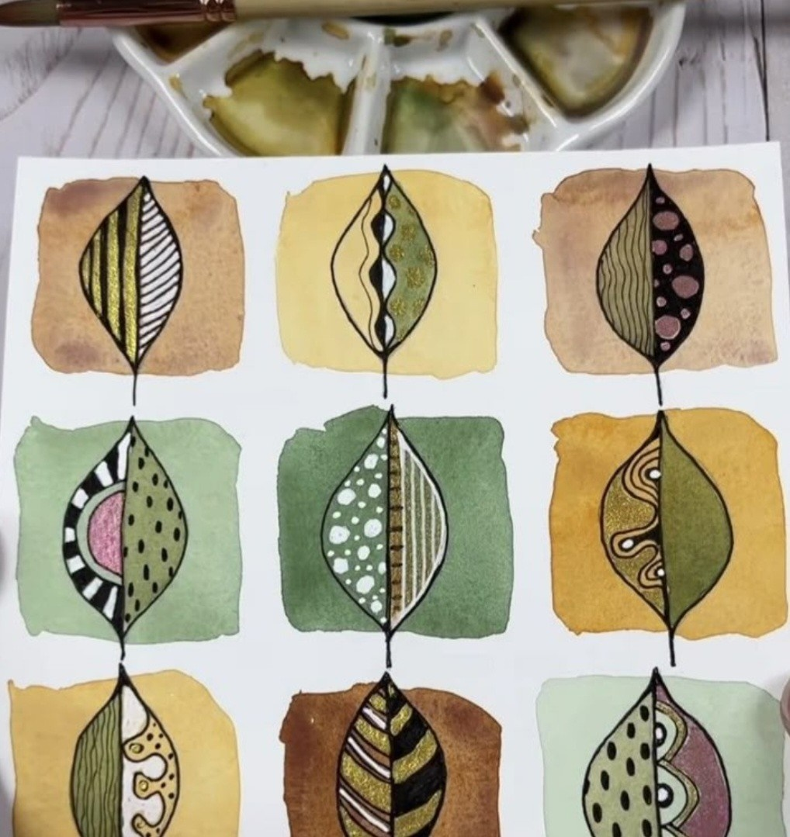

TUESDAY 14TH OCTOBER
Morning -
Social Day - 9.30am - 4pm - (Craft Room - Max. 20ppl)
Exploring Acrylics - 10am - 12pm - Sue (Local Artist) - (Continued - Week 2)
Gardening - 10.30am - 12.30pm - Sandra (Volunteer) - (Meet in Craft Room)
Afternoon -
“Knit Happens” Intermediate - 1.30pm - 3.30pm - Gail (Volunteer) - (The Old School Café)
- Our Intermediate sessions are for experienced knitters or anyone that has completed one or more of our beginners’ sessions. Feel free to bring your own knitting projects or simply turn up without so much as a knitting needle, and our lovely volunteer will get you set away on a project. These sessions will be held every week in our Café situated on the ground floor of our Centre. You will still need to book onto these sessions as there is limited space.

WEDNESDAY 15TH OCTOBER

Morning -
“Magic Painting” Bouquet of Skulls - 10am - 12pm - Olwyn –
(Craft Room - Max.14ppl)
- Using non-waterproof fineliners, we will draw over a
pre-printed image. As we add clean water with a
brush, the ink from the fineliners, the ink will seep
out and we will be able to use this ink to create
shadows in our design, leaving the white paper
behind as our highlights! This is a relaxing technique
which can produce stunning results.

Horticulture Group - 10am - 12pm - Joy (Volunteer) - (Allotments)
Afternoon –
Desert Island Discs - 1.15pm - 3.30pm - Olwyn - (Craft Room - Max. 14ppl)
- Musicals - Spend a class with us enjoying songs from our favourite musicals, old and new. There's plenty to choose from, so get thinking and come along and join this mood boosting musical session!

THURSDAY 16TH OCTOBER
(Busy day)
Morning -
Social Day - 9.30am - 4pm - (Craft Room - Max.20ppl)
Introduction To Woodwork - 10am - 3pm - Tony - (Continued - Week 2)

FRIDAY 17TH OCTOBER
(Very busy day)
Morning -
Watercolour Illustrations - 10am - 12pm - No Tutor - (Craft Room - Max.12ppl)
- In this laid-back session, you will have a selection of pre-printed, simple line illustrations to choose from, which you will bring to life with a pop of watercolour. Note that this is a relaxed and social, self-led session. There will be no tutor delivering the class, so a little watercolour painting experience would be beneficial.

Embroidery Skills - 10am - 12pm - Meg, Alison & Gail - (Continued - Week 2)
Afternoon -
Crosswords & Cuppas - 1.15pm - 3.30pm - Group Led Session - (Room 2 - Max.8ppl)
Textiles “Advent Calendar” - 1.15pm - 3.30pm - Meg, Alison, Gail - (Continued - Week 2)
Walking Group - 1.30pm - 3pm - Nicola - (Meet in The Old School Café)
- We will venture out into our wonderful City, exploring the ‘nooks & crannies’ of Durham. This is a nice relaxed paced walk, with only slight inclines and as few stairs as possible (but to be expected in “Hilly” Durham) The walks usually take around 90mins depending on the route and individuals’ mobility. The walks are weather permitted; you will be contacted by lunchtime if the walk has been cancelled due to adverse conditions. Bring water and wear appropriate clothing for the weather.

MONDAY 20TH OCTOBER
Morning -
Introduction To Line Dancing - 11am - 12pm - Penny - (Continued - Week 6)
Afternoon -
Chatty Café Drop In - 1pm - 2pm - John (Volunteer) - (The Old School Café)
Life Is About Balance - 1.15pm - 3.30pm - Olwyn - (Craft Room - Max.14ppl)
- Immerse yourself in this watercolour puzzle and design a pile of watercolour boulders, precariously balancing upon each other. Then use your imagination to work out how you would scale these boulders to reach the top, adding ladders and supporting poles as you go. Maybe you could add some trees, flowers, animals or a house where you would imagine living!
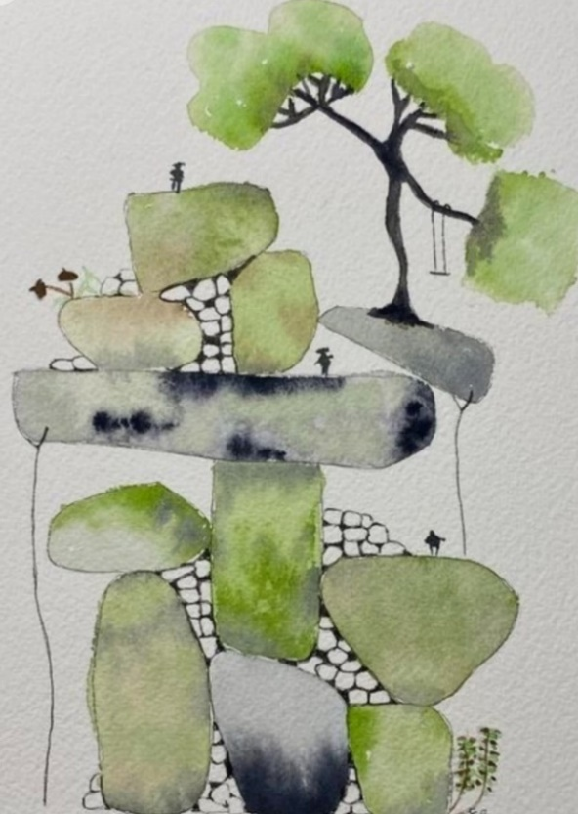

TUESDAY 21ST OCTOBER
Morning -
Social Day - 9.30am - 4pm - (Craft Room - Max.20ppl)
Exploring Acrylics - 10am - 12pm - Sue (Local Artist) - (Continued - Week 3)
Gardening - 10.30am - 12.30pm - Sandra (Volunteer) - (Meet in Craft Room)
Afternoon -
“Knit Happens” Intermediate - 1.30pm - 3.30pm - Gail (Volunteer) - (The Old School Cafe)

WEDNESDAY 22ND OCTOBER
Morning -
Clay Halloween Heads (2 Weeks) - 10am - 12pm - (Craft Room - Max. 14ppl)

- Get creative with these creepy heads made from clay and twigs! In week one, we will create our heads with eyeballs and attach any twigs that we need to enhance the creepiness. In week two, we will paint our masterpieces and add extra ghoulish embellishments as desired. You must be able to attend both sessions to allow for drying time.

Horticulture Group - 10am - 12pm - Joy (Volunteer) - (Meet in Craft Room)
Afternoon –
Woolly Witches - 1.15pm - 3.30pm - Olwyn - (Craft Room - Max.14ppl)
- In this spooky and playful session, you will create your own Halloween witch décor using a selection of coloured wool, fabrics and other craft materials.
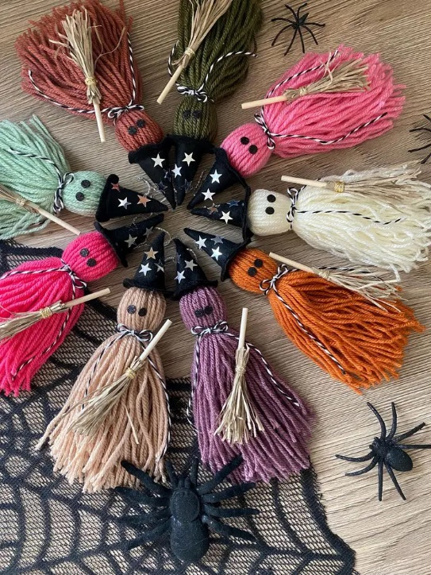

THURSDAY 23RD OCTOBER
(Busy day)
Morning -
Social Day - 9.30am - 4pm - (Craft Room - Max. 20ppl)
Introduction To Woodwork - 10am - 3pm - Tony (Continued - Final Session)

FRIDAY 24TH OCTOBER
Morning -
Autumnal Watercolours - 10am - 12pm - Olwyn - (Craft Room - Max. 14ppl)
Embroidery Skills - 10am - 12pm - Meg, Alison & Gail - (Continued - Week 3)
Afternoon -
“Cute” Toadstool Tutorial - 1.15pm - 3.30pm - Olwyn - (Room 2 - Max. 8ppl)
Textiles “Advent Calendar” - 1.15pm - 3.30pm - Meg, Alison, Gail - (Continued - Week 3)

MONDAY 27TH OCTOBER
Morning -
Introduction To Line Dancing - 11am - 12pm - Penny - (Continued - Week 2)
Afternoon -
Chatty Café Drop In - 1pm - 2pm - John (Volunteer) - (The Old School Café)
Autumn Pastel Drawing - 1.15pm - 3.30pm - Olwyn - (Craft Room - Max.14ppl)
Pumpkin Carving (£2.50 Charge) - 1.15pm - 3.30pm - Nicola - (Room 2 - Max.8ppl)
- In this fun session you will be provided with a fresh pumpkin, some tools and paint to decorate your pumpkin how you wish. Some images will be provided for inspiration if needed.
TUESDAY 28TH OCTOBER
Morning -
Social Day - 9.30am - 4pm - (Craft Room - Max.20ppl)
Exploring Acrylics - 10am - 12pm - Sue (Local Artist) - (Continued - Final Session)
Gardening - 10.30am - 12.30pm - Sandra (Volunteer) - (Meet in Craft Room)
- This will be the final Gardening session before the Winter break. Gardening will continue in Spring.
Afternoon -
“Knit Happens” Intermediate - 1.30pm - 3.30pm - Gail (Volunteer) - (The Old School Cafe)
WEDNESDAY 29TH OCTOBER
Morning -
Clay Halloween Heads - 10am - 12pm - (Continued - Final Session)

Horticulture Group - 10am - 12pm - Joy (Volunteer) - (Meet in Craft Room)
- This will be the final Gardening session before the Winter break. Gardening will continue in Spring.
Afternoon -
Life Is About Balance - 1.15pm - 3.30pm - Olwyn - (Craft Room - Max.14ppl)

THURSDAY 30TH OCTOBER
(Busy day)
Morning -
Social Day - 9.30am - 4pm - (Craft Room - Max. 20ppl)

FRIDAY 31ST OCTOBER
Morning -
“Magic Painting” Bouquet of Skulls - 10am - 12pm - (Craft Room - Max.14ppl)
Embroidery Skills - 10am - 12pm - Meg, Alison, Gail - (Continued - Week 4)
Afternoon -
“Creepers Peepers” - 1.15pm - 3.30pm - Olwyn - (Room 2 - Max. 8ppl)
Textiles “Advent Calendar” - 1.15pm - 3.30pm - Meg, Alison, Gail - (Continued - Week 4)
Walking Group - 1.30pm - 3pm - Nicola - (Meet in The Old School Café)

