Please read carefully.
Hello,
We hope this letter finds you well.
Enclosed you will find the latest timetable of activities for November 2025. We will be taking bookings for these activities via phone call or email from 10am on Monday 27th October Please do not phone us to try booking before this date and time. You will find our contact number and email address on the front page of your timetable.
Our Gardening and Horticulture groups are now finished for the winter. They will return in spring 2026.
After a review to our safety and security measures, we ask that our attendees and volunteers do not enter the building any earlier than 15 minutes before your session starts. All class start and finish times are stated on your timetable. Our Centre door will now be locked until 9.15am. We also ask that if you are not booked onto anything, please do not wander upstairs or into the workshop and disturb staff/classes. You are welcome to come in and purchase food or use a token in our Café. Thank you for your understanding.
Due to the volume of new referrals coming through. You will only be able to book onto one Social Day (Tuesday or Thursday) and two of Olwyn’s classes per week. This is so we can give new attendees a fair chance of booking onto sessions. (Not including volunteer led classes).
We please ask that you pay a £1 attendance fee per session. Your attendance fee goes back into the Centre and helps towards cost of materials and use of our tea and coffee facilities situated in our craft room. Your contribution is much appreciated.
Please turn up to your class on time, unless you have called to say you are running late. Please do not eat food or leave to go for a cigarette during classes, this can be very disruptive for other attendees and the instructor. You are all given a 15-minute break halfway through your classes to eat, make a beverage and smoke.
If you are booked onto any class and cannot make it for whatever reason you must call the centre to inform us of this as early as possible, so that we can offer the space to somebody else. You still need to book to attend Social Days as well as regular classes; to guarantee you have a seat.

Classes with this symbol - are dedicated, quieter sessions. Anybody can join them, but they are designed to be inclusive of neurodivergent individuals who may struggle to access our standard sessions. (Up to a Maximum of 20ppl in our Craft Room and 8ppl in Room 2)

We look forward to seeing you.

To Book Classes Call: 0191 384 8100 or Email: enquiries@stmargaretscentre.co.uk
(There is an attendance fee of £1 per session)


MONDAY 3RD NOVEMBER
Morning -
Introduction to Line Dancing - 11am - 12pm - Penny - (Continued - Week 8)
Afternoon -
Chatty Café Drop In - 1pm - 2pm - John (Volunteer) - (The Old School Café)
- Are you feeling isolated and in need of a chat and some friendly company? Then we welcome you to pop into The Old School Café, where one of our lovely volunteers will be there waiting. This is not a counselling session, but a safe space where you can have a lovely informal chat Hopefully you will leave feeling a little brighter.

Shading & Detailing with Pencils - 1.15pm - 3.30pm - Olwyn - (Craft Room - Max. 14ppl)
- Walnut Mouse - Using our Prisma pencils, we will add colour, light and shade to create an image of a little mouse nestled in a walnut shell. Instruction will be given on how to create the different textures of the fur, blanket, shell and grass.

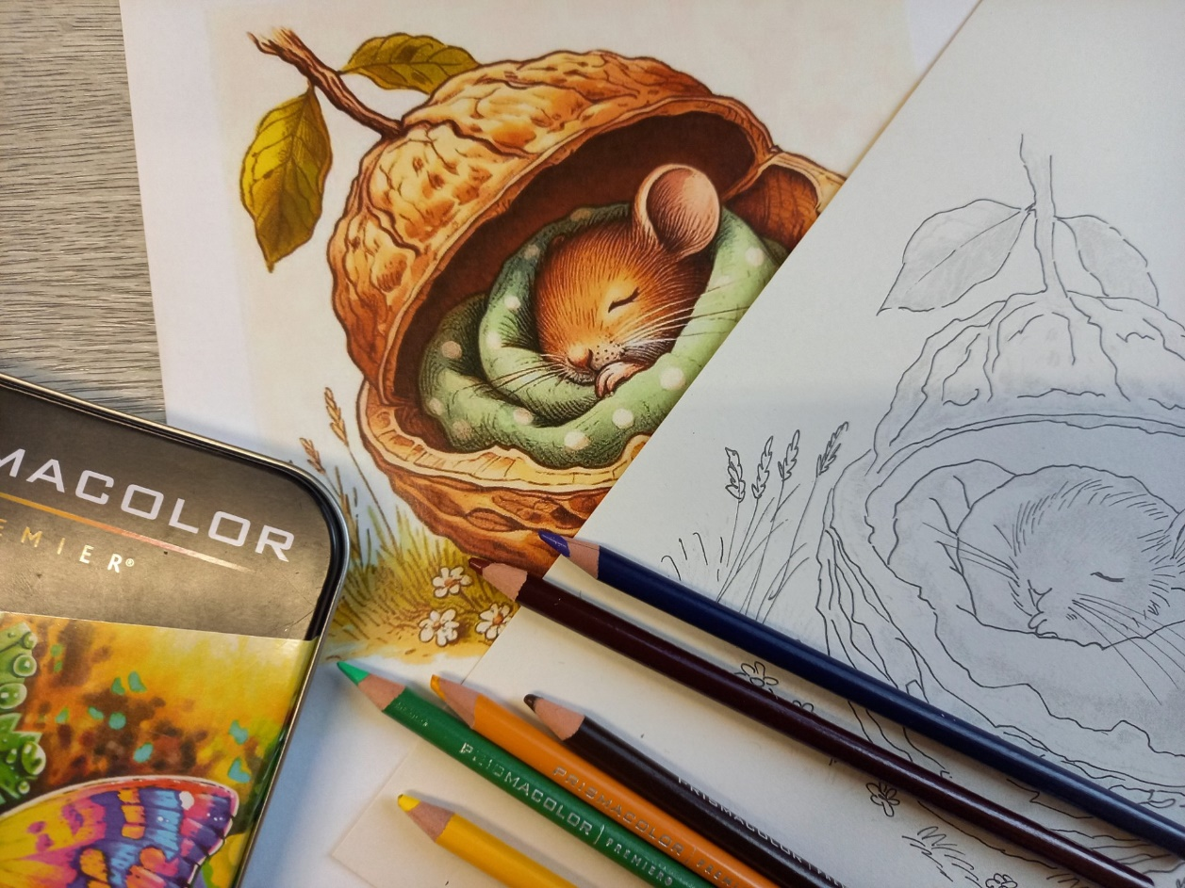
Mondays Class

“Shading & Detailing with Pencils” Example

TUESDAY 4TH NOVEMBER
Morning -
(Busy Morning)
Social Day - 9.30am - 4pm - (Craft Room - Max. 20ppl)
- A day for social interaction and a safe place to get on with any hobbies you may have e.g., Painting, drawing, writing, jigsaws, crosswords, knitting. Or just enjoy a nice little chin wag with a cuppa. You must still book a slot on any social day you wish to attend, to secure a seat.

Afternoon -

“Knit Happens” Introductory - 1.30pm - 3.30pm - Gail - (Volunteer) - (The Old School Café)
- This simple knitting session is ideal for those who have minimal to no experience in knitting. Our lovely volunteer will gently guide you, showing you the basic of techniques. From here, if you feel confident enough, you can then join onto our following sessions each week to gain more knowledge and knitting skills as you go.

WEDNESDAY 5TH NOVEMBER
Morning -
Cabin in The Woods - 10am - 12pm - Olwyn - (Craft Room - Max. 14ppl)

- In this class we will explore how to paint a wintery sunset against a snow – covered foreground, using a large portion of our white paper for dramatic effect. Tiny details like a little cabin nestled in some pine trees, and a solitary figure and interest and depth.

Afternoon -
A Splash of Floral - 1.15pm - 3.30pm - Olwyn - (Craft Room - Max. 14ppl)
- Using a combination of Fineliners and watercolour paints, you will create a beautiful and simplistic hand-made greetings card. You will stick small illustrations of paintbrushes onto your card, then using your watercolours you will create what looks like a delicate stroke of paint from each brush where you will then add floral details using your Fineliner.
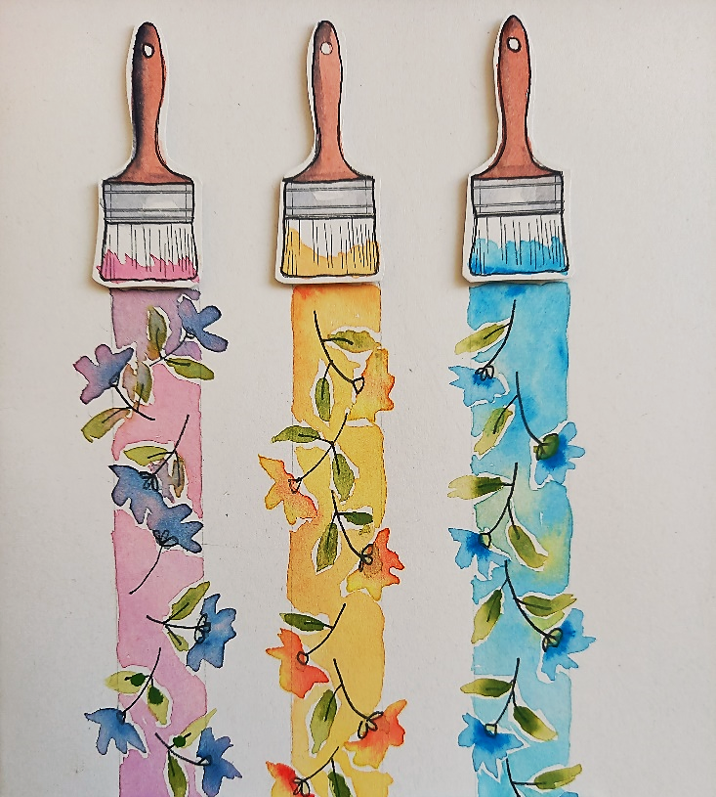

THURSDAY 6TH NOVEMBER
(Busy Day)
Morning -
Social Day - 9.30am - 4pm - (Craft Room - Max. 20ppl)

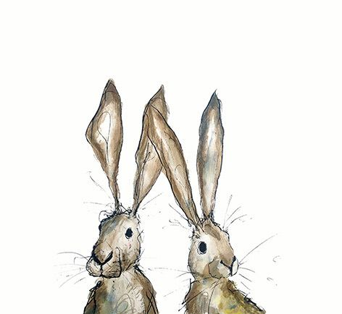
FRIDAY 7TH NOVEMBER
(Very busy day)
Morning -
Watercolour Christmas Tree Card - 10am - 12pm - Olwyn - (Craft Room - Max. 14ppl)
- A simple technique using watercolours to create a basic tree illustration with colourful baubles. Your finished card can be embellished with gems if desired, to add that little extra Christmas sparkle.

Embroidery Skills (4 Weeks) - 10am - 12pm - Meg, Alison & Gail - (Room 2 - Max.7ppl)
- This basic embroidery course teaches students how to hand stitch and embroider using a needle and thread. Sessions may include instruction on how to prepare fabric, transfer designs, practice different stitch patterns and use a hoop. This course is designed for all skill levels. If you book onto this course, please pop the following 4 weeks in your diary.

Afternoon -
Exploring Pastels - 1.15pm - 3.30pm - Olwyn - (Room 2 - Max.8ppl)
- Candlelight - You will be exploring light and dark using chalk pastels. You will be shown how to create the appearance of a glowing candlelight in the darkness; the colours you use will give a warm and atmospheric ambience.

Textiles (4 Weeks) - 1.15pm - 3.30pm - Meg, Alison & Gail - (Craft Room - Max.10ppl)
- Christmas Tree Hanging Decoration - You will be cutting out templates and shapes from fabric, which you will then hand stitch together to create your own Christmas tree hanging decoration. Please be prepared for lots of cutting with scissors and hand stitching, if booking onto this course. If you book onto this course, you must be able to attend the first session. If you cannot make the first session your space on the course will be offered to another attendee.

Fridays Classes
Morning -
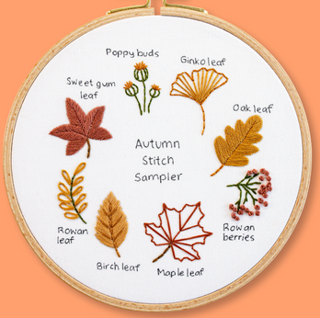
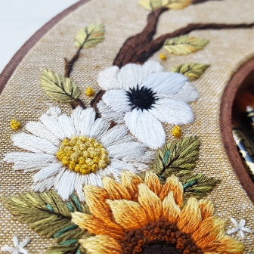
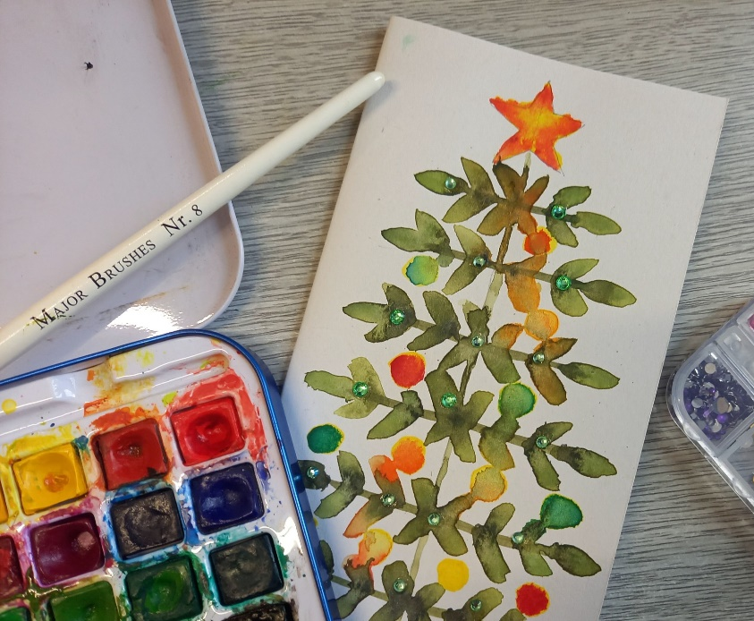

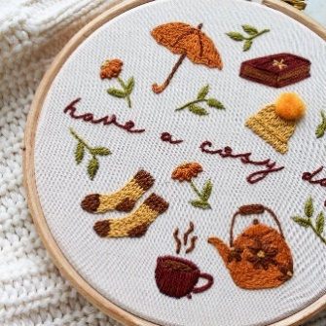
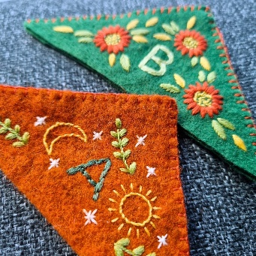

“Watercolour Xmas Tree Card” Example “Embroidery Skills” Examples

Afternoon -
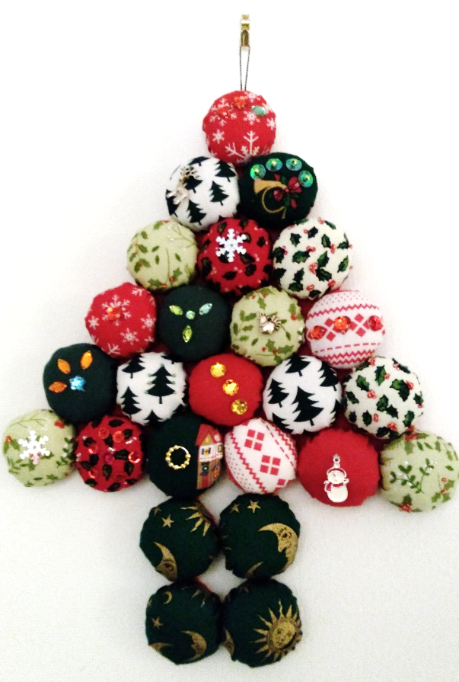


“Exploring Pastels” Example “Xmas Tree Decoration” Example

MONDAY 10TH NOVEMBER
Morning -
Introduction To Line Dancing - 11am - 12pm - Penny - (Continued - Week 9)
Afternoon -

Chatty Café Drop In - 1pm - 2pm - John (Volunteer) - (The Old School Café)
“Torn” Christmas Gift Bag/Card - 1.15pm - 3.30pm - Olwyn - (Craft Room - Max.14ppl)
- In this session you will tear different sized strips of patterned paper which you will assemble and stick down to create a collage style, Christmas tree onto a gift bag or greetings card. You will finish with detailing using Fineliners, sparkling gems and gold/silver ink detailing.


TUESDAY 11TH NOVEMBER
Morning -
Social Day - 9.30am - 4pm - (Craft Room - Max. 20ppl)

WEDNESDAY 12TH NOVEMBER
Morning -
Christmas Clay Heads (2 weeks) - 10am - 12pm - Olwyn - (Craft Room - Max.14ppl)
- A Festive Jack Skellington - Following the success of our “Clay Halloween Heads” in spooky bottles, we are trying something a little more festive with a Nightmare Before Christmas version. In week 1 you will make your clay head and then paint your glass bottle black. In week 2 you will paint your heads to look like Jack Skellington then you will brush your bottles with a metallic finish. Please only book this course if you can attend both sessions as there is drying time in between.



Afternoon –
3D Cardmaking - 1.15pm - 3.30pm - Olwyn - (Craft Room - Max.14ppl)
- The Swinging Snowman - This fun and uplifting cardmaking class involves a little colouring in, cutting out and sticking on small gemstones. Please be sure that you can manage cutting small fiddly shapes out on your own before booking this session, as there is quite a bit of intricate cutting involved.
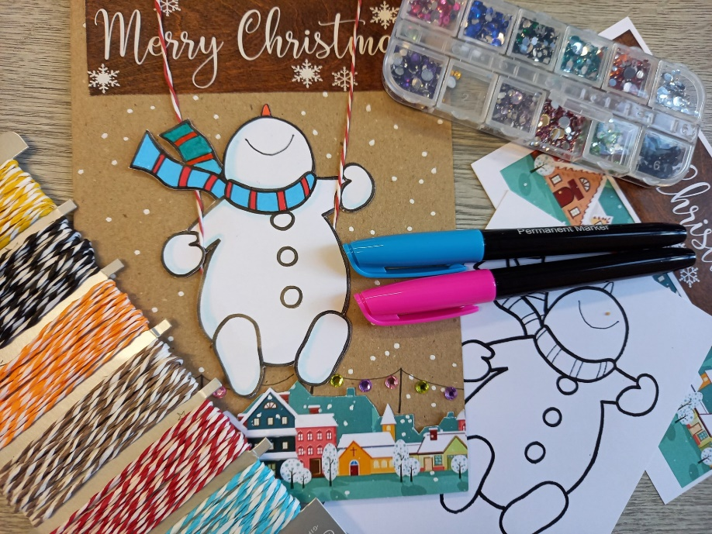

THURSDAY 13TH NOVEMBER
(Busy day)
Morning -
Social Day - 9.30am - 4pm - (Craft Room - Max.20ppl)

Afternoon -
Carers Awareness Workshop - 1.30pm - 2.30pm - Emma (DCC) - (Room 2 - Max.10ppl)
- We have an engagement officer from Durham County Carers Support coming in to do an informative presentation. The point of this workshop is to educate and inform those who are, or who may be an unpaid carer. Whether you regularly look after a neighbour, a sick or disabled relative, child or parent, or your partner, this workshop may be very beneficial to you. The workshop will help you understand what makes a carer, what support is out there for you, and you will have the opportunity to ask questions. You will be given the option to register with Durham County Carers Support at the end of the session. As well as attendees, this workshop is also available to family or friends. If you think you may know someone who is an unpaid carer, please share this information with them, and ask them to contact us if interested. Please find a more in-depth leaflet for more information about Durham County Carers on the back on this Timetable.

FRIDAY 14TH NOVEMBER
(Very busy day)
Morning -
Walnut Mouse - 10am - 12pm - Olwyn - (Craft Room - Max.14ppl)

Embroidery Skills - 10am - 12pm - Meg, Alison & Gail - (Continued - Week 2)
Afternoon -
A splash of Floral - 1.15pm - 3.30pm - Olwyn - (Room 2 - Max.8ppl)
Textiles - 1.15pm - 3.30pm - Meg, Alison, Gail - (Continued - Week 2)
Walking Group (Final session) - 1.30pm - 3pm - Nicola - (Meet in The Old School Café)
- We will venture out into our wonderful City, exploring the ‘nooks & crannies’ of Durham. This is a nice relaxed paced walk, with only slight inclines and as few stairs as possible (but to be expected in “Hilly” Durham) The walks usually take around 90mins depending on the route and individuals’ mobility. The walks are weather permitted; you will be contacted by lunchtime if the walk has been cancelled due to adverse conditions. This is the last walking session of the year. The group will start up again in Spring 2026.

MONDAY 17TH NOVEMBER
Morning -
Introduction To Line Dancing - 11am - 12pm - Penny - (Continued - Week 10)
Afternoon -
Chatty Café Drop In - 1pm - 2pm - John (Volunteer) - (The Old School Café)
Watercolour Xmas Tree Card - 1.15pm - 3.30pm - Olwyn - (Craft Room - Max.14ppl)

TUESDAY 18TH NOVEMBER
Morning -
Social Day - 9.30am - 4pm - (Craft Room - Max.20ppl)
Afternoon -
“Knit Happens” Intermediate - 1.30pm - 3.30pm - Gail (Volunteer) - (The Old School Cafe)
WEDNESDAY 19TH NOVEMBER
Morning -
Christmas Clay Heads - 10am - 12pm - Olwyn - (Continued - Final Session)
Afternoon -
“Torn” Christmas Gift Bag/Card - 1.15pm - 3.30pm - Olwyn - (Craft Room - Max.14ppl)

THURSDAY 20TH NOVEMBER
(Busy day)
Morning -
Social Day - 9.30am - 4pm - (Craft Room - Max. 20ppl)
Beaded Angels (2 Weeks) - 1.15pm - 3.30pm - Elaine (Volunteer) - (Room 2 - Max 8ppl)
- In this short crafty course, you will be making a beautiful, beaded angel. This is perfect as a Christmas tree decoration, bag charm or as a nice little keepsake to gift to a friend. This course is a little bit fiddly and may require nimble and dextrous hands.
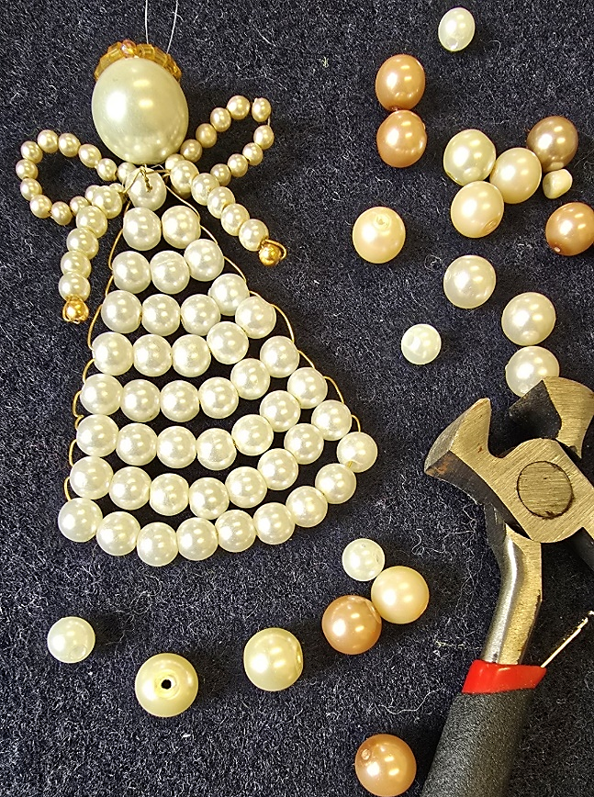

FRIDAY 21ST NOVEMBER
(Very busy day)
Morning -
Cabin In The Woods - 10am - 12pm - Olwyn - (Craft Room - Max. 14ppl)
Embroidery Skills - 10am - 12pm - Meg, Alison & Gail - (Continued - Week 3)
Afternoon -
3D Cardmaking “The Swinging Snowman” - 1.15pm - 3.30pm - Olwyn - (Room 2-Max. 8ppl)
Textiles - 1.15pm - 3.30pm - Meg, Alison, Gail - (Continued - Week 3)

MONDAY 24TH NOVEMBER
Morning -
Introduction To Line Dancing - 11am - 12pm - Penny - (Continued - Week 11)
Afternoon -
Chatty Café Drop In - 1pm - 2pm - John (Volunteer) - (The Old School Café)
A Splash of Floral - 1.15pm - 3.30pm - Olwyn - (Craft Room - Max.14ppl)

TUESDAY 25TH NOVEMBER
Morning -
Social Day - 9.30am - 4pm - (Craft Room - Max.20ppl)
Afternoon -
“Knit Happens” Intermediate - 1.30pm - 3.30pm - Gail (Volunteer) - (The Old School Cafe)
WEDNESDAY 26TH NOVEMBER
Morning -
Exploring Pastels “Candlelight” - 10am - 12pm - Olwyn - (Craft Room - Max.14ppl)

Crafty Christmas Cards - 10am - 12pm - Barry (Volunteer) - (Room 2 - Max.6ppl)

- Come and join our wonderful volunteer in this fun, laid back card craft session. You will create your own Christmas cards, using an array of Christmas themed crafts.

Afternoon -
Walnut Mouse - 1.15pm - 3.30pm - Olwyn - (Craft Room - Max.14ppl)

THURSDAY 27TH NOVEMBER
(Busy day)
Morning -
Social Day - 9.30am - 4pm - (Craft Room - Max. 20ppl)

Beaded Angels - 1.15pm - 3.30pm - Elaine (Volunteer) - (Final Session)

FRIDAY 28TH NOVEMBER
(Very busy day)
Morning -
3D Cardmaking “The Swinging Snowman” - 10am - 12pm - (Craft Room - Max.14ppl)
Embroidery Skills - 10am - 12pm - Meg, Alison, Gail - (Continued - Week 4)
Afternoon -
Desert Island Discs - 1.15pm - 3.30pm - Olwyn - (Room 2 - Max. 8ppl)
- Come along with a song in mind that uplifts you, takes you to a nice place or has a special meaning. You will all get turns to have your song played to the group. If you’d like, you can discuss why you have chosen your song and discuss its importance to you, or simply just listen and enjoy this laid-back session.
Textiles “Xmas Tree Decor” - 1.15pm - 3.30pm - Meg, Alison, Gail - (Final Session)



Carers Awareness Workshop - 13th November - 1.30pm - 2.30pm - Emma(DCCS) - (Room 2)
Caring for a relative, friend or neighbour can be rewarding, challenging and exhausting all at the same time. Our teams are here to support you all the way. We can offer a wide range of specialist information and advice as well as access to practical help.
One of the most important aspects of what we do is to listen and offer emotional support. We are also keen to help you put yourself first and find ways to help you focus on your health and wellbeing. This is all aimed at preventing a crisis and getting help in place before things become difficult.
There is so much help available for Carers from ourselves and many other agencies we work closely with. We have excellent links across health, social care and the voluntary and community sector locally and regionally.
Our team is here to help Carers recharge and refuel and generally be on your side.
We are a voluntary organisation which provides free high-quality services and support to unpaid Carers over the age of 18, who support someone living in County Durham & Darlington or caring for someone living in County Durham & Darlington.
A registered charity and company limited by guarantee, we can work with you to help you find the information you need to care for someone and can inform you about other services to help you look after yourself.

What we do
We support over 24,000 Carers in County Durham and Darlington, offering a one-stop shop for available information and support.
We can provide:
- One to one tailored support
- A listening ear
- Help with completing forms
- Access to grants and funding
- Help to take a break from your caring role
- Signposting to relevant organisations who can also support
- Groups and Events
- Training on various topics
- Counselling sessions
- Carers Discount Card
- Carers Emergency Card

