Please read carefully.
Hello,
We hope this letter finds you well.
Enclosed you will find the latest timetable of activities for December 2025. We will be taking bookings for these activities via phone call or email from 10am on Monday 24th November Please do not phone us to try booking before this date and time. You will find our contact number and email address on the front page of your timetable.
We are now taking bookings for our Christmas parties! Please use the booking sheet in the craft room or book on the phone whilst booking your classes. Party days will be spread over 3 days, 17th, 18th & 19th December from 10am - 2pm. You can attend one party only. There are limited spaces available each day, so please book early to guarantee a space. There is a £4.50 charge, which covers the cost of a Christmas Lunch & drinks throughout the day. There will also be a raffle with prizes to be won at £1 a ticket (Maximum of 2 tickets per person)
After a review to our safety and security measures, our Centre door will now be locked until 9.15am. We ask that our attendees and volunteers do not enter the building any earlier than 15 minutes before your session starts. All class start and finish times are stated on your timetable. We also ask that if you are not booked onto anything, please do not wander upstairs or into the workshop and disturb staff/classes. You are welcome to come in and purchase food or use a token in our Café. Thank you for your understanding.
Due to the volume of new referrals coming through. You will only be able to book onto one Social Day (Tuesday or Thursday) and two of Olwyn’s classes per week. This is so we can give new attendees a fair chance of booking onto sessions. (Not including volunteer led classes)
We please ask that you pay a £1 attendance fee per session. Your attendance fee goes back into the Centre and helps towards cost of materials and use of our tea and coffee facilities situated in our craft room. Your contribution is much appreciated.
Please turn up to your class on time, unless you have called to say you are running late. Please do not eat food or leave to go for a cigarette during classes, this can be very disruptive for other attendees and the instructor. You are all given a 15-minute break halfway through your classes to eat, make a beverage and smoke.
If you are booked onto any class and cannot make it for whatever reason you must call the centre to inform us of this as early as possible, so that we can offer the space to somebody else. You still need to book to attend Social Days as well as regular classes; to guarantee a seat.

Classes with this symbol - are dedicated, quieter sessions. Anybody can join them, but they are designed to be inclusive of neurodivergent individuals who may struggle to access our standard sessions. (Up to a Maximum of 20ppl in our Craft Room and 8ppl in Room 2)

We look forward to seeing you.

To Book Classes Call: 0191 384 8100 or Email: enquiries@stmargaretscentre.co.uk
(There is an attendance fee of £1 per session)


MONDAY 1ST DECEMBER
Afternoon -
Chatty Café Drop In - 1pm - 2pm - John (Volunteer) - (The Old School Café)
- Are you feeling isolated and in need of a chat and some friendly company? Then we welcome you to pop into The Old School Café, where one of our lovely volunteers will be there waiting. This is not a counselling session, but a safe space where you can have a lovely informal chat and hopefully you will leave feeling a little brighter.

Dry Brush Painting - 1.15pm - 3.30pm - Olwyn - (Craft Room - Max. 14ppl)
- Shades of Grey - In this session we will paint in monochrome and then add just a pop of colour to add a focal point to our image. Dry brush technique involves applying acrylic paint with a very dry brush, without the use of water at all. This technique creates a very traditional look. Images will be provided to use as inspiration.


Mondays Class

“Dry Brush Painting” Example
TUESDAY 2ND DECEMBER
Morning -
(Busy Day)
Social Day - 9.30am - 4pm - (Craft Room - Max. 20ppl)
- A day for social interaction and a safe place to get on with any hobbies you may have e.g., Painting, drawing, writing, jigsaws, crosswords, knitting. Or just enjoy a nice little chin wag with a cuppa. You must still book a slot on any social day you wish to attend, to secure a seat.

Let’s Explore Acrylics (2 Weeks) - 10am - 12pm - Sue (Local Artist) - (Room 2 - Max.7ppl)
- Local artist, Sue Goulding is back with us to deliver this short 2-Week acrylic exploration course. You will create wintery landscapes and scenes using acrylic paint on canvas. Imagery provided to help inspire you.
Afternoon -
Needle Felted Bauble (£10 Fee) - 1.15pm - 3.15pm - Karen (Local Artist) - (Rm.2 - 8ppl)
- We have the pleasure of having a talented needle felting artist with us to show you some lovely felting techniques. Needle felting is a very sculptural craft using barbed needles to tangle wool fibres together. The barbed needles are used to repeatedly poke the wool, which causes the fibres to interlock, mat, and become firmer, allowing you to create everything from 2D designs to intricate 3D sculptures. In this session you will create your very own, beautiful Christmas tree bauble.
“Knit Happens” Introductory - 1.30pm - 3.30pm - Gail - (Volunteer) - (The Old School Café)
- This simple knitting session is ideal for those who have minimal to no experience in knitting. Our lovely volunteer will gently guide you, showing you the basic of techniques. From here, if you feel confident enough, you can then join onto our following sessions each week to gain more knowledge and knitting skills as you go.

Tuesdays Classes

Morning -
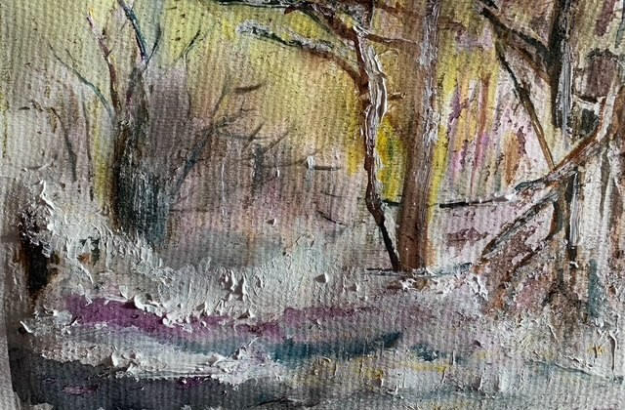
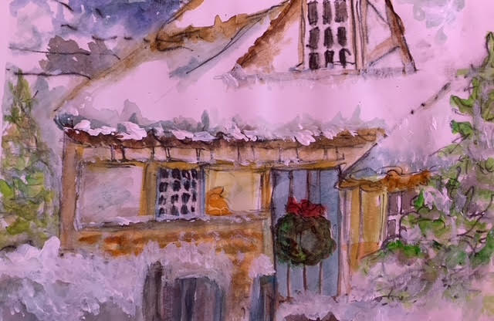

“Let’s Explore Acrylics” Examples

Afternoon -
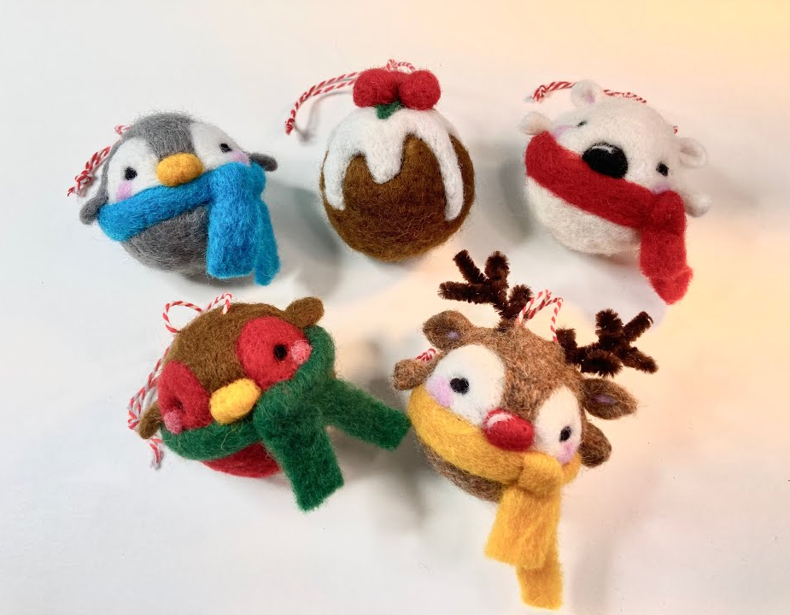
(£10 Session Fee)
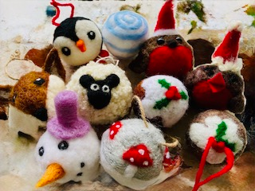

“Needle Felted Bauble” Examples

WEDNESDAY 3RD DECEMBER
Morning -
NO CLASSES THIS MORNING

Afternoon -
Graffiti - 10am - 12pm - Olwyn - (Craft Room - Max. 14ppl)
- In this fun and nostalgic class, we learn the basics of graffiti - style lettering. We will sketch our name in pencil and learn how to convert the single line into 2D. We will then add different types of highlights and finish by adding a thicker outline or even a drop shadow.



THURSDAY 4TH DECEMBER
(Busy Day)
Morning -
Social Day - 9.30am - 4pm - (Craft Room - Max. 20ppl)

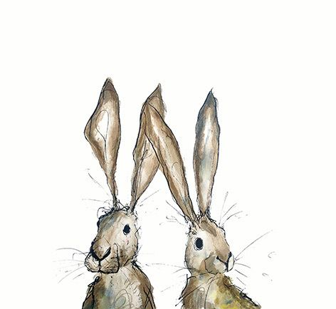
FRIDAY 5TH DECEMBER
(Very busy day)
Morning -
“Polar Express” - 10am - 12pm - Olwyn - (Craft Room - Max. 14ppl)
- Simple illustrations can look more professional with limited colour palette; by using limited colours you can give the illusion of a professional print. This technique was used because it was more economical to print with 2 or 3 colours only. In this simple graphic design inspired session, we will draw simple polar bears in pre-printed windows. We will experiment with different sizes and positions and experiment with backgrounds. One pop of colour will then add the finishing touches to our artwork.

Embroidery Skills (2 Weeks) - 10am - 12pm - Meg, Alison & Gail - (Room 2 - Max.7ppl)
- This basic embroidery, short course teaches students how to hand stitch and embroider using a needle and thread. Sessions may include instruction on how to prepare fabric, transfer designs, practice different stitch patterns and use a hoop. This course is designed for all skill levels. If you book onto this course, please pop the following week in your diary.

Afternoon -
Fairy Lights - 1.15pm - 3.30pm - Olwyn - (Room 2 - Max.8ppl)
- A relaxing class using our Prisma colour pencils. We will shade a quirky little Illustration of a girl wrapped up in fairy lights. This gives us the opportunity to practice our advanced shading techniques, concentrating on those shadows and highlights.
Textiles (2 Weeks) - 1.15pm - 3.30pm - Meg, Alison & Gail - (Craft Room - Max.10ppl)
- Angel & Barbie Tree Decor (£1 for Doll) - Using a combination of hand sewing and machine sewing you will create your own miniature, festive dress, along with a set of fabric wings. This will all be put onto your Barbie doll, to create your very own quirky Christmas tree topper. If preferred, you have the option to make a felt hand sewn angel. If you book onto this course, please pop the following week in your diary.

Fridays Classes

Morning -
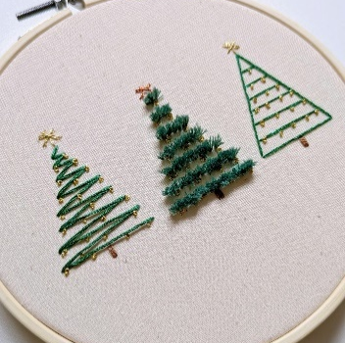
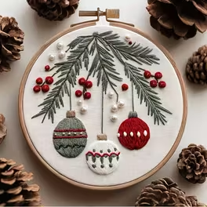

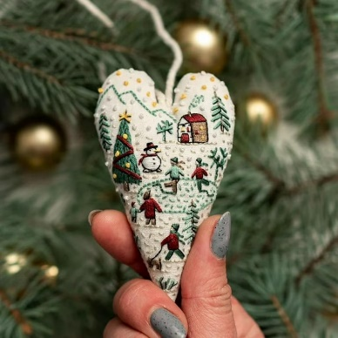
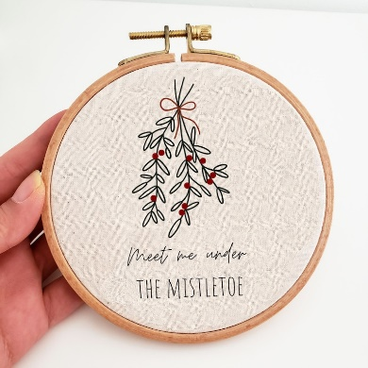

“Polar Express” Example “Embroidery Skills” Examples

Afternoon -

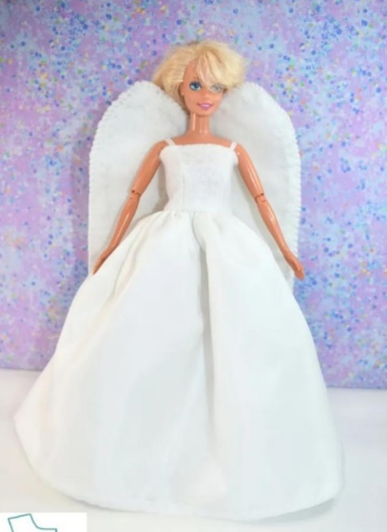
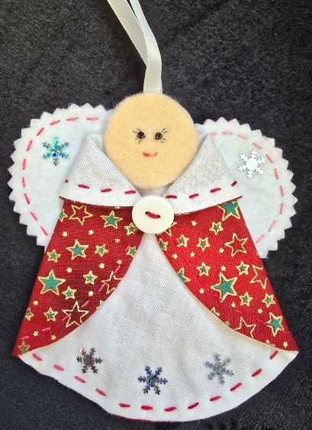
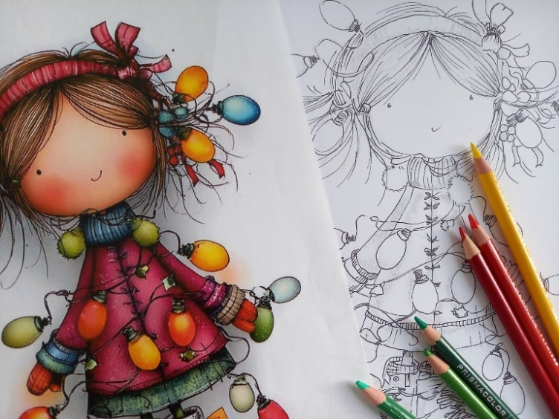

“Fairy Lights” Example “Angel & Barbie Tree Decor” Examples

MONDAY 8TH DECEMBER
Afternoon -
Chatty Café Drop In - 1pm - 2pm - John (Volunteer) - (The Old School Café)
“Red, Red Robin” - 1.15pm - 3.30pm - Olwyn - (Craft Room - Max.14ppl)
- A nice relaxing class where we learn or continue to develop our watercolour techniques. We will delicately add colour to a pre-printed seasonal image, layering up the applications to add depth in the darker areas.
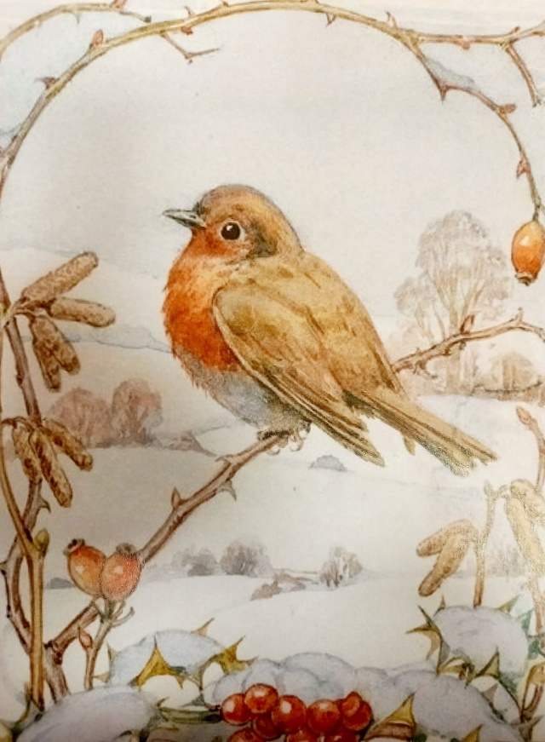

TUESDAY 9TH DECEMBER
Morning -
Social Day - 9.30am - 4pm - (Craft Room - Max. 20ppl)
Let’s Explore Acrylics - 10am - 12pm - Sue (Local Artist) - (Continued - Final Session)

Afternoon -
“Knit Happens” Intermediate - 1.30pm - 3.30pm - Gail (Volunteer) - (The Old School Café)
- Our Intermediate sessions are for experienced knitters or anyone that has completed one or more of our beginners’ sessions. Feel free to bring your own knitting projects or simply turn up without so much as a knitting needle, and our lovely volunteer will get you set away on a project. These sessions will be held every week in our Café situated on the ground floor of our Centre. You will still need to book onto these sessions as there is limited space.

WEDNESDAY 10TH DECEMBER
Morning -
“Polar Express” - 10am - 12pm - Olwyn - (Craft Room - Max.14ppl)
Afternoon –
Desert Island Discs - 1.15pm - 3.30pm - Olwyn - (Craft Room - Max.14ppl)
- Christmas on the island - In this festive themed session, you will be suggesting some of your favourite Christmas tunes! To help share the Christmas cheer. You will all get a turn to have your chosen song played, and if you have any memorable stories to go along with your song choice, please feel free to share it amongst yourselves.

THURSDAY 11TH DECEMBER
(Busy day)
Morning -
Social Day - 9.30am - 4pm - (Craft Room - Max.20ppl)
Self-Care Salon (Hair) - 10am - 12pm - Angela (Volunteer Hairdresser) - (Rm. 2 - Max.5ppl)
- Once again, we have the wonderfully talented Angela, who will be kindly offering free haircuts. She will be Trimming/cutting/shearing to give you that fresh feeling. Self-care is essential to one’s mental health; it can boost your mood, reduce stress and anxiety, and boost your confidence and self-esteem. You must arrive with freshly washed hair before your appointment, preferably on the morning of, or at least the night before.

FRIDAY 12TH DECEMBER
(Very busy day)
Morning -
Dry Brush Painting “Shades of Grey” - 10am - 12pm - Olwyn - (Craft Room - Max.14ppl)

Embroidery Skills - 10am - 12pm - Meg, Alison & Gail - (Continued - Week 2)
Afternoon -
Graffiti - 1.15pm - 3.30pm - Olwyn - (Room 2 - Max.8ppl)
Angel Barbie Tree Topper - 1.15pm - 3.30pm - Meg, Alison, Gail - (Continued - Week 2)

MONDAY 15TH DECEMBER
Afternoon -
Chatty Café Drop In - 1pm - 2pm - John (Volunteer) - (The Old School Café)
One Stroke Painting - 1.15pm - 3.30pm - Olwyn - (Craft Room - Max.14ppl)
- You will be provided with a selection of Christmas images for you to try with this one stroke painting technique. We will load our brush with two strips of coloured paint to produce a blended ombre effect. These images can be painted onto cards, gift bags or even gift wrap.
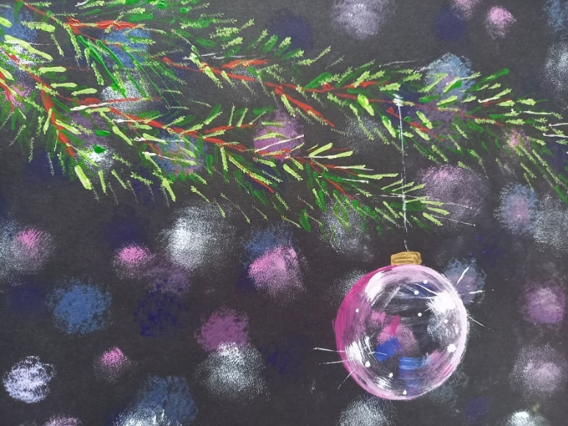

TUESDAY 16TH DECEMBER
Morning -
Social Day - 9.30am - 4pm - (Craft Room - Max.20ppl)
Afternoon -
“Knit Happens” Intermediate - 1.30pm - 3.30pm - Gail (Volunteer) - (The Old School Cafe)
WEDNESDAY 17TH DECEMBER –
(Centre Door will be locked until 10am)
CHRISTMAS PARTY DAY! (£4.50) - 10am - 2pm - (Craft Room - Max. 22ppl)
THURSDAY 18TH DECEMBER -
(Centre Door will be locked until 10am)
CHRISTMAS PARTY DAY! (£4.50) - 10am - 2pm - (Craft Room - Max. 22ppl)
FRIDAY 19TH DECEMBER -
(Centre Door will be locked until 10am)
CHRISTMAS PARTY DAY! (£4.50) - 10am - 2pm - (Craft Room - Max. 22ppl)

MONDAY 22ND DECEMBER
All Day -
Social Day - 9.30am - 3.30pm - (Craft Room - Max.20ppl)

TUESDAY 23RD DECEMBER
CENTRE NOW CLOSED FOR CHRISTMAS HOLIDAYS
We will re-open again on Monday 5th January.


From all the Staff at St. Margaret’s Centre, we wish you a Wonderful Christmas and a Happy New Year! xXx

