Please read carefully.
Hello,
We hope this letter finds you well.
Enclosed you will find the latest timetable of activities for January 2026. We will be taking bookings for these activities via phone call or email from 10am on Monday 22nd December Please do not phone us to try booking before this date and time. You will find our contact number and email address on the front page of your timetable.
The Centre will be closed for Christmas on Tuesday 23rd December onwards. We will re -open on Monday 5th of January.
After a review of our safety and security measures, we ask that our attendees and volunteers do not enter the building any earlier than 15 minutes before your session starts. All class start and finish times are stated on your timetable. Our Centre door will now be locked until 9.15am. We also ask that if you are not booked onto anything, please do not wander upstairs or into the workshop and disturb staff/classes. You are welcome to come in and purchase food or use a token in our Café. Thank you for your understanding.
Due to the volume of new referrals coming through. You will only be able to book onto one Social Day (Tuesday or Thursday) and two of Olwyn’s classes per week. This is so we can give new attendees a fair chance of booking onto sessions. (Not including volunteer led classes).
We please ask that you pay a £1 attendance fee per session. Your attendance fee goes back into the Centre and helps towards cost of materials and use of our tea and coffee facilities situated in our craft room. Your contribution is much appreciated.
Please turn up to your class on time, unless you have called to say you are running late. Please do not eat food or leave to go for a cigarette during classes, this can be very disruptive for other attendees and the instructor. You are all given a 15-minute break halfway through your classes to eat, make a beverage and smoke.
If you are booked onto any class and cannot make it for whatever reason you must call the centre to inform us of this as early as possible, so that we can offer the space to somebody else. You still need to book to attend Social Days as well as regular classes; to guarantee you have a seat.

Classes with this symbol - are dedicated, quieter sessions. Anybody can join them, but they are designed to be inclusive of neurodivergent individuals who may struggle to access our standard sessions. (Up to a Maximum of 20ppl in our Craft Room and 8ppl in Room 2)

We look forward to seeing you.

To Book Classes Call: 0191 384 8100 or Email: enquiries@stmargaretscentre.co.uk
(There is an attendance fee of £1 per session)
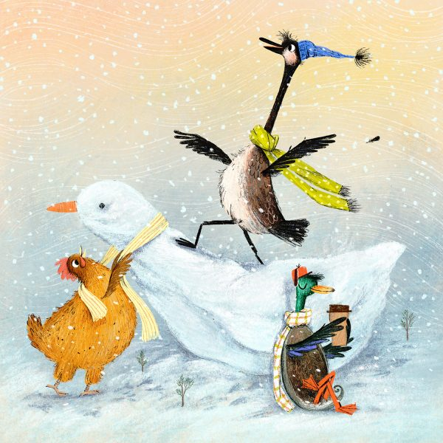

MONDAY 5TH JANUARY
Afternoon -
Chatty Café Drop In - 1pm - 2pm - John (Volunteer) - (The Old School Café)
- Are you feeling isolated and in need of a chat and some friendly company? Then we welcome you to pop into The Old School Café, where one of our lovely volunteers will be there waiting. This is not a counselling session, but a safe space where you can have a lovely informal chat Hopefully you will leave feeling a little brighter.

Positive Posca’s (2 Weeks) - 1.15pm - 3.30pm - Olwyn - (Craft Room - Max. 14ppl)
- A new year, a new class! Let’s start the new year on a positive note, with these vibrantly coloured illustrated affirmations. Images will be provided for inspiration, but the words you choose to illustrate are entirely up to you.


Mondays Class

“Positive Poscas” Example
TUESDAY 6TH JANUARY
Morning -
(Busy Morning)
Social Day - 9.30am - 4pm - (Craft Room - Max. 20ppl)
- A day for social interaction and a safe place to get on with any hobbies you may have e.g., Painting, drawing, writing, jigsaws, crosswords, knitting. Or just enjoy a nice little chin wag with a cuppa. You must still book a slot on any social day you wish to attend, to secure a seat.

Afternoon -

“Knit Happens” Introductory - 1.30pm - 3.30pm - Gail - (Volunteer) - (The Old School Café)
- This simple knitting session is ideal for those who have minimal to no experience in knitting. Our lovely volunteer will gently guide you, showing you the basic of techniques. From here, if you feel confident enough, you can then join onto our following sessions each week to gain more knowledge and knitting skills as you go.

WEDNESDAY 7TH JANUARY
Morning -
Calligraphy (4 Weeks) - 10am - 12pm - Olwyn - (Craft Room - Max. 14ppl)
- Copperplate Calligraphy is a beautiful style of calligraphy which incorporates thick and thin lines within each letter. This is achieved by pressure on the pen nib. There is an amount of focus and attention needed to achieve the right amount of pressure, use the right amount of ink and remember the shape of each letter. The focus and precision in this course make it a lovely distraction from unwanted thoughts and can be very therapeutic!
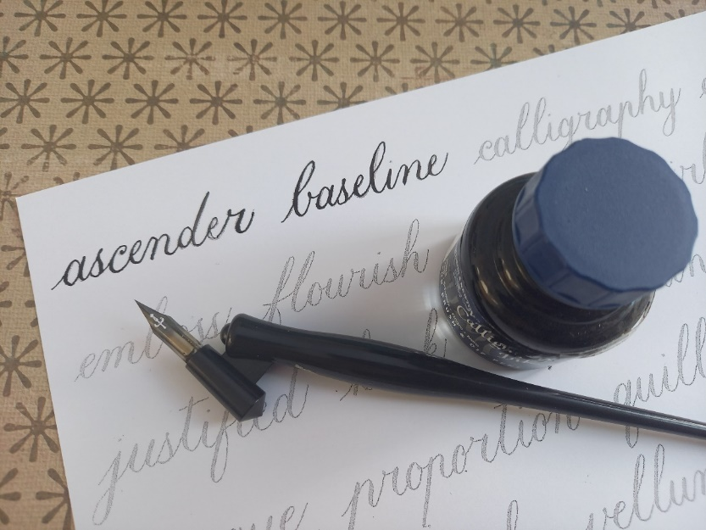

Afternoon –
“I’ll Start Tomorrow” (2 Weeks) - 1.15pm - 3.30pm - Olwyn (Craft Room - Max. 14ppl)
- As we move into the new year, thoughts turn to healthy eating and exercise. Well let’s just have one more burger….to paint! We will use watercolours to layer up colours to add depth to our illustration and create realism.



THURSDAY 8TH JANUARY
(Busy Day)
Morning -
Social Day - 9.30am - 4pm - (Craft Room - Max. 20ppl)
Knitted Winter Socks - 10am - 12pm - Loni (Volunteer) - (Rm. 2 - Continued - Week. 3)
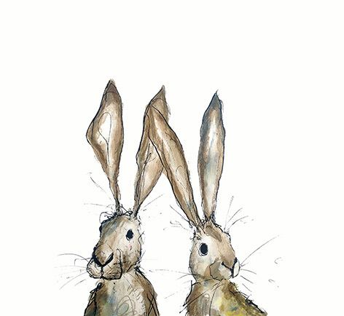
- This is a continuation of a smaller group which formed from the pre-existing “Knit happens” group. If you are interested in this session, please let us know and we may try and put it on again in the near future.
FRIDAY 9TH JANUARY

Morning -
Colour pop! - 10am - 12pm - Olwyn - (Craft Room - Max. 14ppl)
- Each participant will be able to choose a black and white image that appeals to them in some way. The fun part of this class comes when we alter the images by adding colour in the form of outlines, patterns, text and blocks of colour.

Embroidery Skills (4 Weeks) - 10am - 12pm - Meg, Alison & Gail - (Room 2 - Max.7ppl)
- This basic embroidery course teaches students how to hand stitch and embroider using a needle and thread. Sessions may include instruction on how to prepare fabric, transfer designs, practice different stitch patterns and use a hoop. This course is designed for all skill levels. If you book onto this course, please pop the following 4 weeks in your diary.

Afternoon -
From the Top - 1.15pm - 3.30pm - Olwyn - (Room 2 - Max.8ppl)
- We are taking an unusual viewpoint to create our pastel drawings this time, a bird’s eye view from the top looking down. In some ways, this could make drawing our still – life images simpler, so let’s have a go and take to the air.

Textiles Group (4 Weeks) - 1.15pm - 3.30pm - Meg, Alison & Gail - (Craft Rm. - Max.10ppl)
- Cosy Hats & Scarves - With winter in full swing we will be making our own beany hat and/or scarf. You will be using a combination of hand and machine sewing, a little experience is beneficial, but not essential. You be supported by 3 of our wonderful volunteers. If you book onto this course, you must be able to attend the first session, as this is the most informative. If you cannot make the first session your space on the course will be offered to another attendee.
Fridays Classes

Morning -
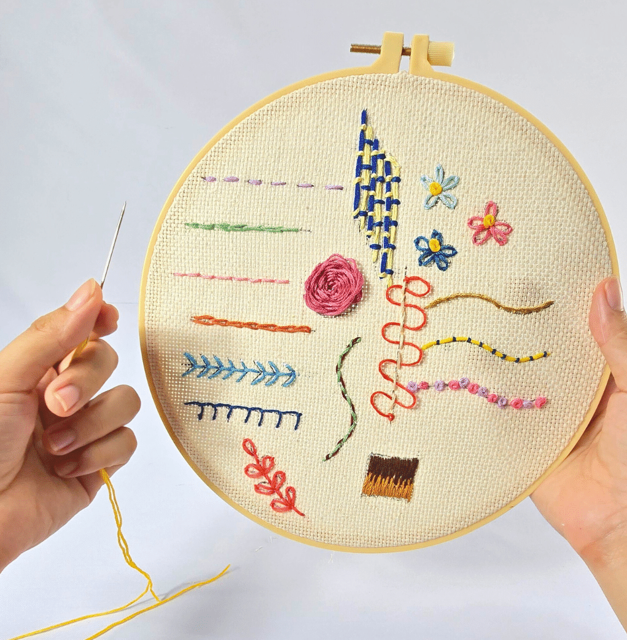
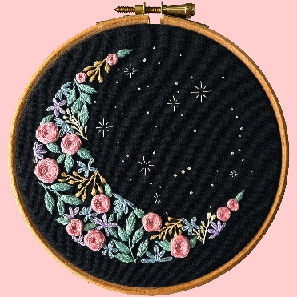


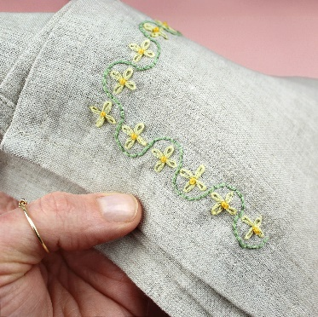
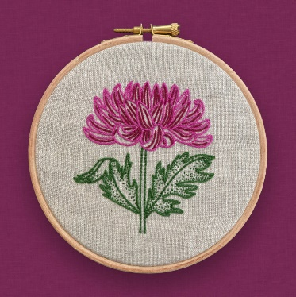

“Colour Pop!” Example “Embroidery Skills” Examples

Afternoon -

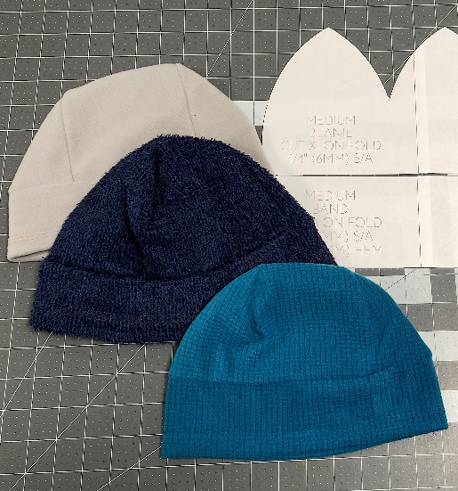

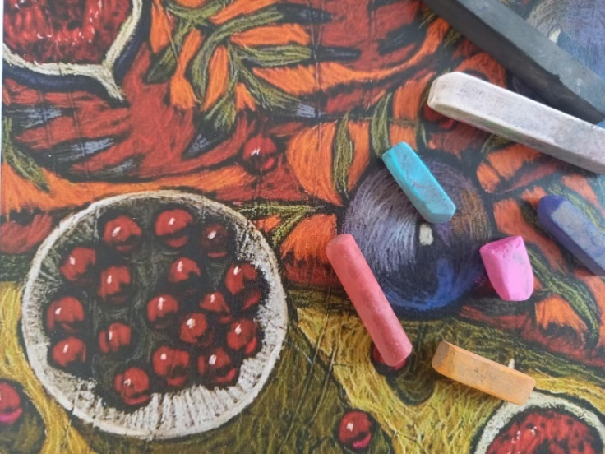

“From The Top” Example “Hats & Scarves” Examples

MONDAY 12TH JANUARY
Afternoon -
Chatty Café Drop In - 1pm - 2pm - John (Volunteer) - (The Old School Café)
Positive Posca’s - 1.15pm - 3.30pm - Olwyn - (Continued - Final Session)

TUESDAY 13TH JANUARY
Morning -
Social Day - 9.30am - 4pm - (Craft Room - Max. 20ppl)
Afternoon -
“Knit Happens” Intermediate - 1.30pm - 3.30pm - Gail (Volunteer) - (The Old School Cafe)
WEDNESDAY 14TH JANUARY
Morning -
Calligraphy - 10am - 12pm - Olwyn - (Continued - Week 2)
Afternoon -

“I’ll Start Tomorrow” - 1.15pm - 3.30pm - Olwyn (Continued - Final Session)

THURSDAY 15TH JANUARY
(Busy day)
Morning -
Social Day - 9.30am - 4pm - (Craft Room - Max.20ppl)
Knitted Winter Socks - 10am - 12pm - Loni (Volunteer) - (Continued - Week 4)

FRIDAY 16TH JANUARY
Morning -
3D Watercolour Wreath - 10am - 12pm - Olwyn - (Craft Room - Max.14ppl)
- A relaxing watercolour class where we will create a wreath from simple leaf shapes in shades of green. We will paint some separate leaf shapes which we can cut out when dry, then add as a final raised embellishment.
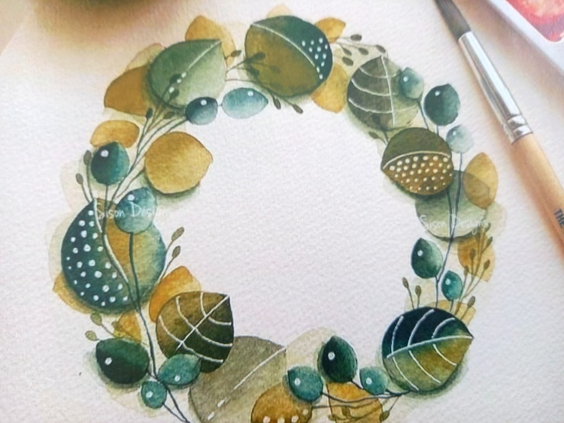

Embroidery Skills - 10am - 12pm - Meg, Alison & Gail - (Continued - Week 2)
Afternoon -
Botanical Drawing - 1.15pm - 3.30pm - Olwyn - (Room 2 - Max.8ppl)
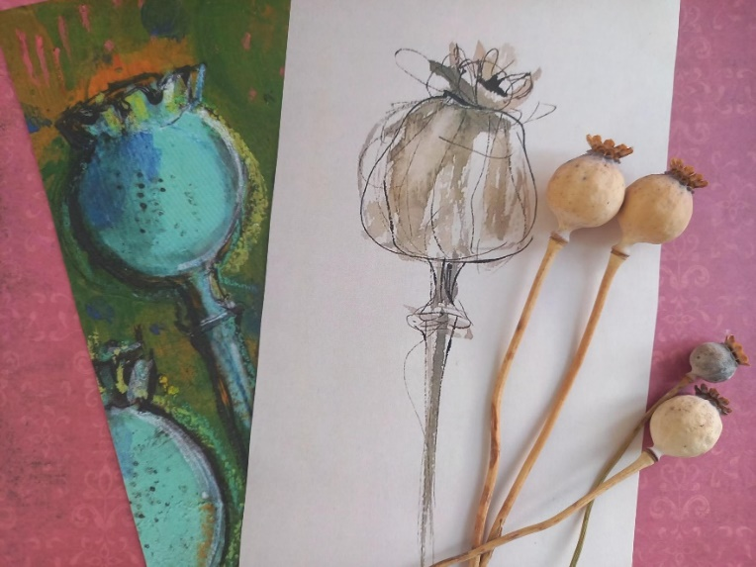
- Poppy Seed Pods - A donation of poppy seed pods has inspired us to draw and paint these beautifully structured wonders of nature. In this class, we will experiment with different styles of illustration, observing the seed pod closely and recording it in a range of mediums.

Textiles Group - 1.15pm - 3.30pm - Meg, Alison, Gail - (Continued - Week 2)
MONDAY 19TH JANUARY
Afternoon -
Chatty Café Drop In - 1pm - 2pm - John (Volunteer) - (The Old School Café)
Botanical Drawing - 1.15pm - 3.30pm - Olwyn - (Craft Room - Max.14ppl)
TUESDAY 20TH JANUARY
Morning -
Social Day - 9.30am - 4pm - (Craft Room - Max.20ppl)
Afternoon -
“Knit Happens” Intermediate - 1.30pm - 3.30pm - Gail (Volunteer) - (The Old School Cafe)
WEDNESDAY 21ST JANUARY
Morning -
Calligraphy - 10am - 12pm - Olwyn - (Continued - Week 3)

Music Therapy Taster Session - 10am - 10.45 - Adriel (Nordoff) - (Room 3 – One-to-One)
- Music therapy uses music to support health and wellbeing, helping people thrive in their own life circumstances. Sessions are tailored to individuals and may include listening, improvisation, learning new skills, songwriting, or other creative work. You don’t need any musical experience - everyone can respond to music. This is a one-to-one taster session, if you enjoy this session, you will have the opportunity to continue them long term. Please read the information on the back page to learn more about these sessions.
Music Therapy Taster Session - 11am - 11.45 - Adriel (Nordoff) - (Room 3 – One-to-One)
- This is a one-to-one taster session, if you enjoy this session, you will have the opportunity to continue them long term
Afternoon -
From The Top - 1.15pm - 3.30pm - Olwyn - (Craft Room - Max.14ppl)
Group Music Therapy Taster Session - 2pm - 3pm - Adriel (Nordoff) - (Room 2 - Max. 8ppl)
- Music therapy uses music to support health and wellbeing, helping people thrive in their own life circumstances. In these sessions you will Improvise and create music together, with a focus on listening and collaboration. This is a taster session, if you enjoy this session, you will have the opportunity to continue them long term. Please read the information sheet on the back page to learn more about these sessions.

THURSDAY 22ND JANUARY
(Busy day)
Morning -
Social Day - 9.30am - 4pm - (Craft Room - Max. 20ppl)
Knitted Winter Socks – 10am - 12pm - Loni (Volunteer) - (Continued - Week 5)

FRIDAY 23RD JANUARY
Morning -
“I’ll start Tomorrow” (2 Weeks) - 10am - 12pm - Olwyn - (Craft Room - Max. 14ppl)
Embroidery Skills - 10am - 12pm - Meg, Alison & Gail - (Continued - Week 3)
Afternoon -
Positive Poscas (2 Weeks) - 1.15pm - 3.30pm - Olwyn - (Room 2 - Max. 8ppl)
Textiles Group - 1.15pm - 3.30pm - Meg, Alison, Gail - (Continued - Week 3)

MONDAY 26TH JANUARY
Afternoon -
Chatty Café Drop In - 1pm - 2pm - John (Volunteer) - (The Old School Café)
From The Top - 1.15pm - 3.30pm - Olwyn - (Craft Room - Max.14ppl)

TUESDAY 27TH JANUARY
Morning -
Social Day - 9.30am - 4pm - (Craft Room - Max.20ppl)
Afternoon -
“Knit Happens” Intermediate - 1.30pm - 3.30pm - Gail (Volunteer) - (The Old School Cafe)
WEDNESDAY 28TH JANUARY
Morning -
Calligraphy - 10am - 12pm - Olwyn - (Continued - Final Session)
Music Therapy Taster Session - 10am - 10.45am - Adriel (Nordoff) - (Room 3 - One to One)
Music Therapy Taster Session - 11am - 11.45am - Adriel (Nordoff) - (Room 3 - One to One)

Afternoon -
Desert Island Discs - 1.15pm - 3.30pm - Olwyn - (Craft Room - Max. 14ppl)
- In this extremely popular and uplifting group session, you will have the opportunity to request and listen to songs that you enjoy or may have meaning to you. If you would like, you will get the opportunity to share why you chose your song and what meaning it has to you, or you may just choose to listen to others.
Group Music Therapy Taster Session - 2pm - 3pm - Adriel (Nordoff) - (Room 2 - Max. 8ppl)

THURSDAY 29TH JANUARY
(Busy day)
Morning -
Social Day - 9.30am - 4pm - (Craft Room - Max. 20ppl)

Knitted Winter Socks - 10am - 12pm - Loni (Volunteer) - (Continued - Week 6)

FRIDAY 30TH JANUARY
(Very busy day)
Morning -
“I’ll start Tomorrow” - 10am - 12pm - Olwyn - (Continued - Final Session)
Embroidery Skills - 10am - 12pm - Meg, Alison, Gail - (Continued - Final Session)
Afternoon -
Positive Poscas - 1.15pm - 3.30pm - Olwyn - (Continued - Final Session)
Textiles Group - 1.15pm - 3.30pm - Meg, Alison, Gail - (Continued - Final Session)



Music Therapy at St Margaret’s Centre Supporting wellbeing through creativity and connection
What is Music Therapy?
Music therapy uses music to support health and wellbeing, helping people thrive in their own life circumstances. Sessions are tailored to individuals or groups and may include listening, improvisation, learning new skills, songwriting, or other creative work.
You don’t need any musical experience - everyone can respond to music.
The Nordoff-Robbins Approach
These sessions draw on the Nordoff-Robbins approach, a world-leading, evidence-based form of music therapy. The approach is based on the principle of core musicality - the understanding that we all have the capacity to express ourselves, communicate and connect through music. It is helpful for mental wellbeing, offering:
- A safe, non-verbal way to explore emotions
- Opportunities to build confidence and agency
- Support for social connection and shared creativity
Taster Sessions – January & February 2026
Taster sessions are available on Wednesdays from 21 January 2026.
Individual Sessions (up to 45 minutes)
One-to-one music making in a supportive space—no musical skills required.
Group Sessions (60 minutes, up to 8 people)
Improvising and creating music together, with a focus on listening and collaboration.

Sessions are facilitated by Adriel Yap, a trainee music therapist with Nordoff & Robbins. Adriel is an organist and a pipe organ builder.
With your written consent, sessions are recorded in video or audio. These will mainly be used in Supervision where a tutor will help Adriel think about the work he is doing with you at St Margaret’s. They will not be shared on social media without further consent.
