Please read carefully.
Hello,
We hope this letter finds you well.
Enclosed you will find the latest timetable of activities for March 2026. We will be taking bookings for these activities via phone call or email from 10am on Monday 23rd February Please do not phone us to try booking before this date and time. You will find our contact number and email address on the front page of your timetable.
After a review of our safety and security measures, we ask that our attendees and volunteers do not enter the building any earlier than 15 minutes before your session starts. All class start and finish times are stated on your timetable. Our Centre door will now be locked until 9.15am. We also ask that if you are not booked onto anything, please do not wander upstairs or into the workshop and disturb staff/classes. You are welcome to come in and purchase food or use a token in our Café. Thank you for your understanding.
Due to the volume of new referrals coming through. You will only be able to book onto one Social Day (Tuesday or Thursday) and two of Olwyn’s classes per week. This is so we can give new attendees a fair chance of booking onto sessions. (Not including volunteer led classes).
We please ask that you pay a £1 attendance fee per session. Your attendance fee goes back into the Centre and helps towards cost of materials and use of our tea and coffee facilities situated in our craft room. Your contribution is much appreciated.
Please turn up to your class on time, unless you have called to say you are running late. Please do not eat food or leave to go for a cigarette during classes, this can be very disruptive for other attendees and the instructor. You are all given a 15-minute break halfway through your classes to eat, make a beverage and smoke.
If you are booked onto any class and cannot make it for whatever reason you must call the centre to inform us of this as early as possible, so that we can offer the space to somebody else. You still need to book to attend Social Days as well as regular classes; to guarantee you have a seat.

Classes with this symbol - are dedicated, quieter sessions. Anybody can join them, but they are designed to be inclusive of neurodivergent individuals who may struggle to access our standard sessions. (Up to a Maximum of 20ppl in our Craft Room and 8ppl in Room 2)

We look forward to seeing you.

To Book Classes Call: 0191 384 8100 or Email: enquiries@stmargaretscentre.co.uk
(There is an attendance fee of £1 per session)
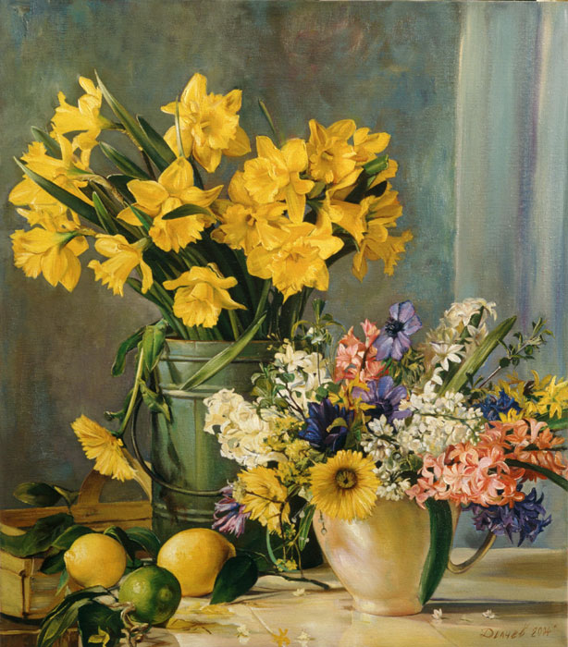

MONDAY 2ND MARCH
Afternoon -
Chatty Café Drop In - 1pm - 2pm - John (Volunteer) - (The Old School Café)
- Are you feeling isolated and in need of a chat and some friendly company? Then we welcome you to pop into The Old School Café, where one of our lovely volunteers will be there waiting. This is not a counselling session, but a safe space where you can have a lovely informal chat Hopefully you will leave feeling a little brighter.

Clay Tealight Holders (2 Weeks) - 1.15pm - 3.30pm - Olwyn - (Craft Room - Max. 14ppl)
- In this short course we will be making decorative tealight holders from air dried clay. Basic trees can be added around the perimeter, or you may want to add your own unique clay decorations. In the second week we will paint our tealight holders with natural, earthy colours. To book onto this course you must be able to attend both weeks.
Mondays Class Examples
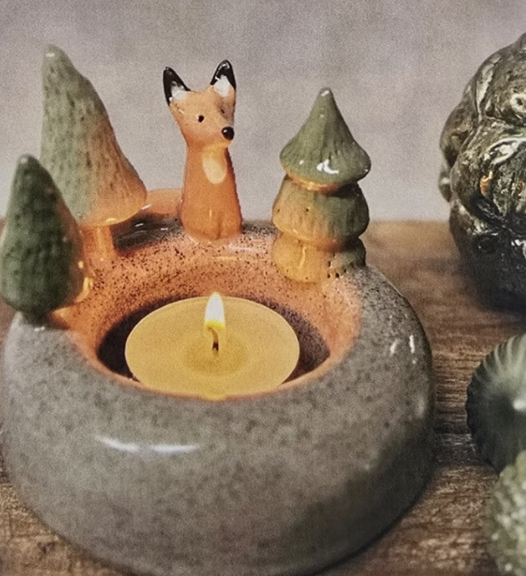
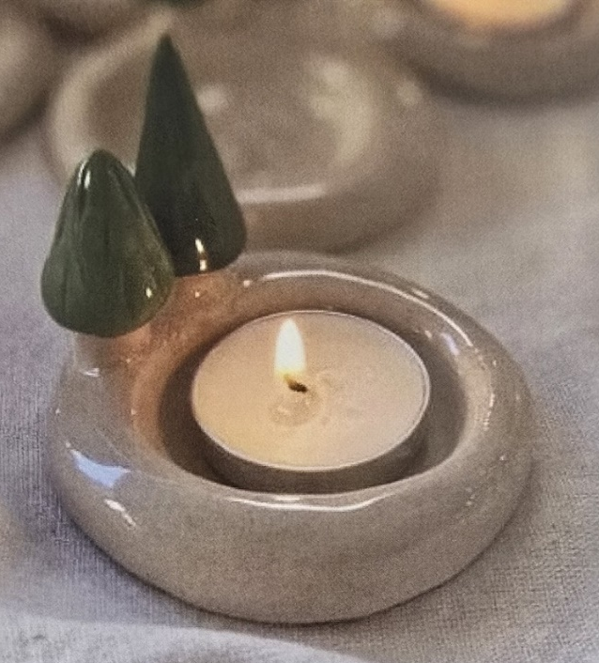

“Clay Tealight Holders” Example

TUESDAY 3RD MARCH
Morning -
Social Day - 9.30am - 4pm - (Craft Room - Max. 20ppl)
- A day for social interaction and a safe place to get on with any hobbies you may have e.g., Painting, drawing, writing, jigsaws, crosswords, knitting. Or just enjoy a nice little chin wag with a cuppa. You must still book a slot on any social day you wish to attend, to secure a seat.

IT’S BACK! Gardening - 10am - 12pm - Sandra (Volunteer) - (Meet in Craft Room)
- You will help with a little weeding, potting plants, and bulbs, watering flowers and assisting with the maintenance of our flower beds, lawns, and hedges. Outdoor activities are proven to help with wellbeing and mental health, so come and potter about, breathe in the fresh air and absorb some of that all-important Vitamin D. These are open sessions; you must book up each week to guarantee a space.
Afternoon -

“Knit Happens” Introductory - 1.30pm - 3.30pm - Gail - (Volunteer) - (The Old School Café)

- This simple knitting session is ideal for those who have minimal to no experience in knitting. Our lovely volunteer will gently guide you, showing you the basic of techniques. From here, if you feel confident enough, you can then join onto our following sessions each week to gain more knowledge and knitting skills as you go.

WEDNESDAY 4TH MARCH
Morning -
The Shape of Colour (2 Weeks) - 10am - 12pm - Olwyn - (Craft Room - Max.14ppl)
- In this watercolour class we will begin by drawing a black and white image of your choice, either free-hand or outlining a pre-printed image. The next step is to choose a shape or multiple shapes to draw on top of your image. For the last step we will watercolour only within the boundaries of your chosen shape.
Music Therapy (5 Weeks) - 10am - 10.45am - Adriel (Nordoff) - (Room 3 - One-to-One)
- Music therapy uses music to support health and wellbeing, helping people thrive in their own life circumstances. Sessions are tailored to individuals and may include listening, improvisation, learning new skills, songwriting, or other creative work. You don’t need any musical experience - everyone can respond to music. These are one-to-one sessions.
Music Therapy (5 Weeks) - 11am - 11.45am - Adriel (Nordoff) - (Room 3 - One-to-One)

Afternoon -
Dry Brush Painting - 1.15pm - 3.30pm - Olwyn - (Craft Room - Max. 14ppl)
- Springtime - Back with an old favourite. Dry Brush painting is a technique where paint is added to a dry brush, and no water is to be used throughout. As a result, the brush strokes are wispy and textured, with unexpected bursts of colour that pop out as you apply your brush strokes. In this session you will be embracing the warmer weather by painting some bright sunlight filled illustrations.
Group Music Therapy - 1.15pm - 2.15pm - Adriel (Nordoff) - (Room 2 - Max. 8ppl)
- Music therapy uses music to support health and wellbeing, helping people thrive in their own life circumstances. In these group sessions you will Improvise and create music together, with a focus on listening and collaboration. These are open, weekly sessions, you can book on as little or as many sessions as you like.

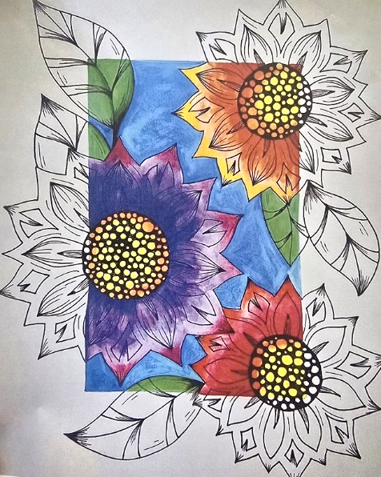
Morning - “The Shape of Colour” Example Afternoon - “Dry Brush Painting” Example

THURSDAY 5TH MARCH
(Busy Day)
Morning -
Social Day - 9.30am - 4pm - (Craft Room - Max. 20ppl)
Introduction to Woodwork (3 Weeks) - 10am - 3pm - Rob - (Workshop - Max.5ppl)
- In this short course you will learn how to design, measure, and build a small wheelbarrow planter from start to finish. The session will guide you through drawing up a plan, using tools safely and effectively, and accurately measuring, cutting, and assembling your project. You’ll work from your own drawing and measurements — and if you’ve never followed a plan before, don’t worry, you’ll be shown exactly how to do it step by step.
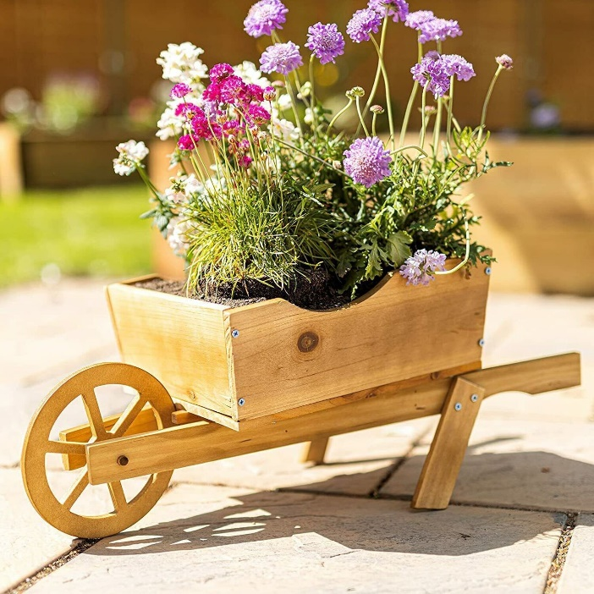


Afternoon -
Hatha Yoga (4 Weeks) - 2.15pm - 3.15pm - Julie (Volunteer) - (Room 2 - Max.4ppl)
- You don't need to be flexible or fit to do yoga. Yoga is a journey, and you join the road at the place you are currently at... Yoga celebrates being perfectly imperfect! Yoga is good for creating space for you. It allows you to develop a mindful awareness of where your body is in time and space, and that helps regulate your nervous system as you feel more grounded. It can help you connect to your body and develop strength and functional mobility. You will be able to learn techniques to regulate and ground yourself through breathing (pranayama) and postures (asanas) and have a good old stretch out whilst you're doing it! Hatha yoga is inclusive and is for everybody. Bring a bottle of water and extra clothing so you can layer up and down, in case you get warm/hot or cold. Sometimes you might be seated for a few minutes for a meditation, and the body can cool down quickly. Any loose, comfortable clothing works for these sessions. No session on Thurs 12th it will continue the 19th of March.

FRIDAY 6th MARCH

Morning -
Gemstone Bookmarks - 10am - 12pm - Olwyn - (Craft Room - Max. 14ppl)
- In this relaxing session you will create your own bookmarks. firstly, you will add colour to your gemstone by shading with our beautiful Prismacolor pencils. You will then intricately add embellishments using fineliners. The result is a realistic looking 3D gemstone surrounded with a decorative border.

Embroidery Skills (5 Weeks) - 10am - 12pm - Meg, Alison & Gail - (Room 2 - Max.7ppl)
- This basic embroidery course teaches students how to hand stitch and embroider using a needle and thread. Sessions may include instruction on how to prepare fabric, transfer designs, practice different stitch patterns and use a hoop. This course is designed for all skill levels. If you book onto this course, please pop the following 4 weeks in your diary.

Afternoon -
Glass Pebble Gift Tags - 1.15pm - 3.30pm - Olwyn - (Room 2 - Max.8ppl)
- These little gift tags make a nice addition to any gift, and it’s always nice to be prepared! A bit of drawing is required to make your small designs come to life, and some fiddly and intricate cutting out is involved. Please make sure that this is something you don’t mind doing and can do independently before you sign up to this class.

Textiles Group - Draught Excluder (5 Weeks) - 1.15pm - 3.30pm - Meg, Alison & Gail - (Craft Room - Max.10ppl)
- In this course you will be creating your own draught excluder which will resemble a row of quaint cottages. These will be mainly hand embroidered with added detailing and some sewing machine work will be involved. If you book onto this course, you must be able to attend all 5 sessions. If you cannot make any of the sessions, your space on the course will be offered to another attendee who can. This is due to this classes’ high demand.

Fridays Class Examples

Morning -
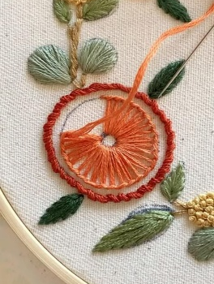
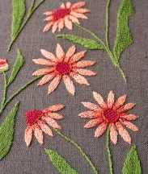
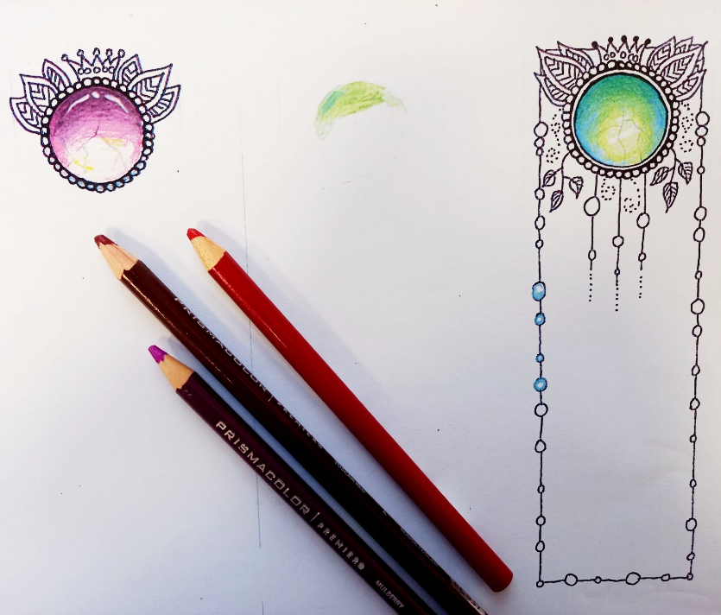

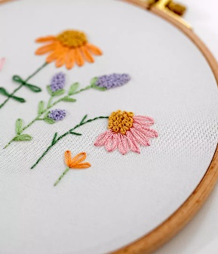


“Gemstone Bookmarks” Example “Embroidery Skills” Examples

Afternoon -


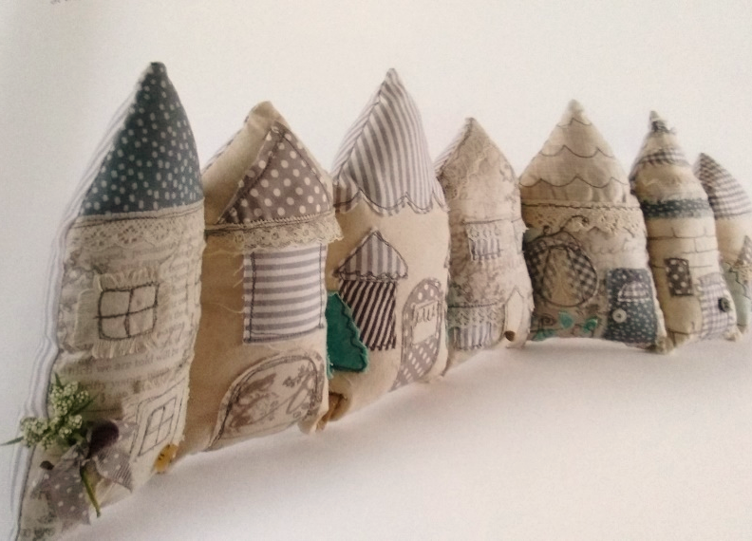

“Glass Pebble Gift Tags” Example “Draught Excluder” Example

SUNDAY 8TH MARCH
SUNDAY LUNCH CLUB (£4.50 paid in advance) - 12pm - 3pm - (Craft Room - Max.22ppl)
- You asked, and we listened! Our Centre will now open one Sunday each month, with our wonderful Chair of Trustees, Erica, and two fabulous volunteers, Lorraine and Jon, cooking and serving a traditional Sunday roast followed by a delicious dessert. While you wait for your meal, enjoy a fun quiz or some light entertainment, then sit back and savour a hearty, home-cooked lunch. It’s the perfect way to brighten your Sunday with great food, friendly faces, and warm conversation. To guarantee your space you must pay in advance. Please let us know which main you would like from the options below. We will ask for any allergies and preferences when taking bookings. If you do not inform us of any preferences prior to arriving for your lunch, there will be no option for last minute changes on the day. Please do not turn up late.


MONDAY 9TH MARCH
Afternoon -
Chatty Café Drop In - 1pm - 2pm - John (Volunteer) - (The Old School Café)
Clay Tealight Holders - 1.15pm - 3.30pm - Olwyn - (Continued - Final Session)
TUESDAY 10TH MARCH
Morning -
Social Day - 9.30am - 4pm - (Craft Room - Max. 20ppl)
Gardening - 10am - 12pm - Sandra (Volunteer) - (Meet in Craft Room)
Afternoon -
“Knit Happens” Intermediate - 1.30pm - 3.30pm - Gail (Volunteer) - (The Old School Cafe)
WEDNESDAY 11TH MARCH
Morning -
The Shape of Colour - 10am - 12pm - Olwyn - (Final Session)
Music Therapy - 10am - 10.45am - Adriel (Nordoff) - (Continued - Week 2)

Music Therapy - 11am - 11.45am - Adriel (Nordoff) - (Continued - Week 2)

Afternoon -

Branch Out - 1.15pm - 3.30pm - Olwyn - (Craft Room - Max.14ppl)
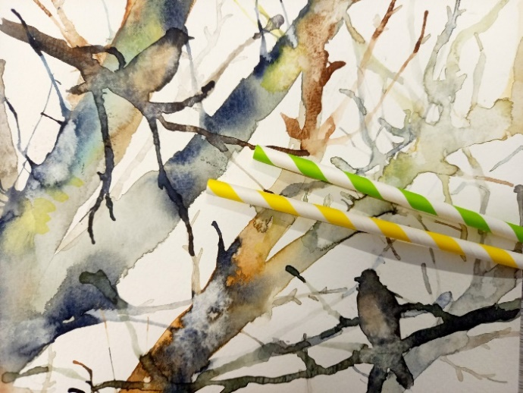
- Watercolours - In this class you will use
a fun technique of blowing watercolours
across card with a straw. This technique
allows you to create tree trunks with
random twigs branching out of it. You
will create a stunning woodland image
worthy of being framed on your wall.
There is a lot of exhaling in this session,
so, if you are struggling at all with any
chest problems, please do not book onto
this session.
Group Music Therapy - 1.15pm - 2.15pm - Adriel (Nordoff) - (Room 2 - Max. 8ppl)

THURSDAY 12TH MARCH
(Busy day)
Morning -
Social Day - 9.30am - 4pm - (Craft Room - Max.20ppl)
Introduction to Woodwork - 10am - 3pm - Rob - (Continued - Week 2)
Afternoon -
No Yoga Today - Continues Next Thursday 19th

FRIDAY 13TH MARCH
Morning -
Dry Brush Painting - 10am - 12pm - Olwyn - (Craft Room - Max.14ppl)
Embroidery Skills - 10am - 12pm - Meg, Alison & Gail - (Continued - Week 2)
Afternoon -
An Introduction to Gouache - 1.15pm - 3.30pm - Olwyn - (Room 2 - Max.8ppl)
- Gouache is a water – based paint, but unlike watercolours it is very opaque, allowing you to paint one colour over another, creating layers and textures. It is nice and smooth, so you can paint neat lines and blocks of colour, without the stickiness of acrylic. In this basic introduction, we will paint simple graphic landscapes, just to get a feel of this medium.


Textiles - Draught Excluder - 1.15pm - 3.30pm - Meg, Alison, Gail - (Continued - Week 2)

MONDAY 16TH MARCH
Afternoon -
Chatty Café Drop In - 1pm - 2pm - John (Volunteer) - (The Old School Café)
Branch Out - 1.15pm - 3.30pm - Olwyn - (Craft Room - Max.14ppl)
TUESDAY 17TH MARCH
Morning -
Social Day - 9.30am - 4pm - (Craft Room - Max.20ppl)
Gardening - 10am - 12pm - Sandra (Volunteer) - (Meet in Craft Room)
Afternoon -
Whimsical Hand Puppet (2 Weeks) - 1.15pm - 3.30pm - Marie (Volunteer) - (Rm.2 -Max.8ppl)

- Please bring a large sock of your choice and make it personal. In this class you will learn how to make a fun and easy sock puppet. Marie will lead a step-by-step tutorial where you'll transform an old sock into a cute character using simple craft supplies. Making it your own by bringing your own sock and choosing eye and hair colour from the supplies provided by the centre. An ability to comfortably use scissors and a glue gun independently is essential.

“Knit Happens” Intermediate - 1.30pm - 3.30pm - Gail (Volunteer) - (The Old School Cafe)
WEDNESDAY 18TH MARCH
Morning -
Gemstone Bookmarks - 10am - 12pm - Olwyn - (Craft Room - Max.14ppl)

Music Therapy - 10am - 10.45am - Adriel (Nordoff & Robbins) - (Continued - Week 3)

Music Therapy - 11am - 11.45am - Adriel (Nordoff & Robbins) - (Continued - Week 3)

Afternoon -
Desert Island Discs - 1.15pm - 3.30pm - Olwyn - (Craft Room - Max.14ppl)
- In this extremely popular and uplifting group session, you will have the opportunity to request and listen to songs that you enjoy or may have meaning to you. If you would like, you will get the opportunity to share why you chose your song and what meaning it has to you, or you may just choose to listen to others.
Group Music Therapy - 1.15pm - 2.15pm - Adriel (Nordoff) - (Room 2 - Max. 8ppl)

THURSDAY 19TH MARCH
(Busy day)
Morning -
Social Day - 9.30am - 4pm - (Craft Room - Max. 20ppl)
Introduction to Woodwork - 10am - 3pm - Rob - (Final Session)
Afternoon –
Hatha Yoga - 2.15pm - 3.15pm - Julie (Volunteer) - (Continued - Week 2)
FRIDAY 20TH MARCH
Morning -
Watercolour Illustrations - 10am - 12pm - No Tutor - (Room 2 - Max.8ppl)
- Due to no instructor this morning, you will be offered a pre-illustrated image which you will paint using watercoloured paints.
Embroidery Skills - 10am - 12pm - Meg, Alison & Gail - (Continued - Week 3)
Afternoon -
Crosswords & Cuppas - 1.15pm - 3.30pm - No Tutor - (Room 2 - Max. 8ppl)
- Due to no instructor this afternoon, you will be offered a selection of crosswords and wordsearches to do whilst you enjoy a cuppa and a chat with the other clients.
Textiles - Draught Excluder - 1.15pm - 3.30pm - Meg, Alison, Gail - (Continued - Week 3)

MONDAY 23RD MARCH
Afternoon -
Chatty Café Drop In - 1pm - 2pm - John (Volunteer) - (The Old School Café)
Chalk Pastel Drawing - 1.15pm - 3.30pm - No Tutor - (Craft Room - Max.14ppl)
- Due to no instructor this afternoon, you will be offered a pre-printed Illustration which you will add colour and shading with chalk pastels.

TUESDAY 24TH MARCH
Morning -
Social Day - 9.30am - 4pm - (Craft Room - Max.20ppl)
Afternoon –
Gardening - 10am - 12pm - Sandra (Volunteer) - (Meet in Craft Room)
Whimsical Hand Puppet - 1.15pm - 3.30pm - Marie (Volunteer) - (Final Session)
“Knit Happens” Intermediate - 1.30pm - 3.30pm - Gail (Volunteer) - (The Old School Cafe)
WEDNESDAY 25TH MARCH
Morning -
Social Day - 9.30 - 4pm - (Craft Room - Max.20ppl)

Music Therapy - 10am - 10.45am - Adriel (Nordoff & Robbins) - (Continued - Week 4)

Music Therapy - 11am - 11.45am - Adriel (Nordoff & Robbins) - (Continued - Week 4)

Afternoon -
Group Music Therapy - 1.15pm - 2.15pm - Adriel (Nordoff) - (Room 2 - Max. 8ppl)

THURSDAY 26TH MARCH
(Busy day)
Morning -
Social Day - 9.30am - 4pm - (Craft Room - Max. 20ppl)

Afternoon -
Hatha Yoga - 2.15pm - 3.15pm - Julie (Volunteer) - (Continued - Week 3)

FRIDAY 27TH MARCH
(Very busy day)
Morning -
Crosswords & Cuppas - 10am - 12pm - No Tutor - (Room 2 - Max.8ppl)
- Due to no instructor this afternoon, you will be offered a selection of crosswords and wordsearches to do whilst you enjoy a cuppa and a chat with the other clients.
Embroidery Skills - 10am - 12pm - Meg, Alison, Gail - (Continued - Week 4)
Afternoon -
Chalk Pastel Drawing - 1.15pm - 3.30pm - No Tutor - (Room 2 - Max.8ppl)
- Due to no instructor this afternoon, you will be offered a pre-printed Illustration which you will add colour and shading with chalk pastels.
Textiles - Draught Excluder - 1.15pm - 3.30pm - Meg, Alison, Gail - (Continued - Week 4)

MONDAY 30TH MARCH
Afternoon -
Chatty Café Drop In - 1pm - 2pm - John (Volunteer) - (The Old School Café)
Watercolour Illustrations - 1.15pm - 3.30pm - No Tutor - (Craft Rm - Max.14ppl)
- Due to no instructor this morning, you will be offered a pre-illustrated image which you will paint using watercoloured paints.

TUESDAY 31ST MARCH
Morning -
Social Day - 9.30am - 4pm - (Craft Room - Max.20ppl)
Gardening - 10am - 12pm - Sandra (Volunteer) - (Meet in Craft Room)
Afternoon -
“Knit Happens” Intermediate - 1.30pm - 3.30pm - Gail (Volunteer) - (The Old School Cafe)

WEDNESDAY 1ST APRIL
Morning -
Dry Brush Painting - 10am - 12pm - Olwyn - (Craft Room - Max.14ppl)

Music Therapy - 10am - 10.45am - Adriel (Nordoff & Robbins) - (Final Session)

Music Therapy - 11am - 11.45am - Adriel (Nordoff & Robbins) - (Final Session)

Afternoon -
Gemstone Bookmarks - 1.15pm - 3.30pm - Olwyn - (Craft Room - Max.14ppl)
Group Music Therapy - 1.15pm – 2.15pm - Adriel (Nordoff) - (Room 2 - Max. 8ppl)

THURSDAY 2ND APRIL
(Busy day)
Morning -
Social Day - 9.30am - 4pm - (Craft Room - Max. 20ppl)

Afternoon -
Hatha Yoga - 2.15pm - 3.15pm - Julie (Volunteer) - (Final Session)

FRIDAY 3RD APRIL
CENTRE CLOSED – Good Friday

