Please read carefully.
Hello,
We hope this letter finds you well.
Enclosed you will find the latest timetable of activities for April 2026. We will be taking bookings for these activities via phone call or email from 10am on Monday 30th March Please do not phone us to try booking before this date and time. You will find our contact number and email address on the front page of your timetable.
After a review of our safety and security measures, we ask that our attendees and volunteers do not enter the building any earlier than 15 minutes before your session starts. All class start and finish times are stated on your timetable. Our Centre door will now be locked until 9.15am. We also ask that if you are not booked onto anything, please do not wander upstairs or into the workshop and disturb staff/classes. You are welcome to come in and purchase food or use a token in our Café. Thank you for your understanding.
Due to the volume of new referrals coming through. You will only be able to book onto one Social Day (Tuesday or Thursday) and two of Olwyn’s classes per week. This is so we can give new attendees a fair chance of booking onto sessions. (Not including volunteer led classes).
We please ask that you pay a £1 attendance fee per session. Your attendance fee goes back into the Centre and helps towards cost of materials and use of our tea and coffee facilities situated in our craft room. Your contribution is much appreciated.
Please turn up to your class on time, unless you have called to say you are running late. Please do not eat food or leave to go for a cigarette during classes, this can be very disruptive for other attendees and the instructor. You are all given a 15-minute break halfway through your classes to eat, make a beverage and smoke.
If you are booked onto any class and cannot make it for whatever reason you must call the centre to inform us of this as early as possible, so that we can offer the space to somebody else. You still need to book to attend Social Days as well as regular classes; to guarantee you have a seat.

Classes with this symbol - are dedicated, quieter sessions. Anybody can join them, but they are designed to be inclusive of neurodivergent individuals who may struggle to access our standard sessions. (Up to a Maximum of 20ppl in our Craft Room and 8ppl in Room 2)

We look forward to seeing you.

To Book Classes Call: 0191 384 8100 or Email: enquiries@stmargaretscentre.co.uk
(There is an attendance fee of £1 per session)
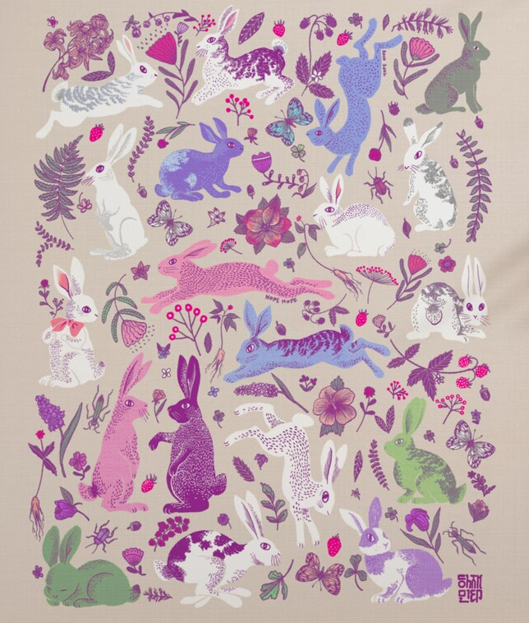

MONDAY 6TH APRIL
CENTRE CLOSED - Easter Monday

TUESDAY 7TH APRIL
Morning -
Social Day - 9.30am - 4pm - (Craft Room - Max. 20ppl)
- A day for social interaction and a safe place to get on with any hobbies you may have e.g., Painting, drawing, writing, jigsaws, crosswords, knitting. Or just enjoy a nice little chin wag with a cuppa. You must still book a slot on any social day you wish to attend, to secure a seat.

Gardening - 10am - 12pm - Sandra (Volunteer) - (Meet in Craft Room)
- You will help with a little weeding, potting plants, and bulbs, watering flowers and assisting with the maintenance of our flower beds, lawns, and hedges. Outdoor activities are proven to help with wellbeing and mental health, so come and potter about, breathe in the fresh air and absorb some of that all-important Vitamin D. These are open sessions; you must book up each week to guarantee a space.
Afternoon -
“Knit Happens” Introductory - 1.30pm - 3.30pm - Gail - (Volunteer) - (The Old School Café)
- This simple knitting session is ideal for those who have minimal to no experience in knitting. Our lovely volunteer will gently guide you, showing you the basic of techniques. From here, if you feel confident enough, you can then book onto the following sessions, each week to gain more knowledge and knitting skills as you go.

WEDNESDAY 8TH APRIL
Morning -
Blowing Bubbles - 10am - 12pm - Olwyn - (Craft Room - Max.14ppl)
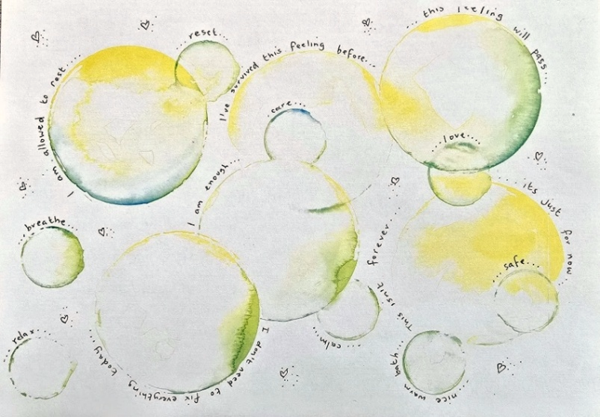
- Blowing bubbles is known to reduce the severity of panic attacks and anxiety, because it regulates the breathing and distracts the person by focusing on their breathing and the visual effects. We thought that it would be nice to embrace this lovely little technique, by printing our own bubbles on to paper and adding positive affirmations to our artwork.

Horticulture Group - 10am - 12pm - Joy (Volunteer) - (Allotments)
- You will assist in the general upkeep of our allotment, helping with digging, planting
fresh bulbs, weeding, and maintaining the grounds. You will help grow fresh produce
such as fruit, vegetables, and herbs as well as growing flowers, whilst learning new
skills as you go. Outdoor activities are proven to help with wellbeing and mental
health, so come and potter about, breath in the fresh air and absorb some of that all-important Vitamin D

Afternoon -
Cherry Blossom Wreath - 1.15pm - 3.30pm - Olwyn - (Craft Room - Max. 14ppl)
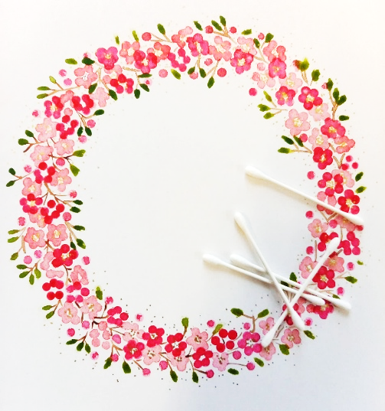
- Watercolours - Late March - early April, is when the beautiful pink cherry blossom appears! Using this simple technique, dipping cotton buds into watercolours, we will create a pretty wreath. We will build up the layers of pale pinks to deeper pinks, this is key to giving your painting a three-dimensional appearance, so why not have a go.

THURSDAY 9TH APRIL
(Busy Day)
Morning -
Social Day - 9.30am - 4pm - (Craft Room - Max. 20ppl)

FRIDAY 10TH APRIL

Morning -
Funky Emus - 10am - 12pm - Olwyn - (Craft Room - Max. 14ppl)
- Pastel Drawing - A fun pastel drawing class, where we can just scribble away and enjoy the process. Big eyes, a beak, and lots of wildly coloured feathers will bring your emu to life!

Afternoon -
Pen and Ink Landscapes (2 Weeks) - 1.15pm - 3.30pm - Olwyn - (Craft Room - Max.14ppl)
- Calligraphy is not the only way we can use our dipping pens and ink. They can be used to create outlines of varying weight, from whisper fine lines to heavier, thicker lines with the addition of a little pressure. This brings a more interesting appearance to our artwork. In the first week, we will create our outlines, and in the second week we will use our watercolours. Please pop the following week in your diary.

IT’S BACK! Walking Group - 1.30pm - 3pm - Nicola - (Meet in The Old School Café)
- We will venture out into our wonderful City, exploring the ‘nooks & crannies’ of Durham. This is a nice relaxed paced walk, with only slight inclines and as few stairs as possible (but to be expected in “Hilly” Durham) The walks usually take around 90mins depending on the route and individuals’ mobility. The walks are weather permitted; you will be contacted by lunchtime if the walk has been cancelled due to bad weather. Bring water and wear appropriate clothing for the weather.

Fridays Class Examples

Morning -


“Funky Emu’s” Example

Afternoon -
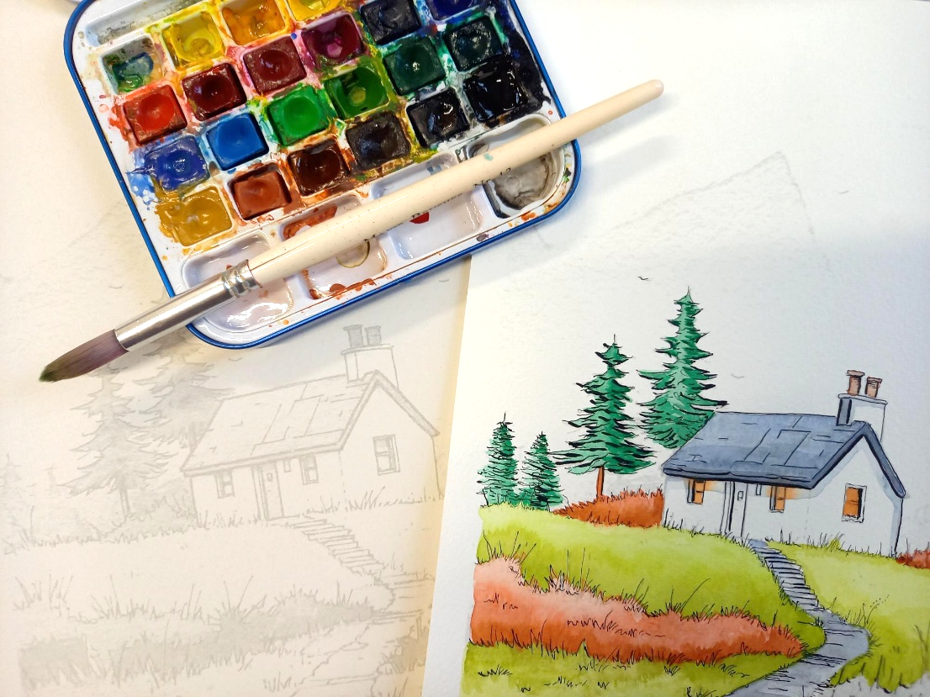

“Pen and Ink Lanscapes” Example

SUNDAY 12TH APRIL
SUNDAY LUNCH CLUB (£4.50 paid in advance) - 12pm - 3pm - (Craft Room - Max.16ppl)
- Our Centre will now open one Sunday each month. Our wonderful Chair of Trustees, Erica, and two volunteers, Lorraine and Jon, will be cooking and serving a traditional Sunday roast followed by a delicious dessert. While you wait for your meal, enjoy a fun quiz or some light entertainment, then sit back and savour a hearty, home-cooked lunch. It’s the perfect way to brighten your Sunday with great food, friendly faces, and warm conversation. To guarantee your space you must pay in advance. Please let us know which main you would like from the options below. We will ask for any allergies and preferences when taking bookings. If you do not inform us of any preferences prior to arriving for your lunch, there will be no option for last minute changes on the day. Please do not turn up late.


MONDAY 13TH APRIL
Afternoon -
Chatty Café Drop In - 1pm - 2pm - John (Volunteer) - (The Old School Café)
“Something Fishy” - 1.15pm - 3.30pm - Olwyn - (Craft Room - Max.14ppl)
- Collage With Acetate - This is a fun collage project, involving cutting, sticking and drawing with our lovely ‘Posca’ paint pens. The result is a quirky piece of artwork with a transparent fishbowl as a feature. Please be aware that there is fiddly cutting with scissors involved.
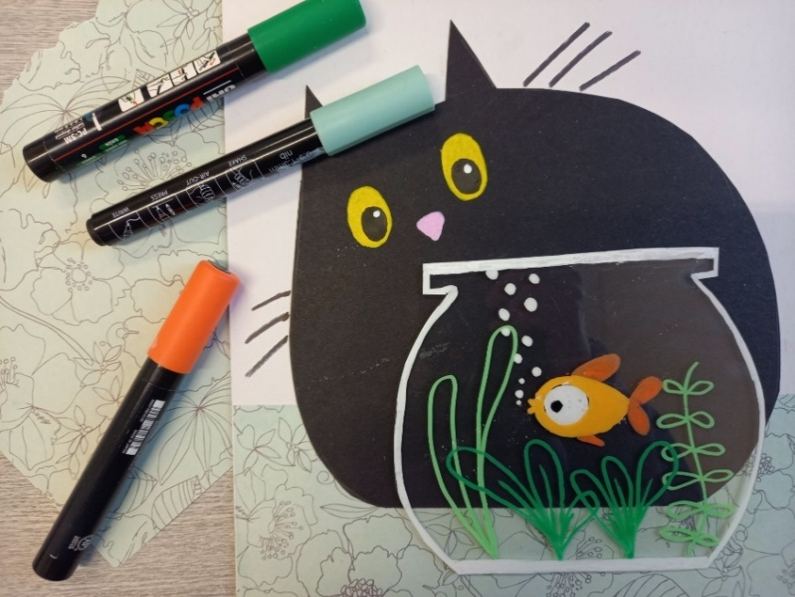

New Client Inductions - 2pm - 3.30pm - Andrea - (Room 2 - Max 8.ppl)
- This is for anybody new who has recently referred to our centre and has already had their initial visit. Andrea will be going through some essential introductory paperwork. Everybody must complete their Inductions before they are able to book onto our regular sessions. You will have the opportunity to book onto sessions at the end of the induction if you choose to do so. These will run every Monday afternoon, if you cannot make a Monday for personal reasons, speak to a member of staff to rearrange.

TUESDAY 14TH APRIL
Morning -
Social Day - 9.30am - 4pm - (Craft Room - Max. 20ppl)
Gardening - 10am - 12pm - Sandra (Volunteer) - (Meet in Craft Room)
Afternoon -
“Knit Happens” Intermediate - 1.30pm - 3.30pm - Gail (Volunteer) - (The Old School Cafe)
WEDNESDAY 15TH APRIL
Morning -
Watercolour Poppies - 10am - 12pm - Olwyn - (Craft Room - Max.14ppl)
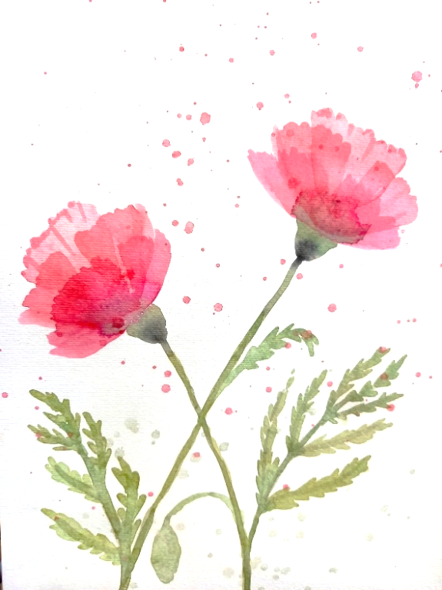
- A simple watercolour technique, where we layer up individual petals, allowing each layer to dry in between. This enhances the translucent effect of the watercolours, as it allows us to see through each layer of petals.

Horticulture Group - 10am - 12pm - Joy (Volunteer) - (Allotments)

Afternoon -

Embossed Metallic Picture Frames - 1.15pm - 3.30pm - Olwyn - (Craft Room - Max.14ppl)
- Create a beautiful, embossed metal effect picture frame, using a cardboard mount, some embossed wallpaper and acrylic paints. After covering our mounts with the wallpaper, we will paint them in black acrylic. We will then brush the embossed decoration with gold or silver or add any other touches of colour if you wish.
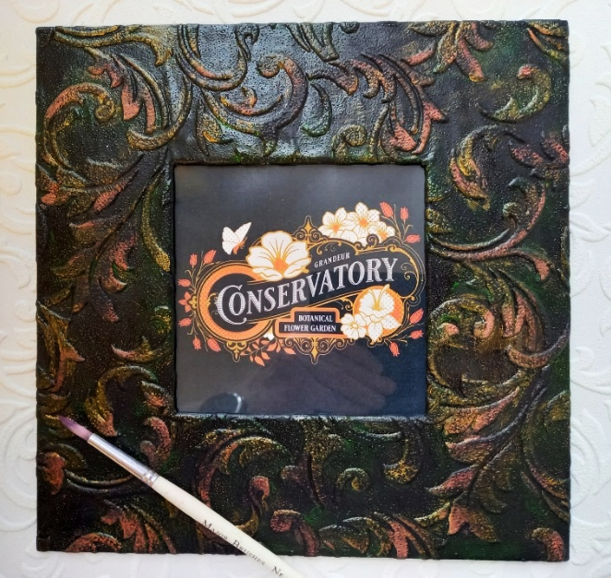

THURSDAY 16TH APRIL
(Busy day)
Morning -
Social Day - 9.30am - 4pm - (Craft Room - Max.20ppl)
Introduction to Woodwork (£8 fee) - (3 Weeks) - 10am - 3pm - Rob - (Workshop-Max.5ppl)
- In this short course you will learn how to design, measure, and build a Lantern from start to finish. The session will guide you through drawing up a plan, using tools safely and effectively, and accurately measuring, cutting, and assembling your project. You’ll work from your own drawing and measurements, with support throughout.
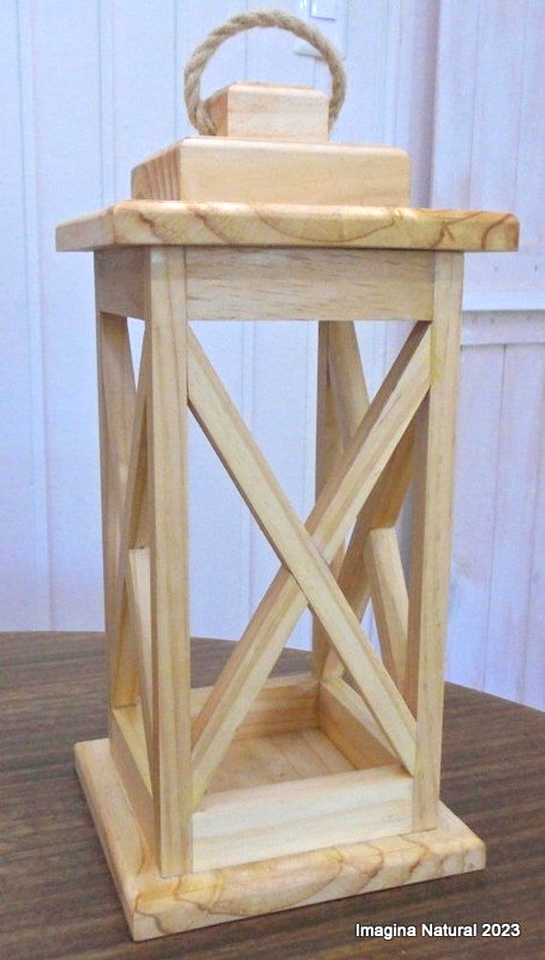

FRIDAY 17Th APRIL
Morning -
“Square Deal” - 10am - 12pm - Olwyn - (Craft Room - Max.14ppl)

- Drawing With Marker Pens - In this session we will be drawing and colouring very simple icons. An A3 piece of card with 12 blank squares will be provide, and it is your challenge to fill these squares with icons of your choice. References will be available to help with ideas.

Afternoon -
Pen And Ink Landscapes - 1.15pm - 3.30pm - Olwyn - (Continued - Final Session)

MONDAY 20TH APRIL
Afternoon -
Chatty Café Drop In - 1pm - 2pm - John (Volunteer) - (The Old School Café)
Cherry Blossom Wreath - 1.15pm - 3.30pm - Olwyn - (Craft Room - Max.14ppl)
New Client Inductions - 2pm - 3.30pm - Andrea - (Room 2 - Max 8.ppl)
TUESDAY 21ST APRIL
Morning -
Social Day - 9.30am - 4pm - (Craft Room - Max.20ppl)
Gardening - 10am - 12pm - Sandra (Volunteer) - (Meet in Craft Room)
Afternoon -
“Knit Happens” Intermediate - 1.30pm - 3.30pm - Gail (Volunteer) - (The Old School Cafe)

WEDNESDAY 22ND APRIL
Morning -
Funky Emus Pastel Drawing - 10am - 12pm - Olwyn - (Craft Room - Max.14ppl)

Music Therapy - 10am - 10.45am - Adriel (Nordoff) - (Room 3 - One-to-One)
- Music therapy uses music to support health and wellbeing, helping people thrive in their own life circumstances. Sessions are tailored to individuals and may include listening, improvisation, learning new skills, songwriting, or other creative work. You don’t need any musical experience - everyone can respond to music. These are one-to-one, open sessions.
Horticulture Group - 10am - 12pm - Joy (Volunteer) - (Allotments)
Afternoon -
(Busy Afternoon)
Pen And Ink Landscapes (2 Weeks) - 1.15pm - 3.30pm – Olwyn (Craft Room - Max.14ppl)
Group Music Therapy - 1.15pm - 2.15pm - Adriel (Nordoff) - (Room 2 - Max. 8ppl)
- Music therapy uses music to support health and wellbeing, helping people thrive in their own life circumstances. In these group sessions you will Improvise and create music together, with a focus on listening and collaboration. These are open, weekly sessions, you can book on as little or as many sessions as you like.

THURSDAY 23RD APRIL
(Busy day)
Morning -
Social Day - 9.30am - 4pm - (Craft Room - Max. 20ppl)
Introduction to Woodwork - 10am - 2pm - Rob - (Continued - Week 2)
- This session will finish an hour early at 2pm.
FRIDAY 24TH APRIL
Morning -
“Something Fishy” Collage - 10am - 12pm - Olwyn - (Craft Room - Max.14ppl)
Afternoon -
Embossed Picture Frames - 1.15pm - 3.30pm - Olwyn - (Craft Room - Max. 14ppl)

Walking Group - 1.30pm - 3pm - Nicola - (Meet in The Old School Café)

MONDAY 27TH APRIL
Afternoon -
Chatty Café Drop In - 1pm - 2pm - John (Volunteer) - (The Old School Café)
Watercolour Poppies - 1.15pm - 3.30pm - Olwyn - (Craft Room - Max.14ppl)

New Client Inductions - 2pm - 3.30pm - Andrea - (Room 2 - Max 8.ppl)

TUESDAY 28TH APRIL
Morning -
Social Day - 9.30am - 4pm - (Craft Room - Max.20ppl)
Afternoon –
Gardening - 10am - 12pm - Sandra (Volunteer) - (Meet in Craft Room)
“Knit Happens” Intermediate - 1.30pm - 3.30pm - Gail (Volunteer) - (The Old School Cafe)

WEDNESDAY 29TH APRIL
Morning -
“Something Fishy” Collage - 10am - 12pm - Olwyn - (Craft Room - Max.14ppl)

Music Therapy - 10am - 10.45am - Adriel (Nordoff & Robbins) - (Room 3 - One-to-One)

Horticulture Group - 10am - 12pm - Joy (Volunteer) - (Allotments)

Afternoon -
(Busy Afternoon)
Pen And Ink Landscapes - 1.15pm - 3.30pm - Olwyn - (Continued - Final Session)
Group Music Therapy - 1.15pm - 2.15pm - Adriel (Nordoff) - (Room 2 - Max. 8ppl)

THURSDAY 30TH APRIL
(Busy day)
Morning -
Social Day - 9.30am - 4pm - (Craft Room - Max. 20ppl)

Introduction to Woodwork - 10am - 2pm - Rob - (Continued - Final Session)
Afternoon -
Gentle Restorative Seated Yoga - 2.15pm - 3.15pm - Julie (Volunteer) - (Room.2-Max 4ppl)
- This session is aimed at those who may struggle with mobility. You don't need to be flexible or fit to do yoga. Yoga is a journey, and you join the road at the place you are currently at... Yoga celebrates being perfectly imperfect! Yoga is good for creating space for you Bring a bottle of water and extra clothing so you can layer up and down, in case you get warm/hot or cold. Sometimes you might be seated for a few minutes for a meditation, and the body can cool down quickly. Any loose, comfortable clothing works for these sessions.

FRIDAY 1ST MAY
Morning -
Blowing Bubbles - 10am - 12pm - Olwyn - (Craft Room - Max.14ppl)
Afternoon -
Desert Island Discs - 1.15pm - 3.30pm - Olwyn - (Craft Room - Max.14ppl)
- In this extremely popular and uplifting group session, you will have the opportunity to request and listen to songs that you enjoy or may have meaning to you. If you would like, you will get the opportunity to share why you chose your song and what meaning it has to you, or you may just choose to listen to others.

