Please read carefully.
Hello,
We hope this letter finds you well.
Enclosed you will find the latest timetable of activities for May 2026. We will be taking bookings for these activities via phone call or email from 10am on Monday 27th April Please do not phone us to try booking before this date and time. You will find our contact number and email address on the front page of your timetable.
After a review of our safety and security measures, we ask that our attendees and volunteers do not enter the building any earlier than 15 minutes before your session starts. All class start and finish times are stated on your timetable. Our Centre door will be locked until 9.15am to allow access to our volunteers. We also ask that if you are not booked onto anything, please do not wander upstairs or into the workshop and disturb staff/classes. You are welcome to come in and purchase food or use a token in our Café. Thank you for your understanding.
Due to the volume of new referrals coming through. You will only be able to book onto one Social Day (Tuesday or Thursday) and two of Olwyn’s classes per week. This is so we can give new attendees a fair chance of booking onto sessions. (Not including volunteer led classes).
We please ask that you pay a £1 attendance fee per session. Your attendance fee goes back into the Centre and helps towards cost of materials and use of our tea and coffee facilities situated in our craft room. Your contribution is much appreciated.
Please turn up to your class on time, unless you have called to say you are running late. Please do not eat food or leave to go for a cigarette during classes, this can be very disruptive for other attendees and the instructor. You are all given a 15-minute break halfway through your classes to eat, make a beverage and smoke.
If you are booked onto any class and cannot make it for whatever reason you must call the centre to inform us of this as early as possible, so that we can offer the space to somebody else. You still need to book to attend Social Days as well as regular classes; to guarantee you have a seat.

Classes with this symbol - are dedicated, quieter sessions. Anybody can join them, but they are designed to be inclusive of neurodivergent individuals who may struggle to access our standard sessions. (Up to a Maximum of 20ppl in our Craft Room and 8ppl in Room 2)

We look forward to seeing you.

To Book Classes Call: 0191 384 8100 or Email: enquiries@stmargaretscentre.co.uk
(There is an attendance fee of £1 per session)
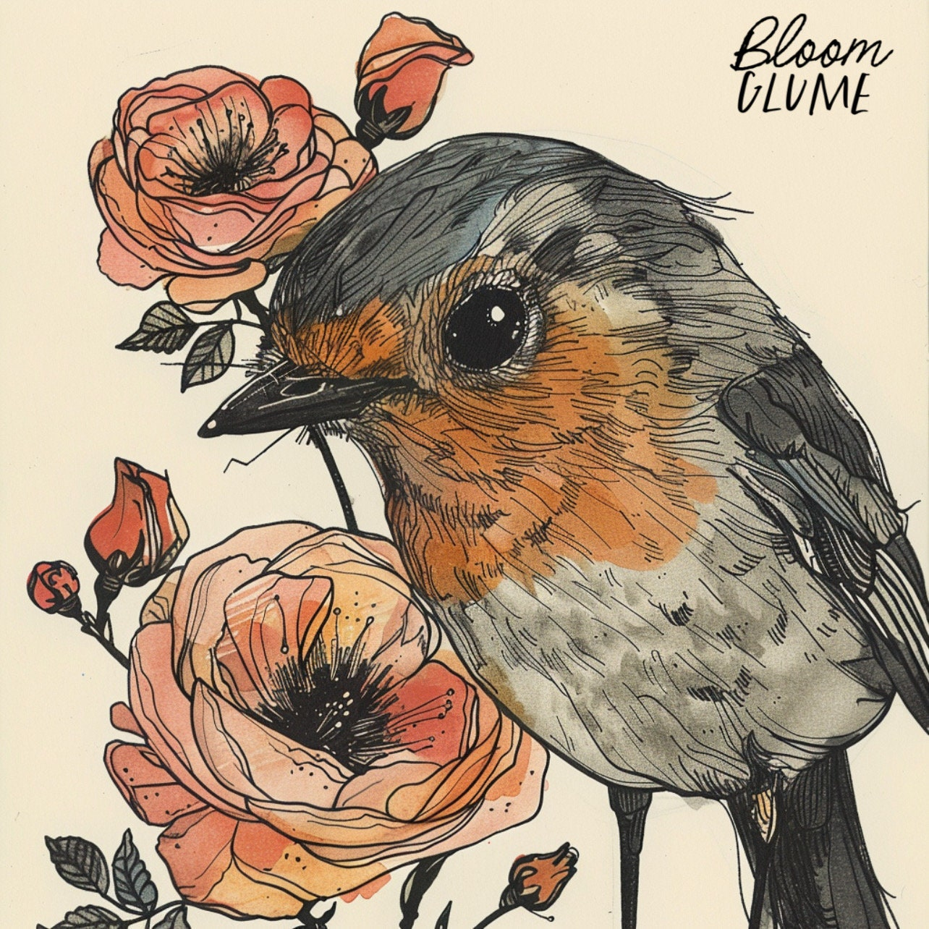

SUNDAY 3RD MAY
SUNDAY LUNCH CLUB (£4.50 paid in advance) - 12pm - 3pm - (Craft Room - Max.16ppl)
- Our Centre will now open one Sunday each month. Our wonderful Chair of Trustees, Erica, and three volunteers, Lorraine, Jon and Eileen will be cooking and serving a traditional Sunday roast followed by a delicious dessert. While you wait for your meal, enjoy a fun quiz or some light entertainment, then sit back and savour a hearty, home-cooked lunch. It’s the perfect way to brighten your Sunday with great food, friendly faces, and warm conversation. To guarantee a space you must pay in advance. Please let us know what you would like from the options below. We will ask for any allergies and preferences when taking bookings. If you do not inform us of any preferences prior to arriving for your lunch, there will be no option for last minute changes on the day. Please turn up on time to ensure your food is served hot and fresh. Enjoy!


Tea, Coffee, Fruit Juice and a glass of Alcohol-free Wine will also be provided.

MONDAY 4TH MAY
CENTRE CLOSED - May Bank Holiday

TUESDAY 5TH MAY
Morning -
Social Day - 9.30am - 4pm - (Craft Room - Max. 20ppl)
- A day for social interaction and a safe place to get on with any hobbies you may have e.g., Painting, drawing, writing, jigsaws, crosswords, knitting. Or just enjoy a nice little chin wag with a cuppa. You must still book a slot on any social day you wish to attend, to secure a seat.
Exploring Acrylics (4 Weeks) - 10am - 12pm - Sue (Local Artist) - (Room 2 - Max.7ppl)
- Local artist, Sue Goulding is back with us to deliver this short 4 -Week acrylic exploration course. In this course you will create bold, vibrant flowers and birds using acrylic paint, whilst also experimenting with texture onto canvas. Imagery will be provided to help inspire you.
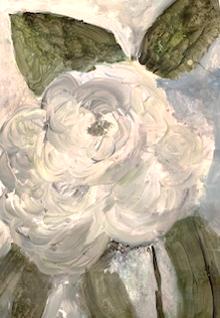
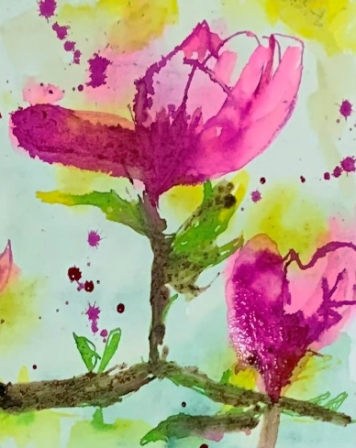
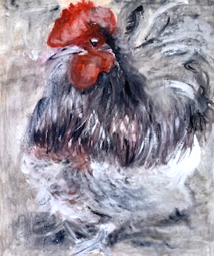
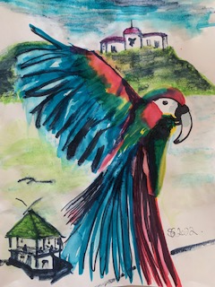

Gardening - 10am - 12pm - Sandra (Volunteer) - (Meet in Craft Room)
- You will help with a little weeding, potting plants, and bulbs, watering flowers and assisting with the maintenance of our flower beds, lawns, and hedges. Outdoor activities are proven to help with wellbeing and mental health, so come and potter about, breathe in the fresh air and absorb some of that all-important Vitamin D. These are open sessions; you must book up each week to guarantee a space.
Afternoon -
“Knit Happens” Introductory - 1.30pm - 3.30pm - Gail - (Volunteer) - (The Old School Café)
- This simple knitting session is ideal for those who have minimal to no experience in knitting. Our lovely volunteer will gently guide you, showing you the basic of techniques. From here, if you feel confident enough, you can then book onto the following sessions, each week to gain more knowledge and knitting skills as you go.

WEDNESDAY 6TH MAY
Morning -
Go With the Flow - 10am - 12pm - Olwyn - (Craft Room - Max.14ppl)
- Ammonites were shelled Cephalopods that died out about 66 million years ago. Fossils of them are found all around the world. Their beautiful spiral shape will inspire us in our artwork today, as we draw on black paper with our new metallic Posca paint pens. At the end of the class, the flow of water will link the individual pieces together as we lay our work out side by side.

Horticulture Group - 10am - 12pm - Joy (Volunteer) - (Allotments)
- You will assist in the general upkeep of our allotment, helping with digging, planting
fresh bulbs, weeding, and maintaining the grounds. You will help grow fresh produce
such as fruit, vegetables, and herbs as well as growing flowers, whilst learning new
skills as you go. Outdoor activities are proven to help with wellbeing and mental
health, so come and potter about, breath in the fresh air and absorb some of that all-important Vitamin D

Music Therapy - 11am - 11.45am - Adriel (Nordoff) - (Room 3 - One-to-One)
- Music therapy uses music to support health and wellbeing, helping people thrive in their own life circumstances. Sessions are tailored to individuals and may include listening, improvisation, learning new skills, songwriting, or other creative work. You don’t need any musical experience - everyone can respond to music. These are one-to-one, open sessions.

Afternoon -
(Busy Afternoon)
2B Or Not 2B - 1.15pm - 3.30pm - Olwyn - (Craft Room - Max. 14ppl)
- A simple pencil can create beautiful images with depth. Practise is key, so let’s explore some shading techniques and create a realistic looking ribbon. We will apply a combination of dark and light shadows, gently blended creating amazing results.
Group Music Therapy - 1.15pm - 2.15pm - Adriel (Nordoff) - (Room 2 - Max. 8ppl)
- Music therapy uses music to support health and wellbeing, helping people thrive in their own life circumstances. In these group sessions you will Improvise and create music together, with a focus on listening and collaboration. These are open, weekly sessions, you can book on as little or as many sessions as you like.

WEDNESDAY CLASS EXAMPLES
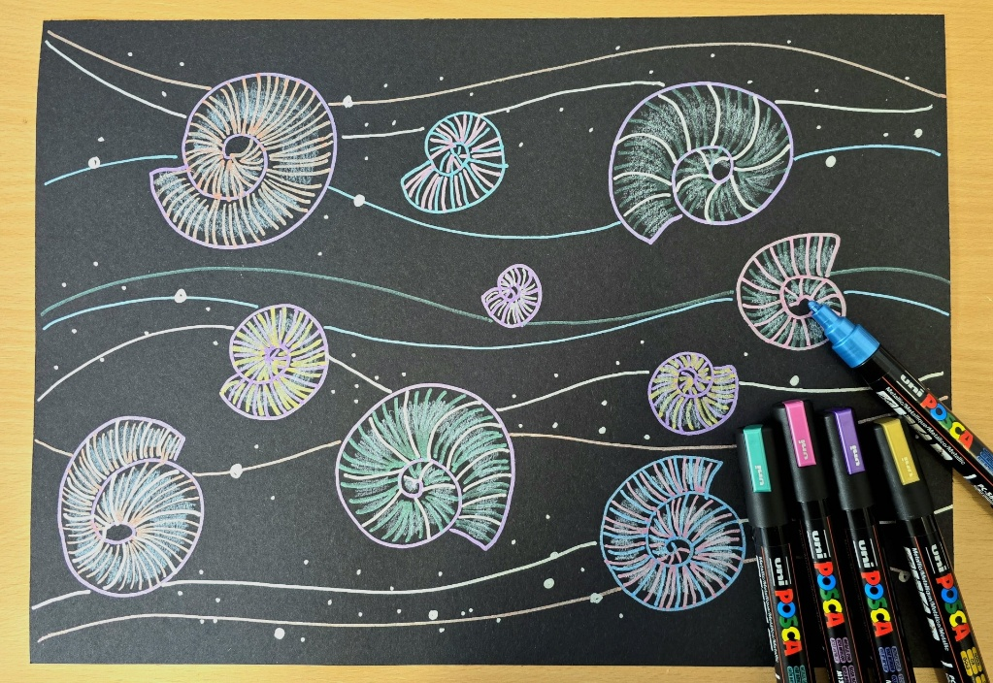
Morning -

“Go With the Flow” Example

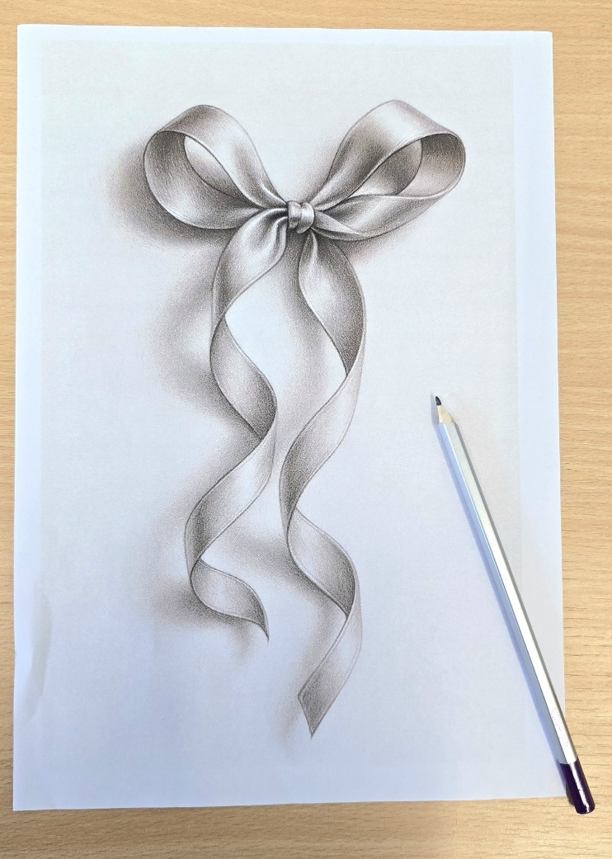
Afternoon –

“2B Or Not 2B” Example

THURSDAY 7TH MAY
(Busy Day)
Morning -
Social Day - 9.30am - 4pm - (Craft Room - Max. 20ppl)
Introduction to Woodwork (£6 fee) - (2 Weeks) - 10am - 3pm - Rob - (Workshop-Max.5ppl)
- Wall Mounted Key Holder - In this short course you will learn how to design, measure, and build a wall mounted key holder. The session will guide you through drawing up a plan, using tools safely and effectively, and accurately measuring, cutting, and assembling your project. You’ll work from your own drawing and measurements, with support throughout.
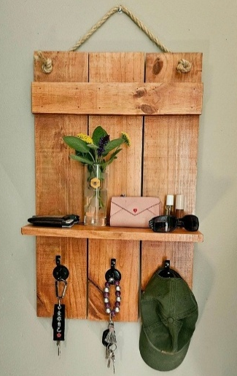

FRIDAY 8TH MAY

Morning -
Optical Illusions - 10am - 12pm - Olwyn - (Craft Room - Max. 14ppl)
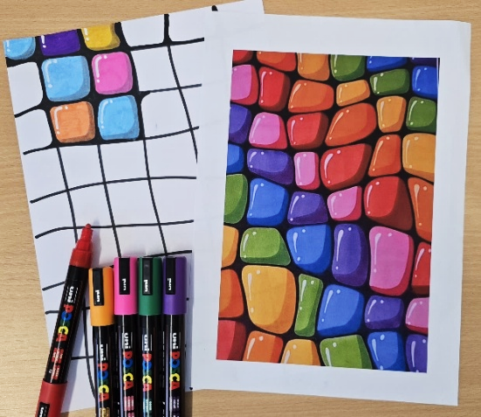
- We will apply bold and beautiful colours using simple techniques, which will help bring your artwork to life. A relaxing and meditative colouring class with striking results.

Afternoon -
Animal Magnetism (2 Weeks) - 1.15pm - 3.30pm - Olwyn - (Craft Room - Max.14ppl)
- Let’s have some fun with the airdry clay and make some personalised fridge magnets! In the first week you will create the animal shape of your choice. In the second week you will paint the quirky details onto your clay using acrylics then add a magnet to create your unique and whimsical keepsake.
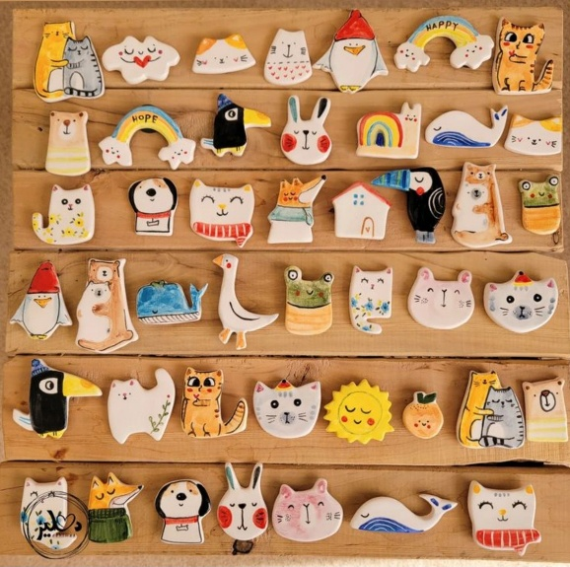

Walking Group - 1.30pm - 3pm - Nicola - (Meet in The Old School Café)
- We will venture out into our wonderful City, exploring the ‘nooks & crannies’ of Durham. This is a nice relaxed paced walk, with only slight inclines and as few stairs as possible (but to be expected in “Hilly” Durham) The walks usually take around 90mins depending on the route and individuals’ mobility. These walks are weather permitted; you will be contacted by lunchtime if the walk has been cancelled due to bad weather. Bring water and wear appropriate clothing for the weather.

MONDAY 11TH MAY
Afternoon -
Chatty Café Drop In - 1pm - 2pm - John (Volunteer) - (The Old School Café)
“Oakey Dokie” - 1.15pm - 3.30pm - Olwyn - (Craft Room - Max.14ppl)
- Let’s get botanical with this delicate watercolour class. Learn how to blend soft sage greens with yellow ochre to produce realistic yellowing leaves and warm browns to create the acorns and their little caps.
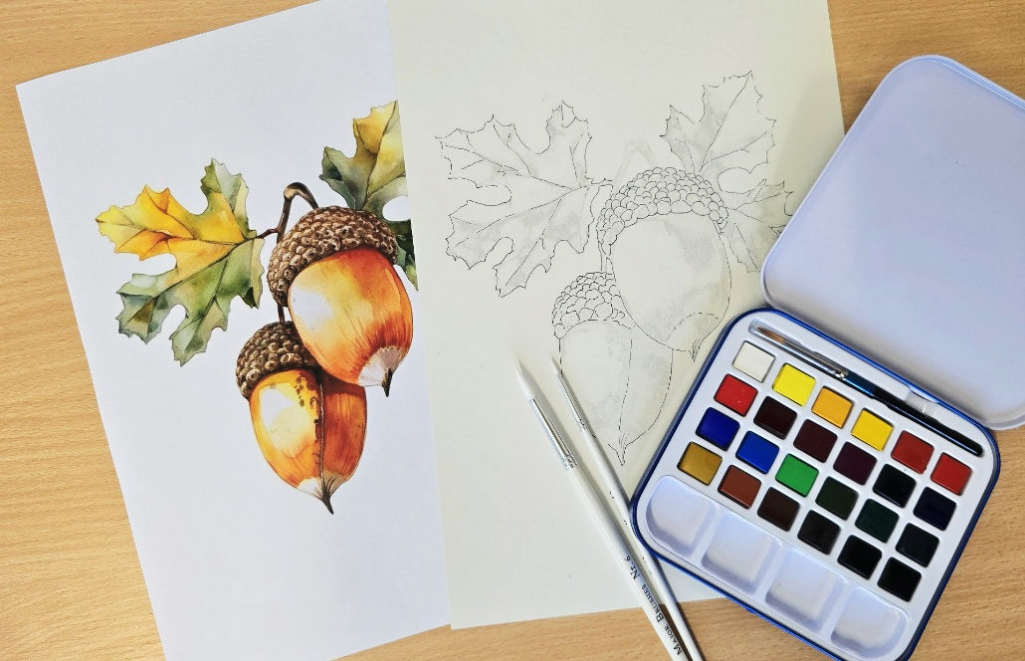

New Client Inductions - 2pm - 3.30pm - Andrea - (Room 2 - Max 8.ppl)
- This is for anybody new who has recently referred to our centre and has already had their initial visit. Andrea will be going through some essential introductory paperwork. Everybody must complete their Inductions before they are able to book onto our regular sessions. You will have the opportunity to book onto sessions at the end of the induction if you choose to do so. These will run every Monday afternoon, if you cannot make a Monday for personal reasons, speak to a member of staff to rearrange.

TUESDAY 12TH MAY
Morning -
Social Day - 9.30am - 4pm - (Craft Room - Max. 20ppl)
Exploring Acrylics - 10am - 12pm - Sue (Local Artist) - (Continued - Week 2)
Gardening - 10am - 12pm - Sandra (Volunteer) - (Meet in Craft Room)
Afternoon -
“Knit Happens” Intermediate - 1.30pm - 3.30pm - Gail (Volunteer) - (The Old School Cafe)

WEDNESDAY 13TH MAY
Morning -
Bouquet of Tulips - 10am - 12pm - Olwyn - (Craft Room - Max.14ppl)
- One Stroke Painting - This is a clever technique where we load a square ended brush with two colours. When we apply this to our painting, the two colours are blended effortlessly which creates stunning effects. Today we will learn how to paint tulips and their leaves, to create a beautiful bouquet.

Horticulture Group - 10am - 12pm - Joy (Volunteer) - (Allotments)

Music Therapy - 11am - 11.45am - Adriel (Nordoff) - (Room 3 - One-to-One)

Afternoon –
(Busy Afternoon)
The Circle of Life - 1.15pm - 3.30pm - Olwyn - (Craft Room - Max.14ppl)
- In this class, we will spread lots of colourful magazines out on the table to flick through. You will use a template to cut out an image out, that you feel says something about you. It may be some delicious food, or a warm cosy fire. We will choose 8 triangular images and piece them together to make a circle. There will be plenty of opportunity to chat about what we enjoy and what we cherish in our lives.

Group Music Therapy - 1.15pm - 2.15pm - Adriel (Nordoff) - (Room 2 - Max. 8ppl)

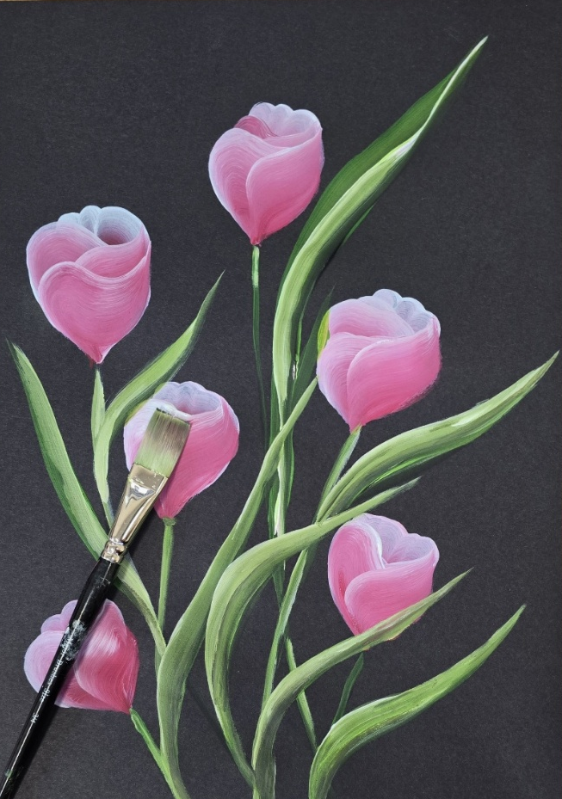
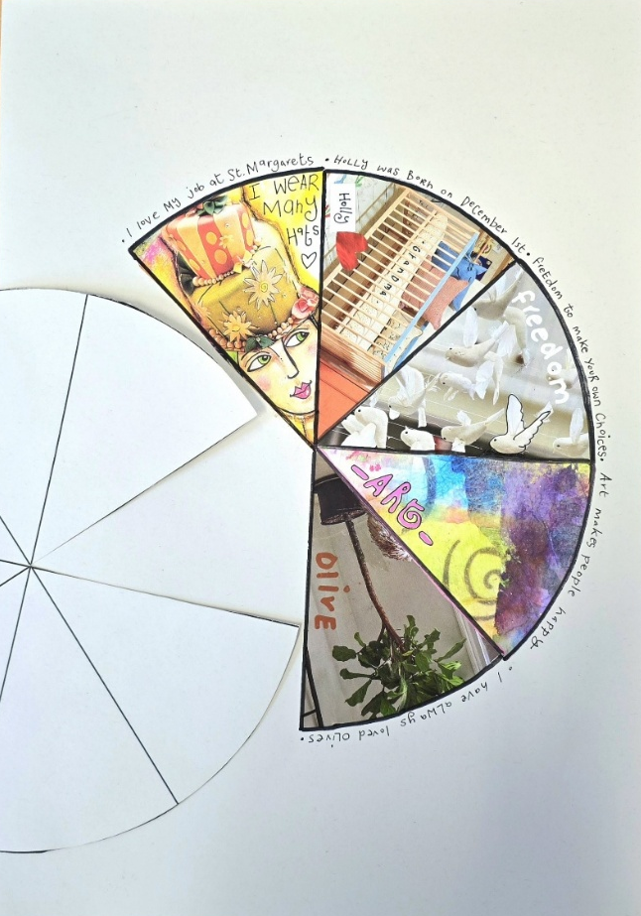
“Bouquet Of Tulips” Example “The Circle of Life” Example

THURSDAY 14TH MAY
(Busy day)
Morning -
Social Day - 9.30am - 4pm - (Craft Room - Max.20ppl)
Introduction to Woodwork - 10am - 3pm - Rob - (Final Session)
Afternoon -
Hatha Yoga (3 Weeks) - 2.15pm - 3.15pm - Julie (Volunteer) - (Room 2 - Max.4ppl)
- You don't need to be flexible or fit to do yoga. Yoga is a journey, and you join the road at the place you are currently at... Yoga celebrates being perfectly imperfect! Yoga is good for creating space for you. It allows you to develop a mindful awareness of where your body is in time and space, and that helps regulate your nervous system as you feel more grounded. It can help you connect to your body and develop strength and functional mobility. You will be able to learn techniques to regulate and ground yourself through breathing (pranayama) and postures (asanas) and have a good old stretch out whilst you're doing it! Hatha yoga is inclusive and is for everybody. Bring a bottle of water and extra clothing so you can layer up and down, in case you get warm/hot or cold. Sometimes you might be seated for a few minutes for a meditation, and the body can cool down quickly. Any loose, comfortable clothing works for these sessions.

FRIDAY 15Th MAY
Morning -

Go With the Flow - 10am - 12pm - Olwyn - (Craft Room - Max.14ppl)
Playing With Words - 10am - 12pm - Katharine - (Room 2 - Max 8ppl)
- Writing poems is all about putting ideas, stories or questions next to each other and seeing what happens. Whether you enjoy reading poems, already write or would just like to have a play with words in new ways, this session will be a chance to experiment with words - 6 or 600 - to create your own poems as well as choice of word-decorated craft e.g. coaster, prism or keyring to keep your ideas with you.

Afternoon -
Animal Magnetism - 1.15pm - 3.30pm - Olwyn - (Continued - Final Session)

MONDAY 18TH MAY
Afternoon -
Chatty Café Drop In - 1pm - 2pm - John (Volunteer) - (The Old School Café)
Crosswords & Cuppas - 1.15pm - 3.30pm - NO TUTOR - (Craft Room - Max.14ppl)
New Client Inductions - 2pm - 3.30pm - Andrea - (Room 2 - Max 8.ppl)

TUESDAY 19TH MAY
Morning -
Social Day - 9.30am - 4pm - (Craft Room - Max.20ppl)
Exploring Acrylics - 10am - 12pm - Sue (Local Artist) - (Continued - Week 3)
Gardening - 10am - 12pm - Sandra (Volunteer) - (Meet in Craft Room)
Afternoon -
“Knit Happens” Intermediate - 1.30pm - 3.30pm - Gail (Volunteer) - (The Old School Cafe)

WEDNESDAY 20TH MAY
Morning -
Optical Illusions - 10am - 12pm - Olwyn - (Craft Room - Max.14ppl)
Horticulture Group - 10am - 12pm - Joy (Volunteer) - (Allotments)
Music Therapy - 11am - 11.45am - Adriel (Nordoff) - (Room 3 - One-to-One)

Afternoon -
(Busy Afternoon)
Oakey Dokie - 1.15pm - 3.30pm – Olwyn (Craft Room - Max.14ppl)
Group Music Therapy - 1.15pm - 2.15pm - Adriel (Nordoff) - (Room 2 - Max. 8ppl)

THURSDAY 21ST MAY
(Busy day)
Morning -
Social Day - 9.30am - 4pm - (Craft Room - Max. 20ppl)
Afternoon -
Hatha Yoga - 2.15pm - 3.15pm - Julie (Volunteer) - (Continued - Week 2)

FRIDAY 22ND MAY
Morning -
The Circle of Life - 10am - 12pm - Olwyn - (Craft Room - Max.14ppl)
Afternoon -
Message In a Bottle - 1.15pm - 3.30pm - Olwyn - (Craft Room - Max. 14ppl)
- 3D Card Making – A nice relaxing card making class where we will focus on a simple illustration, coloured with pencils and fineliners. A small incision will allow a message of your choice to be pulled from the bottle to add a clever little finishing touch.
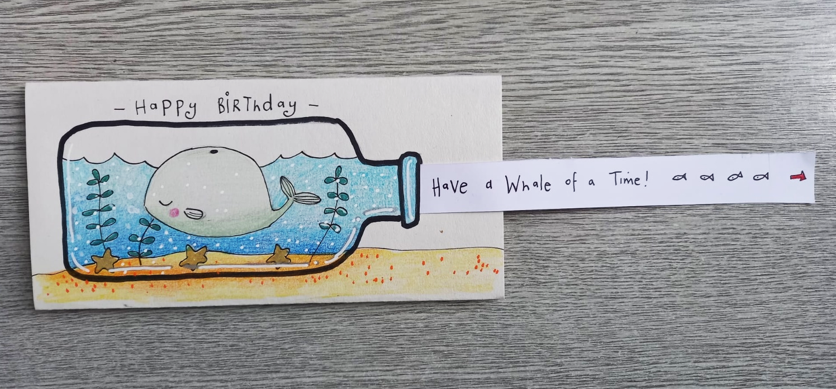

Walking Group - 1.30pm - 3pm - Nicola - (Meet in The Old School Café)

MONDAY 25TH MAY
CENTRE CLOSED - SPRING BANK HOLIDAY

TUESDAY 26TH MAY
Morning -
Social Day - 9.30am - 4pm - (Craft Room - Max.20ppl)
Exploring Acrylics - 10am - 12pm - Sue (Local Artist) - (Final Session)
Gardening - 10am - 12pm - Sandra (Volunteer) - (Meet in Craft Room)
Afternoon -
“Knit Happens” Intermediate - 1.30pm - 3.30pm - Gail (Volunteer) - (The Old School Cafe)

WEDNESDAY 27TH MAY
Morning -
Message In a Bottle - 10am - 12pm - Olwyn - (Craft Room - Max.14ppl)

Horticulture Group - 10am - 12pm - Joy (Volunteer) - (Allotments)

Music Therapy - 11am - 11.45am - Adriel (Nordoff & Robbins) - (Room 3 - One-to-One)

Afternoon -
(Busy Afternoon)
Desert Island Discs - 1.15pm - 3.30pm - Olwyn - (Craft Room – Max.14ppl)
- In this extremely popular and uplifting group session, you will have the opportunity to request and listen to up- beat tracks to start then finish the session of with some chilled tracks. We encourage you to choose songs that you enjoy or may have meaning to you. If you would like, you will get the opportunity to share why you chose your song and what meaning it has to you, or you may just choose to listen to others.

Group Music Therapy - 1.15pm - 2.15pm - Adriel (Nordoff) - (Room 2 - Max. 8ppl)

THURSDAY 28TH MAY
(Busy day)
Morning -
Social Day - 9.30am - 4pm - (Craft Room - Max. 20ppl)
Fabric Notebook Cover - 10am - 12pm - Katharine - (Room 2 - Max 8ppl)
- Make and decorate a notebook cover as a gift, for your own ideas or reminders or even just extra lovely shopping lists. We'll use fabric, embroidery thread, buttons, ribbons - the sky's the limit. This will involve simple pinning and hand sewing. If you already have a book you'd like to cover e.g. a cookbook, diary, photo album, just bring it along and we'll work it out together.

Afternoon -
Hatha Yoga - 2.15pm - 3.15pm - Julie (Volunteer) - (Final Session)

FRIDAY 29TH MAY
Morning -
2B Or Not 2B - 10am - 12pm - Olwyn - (Craft Room - Max.14ppl)
Afternoon -
Oakey Dokie - 1.15pm - 3.30pm - Olwyn - (Craft Room - Max.14ppl)

