Please read carefully.
Hello,
We hope this letter finds you well.
Enclosed you will find the latest timetable of activities for June 2026. We will be taking bookings for these activities via phone call or email from 10am on Tuesday 26th May Please do not phone us to try booking before this date and time. You will find our contact number and email address on the front page of your timetable.
After a review of our safety and security measures, we ask that our attendees and volunteers do not enter the building any earlier than 15 minutes before your session starts. All class start and finish times are stated on your timetable. Our Centre door will be locked until 9.15am to allow access to our volunteers. We also ask that if you are not booked onto anything, please do not wander upstairs or into the workshop and disturb staff/classes. You are welcome to come in and purchase food or use a token in our Café. Thank you for your understanding.
Due to the volume of new referrals coming through. You will only be able to book onto one Social Day (Tuesday or Thursday) and two of Olwyn’s classes per week. This is so we can give new attendees a fair chance of booking onto sessions. (Not including volunteer led classes).
We please ask that you pay a £1 attendance fee per session. Your attendance fee goes back into the Centre and helps towards cost of materials and use of our tea and coffee facilities situated in our craft room. Your contribution is much appreciated.
Please turn up to your class on time, unless you have called to say you are running late. Please do not eat food or leave to go for a cigarette during classes, this can be very disruptive for other attendees and the instructor. You are all given a 15-minute break halfway through your classes to eat, make a beverage and smoke.
If you are booked onto any class and cannot make it for whatever reason you must call the centre to inform us of this as early as possible, so that we can offer the space to somebody else. You still need to book to attend Social Days as well as regular classes; to guarantee you have a seat.

Classes with this symbol - are dedicated, quieter sessions. Anybody can join them, but they are designed to be inclusive of neurodivergent individuals who may struggle to access our standard sessions. (Up to a Maximum of 20ppl in our Craft Room and 8ppl in Room 2)

We look forward to seeing you.

To Book Classes Call: 0191 384 8100 or Email: enquiries@stmargaretscentre.co.uk
(There is an attendance fee of £1 per session)
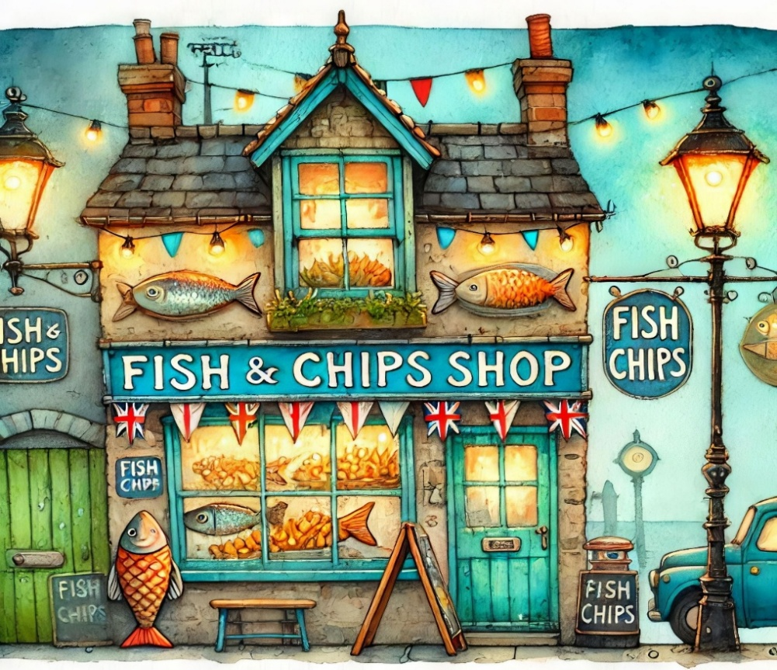

MONDAY 1ST JUNE
Afternoon -
Chatty Café Drop In - 1pm - 2pm - John (Volunteer) - (The Old School Café)
- Are you feeling isolated and in need of a chat and some friendly company? Then we welcome you to pop into The Old School Café, where one of our lovely volunteers will be there waiting. This is not a counselling session, but a safe space where you can have a lovely informal chat. Hopefully you will leave feeling a little brighter.

Wildflowers - 1.15pm - 3.30pm - Olwyn - (Craft Room - Max. 14ppl)
- Discover the magic of blending and layering coloured chalk pastels as we create a dreamy wildflower scene. We'll start by building an atmospheric misty background, softly blending colourful shades from light to dark. Once our backdrop is complete, we'll bring the scene to life by adding delicate flower stems and vibrant blooms in the foreground, using varied pressure to create depth and detail.

Client Inductions - 2pm - 3.30pm - Andrea - (Room 2 - Max 8.ppl)
- This is for anybody new who has recently referred to our centre and has had their initial visit. Andrea will be going through some essential introductory paperwork. You will have the opportunity to book onto sessions at the end of the induction if you choose to do so. These will run every Monday afternoon, if you cannot make a Monday for personal reasons, speak to a member of staff to rearrange.

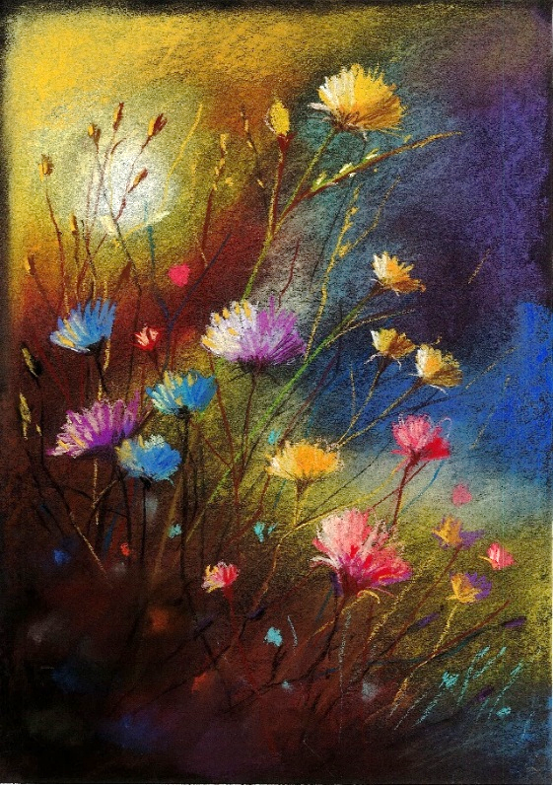
Monday Class Example

“Wildflowers” Example
TUESDAY 2ND JUNE
Morning -
Social Day - 9.30am - 4pm - (Craft Room - Max. 20ppl)
- A day for social interaction and a safe place to get on with any hobbies you may have e.g., Painting, drawing, writing, jigsaws, crosswords, knitting. Or just enjoy a nice little chin wag with a cuppa. You must still book a slot on any social day you wish to attend, to secure a seat.

Gardening - 10am - 12pm - Sandra (Volunteer) - (Meet in Craft Room)
- You will help with a little weeding, potting plants, and bulbs, watering flowers and assisting with the maintenance of our flower beds, lawns, and hedges. Outdoor activities are proven to help with wellbeing and mental health, so come and potter about, breathe in the fresh air and absorb some of that all-important Vitamin D. These are open sessions; you must book up each week to guarantee a space.
Afternoon -
“Knit Happens” Introductory - 1.30pm - 3.30pm - Gail - (Volunteer) - (Room 2 - Max.8ppl)
- This simple knitting session is ideal for those who have minimal to no experience in knitting. Our lovely volunteer will gently guide you, showing you the basic of techniques. From here, if you feel confident enough, you can then book onto the following sessions, each week to gain more knowledge and knitting skills as you go.

WEDNESDAY 3RD JUNE
Morning -
Embossed Mosaic Tile Card - 10am - 12pm - Olwyn - (Craft Room - Max.14ppl)
- Transform reclaimed embossed wallpaper into elegant greetings cards in this relaxing workshop. Arrange textured white squares, then add shimmer with metallic Posca paint pens in silver, gold, or jewel tones. This gentle, meditative process creates beautiful minimalist cards while encouraging mindfulness and creativity. Perfect for all skill levels - just bring yourself and enjoy the therapeutic rhythm of making something special.

Horticulture Group - 10am - 12pm - Joy (Volunteer) - (Allotments)
- You will assist in the general upkeep of our allotment, helping with digging, planting
fresh bulbs, weeding, and maintaining the grounds. You will help grow fresh produce
such as fruit, vegetables, and herbs as well as growing flowers, whilst learning new
skills as you go. Outdoor activities are proven to help with wellbeing and mental
health, so come and potter about, breath in the fresh air and absorb some of that all-important Vitamin D

Music Therapy - 11am - 11.45am - Adriel (Nordoff) - (Room 3 - One-to-One)
- Music therapy uses music to support health and wellbeing, helping people thrive in their own life circumstances. In these group sessions you will Improvise and create music together, with a focus on listening and collaboration. These are open, weekly sessions, you can book on as little or as many sessions as you like.
Afternoon -
(Busy Afternoon)
Leopard Print Wrapping Paper - 1.15pm - 3.30pm - Olwyn - (Craft Room - Max. 14ppl)
- A simple, calming painting class for everyone - no experience needed. We’ll paint irregular circles in yellow ochre on brown paper. Once dry, we'll add black shapes around the edges to create leopard spots. You'll also make a matching gift tag to keep or use for wrapping. All materials provided. Just come and enjoy creating.

Group Music Therapy - 1.15pm - 2.15pm - Adriel (Nordoff) - (Room 2 - Max. 8ppl)
Music Therapy - 2.45pm - 3.30pm - Adriel (Nordoff) - (Room 3 - One-to-One)

WEDNESDAY CLASS EXAMPLES
Morning -


“Embossed Mosaic Tile Card” Example

Afternoon -


“Leopard Print Wrapping Paper” Example

THURSDAY 4TH JUNE
(Busy Day)
Morning -
Social Day - 9.30am - 4pm - (Craft Room - Max. 20ppl)
Afternoon -
Hatha Yoga (3 Weeks) - 2.15pm - 3.15pm - Julie (Volunteer) - (Room 2 - Max.4ppl)
- You don't need to be flexible or fit to do yoga. Yoga is a journey, and you join the road at the place you are currently at... Yoga celebrates being perfectly imperfect! Yoga is good for creating space for you. It allows you to develop a mindful awareness of where your body is in time and space, and that helps regulate your nervous system as you feel more grounded. It can help you connect to your body and develop strength and functional mobility. You will be able to learn techniques to regulate and ground yourself through breathing (pranayama) and postures (asanas) and have a good old stretch out whilst you're doing it! Hatha yoga is inclusive and is for everybody. Bring a bottle of water and extra clothing so you can layer up and down, in case you get warm/hot or cold. Sometimes you might be seated for a few minutes for a meditation, and the body can cool down quickly. Any loose, comfortable clothing works for these sessions.

FRIDAY 5TH JUNE

Morning -
“Let’s Face It”- 10am - 12pm - Olwyn - (Craft Room - Max. 14ppl)
- Well let’s face it, we have not done this before! We will sit in pairs, opposite each other, and try to draw each other’s face, head and shoulders using coloured chalk pastels. The emphasis is on FUN! and expression, so come along and have a good time!

Embroidery (5 Weeks) - (£2 fee) - 10am - 12pm - Meg, Alison & Gail - (Room 2 - Max.7ppl)
- Sashiko Decorated Tote Bags - This is an introduction to traditional Japanese embroidery technique and pattern marking. Some experience with hand sewing would be beneficial. There is a small charge for materials on this course. If you book onto this course, please pop the following 4 weeks in your diary.

Afternoon -
3D Pop-up Butterfly Card (2 weeks) - 1.15pm - 3.30pm - Olwyn - (Room 2 - Max.8ppl)
- Create a card that comes to life when you open it! Colourful butterflies will pop up right before your eyes. We'll colour a large butterfly for the front of the card, then cut out smaller butterflies for the inside. When arranged just right, they'll spring up as the card opens—simple, satisfying, and fun to make. A lovely card to keep or give to someone special. Please be prepared to do a lot of small fiddly cutting before you sign up to this class, this card will take around 2-weeks to create so please make sure you can attend sessions before taking up a space.

Textiles Group (5 Weeks) - 1.15pm - 3.30pm - Meg, Alison & Gail - (Craft Rm. - Max.10ppl)
- Sewing Room Acessories - In this 5-week textiles course, from an array of fabrics and materials you will make a needle case, a pumpkin pin cushion and a storage pouch. This course will involve machine sewing, so experience in machine sewing is beneficial. If you book onto this course, please pop the following 4 weeks in your diary.

Walking Group - 1.30pm - 3pm - Nicola - (Meet in The Old School Café)
- We will venture out into our wonderful City, exploring the ‘nooks & crannies’ of Durham. This is a nice relaxed paced walk, with only slight inclines and as few stairs as possible (but to be expected in “Hilly” Durham) The walks usually take around 90mins depending on the route and individuals’ mobility. These walks are weather permitted; you will be contacted by lunchtime if the walk has been cancelled due to bad weather. Bring water and wear appropriate clothing for the weather.

FRIDAYS CLASS EXAMPLES

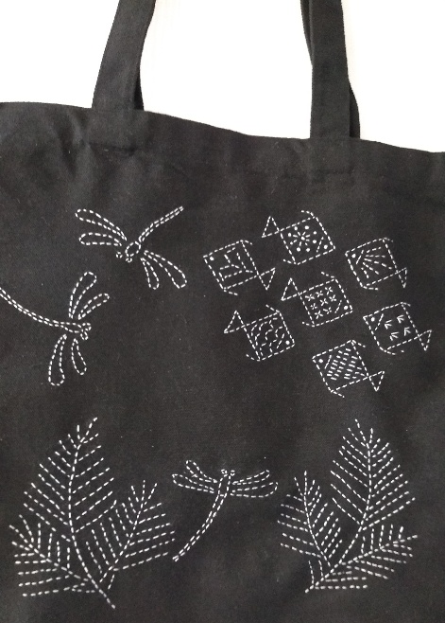
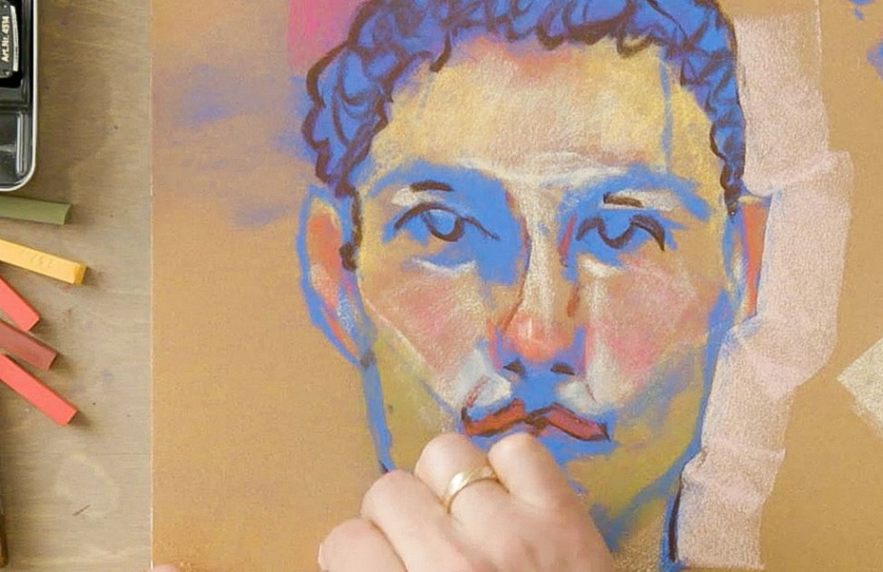
Morning -

“Let’s Face it” Example “Sashiko Tote Bag” Example

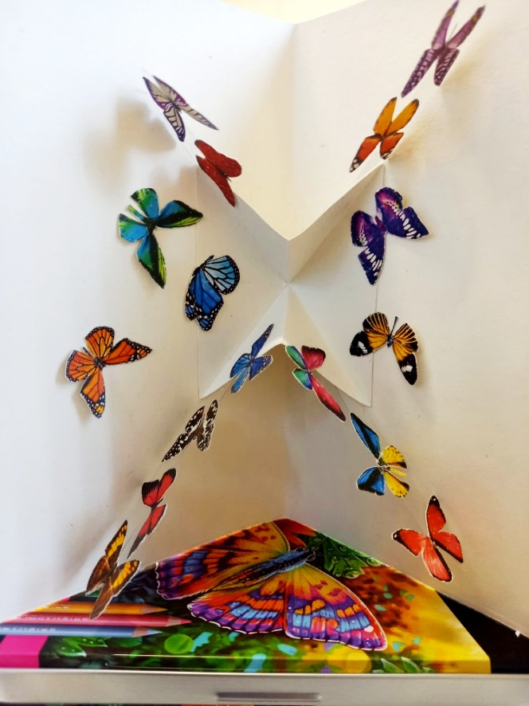
Afternoon -
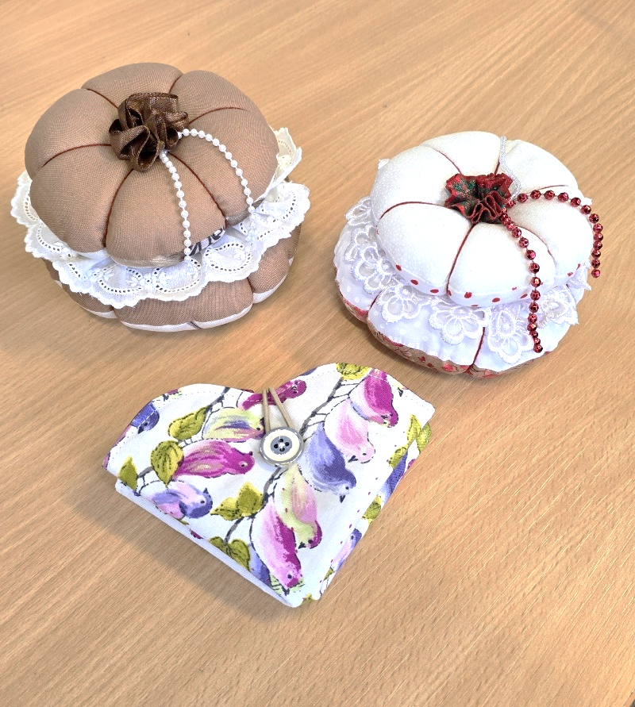

“3D Pop-up Butterfly Card” Example “Sewing Room Acessories” Examples

SUNDAY 7th JUNE
SUNDAY LUNCH CLUB (£4.50 paid in advance) - 12pm - 3pm - (Craft Room - Max.16ppl)
- Our wonderful Chair of Trustees, Erica, and four of our lovely volunteers, Lorraine, Jon, Eileen and Kevin will be cooking and serving a traditional Sunday roast followed by a delicious dessert. While you wait for your meal, enjoy a fun quiz or some light entertainment, then sit back and savour a hearty, home-cooked lunch. It’s the perfect way to brighten your Sunday with great food, friendly faces, and warm conversation. To guarantee a space you must pay in advance. Please let us know what you would like from the options below. We will ask for any allergies and preferences when taking bookings. Please turn up on time to ensure your food is served hot and fresh. Enjoy!


Tea, Coffee, Fruit Juice or a glass of Alcohol-free Wine will also be provided.

MONDAY 8TH JUNE
Afternoon -
Chatty Café Drop In - 1pm - 2pm - John (Volunteer) - (The Old School Café)
Magnetic Peg Fridge Magnets - 1.15pm - 3.30pm - Olwyn - (Craft Room - Max.14ppl)
- A creative and fun activity that makes a unique handmade gift. Choose an image from a magazine, then cut it into 4 thin strips. We'll glue each strip onto a wooden peg and add magnets to the back. When the pegs are lined up correctly on the card, your image appears complete—like a little puzzle! We'll use fineliners to add finishing touches and make it extra special. Perfect for friends and family.
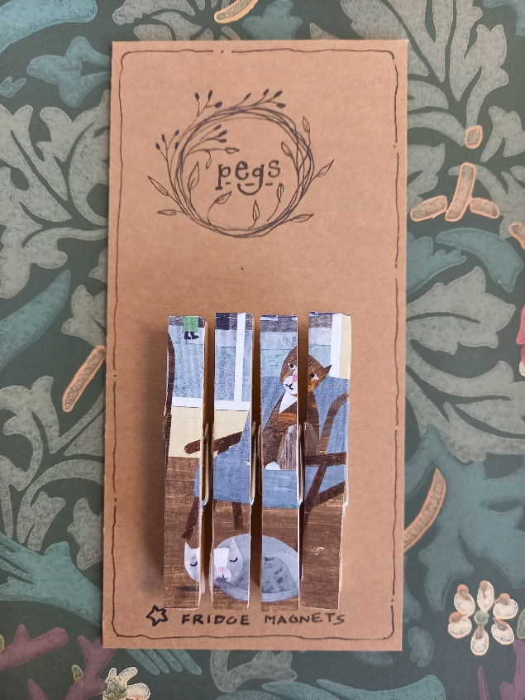

New Client Inductions - 2pm - 3.30pm - Andrea - (Room 2 - Max 8.ppl)
TUESDAY 9TH JUNE
Morning -
Social Day - 9.30am - 4pm - (Craft Room - Max. 20ppl)
Gardening - 10am - 12pm - Sandra (Volunteer) - (Meet in Craft Room)
Afternoon -
“Knit Happens” Intermediate - 1.30pm - 3.30pm - Gail (Volunteer) - (Room 2 - Max.8ppl)

WEDNESDAY 10TH JUNE
Morning -
Sunlight - 10am - 12pm - Olwyn - (Craft Room - Max.14ppl)
- Using a very popular and effective dry brush painting technique, we will learn how to let natural sunlight into our paintings. Using pre-printed imagery as inspiration, you may choose to create light beaming through a window, bursting through the clouds or dappled onto water. Let’s relax, unwind and paint!


Horticulture Group - 10am - 12pm - Joy (Volunteer) - (Allotments)

Music Therapy - 11am - 11.45am - Adriel (Nordoff) - (Room 3 - One-to-One)
Afternoon -
(Busy Afternoon)
Wildflowers - 1.15pm - 3.30pm - Olwyn - (Craft Room - Max.14ppl)

Group Music Therapy - 1.15pm - 2.15pm - Adriel (Nordoff) - (Room 2 - Max. 8ppl)

Music Therapy - 2.45pm - 3.30pm - Adriel (Nordoff) - (Room 3 - One-to-One)

THURSDAY 11TH JUNE
(Busy day)
Morning -
Social Day - 9.30am - 4pm - (Craft Room - Max.20ppl)

Afternoon -
HAP Enrolments - 2pm - 3.30pm - Linda - Homegroup - (The Old School Café)
- Would you like to boost your confidence, improve your health, and gain independence? Join the Home Achievement Programme and earn a FREE recognised qualification! Develop skills for learning, life and work with the Home Achievement Programme Over 40 modules to choose from. You will be supported by Linda throughout the programme. When you complete your booklets, you will achieve a Level 1 accreditation. If you want to see what modules are available, please see the list attached to the back of this timetable. Once this enrolment session is complete HAP Sessions will run weekly from Thursday 25th June 2pm - 4pm, until you have completed your module.

Hatha Yoga - 2.15pm - 3.15pm - Julie (Volunteer) - (Continued - Week 2)

FRIDAY 12TH JUNE
Morning -
Embossed Mosaic Tile Card - 10am - 12pm - Olwyn - (Craft Room - Max.14ppl)

Embroidery - 10am - 12pm - Meg, Alison & Gail - (Continued - Week 2)

Afternoon -
3D Pop-up Butterfly Card - 1.15pm - 3.30pm - Olwyn - (Continued - Final Session)
Textiles Group - 1.15pm - 3.30pm - Meg, Alison & Gail - (Continued - Week 2)

MONDAY 15TH JUNE
Afternoon -
Chatty Café Drop In - 1pm - 2pm - John (Volunteer) - (The Old School Café)
Crosswords & Cuppas - 1.15pm - 3.30pm - NO TUTOR - (Craft Room - Max.14ppl)
- You will have a selection of crosswords to choose from. You can either do these individually or as a group if you wish, whilst enjoying a cuppa and a chit chat amongst yourselves.

New Client Inductions - 2pm - 3.30pm - Andrea - (Room 2 - Max 8.ppl)

TUESDAY 16TH JUNE
Morning -
Social Day - 9.30am - 4pm - (Craft Room - Max.20ppl)
Gardening - 10am - 12pm - Sandra (Volunteer) - (Meet in Craft Room)
Afternoon -
“Knit Happens” Intermediate - 1.30pm - 3.30pm - Gail (Volunteer) - (Room 2 - Max.8ppl)

WEDNESDAY 17TH JUNE
Morning -
Social Day - 9.30am - 4pm - (Craft Room - Max. 20ppl)
Horticulture Group - 10am - 12pm - Joy (Volunteer) - (Allotments)
Music Therapy - 11am - 11.45am - Adriel (Nordoff) - (Room 3 - One-to-One)

Afternoon -
Group Music Therapy - 1.15pm - 2.15pm - Adriel (Nordoff) - (Room 2 - Max. 8ppl)

Music Therapy - 2.45pm - 3.30pm - Adriel (Nordoff) - (Room 3 - One-to-One)

THURSDAY 18TH JUNE
(Busy day)
Morning -
Social Day - 9.30am - 4pm - (Craft Room - Max. 20ppl)
Introduction to Woodwork (£6 fee)-(3 Weeks) - 10am - 3pm - Rob - (Workshop - Max.5ppl)
- Character Garden Planter and Mini Bench - In this short course you will learn how to design, measure, and build a garden planter and mini bench. The session will guide you through drawing up a plan, using tools safely and effectively, and accurately measuring, cutting, and assembling your project. You’ll work from your own drawing and measurements, with support throughout.
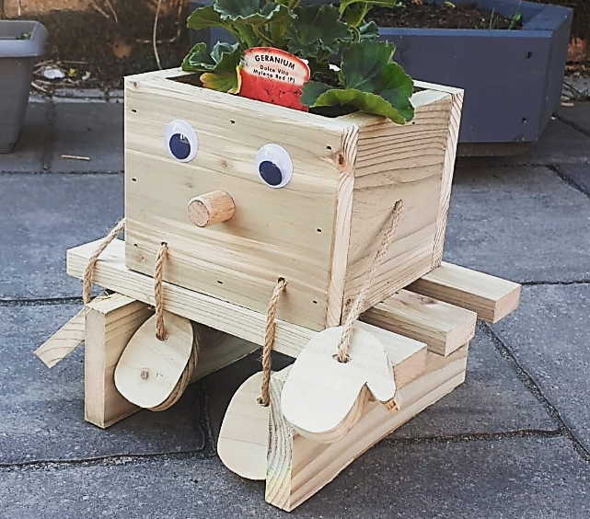

Afternoon -
Hatha Yoga - 2.15pm - 3.15pm - Julie (Volunteer) - (Final Session)

FRIDAY 19TH JUNE
Morning -
Crosswords & Cuppas - 10am - 12pm - NO TUTOR - (Room 2 - Max.8ppl)
Embroidery - 10am - 12pm - Meg, Alison & Gail - (Continued - Week 3)
Afternoon -
Watercolour Illustrations - 1.15pm - 3.30pm - NO TUTOR - (Room 2 - Max.8ppl)
- You will have a selection of preprinted Illustrations to choose from, where you will add a pop of colour using watercolours. This is a self-led session with no instructor.

Textiles Group - 1.15pm - 3.30pm - Meg, Alison & Gail - (Continued - Week 3)

Walking Group - 1.30pm - 3pm - Nicola - (Meet in The Old School Café)

MONDAY 22ND JUNE
Afternoon -
Chatty Café Drop In - 1pm - 2pm - John (Volunteer) - (The Old School Café)
Pastels drawing - 1.15pm - 3.30pm - NO TUTOR - (Craft Room - Max.14ppl)
- You will be offered a selection of preprinted illustrations that you will colour and shade with coloured chalk pastels.

New Client Inductions - 2pm - 3.30pm - Andrea - (Room 2 - Max 8.ppl)

TUESDAY 23RD JUNE
Morning -
Social Day - 9.30am - 4pm - (Craft Room - Max.20ppl)
Gardening - 10am - 12pm - Sandra (Volunteer) - (Meet in Craft Room)
Afternoon -
“Knit Happens” Intermediate - 1.30pm - 3.30pm - Gail (Volunteer) - (Room 2 - Max.8ppl)

WEDNESDAY 24TH JUNE
Morning -
Magnetic Peg Fridge Magnets - 10am - 12pm - Olwyn - (Craft Room - Max.14ppl)

Horticulture Group - 10am - 12pm - Joy (Volunteer) - (Allotments)

Music Therapy - 11am - 11.45am - Adriel (Nordoff & Robbins) - (Room 3 - One-to-One)
Afternoon -
(Busy Afternoon)
Desert Island Discs - 1.15pm - 3.30pm - Olwyn - (Craft Room - Max.14ppl)
- Sounds of Summer - In this extremely popular and uplifting group session, you will have the opportunity to request and listen to songs that give you that summer feeling! We encourage you to choose songs that give you those uplifting summer vibes. If you would like, you will get the opportunity to share why you chose your song and what meaning it may have to you, or you may just choose to listen to others.

Group Music Therapy - 1.15pm - 2.15pm - Adriel (Nordoff) - (Room 2 - Max. 8ppl)
Music Therapy - 2.45pm - 3.30pm - Adriel (Nordoff) - (Room 3 - One-to-One)

THURSDAY 25TH JUNE
(Busy day)
Morning -
Social Day - 9.30am - 4pm - (Craft Room - Max. 20ppl)

Introduction to Woodwork - 10am - 3pm - Rob - (Continued - Week 2)

Afternoon -
Beginners Gentle Chair Yoga - 12pm - 1pm - Julie (Volunteer) - (Room 2 - Max.8ppl)
- This one-off taster session is aimed at those who may struggle with mobility. You don't need to be flexible or fit to do yoga. Yoga is a journey, and you join the road at the place you are currently at... Yoga celebrates being perfectly imperfect! Yoga is good for creating space for you. Bring a bottle of water and extra clothing so you can layer up and down, in case you get warm/hot or cold. Loose comfortable clothing is recommended. If you enjoy this gentler version of seated yoga and would like to see it on again, please let the instructor or a member of staff know, and we will aim at putting these sessions on more regularly.
HAP Session - 2pm - 3.30pm - Linda - Homegroup - (Continued)
- This is for those who have already enrolled onto HAP Modules on the 11th of June. If you missed the enrolments but are interested in any of the modules listed on the back of this timetable, please speak to a member of staff.

FRIDAY 26TH JUNE
Morning -
3D Pop-up Butterfly Cards (2 Weeks) - 10am - 12pm - Olwyn - (Craft Room - Max.14ppl)
Embroidery - 10am - 12pm - Meg, Alison & Gail - (Continued - Week 3)
Afternoon -
Wildflowers - 1.15pm - 3.30pm - Olwyn - (Room 2 - Max.8ppl)

Textiles Group - 1.15pm - 3.30pm - Meg, Alison & Gail - (Continued - Week 3)

SUNDAY 28th JUNE
SUNDAY LUNCH CLUB (£4.50 paid in advance) - 12pm - 3pm - (Craft Room - Max.16ppl)
- We have put on a second Sunday Lunch Club this month, as we will not be able to run one in July. To guarantee a space you must pay in advance. Please let us know what you would like from the options below. We will ask for any allergies and preferences when taking bookings. Please turn up on time to ensure your food is served hot and fresh. Enjoy!


Tea, Coffee, Fruit Juice or a glass of Alcohol-free Wine will also be provided.

MONDAY 29TH JUNE
Afternoon -
Chatty Café Drop In - 1pm - 2pm - John (Volunteer) - (The Old School Café)
“Let’s Face It” - 1.15pm - 3.30pm - Olwyn - (Craft Room - Max.14ppl)

TUESDAY 30TH JUNE
Morning -
Social Day - 9.30am - 4pm - (Craft Room - Max. 20ppl)
Gardening - 10am - 12pm - Sandra (Volunteer) - (Meet in Craft Room)
Afternoon -
“Knit Happens” Intermediate - 1.30pm - 3.30pm - Gail (Volunteer) - (Room 2 - Max.8ppl)
WEDNESDAY 1ST JULY
Morning -
Leopard Print Wrapping Paper - 10am - 12pm - Olwyn - (Craft Room - Max.14ppl)

Horticulture Group - 10am - 12pm - Joy (Volunteer) - (Allotments)

Music Therapy - 11am - 11.45am - Adriel (Nordoff) - (Room 3 - One-to-One)

Afternoon -
(Busy Afternoon)
Sunlight - 1.15pm - 3.30pm - Olwyn - (Craft Room - Max.14ppl)

Group Music Therapy - 1.15pm - 2.15pm - Adriel (Nordoff) - (Room 2 - Max. 8ppl)

Music Therapy - 2.45pm - 3.30pm - Adriel (Nordoff) - (Room 3 - One-to-One)

THURSDAY 2ND JULY
(Busy day)
Morning -
Social Day - 9.30am - 4pm - (Craft Room - Max.20ppl)
Introduction to Woodwork - 10am - 3pm - Rob - (Final Session)
Afternoon –
HAP Session - 2pm - 3.30pm - Linda - Homegroup - (Continued)

FRIDAY 3RD JULY
Morning -
3D Pop-up Butterfly Cards - 10am - 12pm - Olwyn - (Final Session)

Embroidery - 10am - 12pm - Meg, Alison & Gail - (Continued - Week 2)

Afternoon -
Magnetic Fridge Magnets - 1.15pm - 3.30pm - Olwyn - (Room 2 - Max.8ppl)
Textiles Group - 1.15pm - 3.30pm - Meg, Alison & Gail - (Continued - Week 2)

Walking Group - 1.30pm - 3pm - Nicola - (Meet in The Old School Café)

